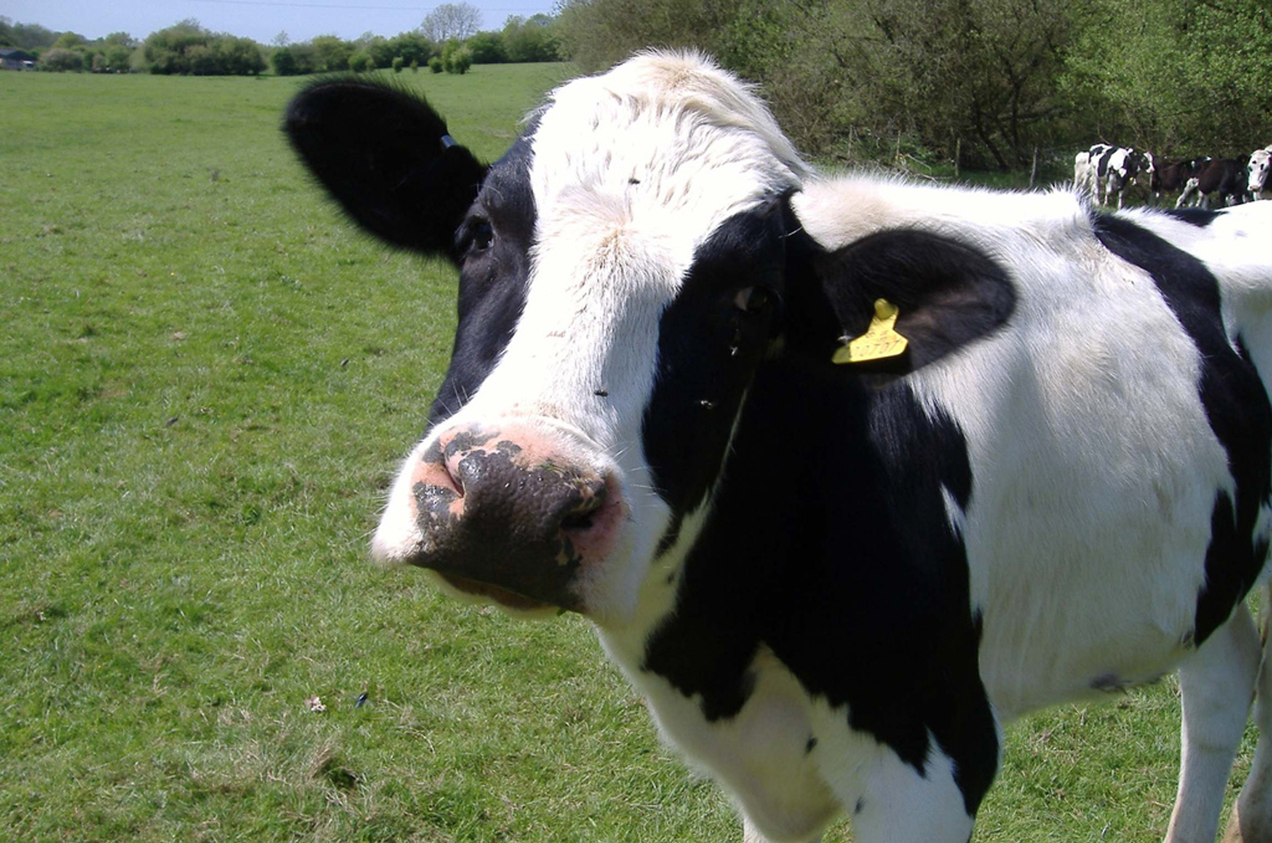
Photo courtesy of Cathy, Sam, Max and Mai on Flickr
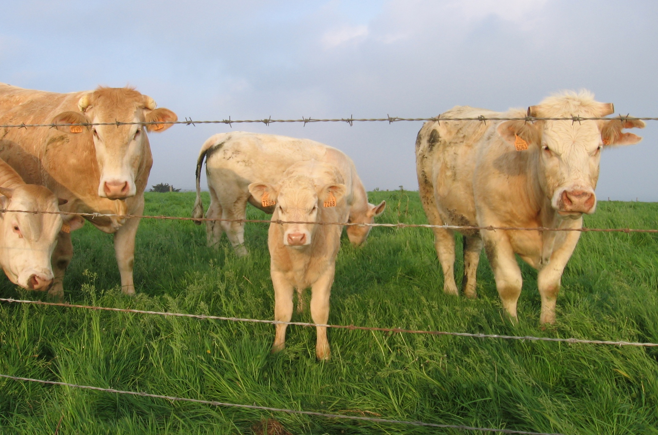
Photo courtesy of JelleS on Flickr
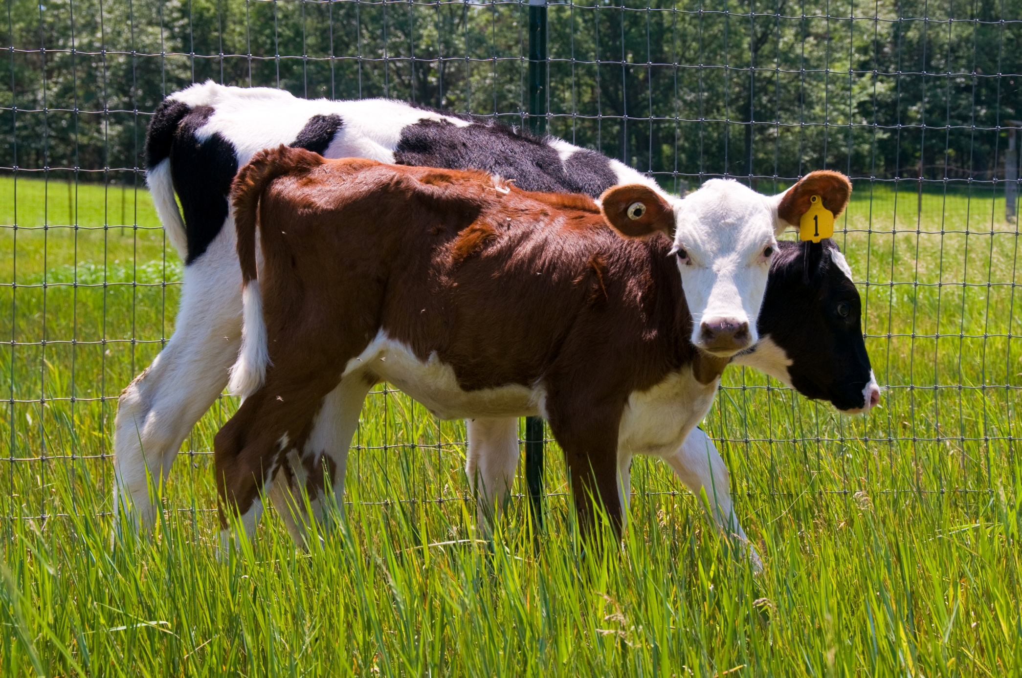
Photo courtesy of Paladin27 on Flickr
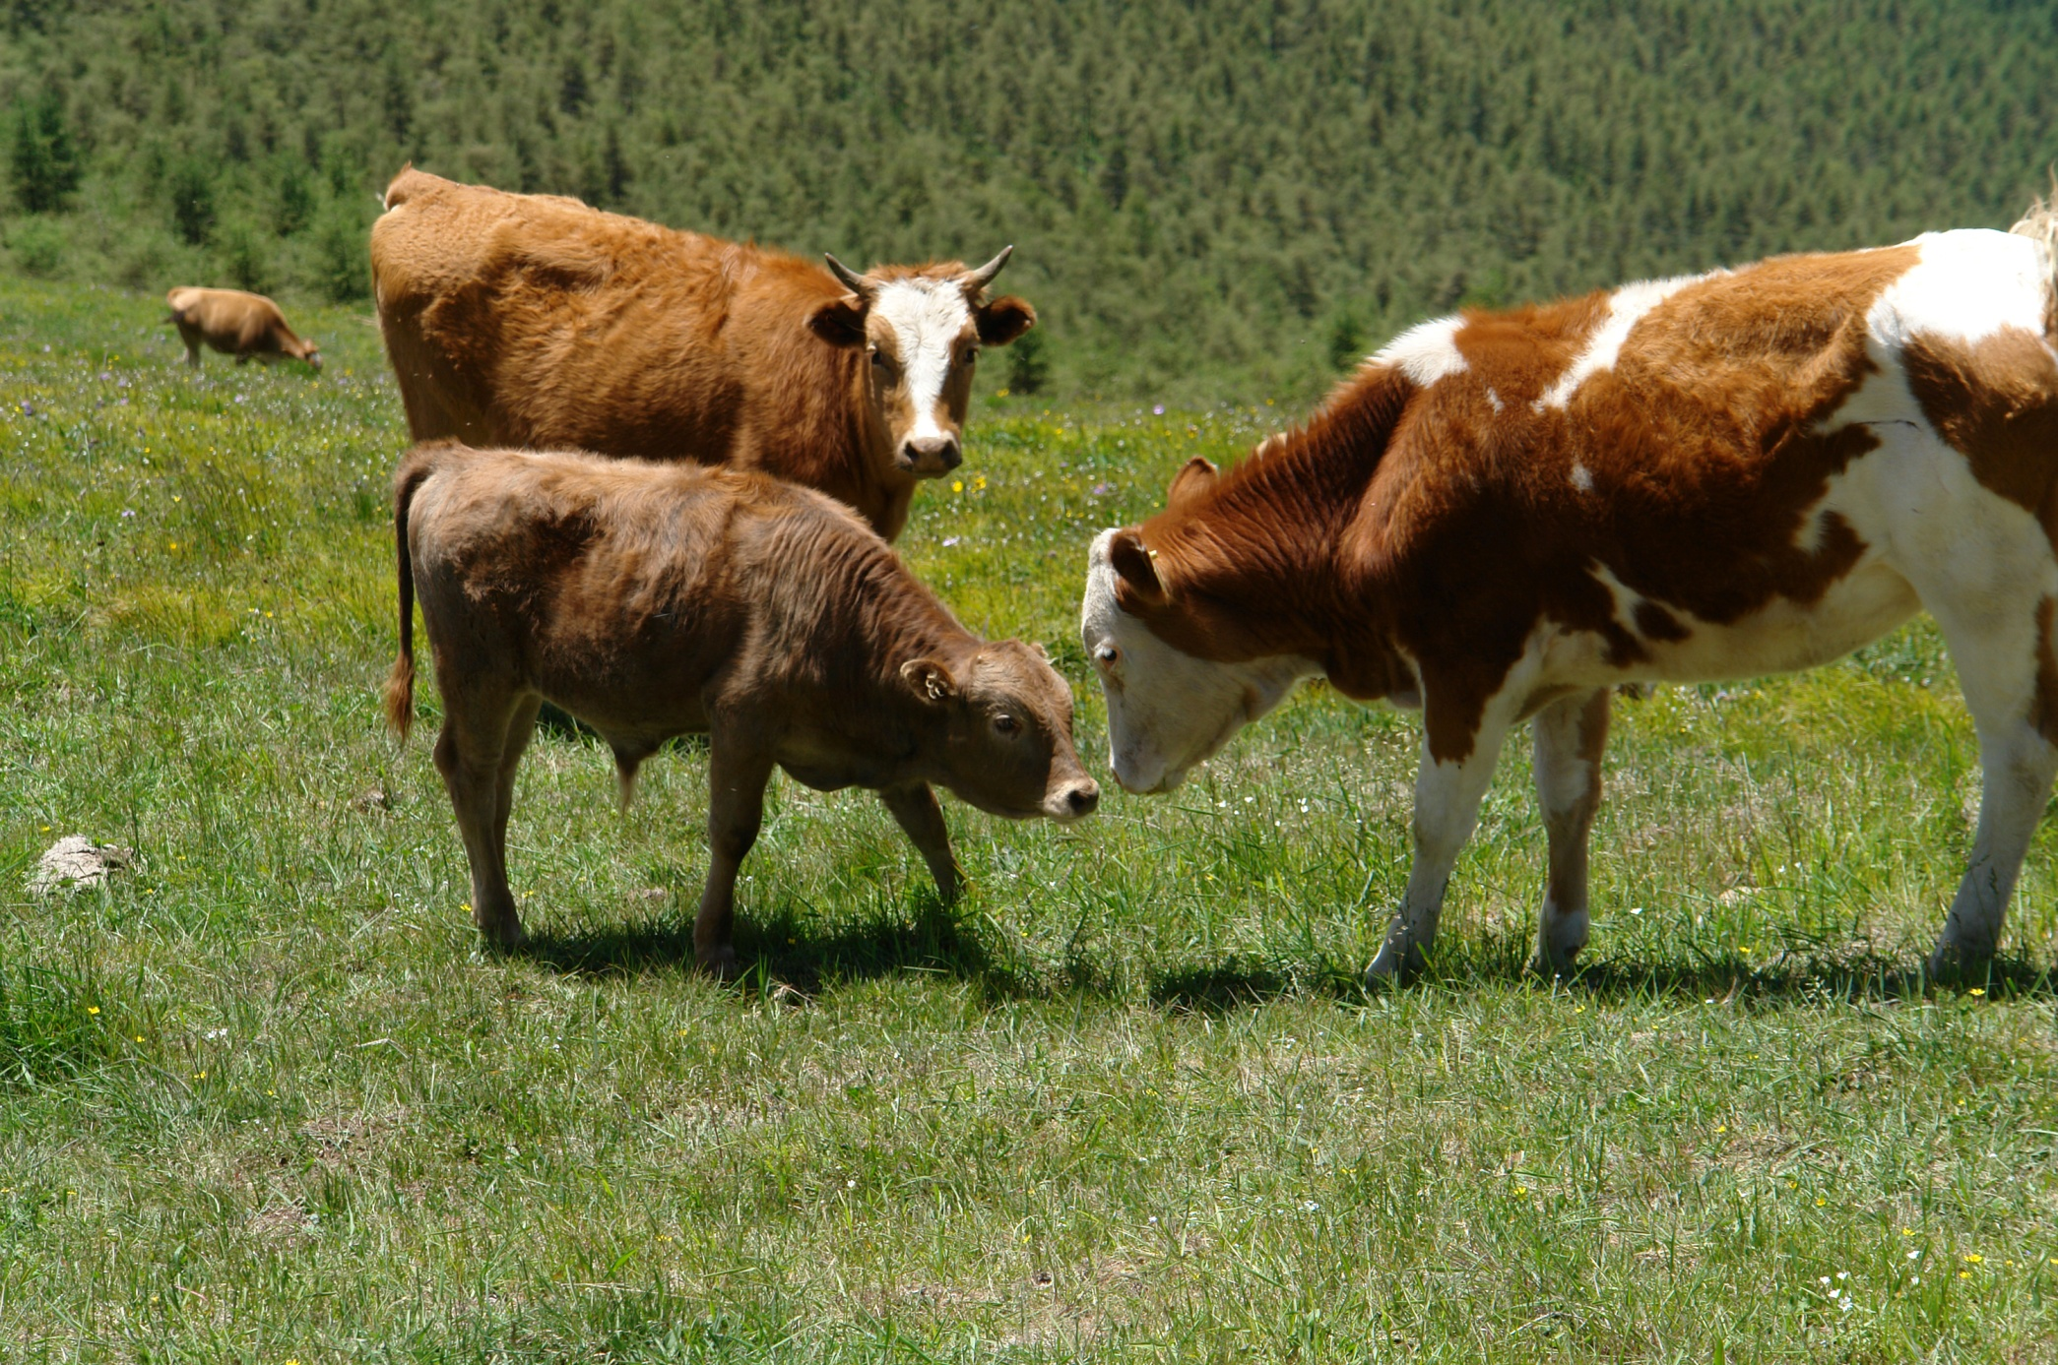
Photo courtesy of Liz Wong on Flickr
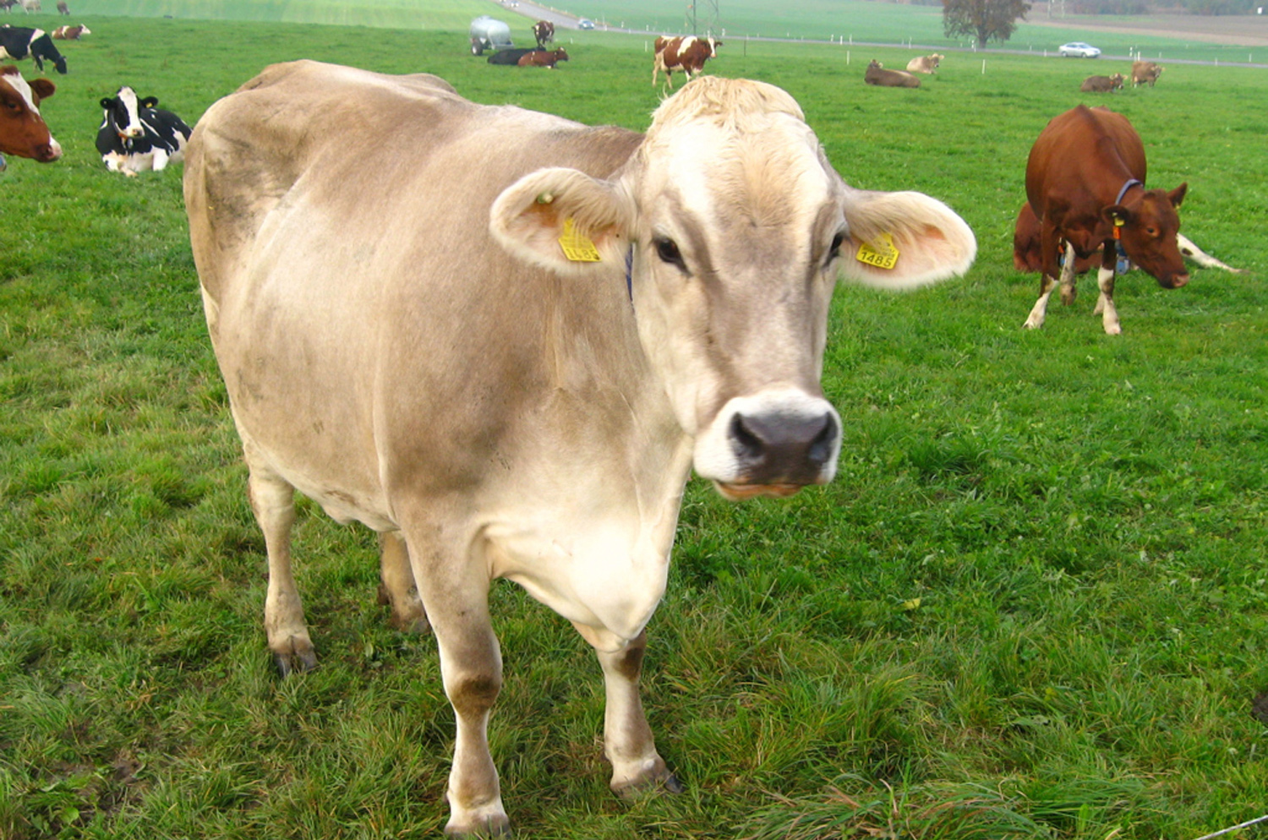
Photo courtesy of Simon Aughton on Flickr
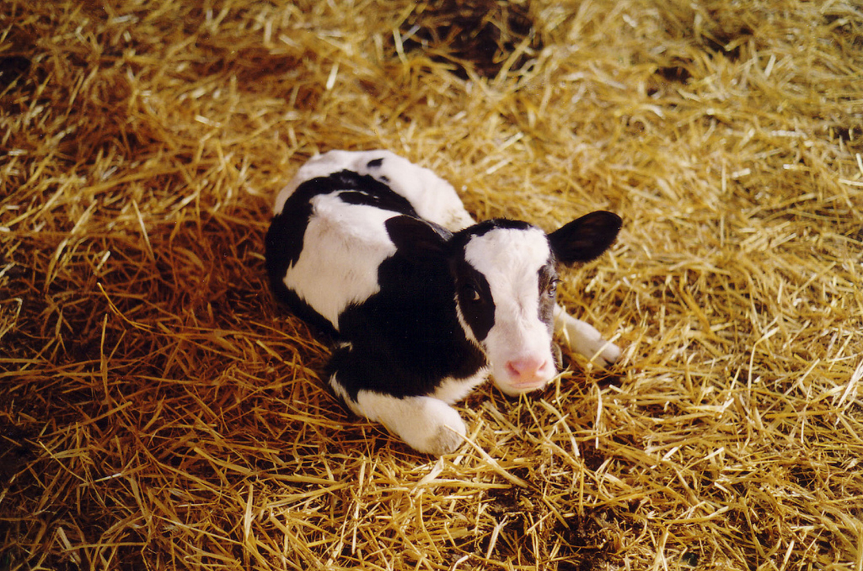
Photo courtesy of Compassion in World Farming on Flickr
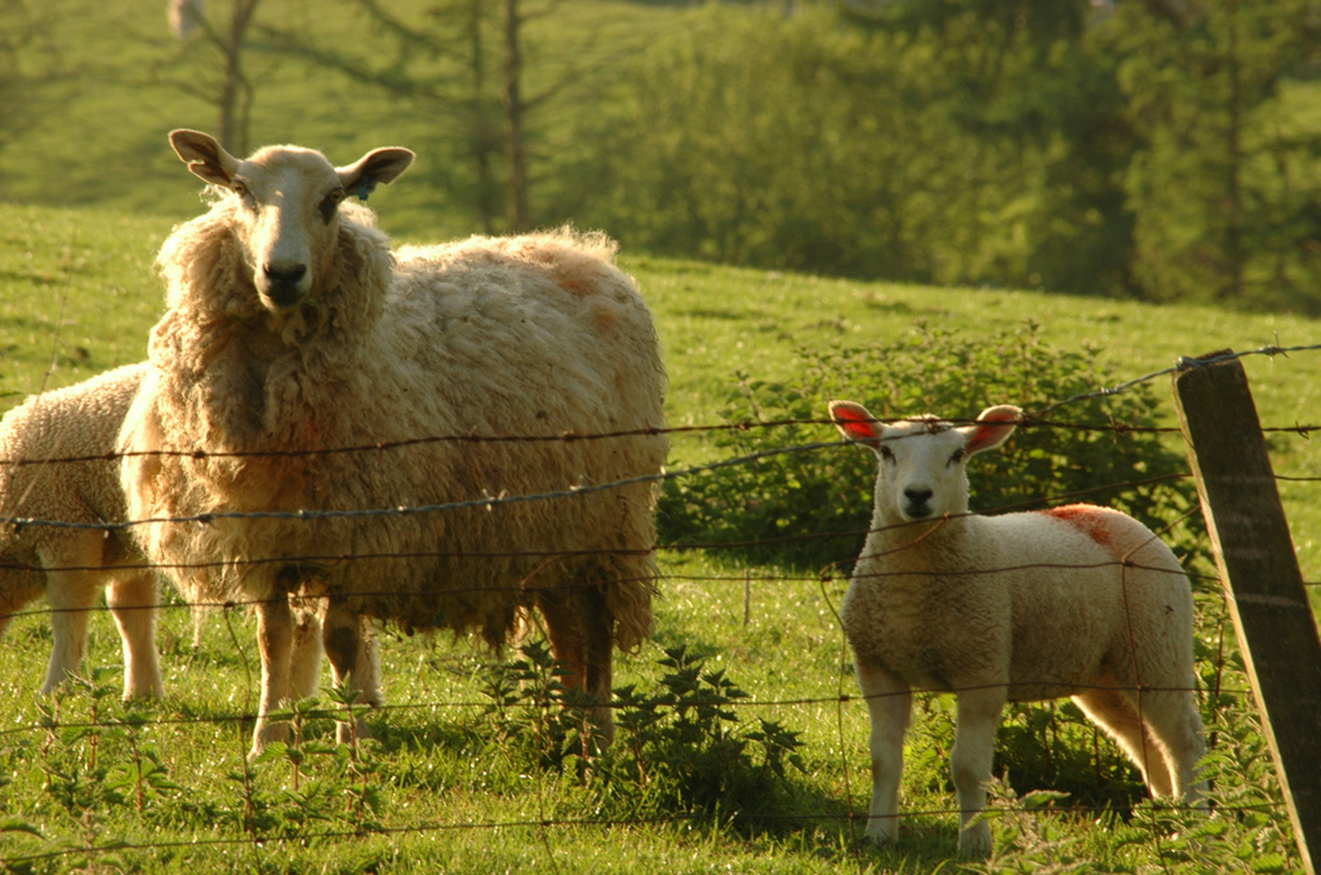
Photo courtesy of A Roger Davies on Flickr
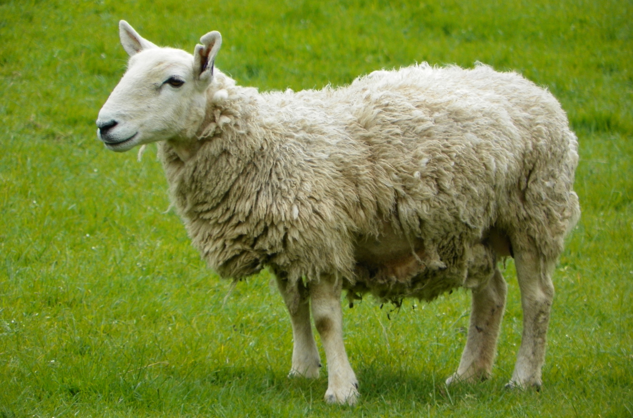
Photo courtesy of Ambersky235 on Flickr
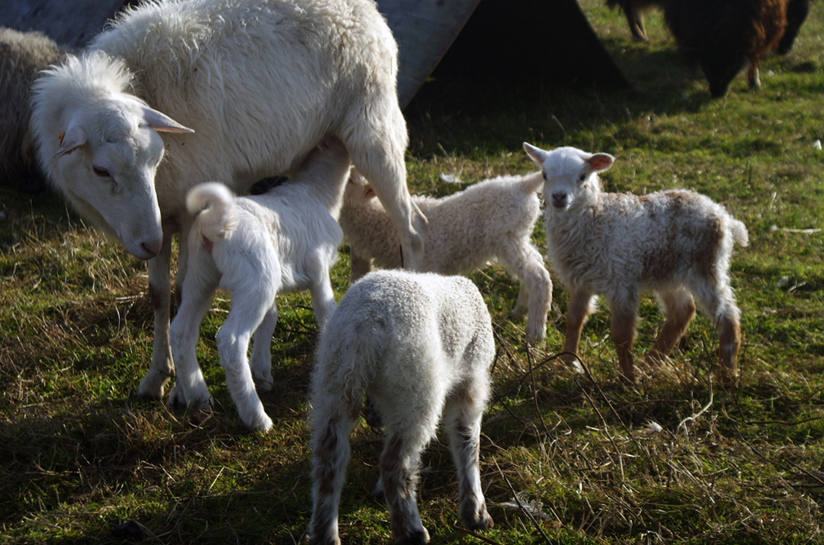
Photo courtesy of Linnea â˜€ on Flickr
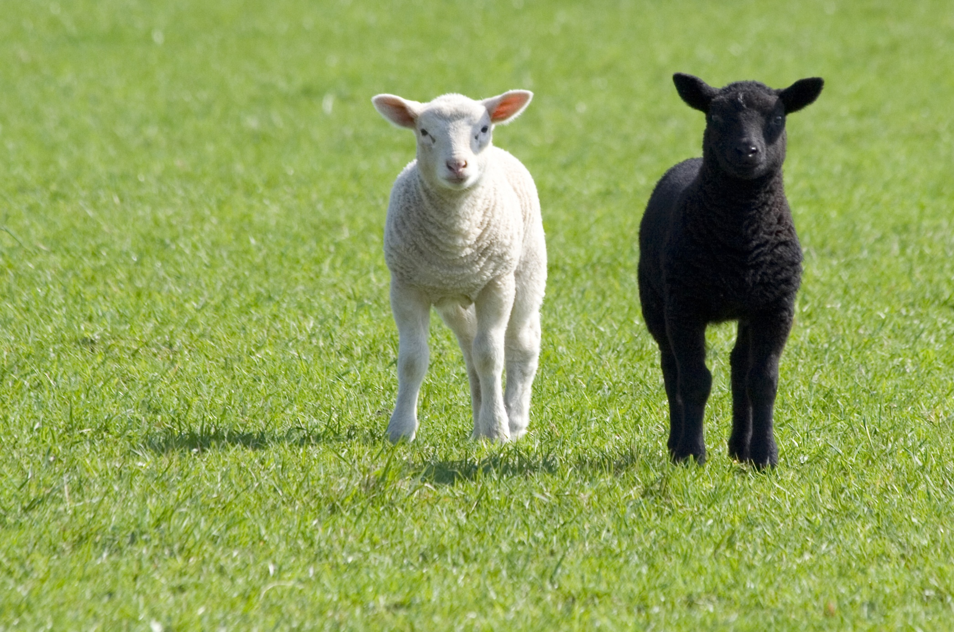
Photo courtesy of Maurice Koop on Flickr
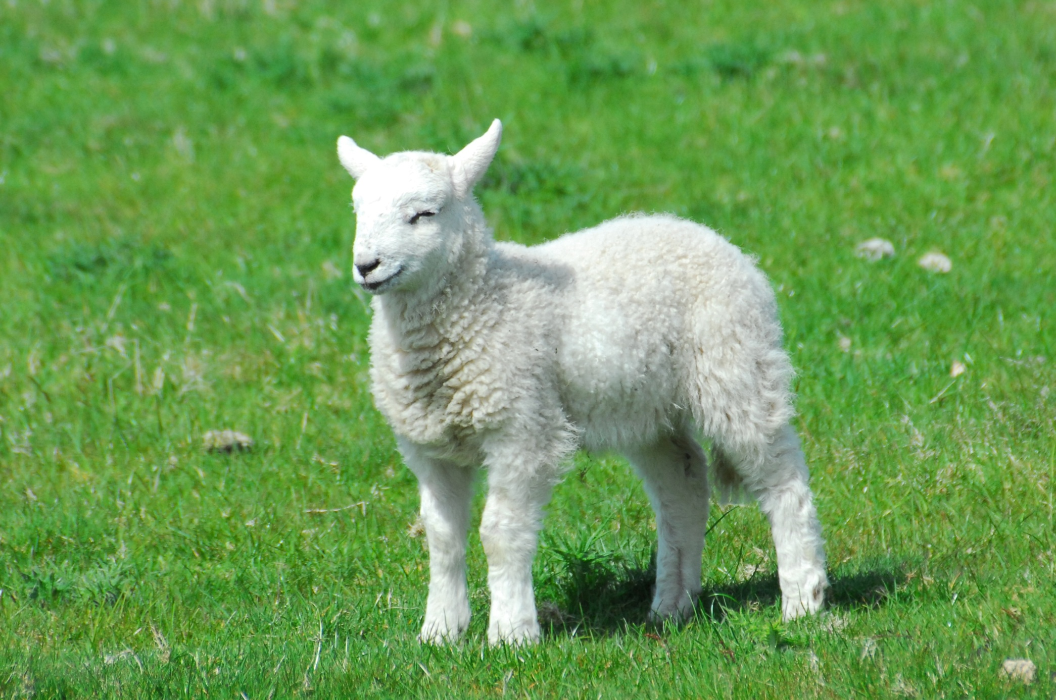
Photo courtesy of Seabeak on Flickr
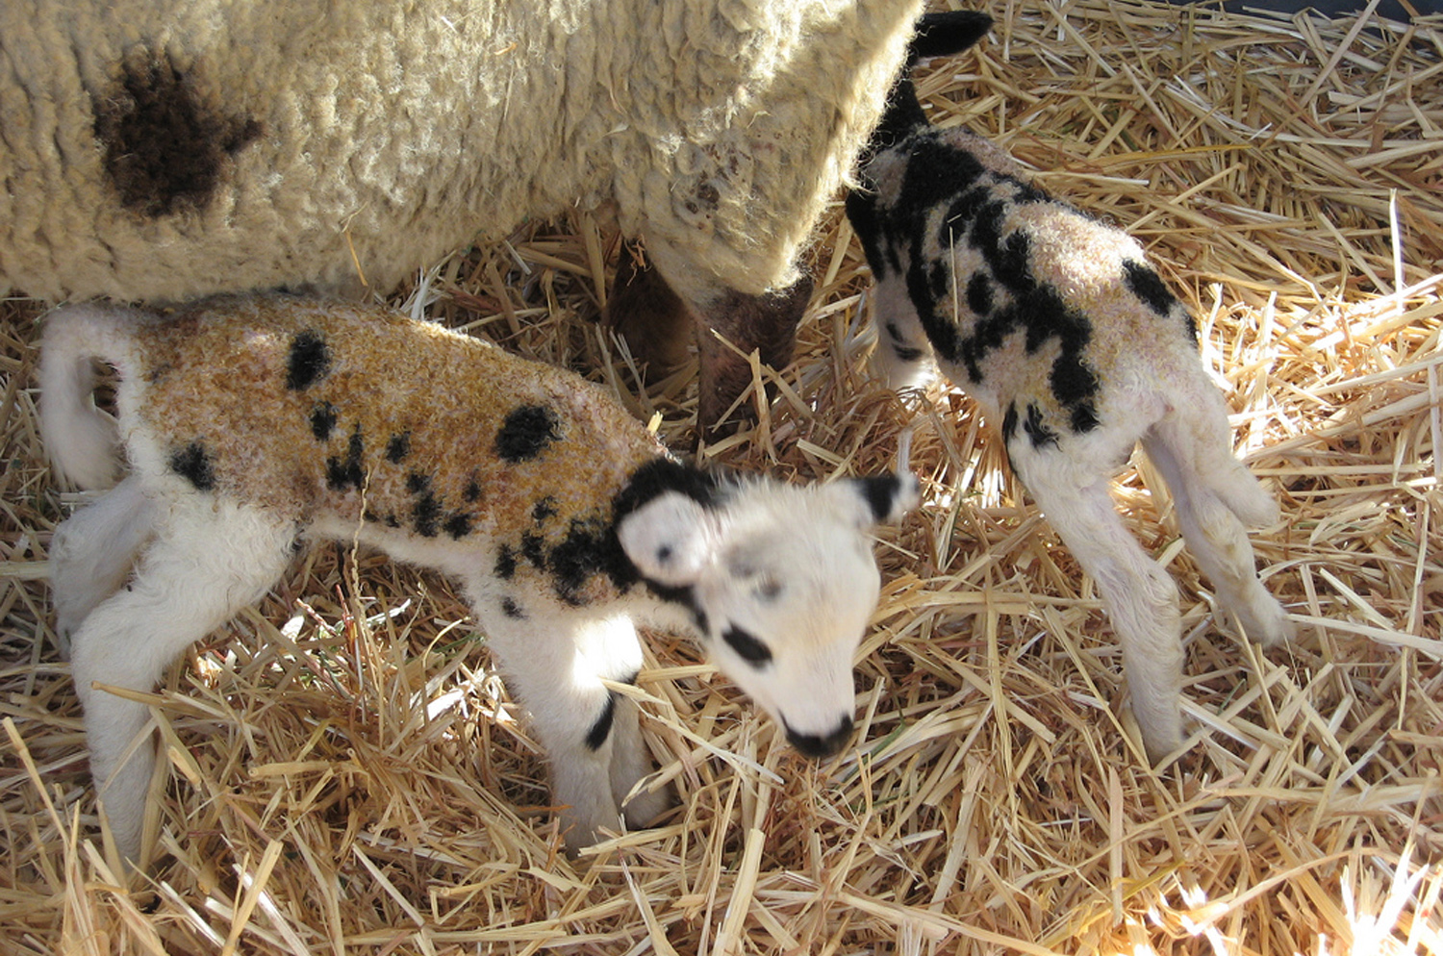
Photo courtesy of The Brain Toad on Flickr
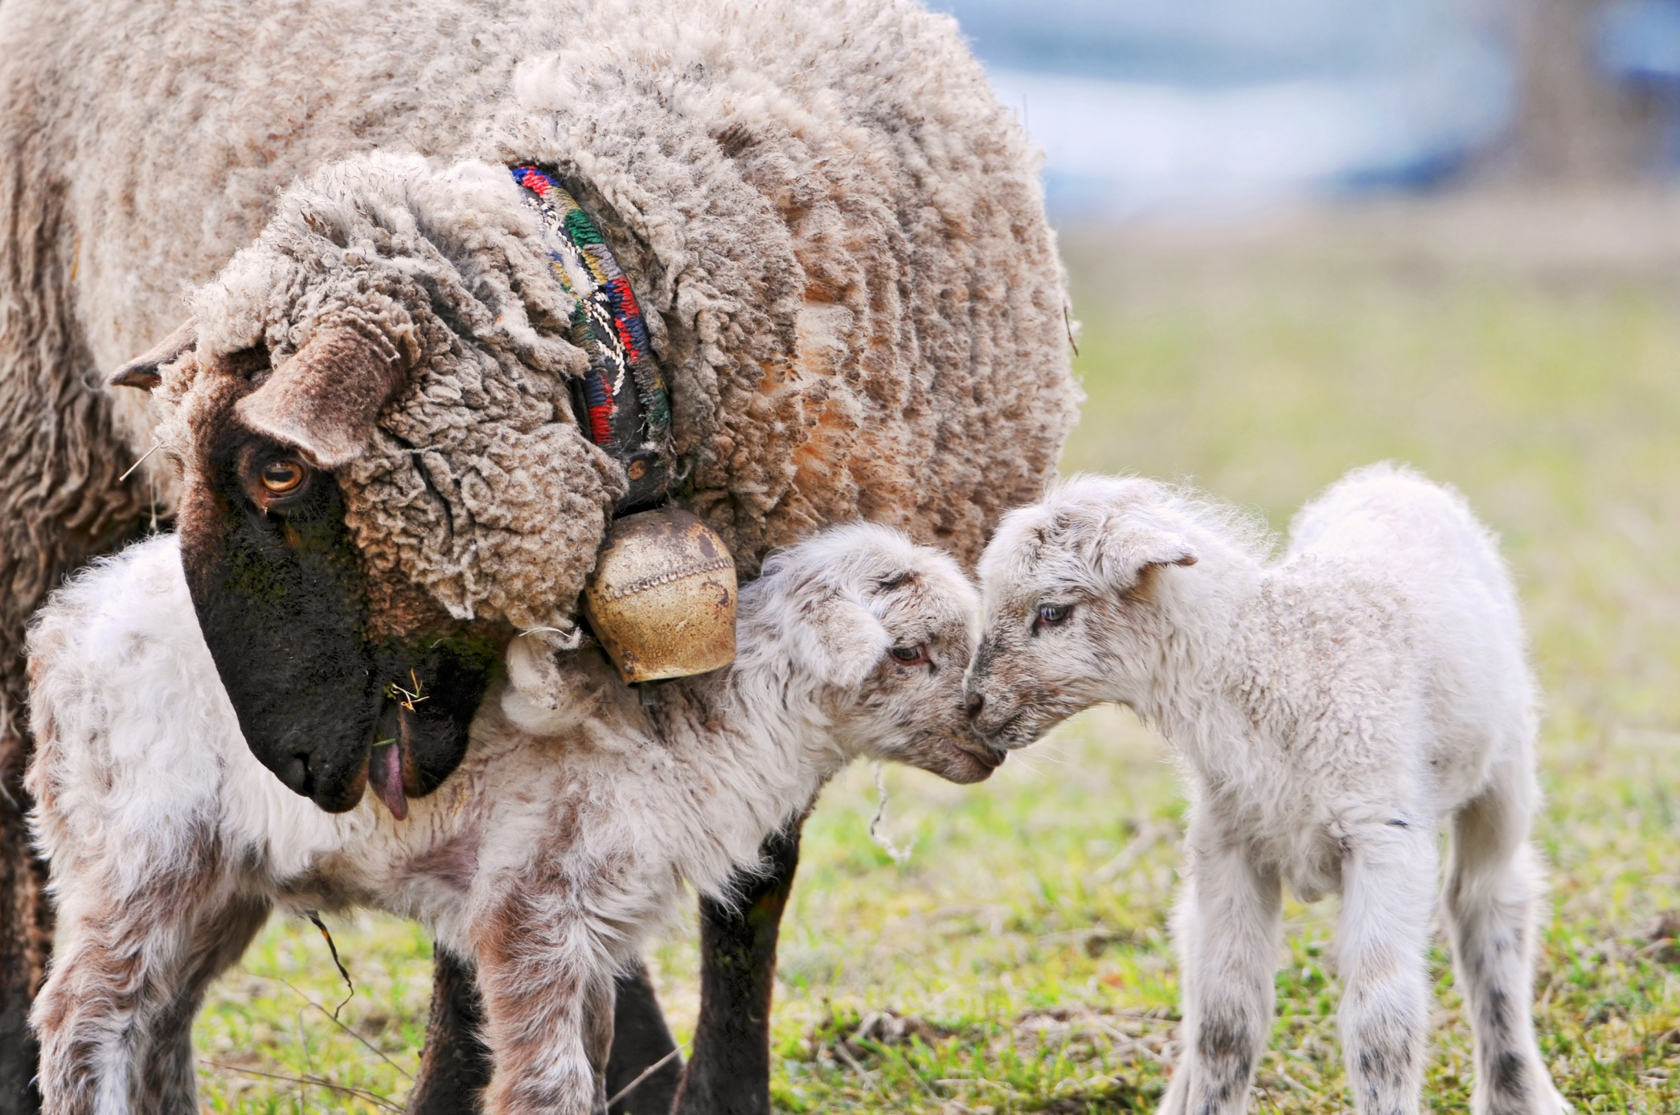
Photo courtesy of Tambako the Jaguar on Flickr
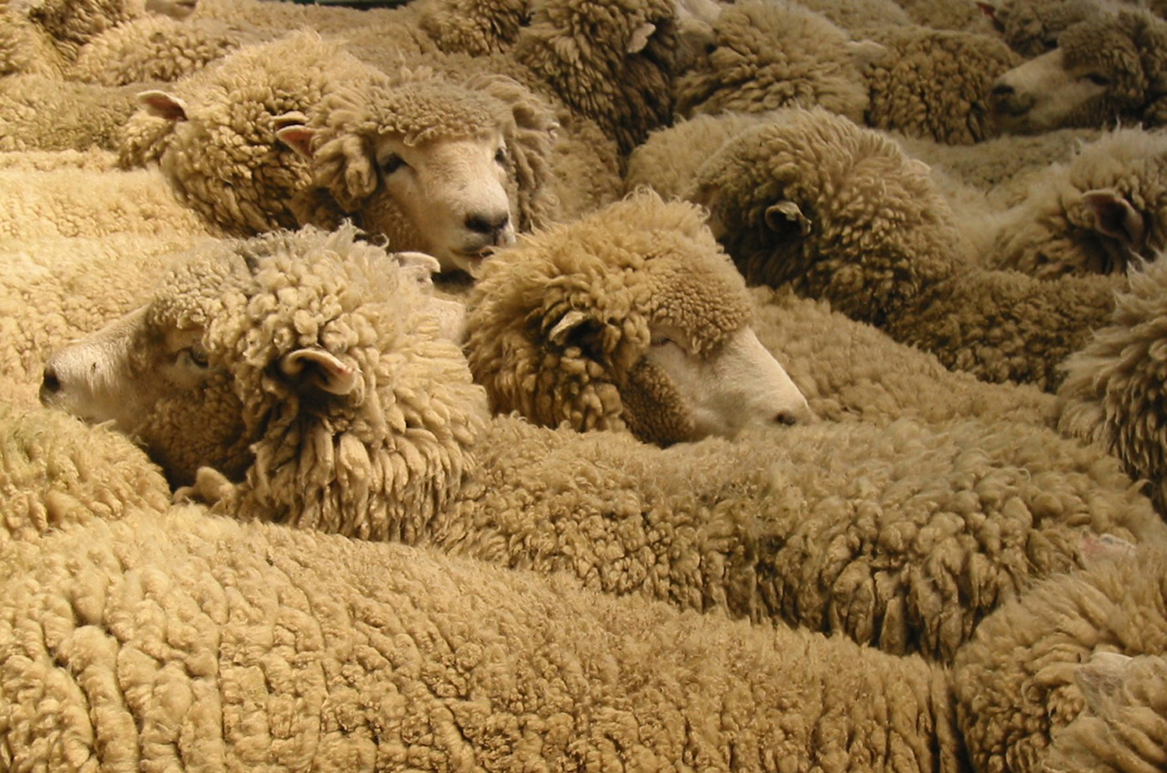
Photo courtesy of Mollivan Jon on Flickr
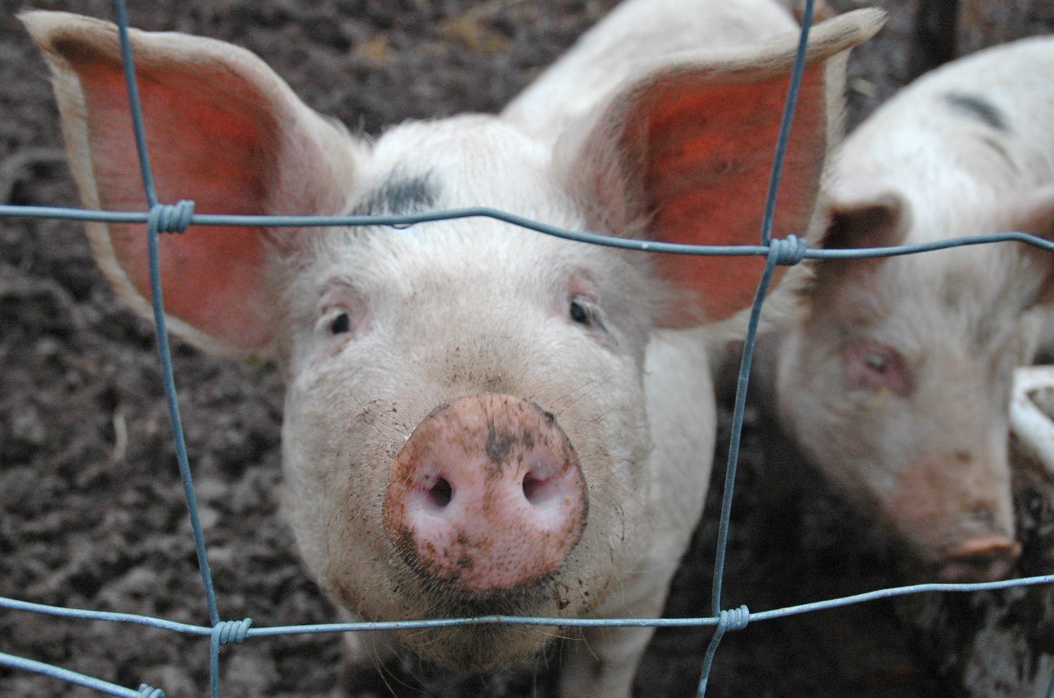
Photo courtesy of thornypup on Flickr
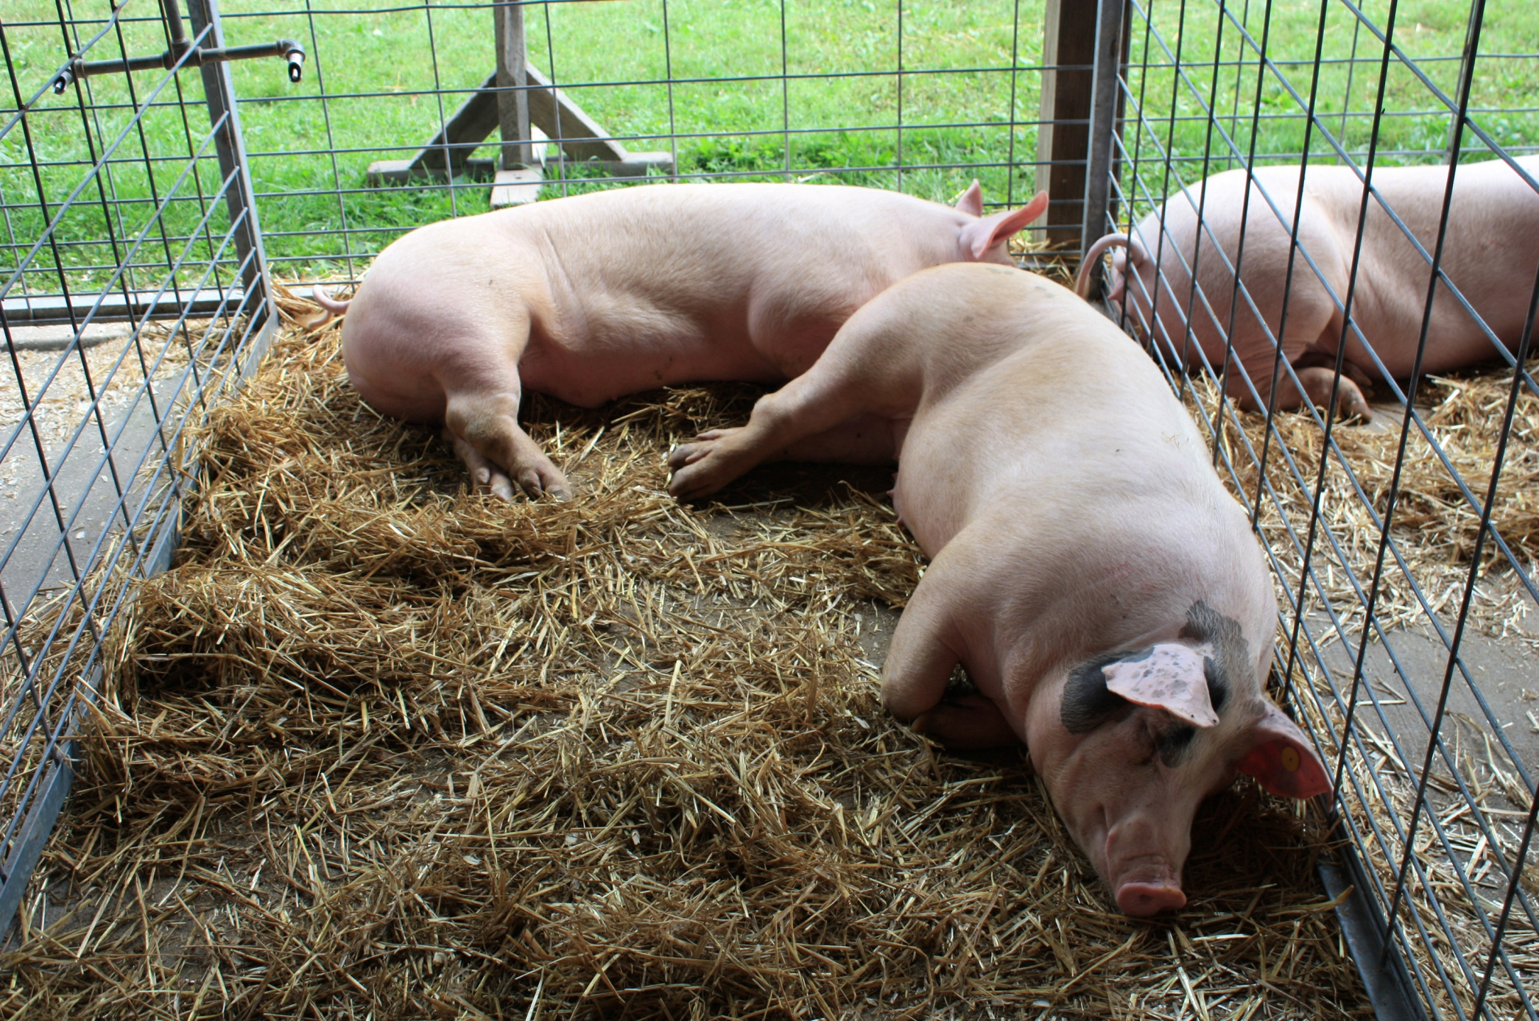
Photo courtesy of Montgomery County Planning Commission on Flickr
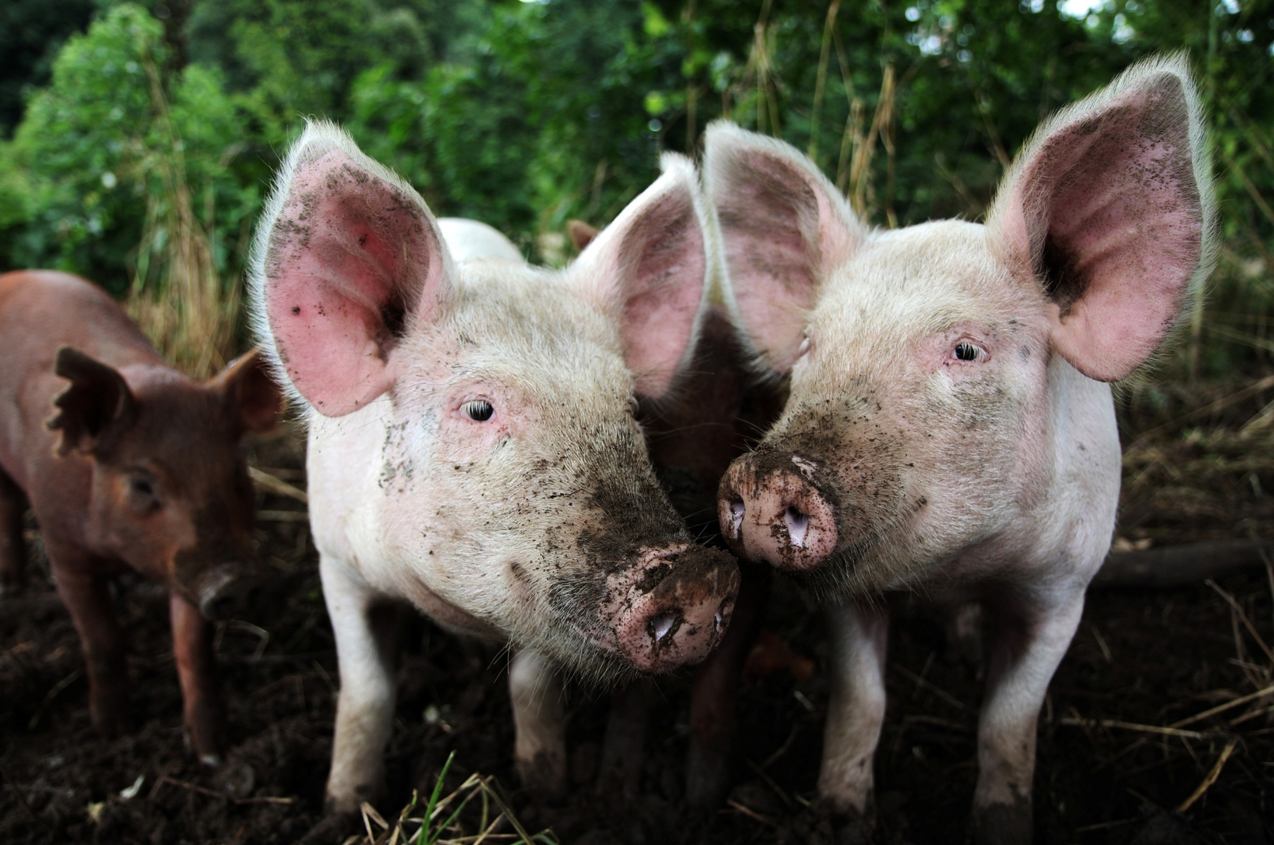
Photo courtesy of Jessica Kennedy on Flickr
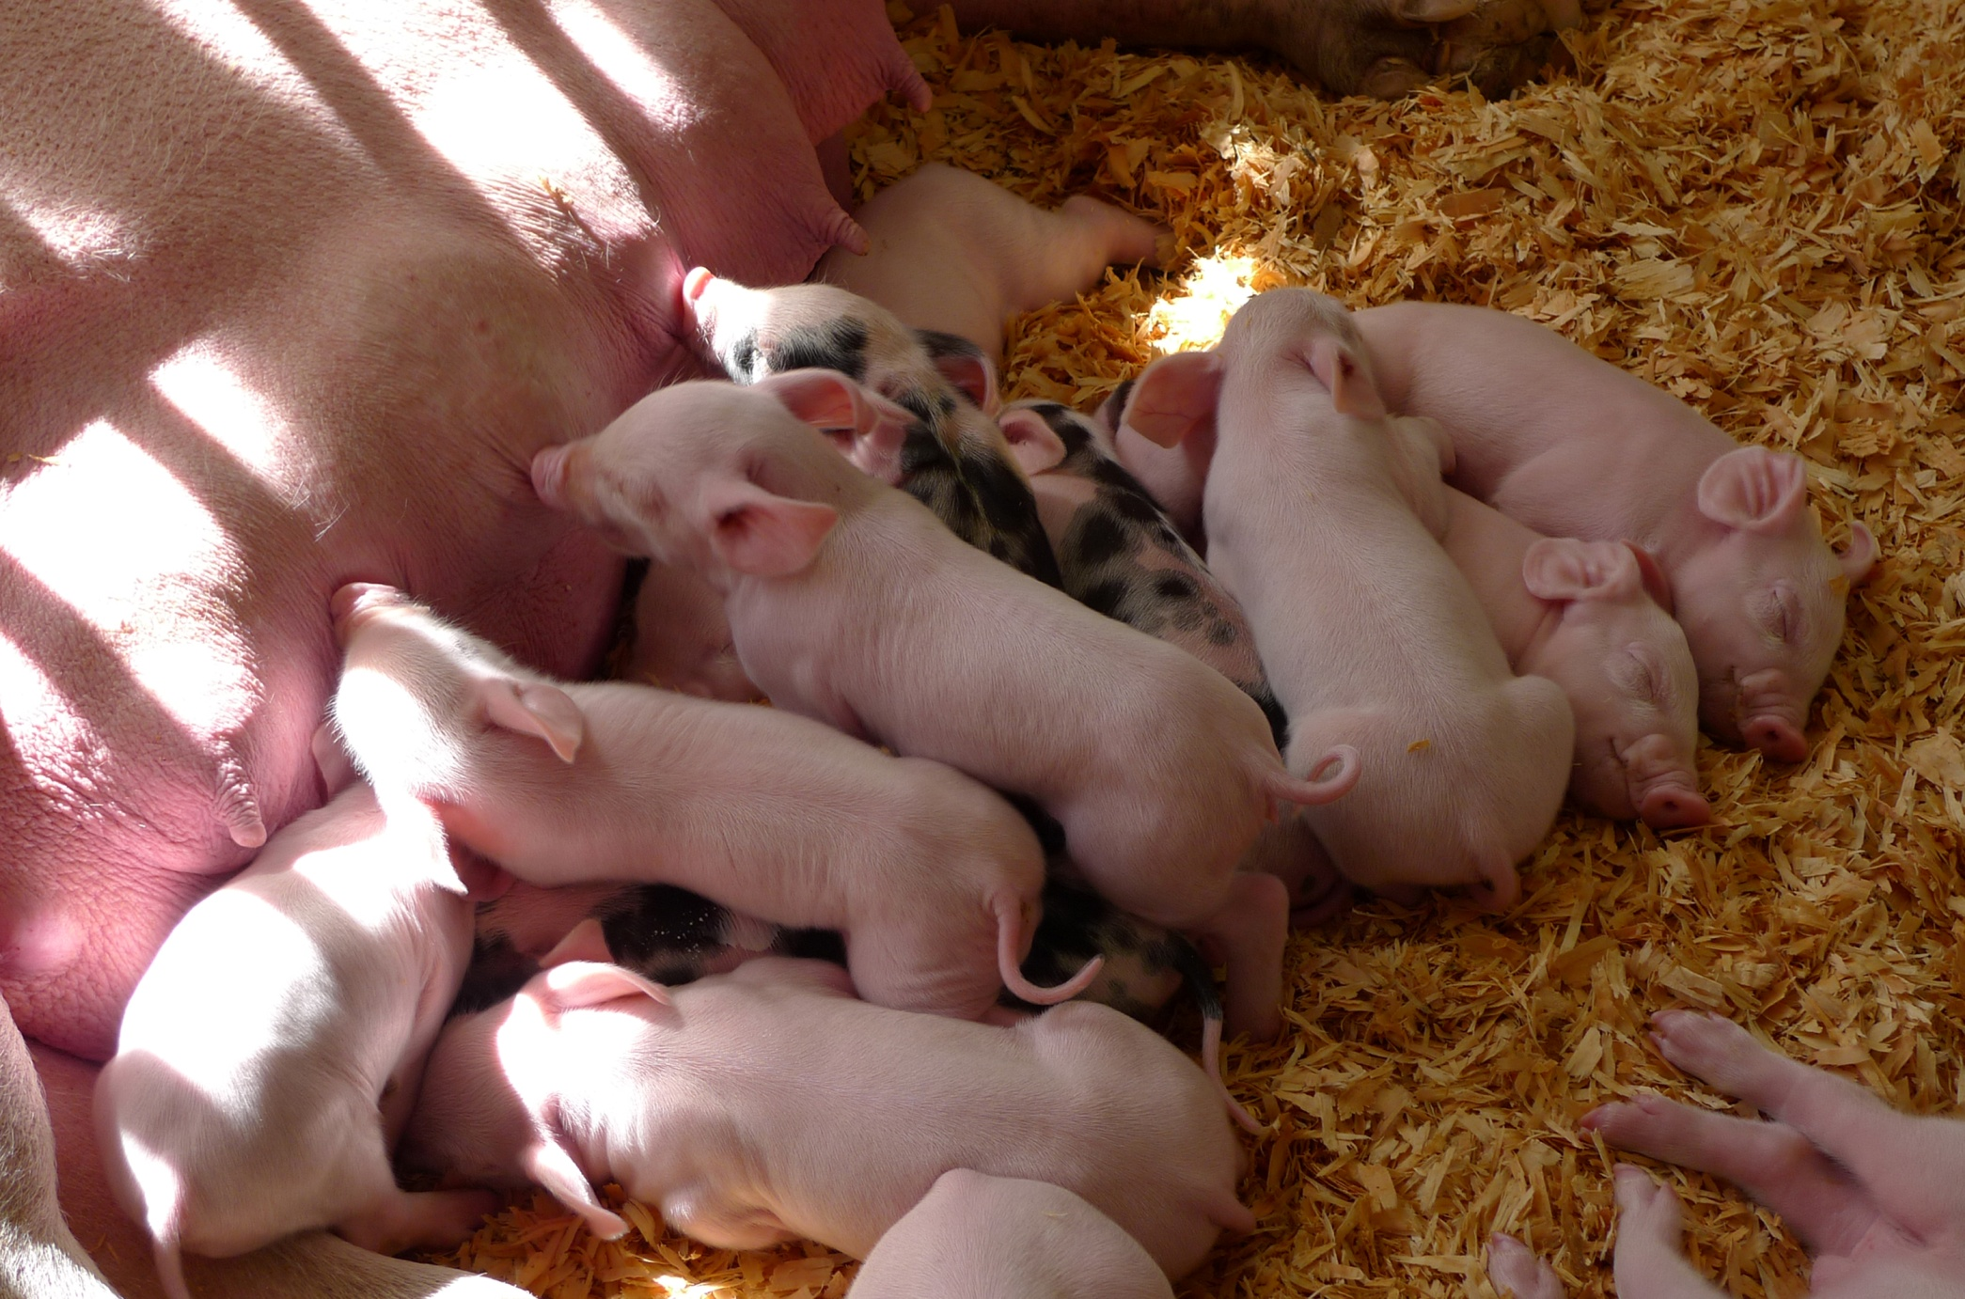
Photo courtesy of camknows on Flickr
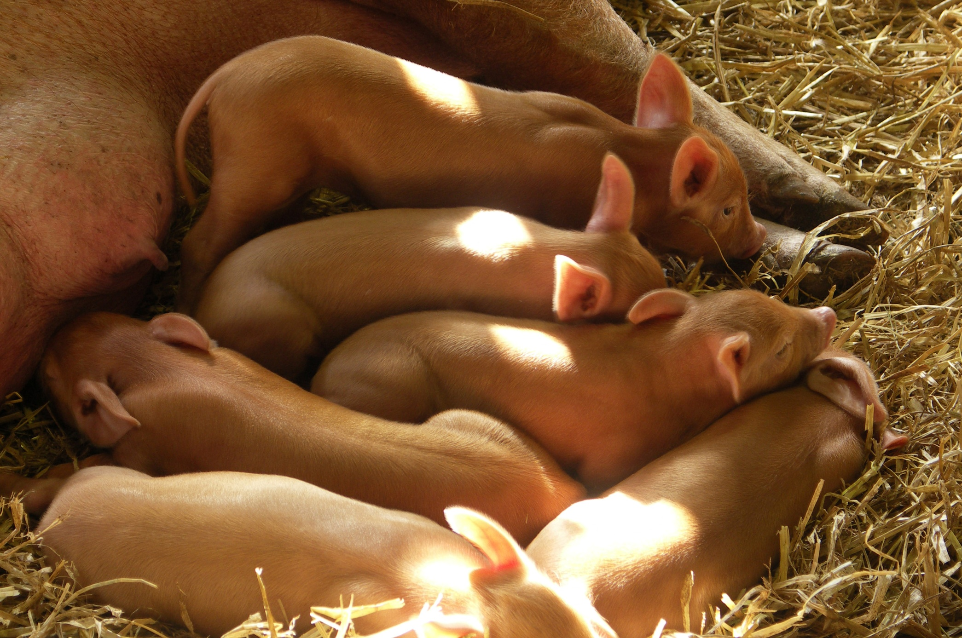
Photo courtesy of Stephen & Claire Farnsworth on Flickr
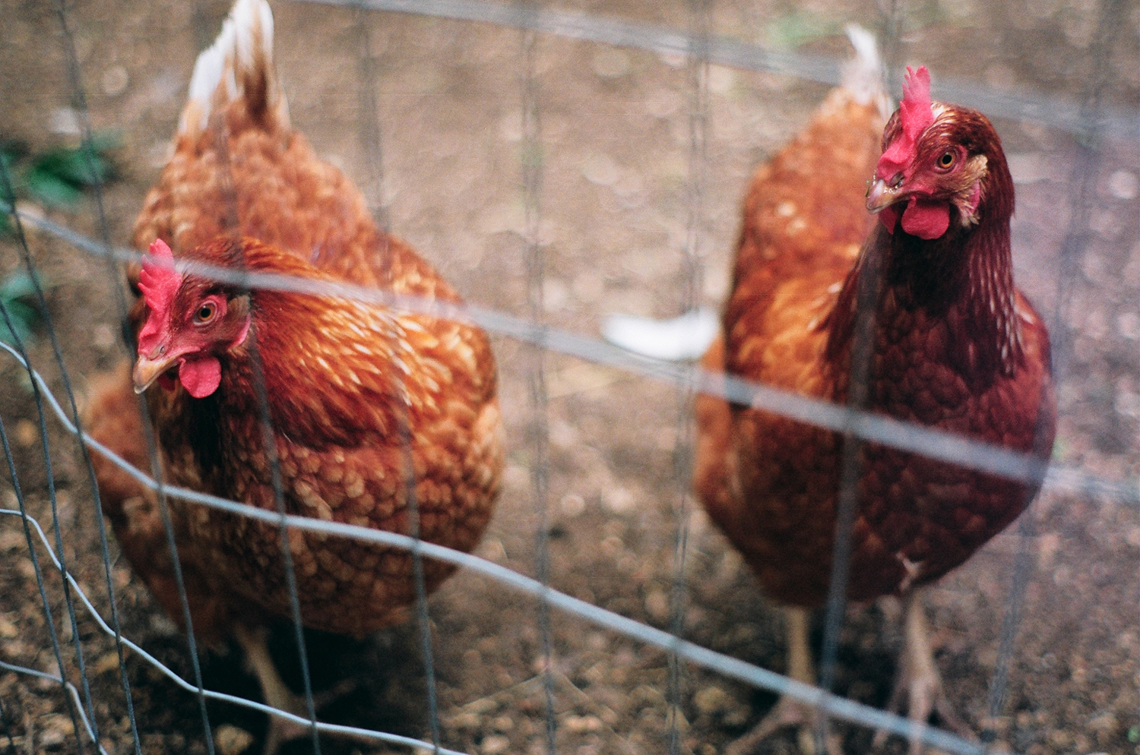
Photo courtesy of gina pina on Flickr
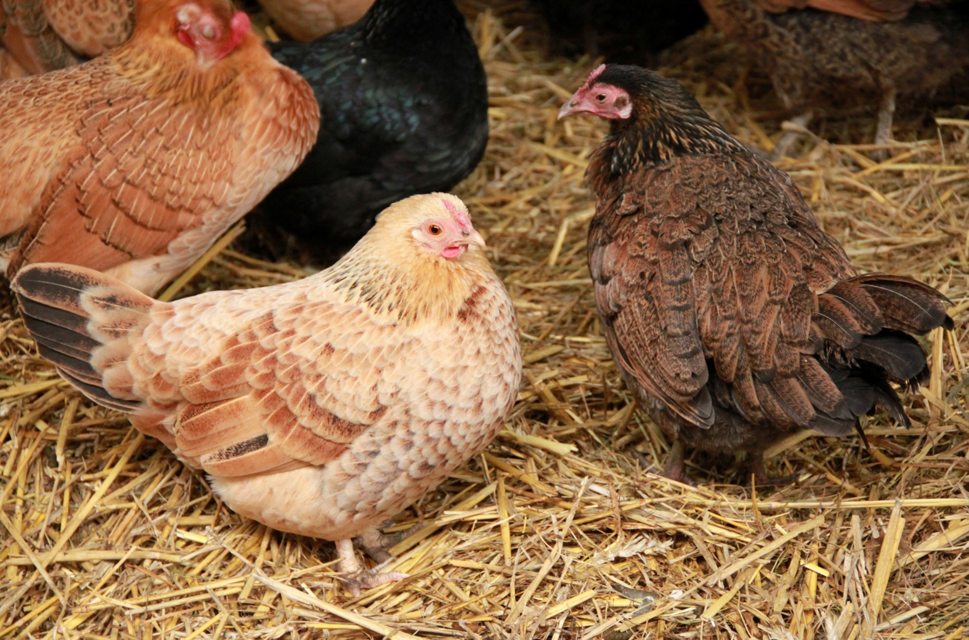
Photo courtesy of Jane Starz on Flickr
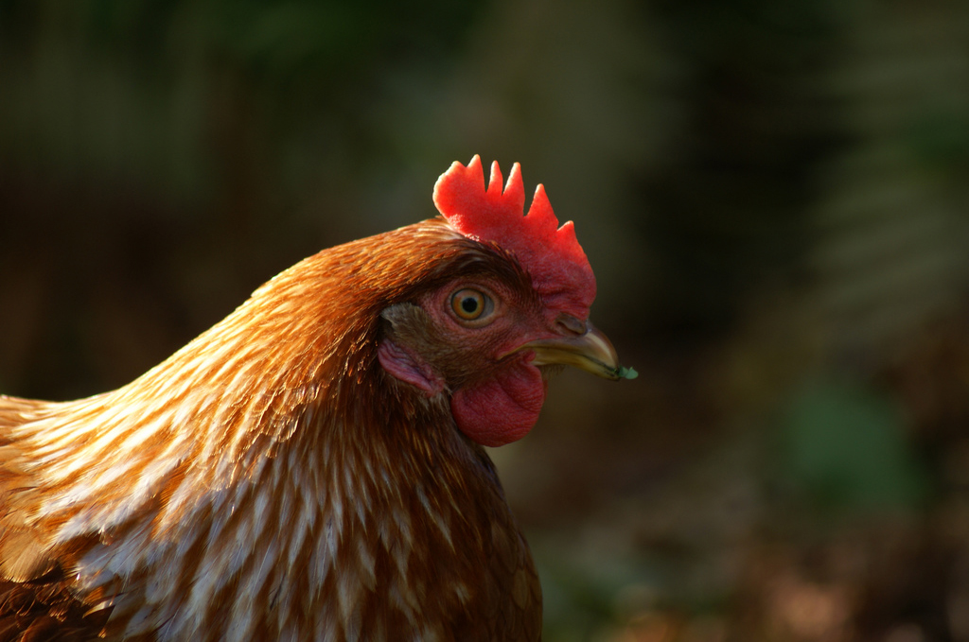
Photo courtesy of kusabi on Flickr
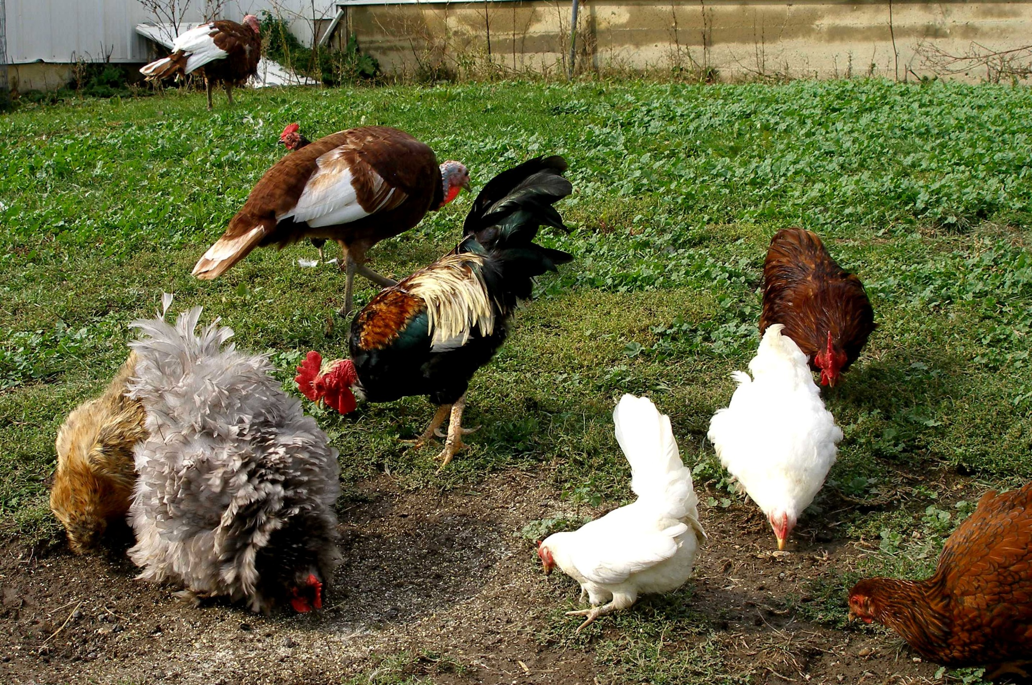
Photo courtesy of stpaulgirl on Flickr
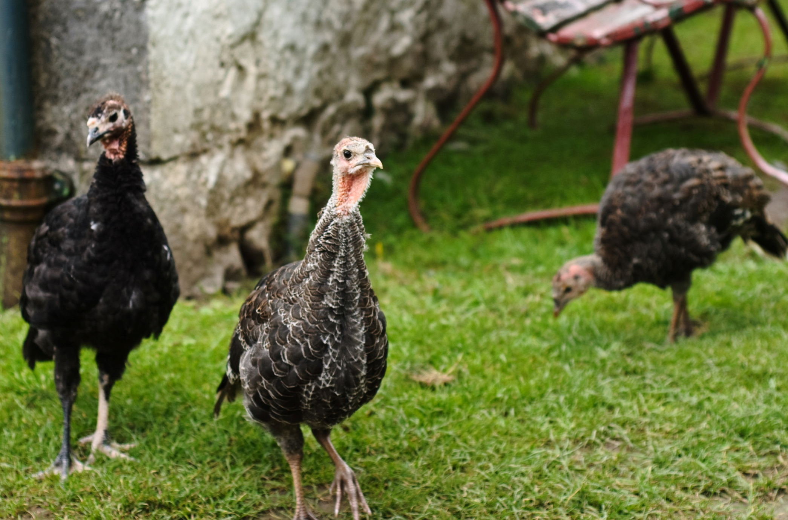
Photo courtesy of Sam E Roper
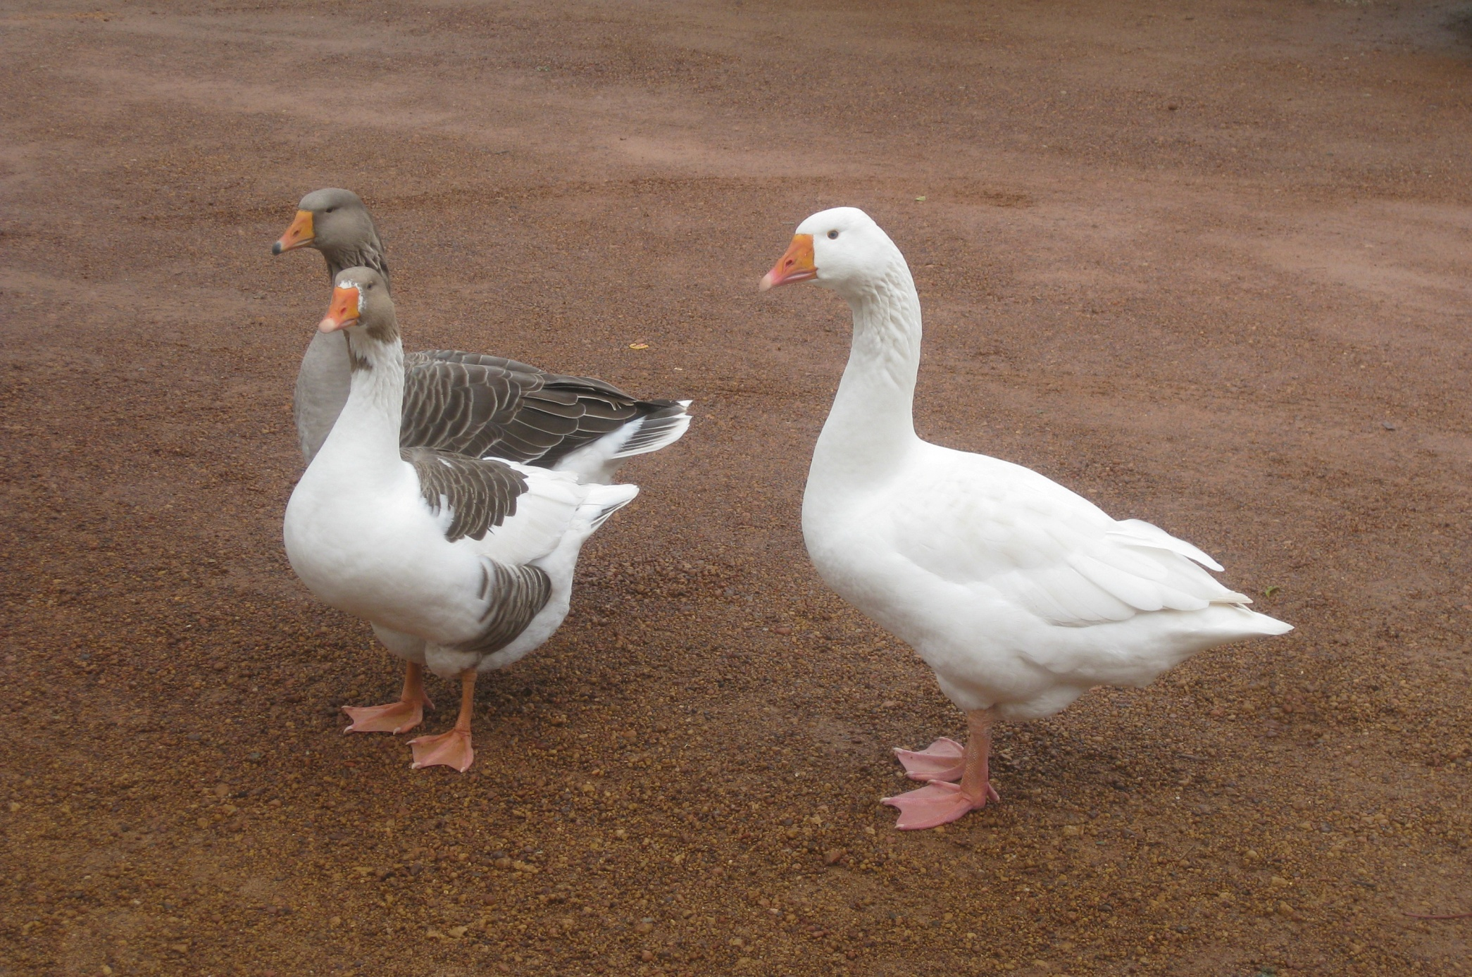
Photo courtesy of Wyrmworld on Flickr
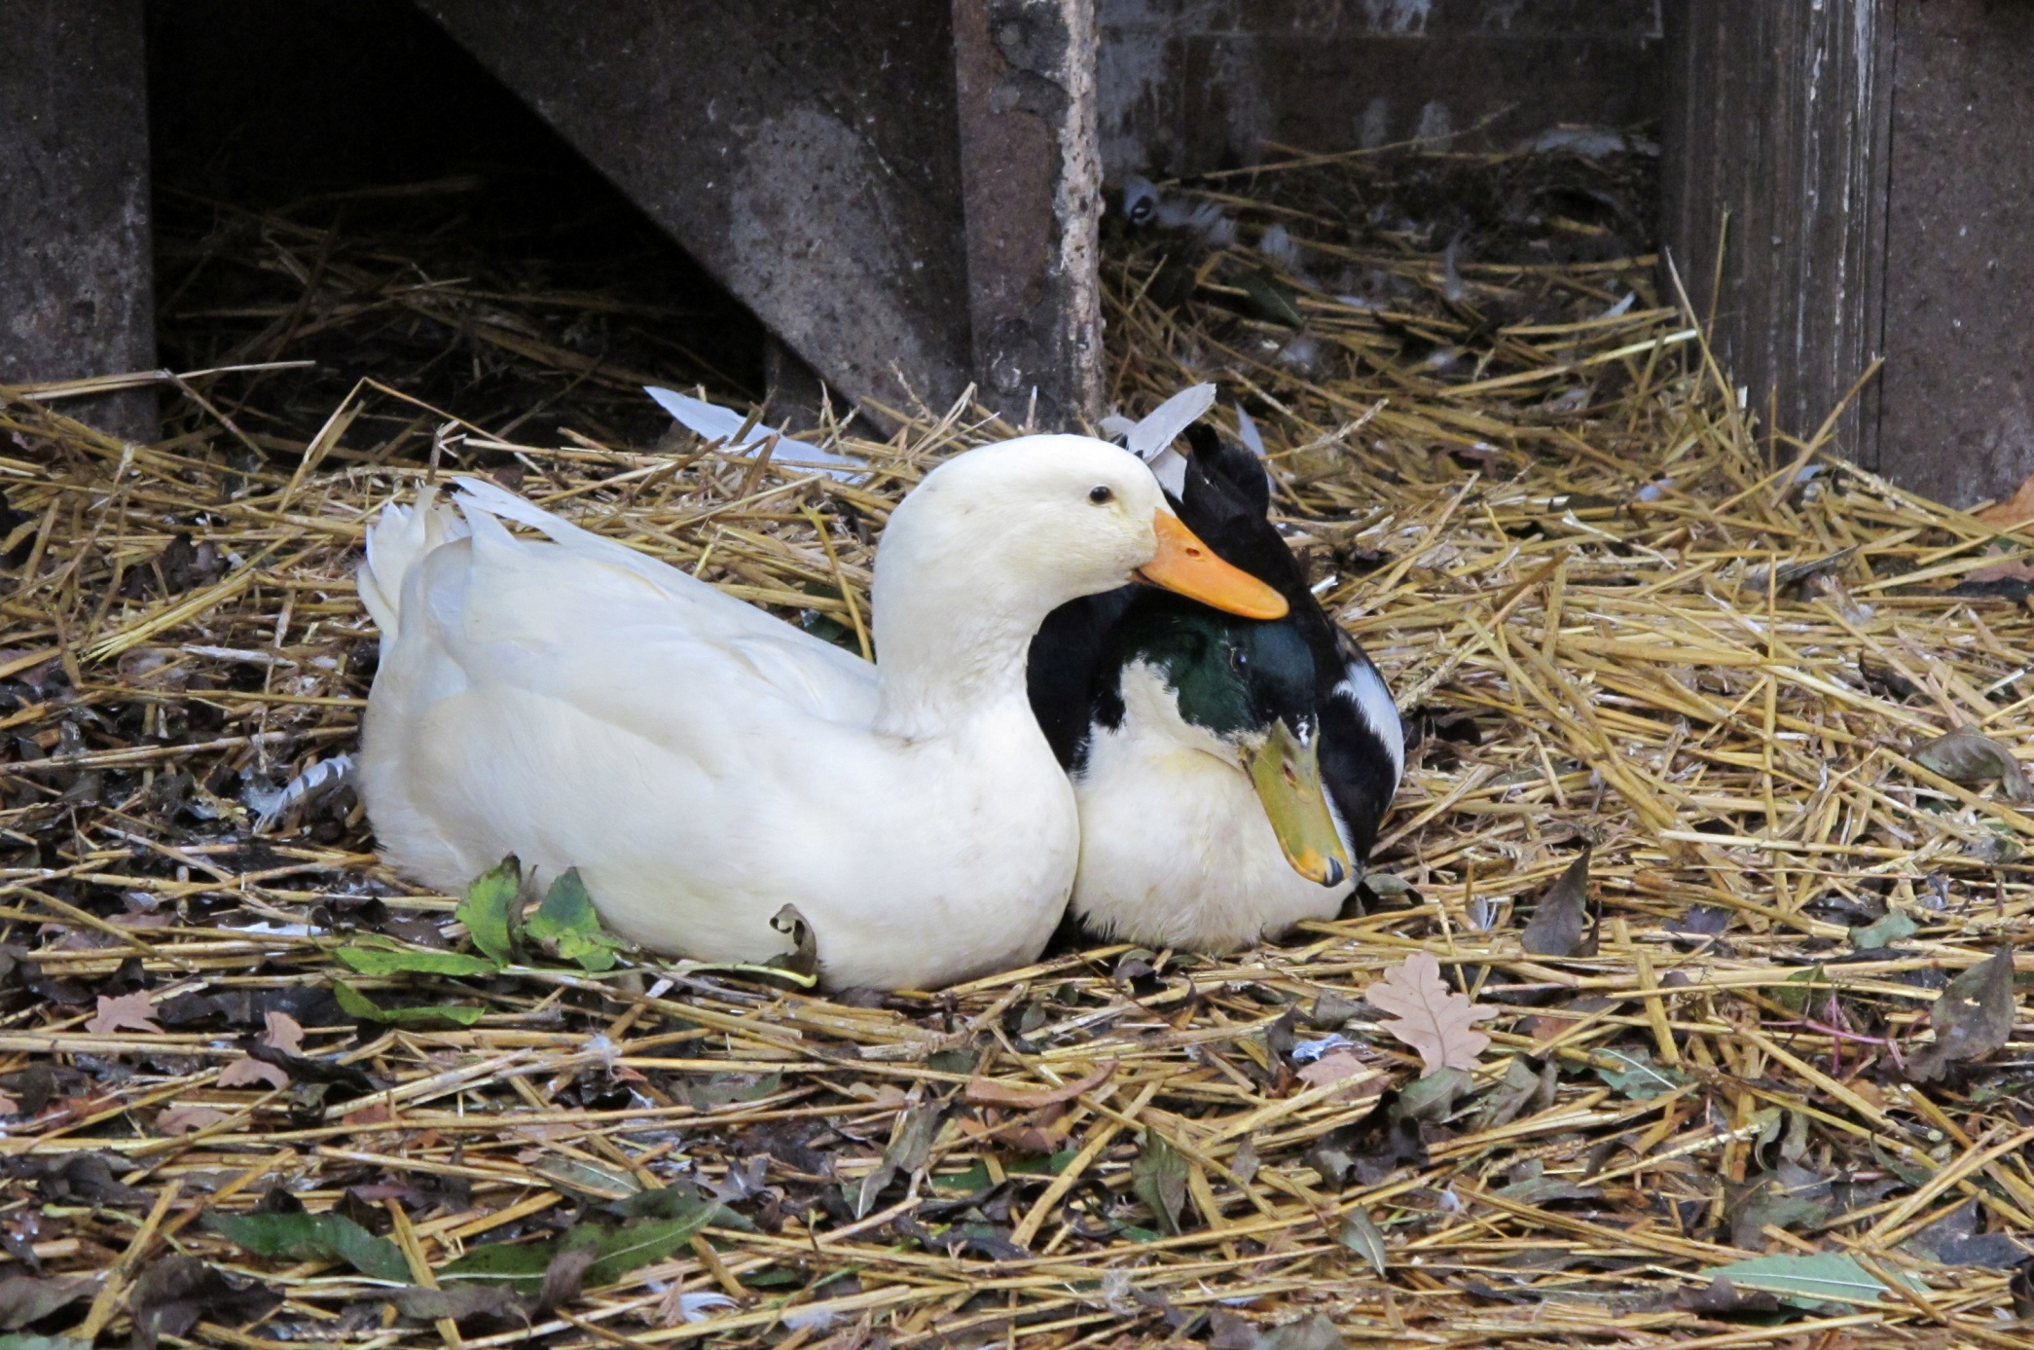
Photo courtesy of quimby on Flickr
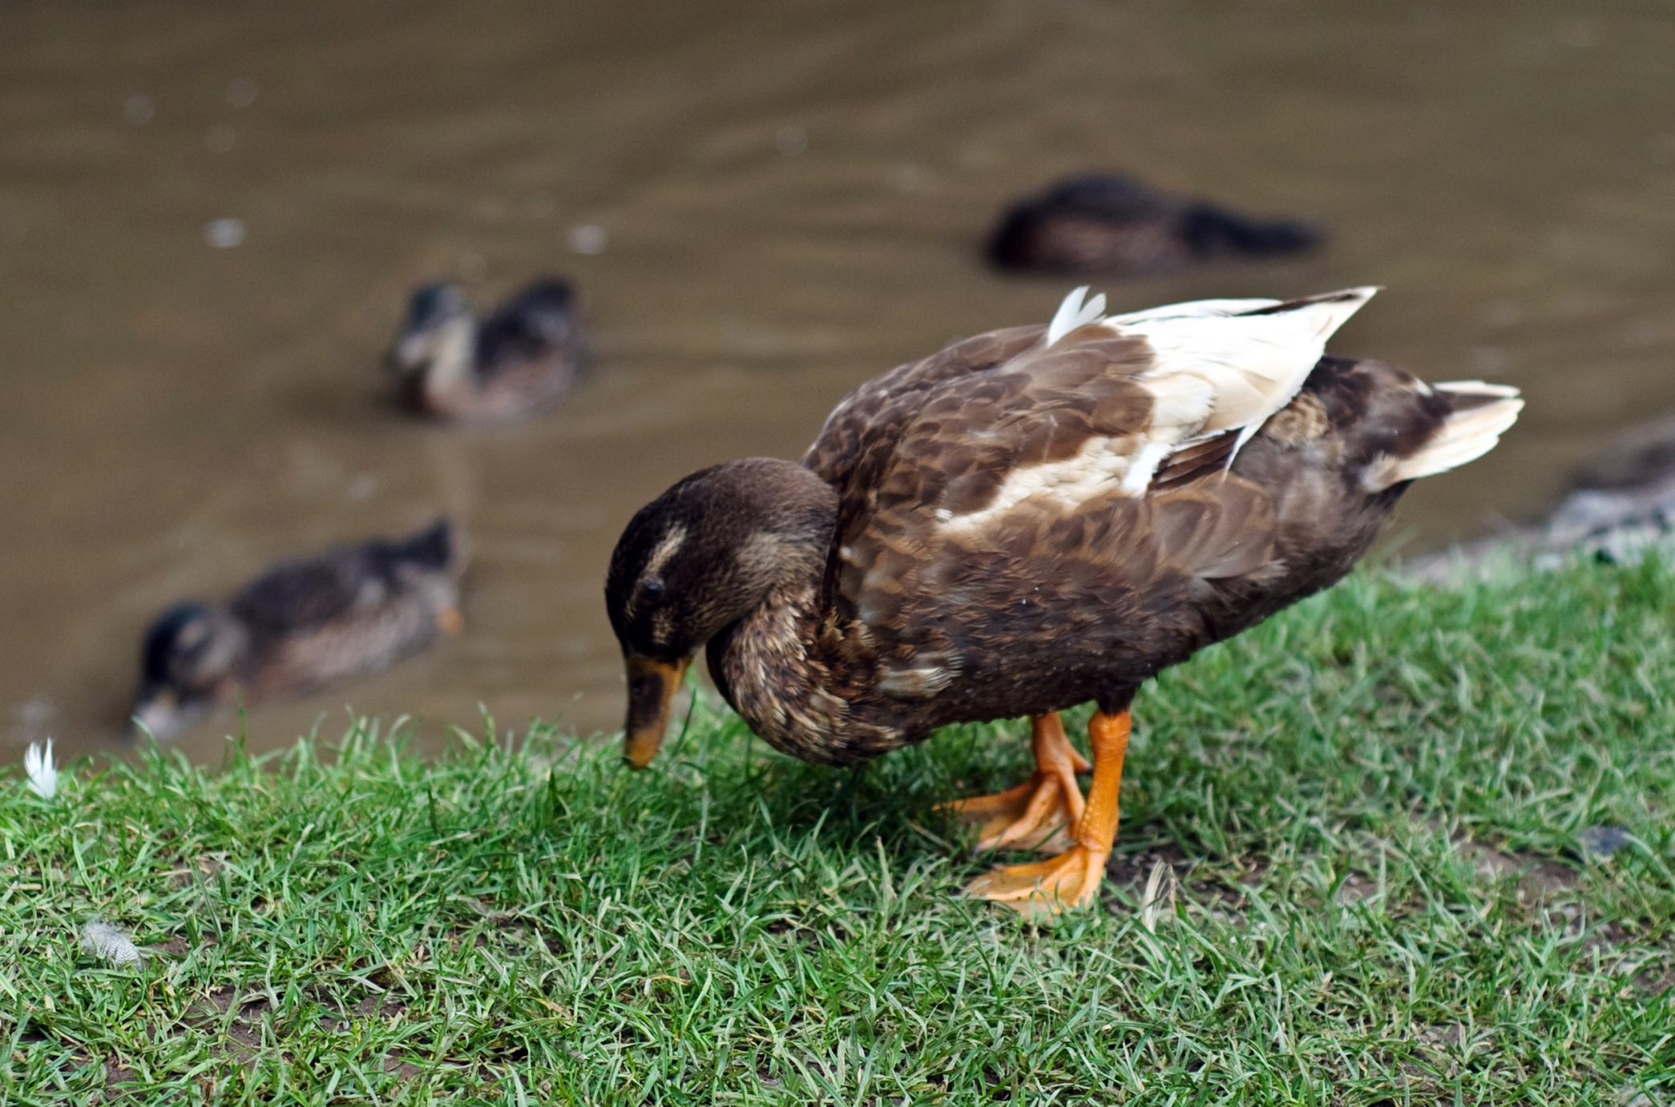
Photo courtesy of Sam E Roper
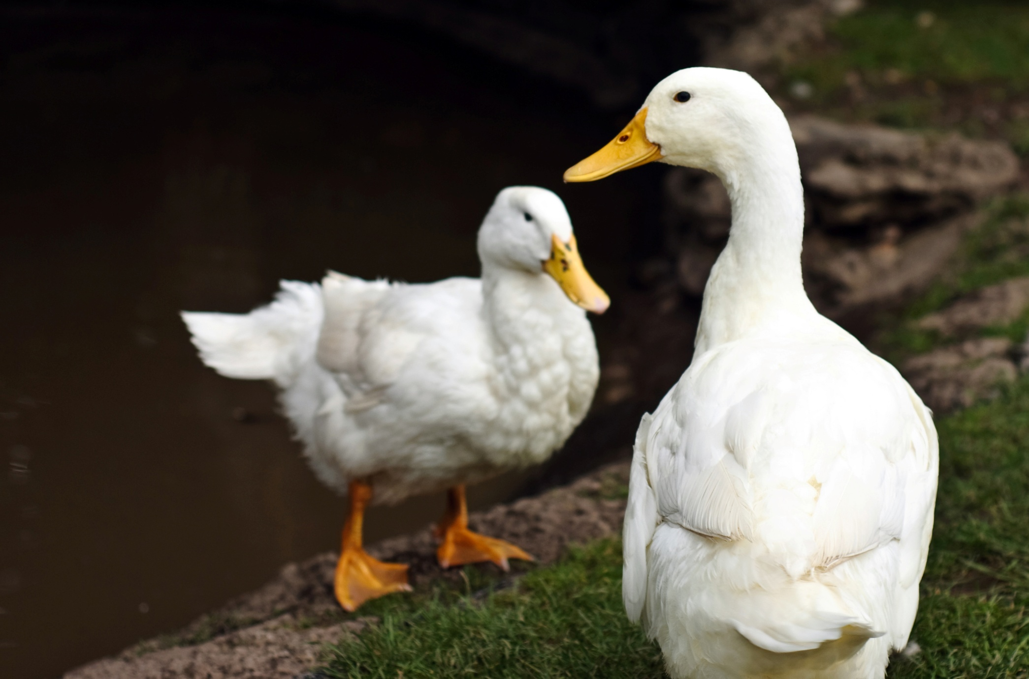
Photo courtesy of Sam E Roper
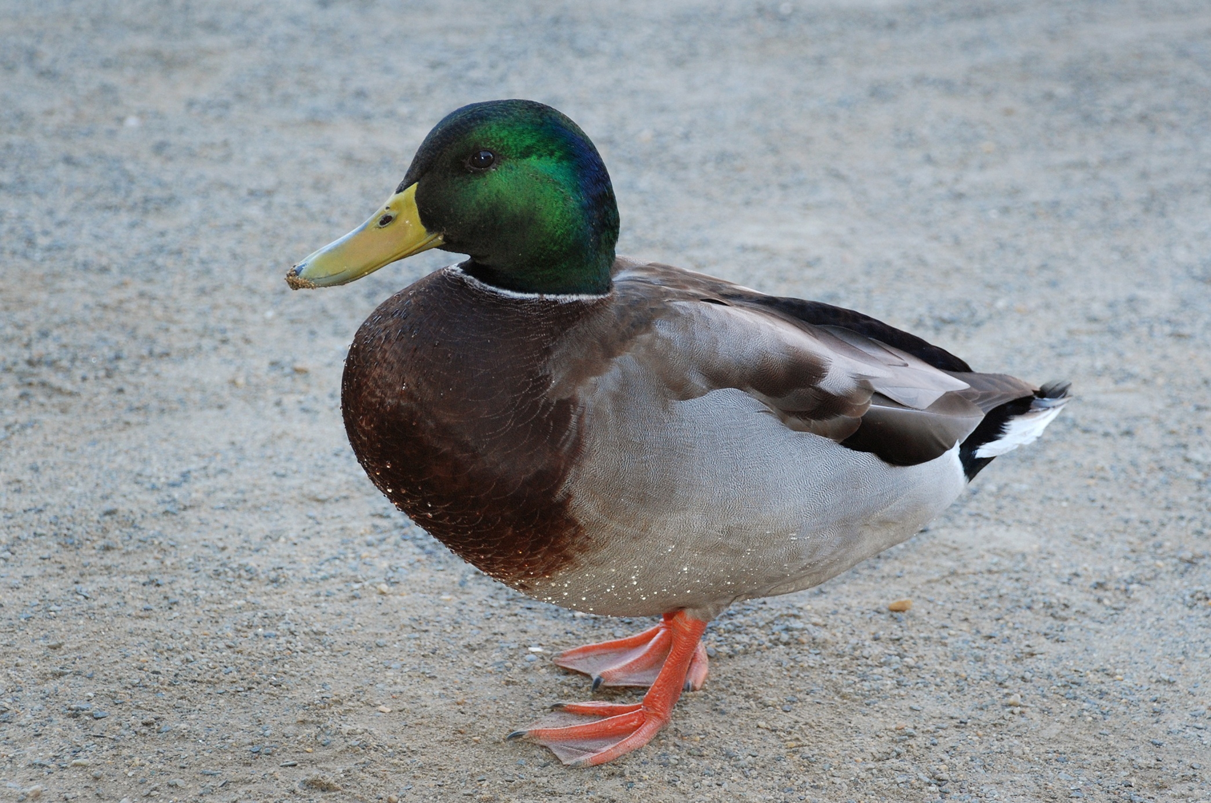
Photo courtesy of pag2525 on Flickr
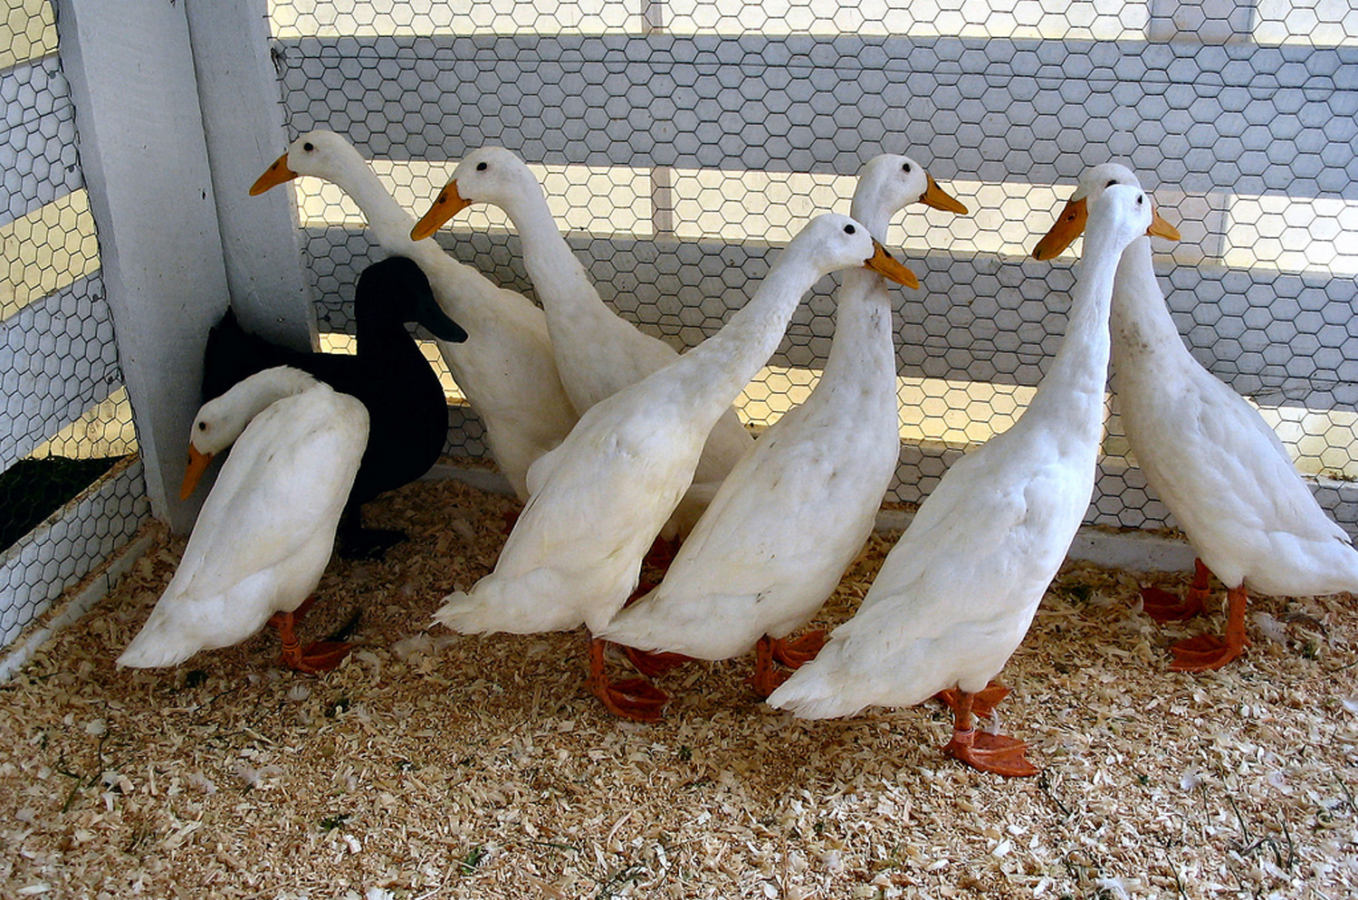
Photo courtesy of muffinman71xx on Flickr
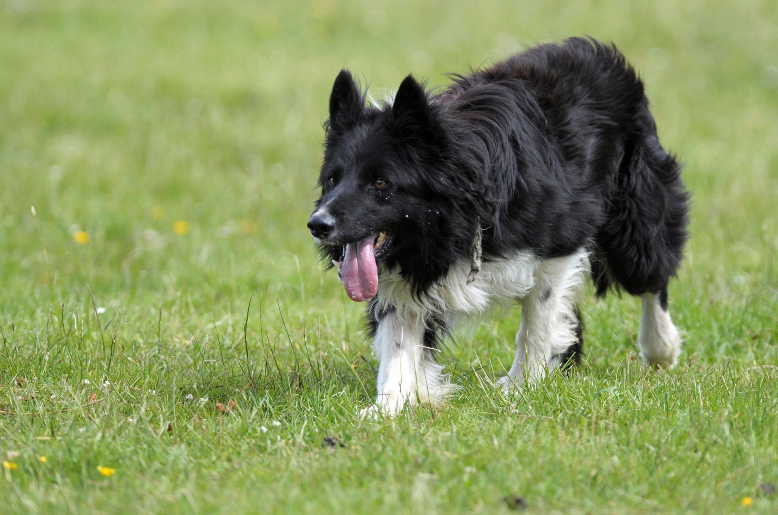
Photo courtesy of RayMorris1 on Flickr
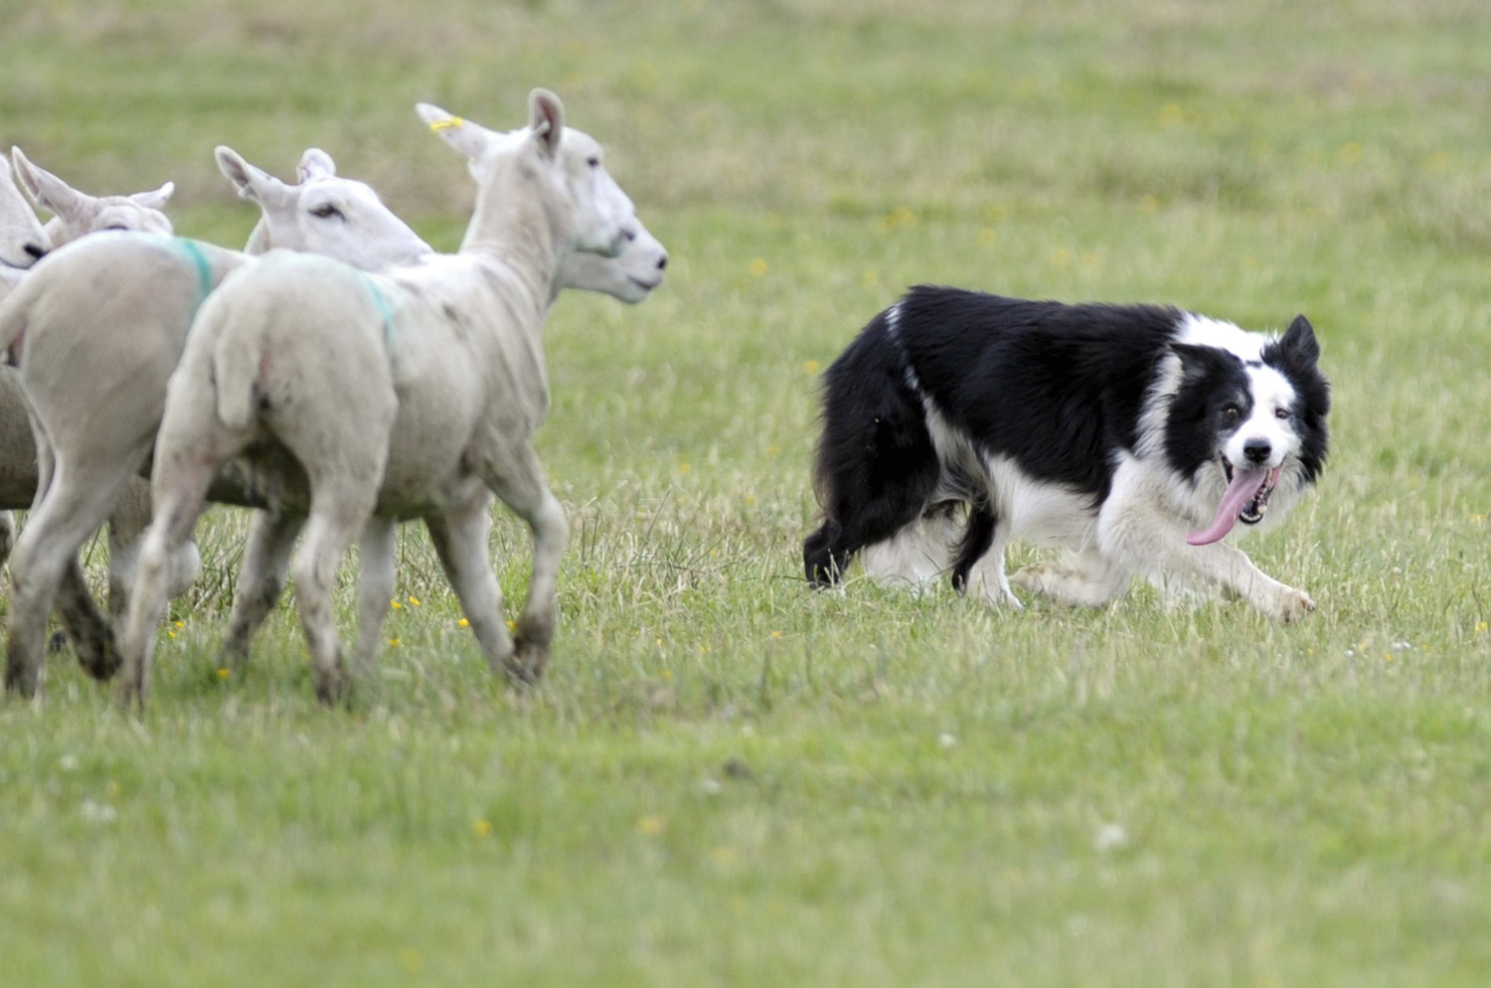
Photo courtesy of RayMorris1 on Flickr
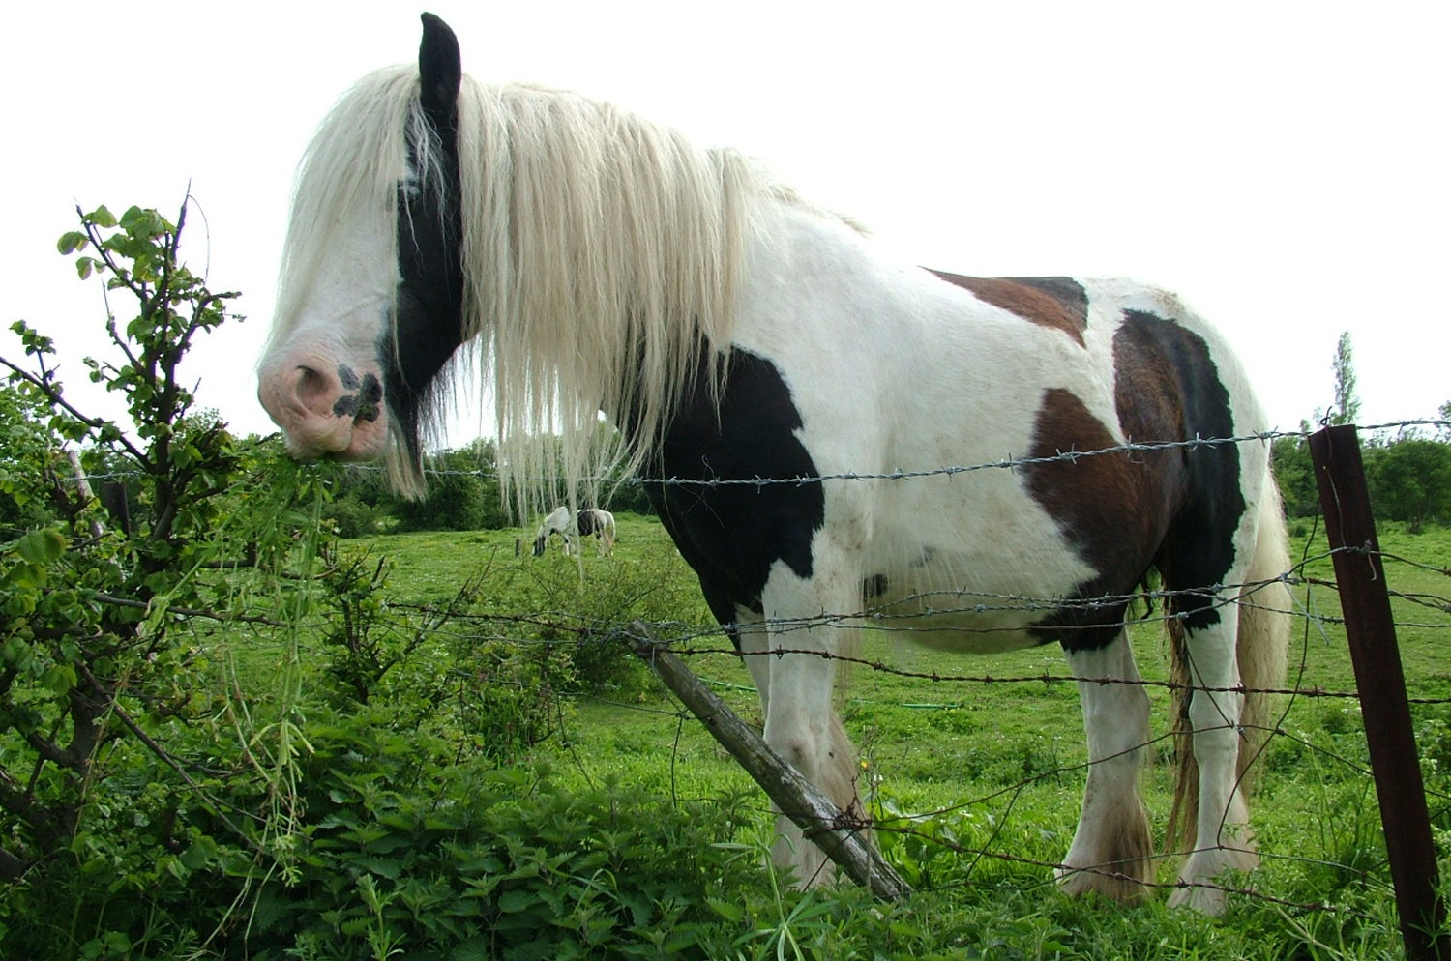
Photo courtesy of kenjonbro on Flickr
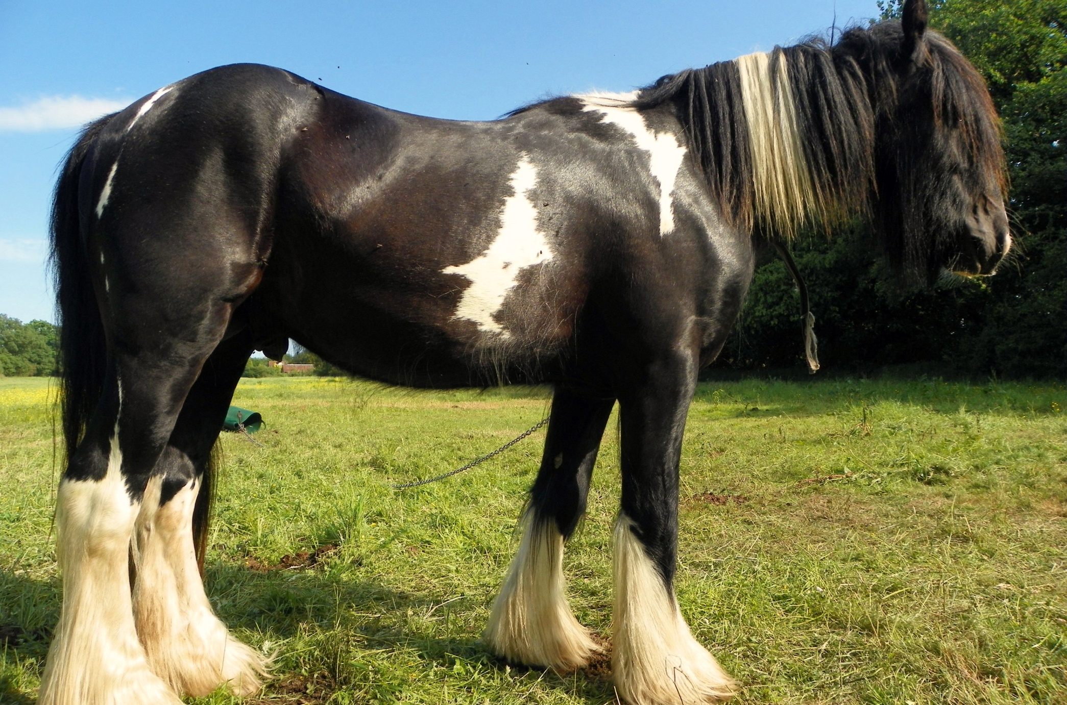
Photo courtesy of anemoneprojectors (Peter O) on Flickr
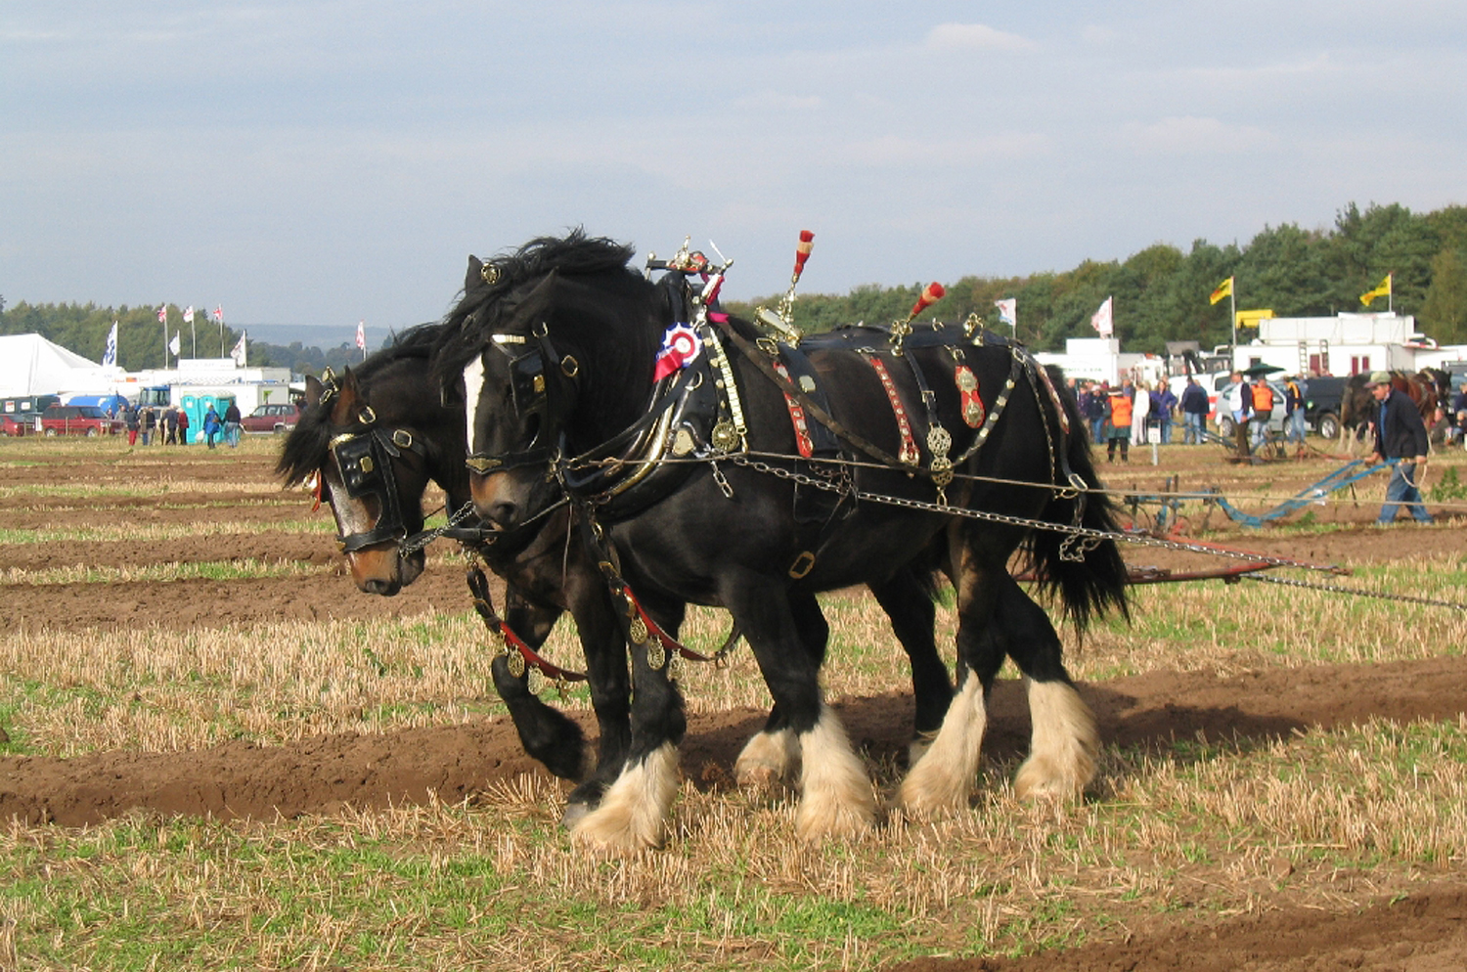
Photo courtesy of camera bag on Flickr
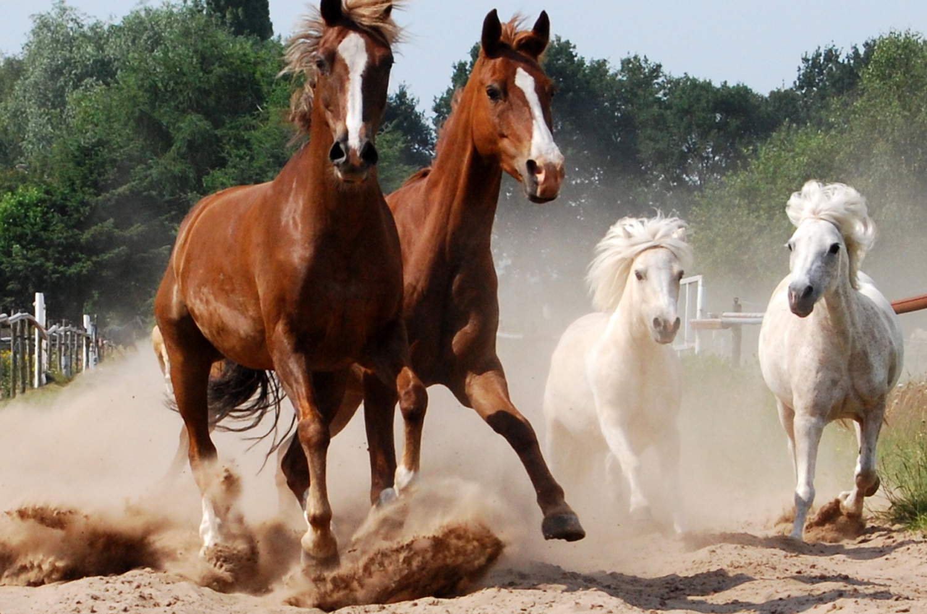
Photo courtesy of Saparevo on Flickr
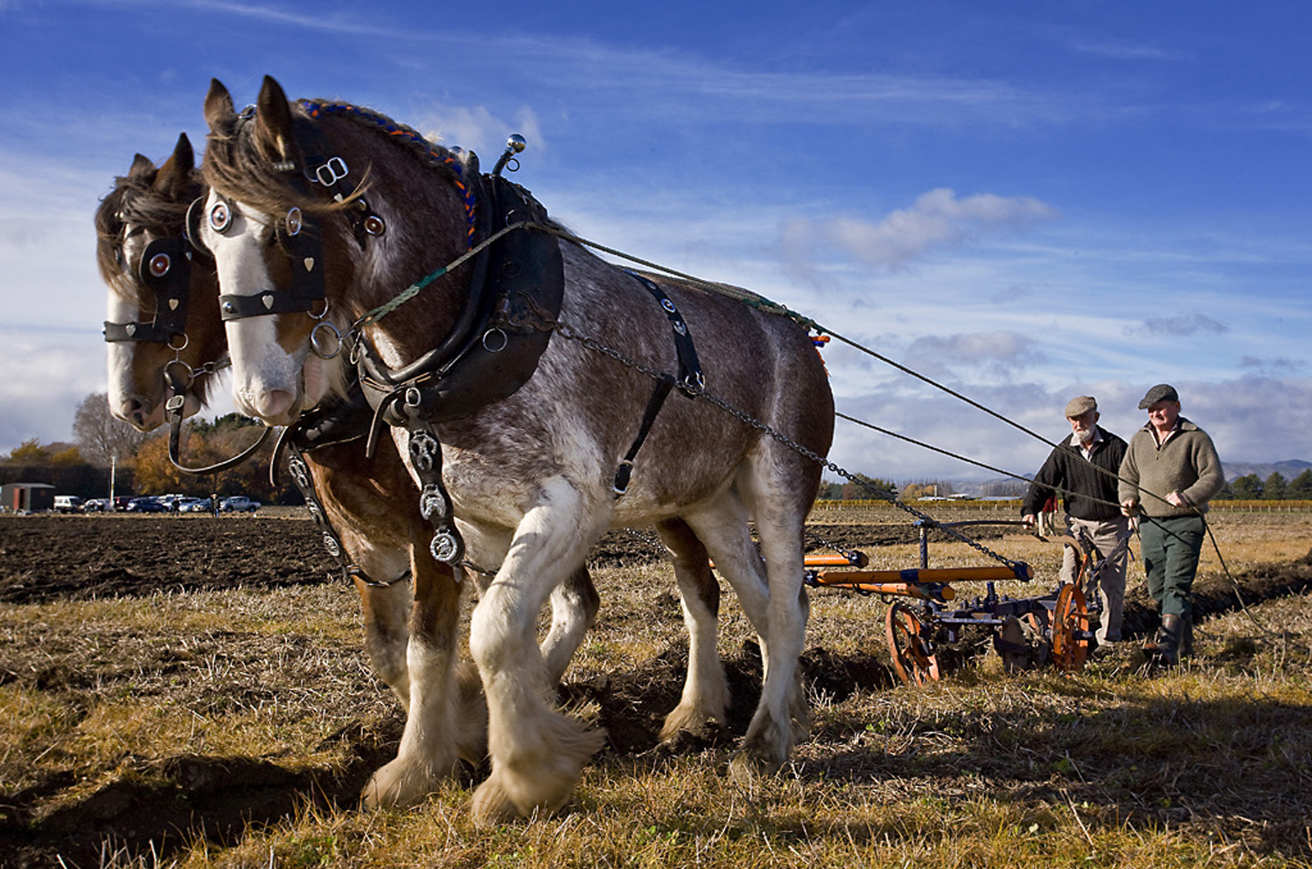
Photo courtesy of Trevor Dennis on Flickr
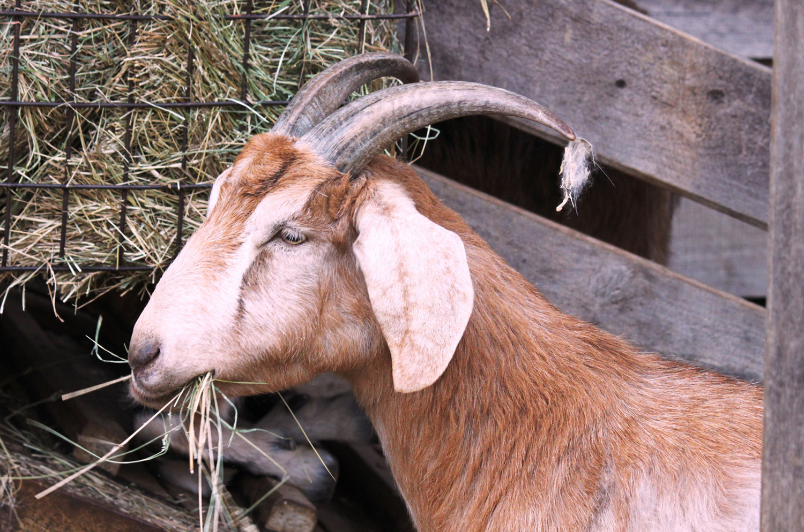
Photo courtesy of OZinOH on Flickr
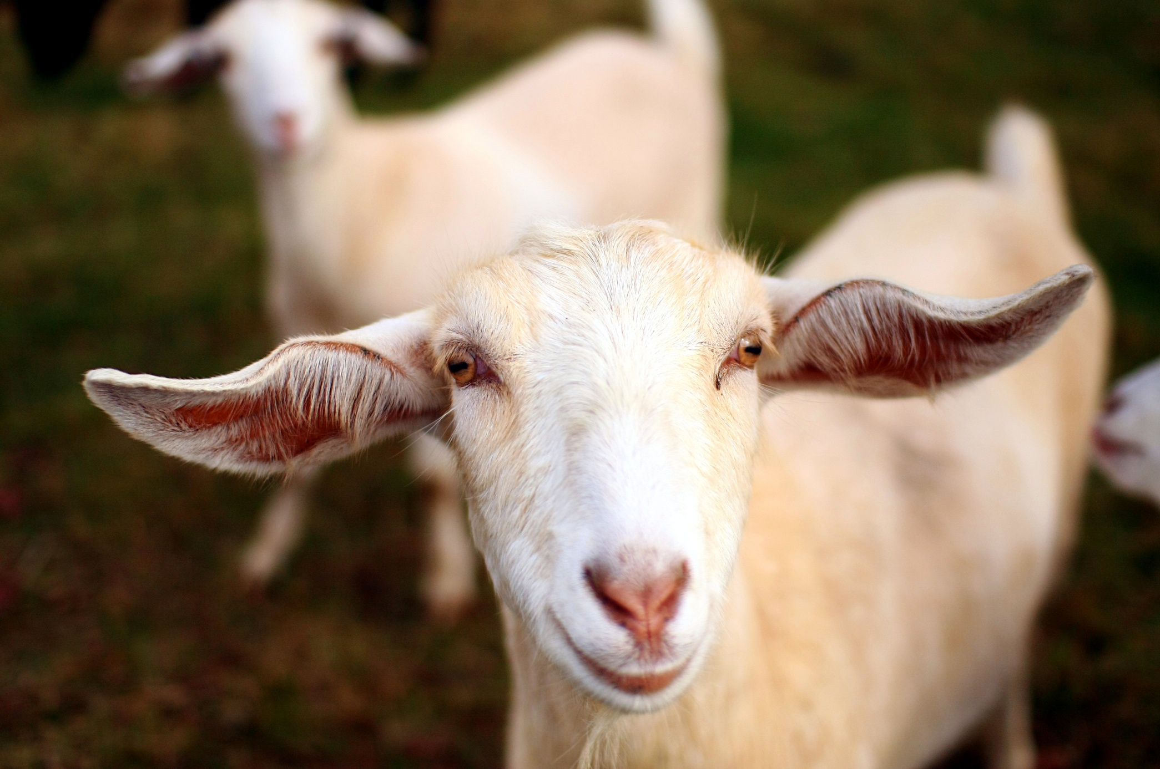
Photo courtesy of Martin Cathrae on Flickr
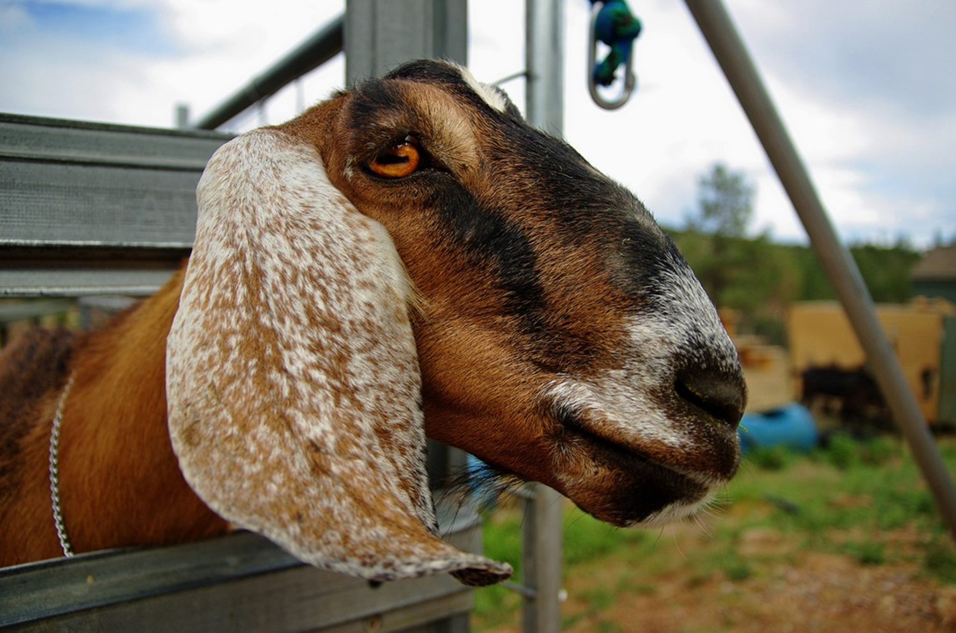
Photo courtesy of PartyNoParty on Flickr
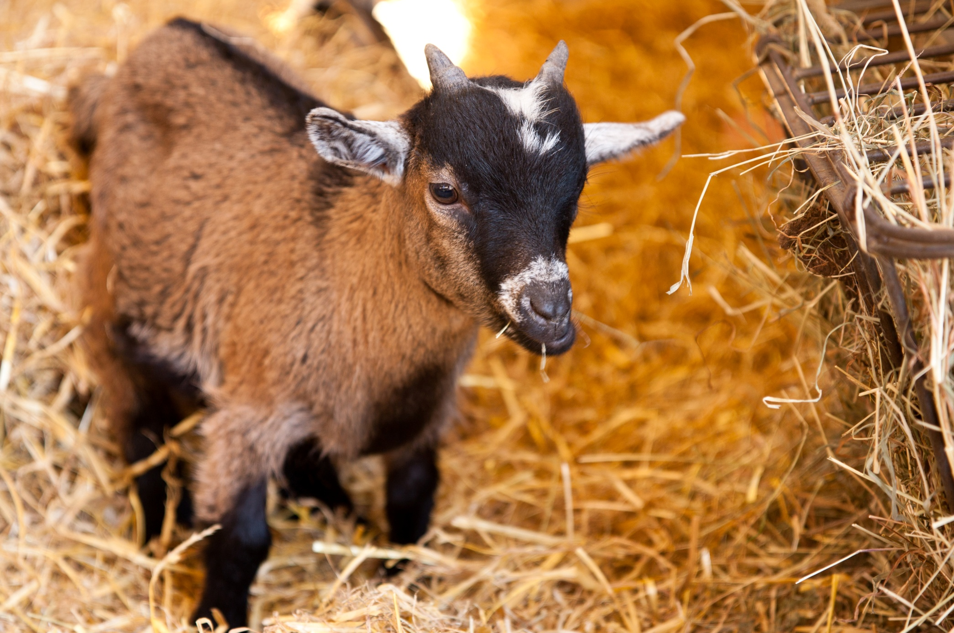
Photo courtesy of Ross Burton on Flickr

