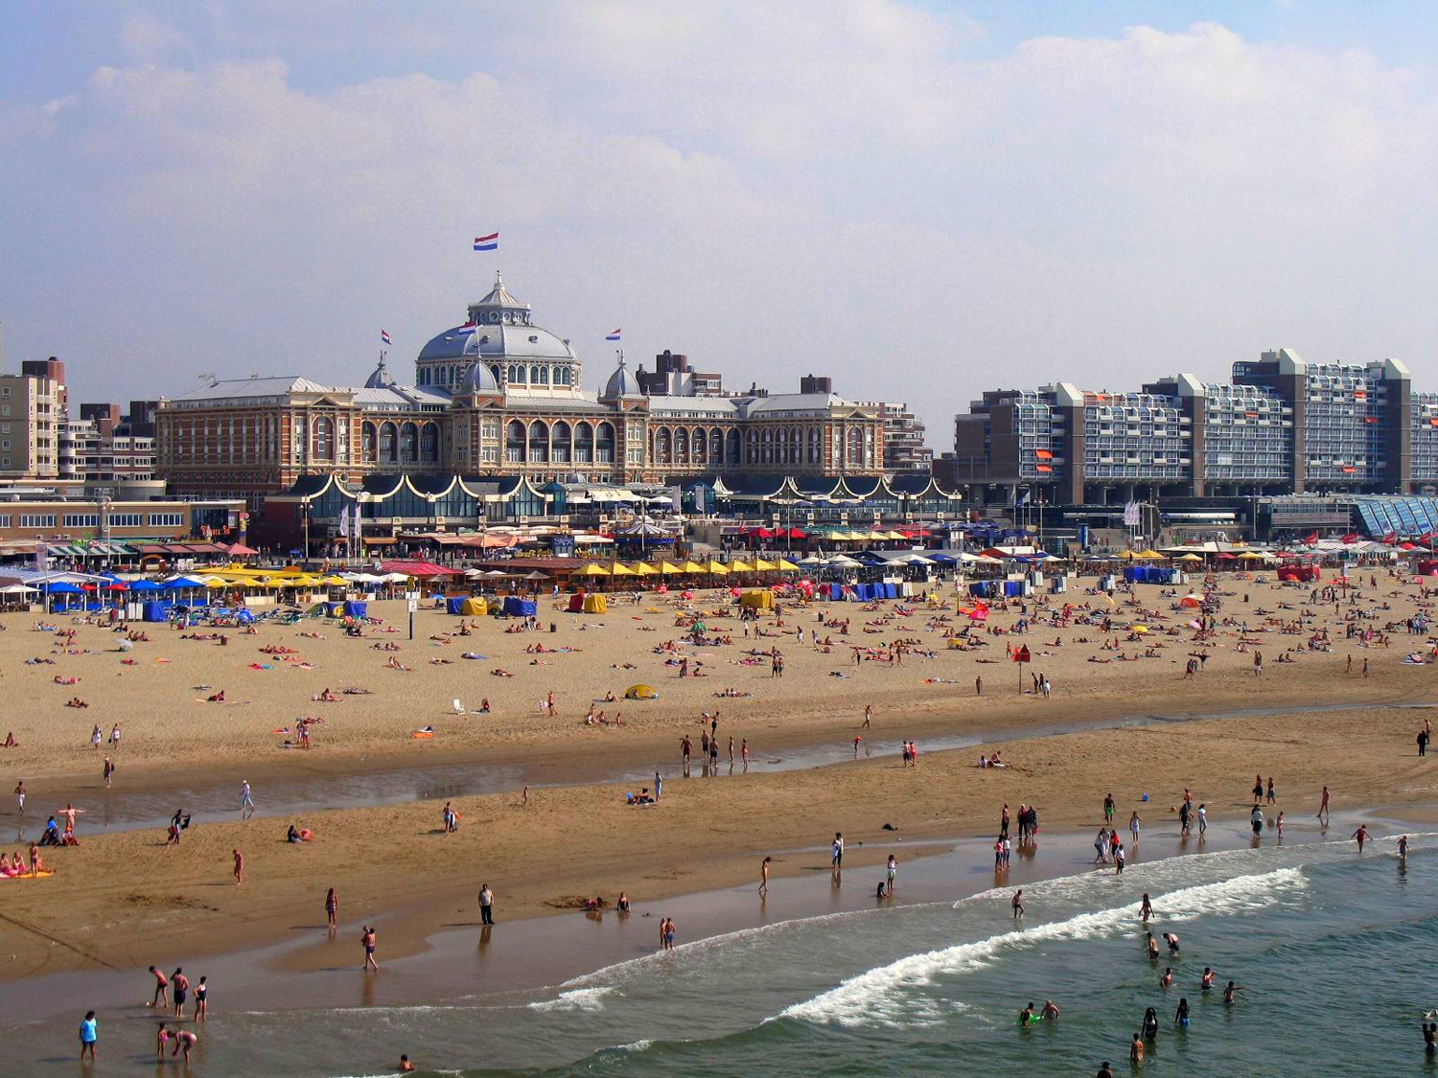

Photo courtesy of CoanriRita on Flickr
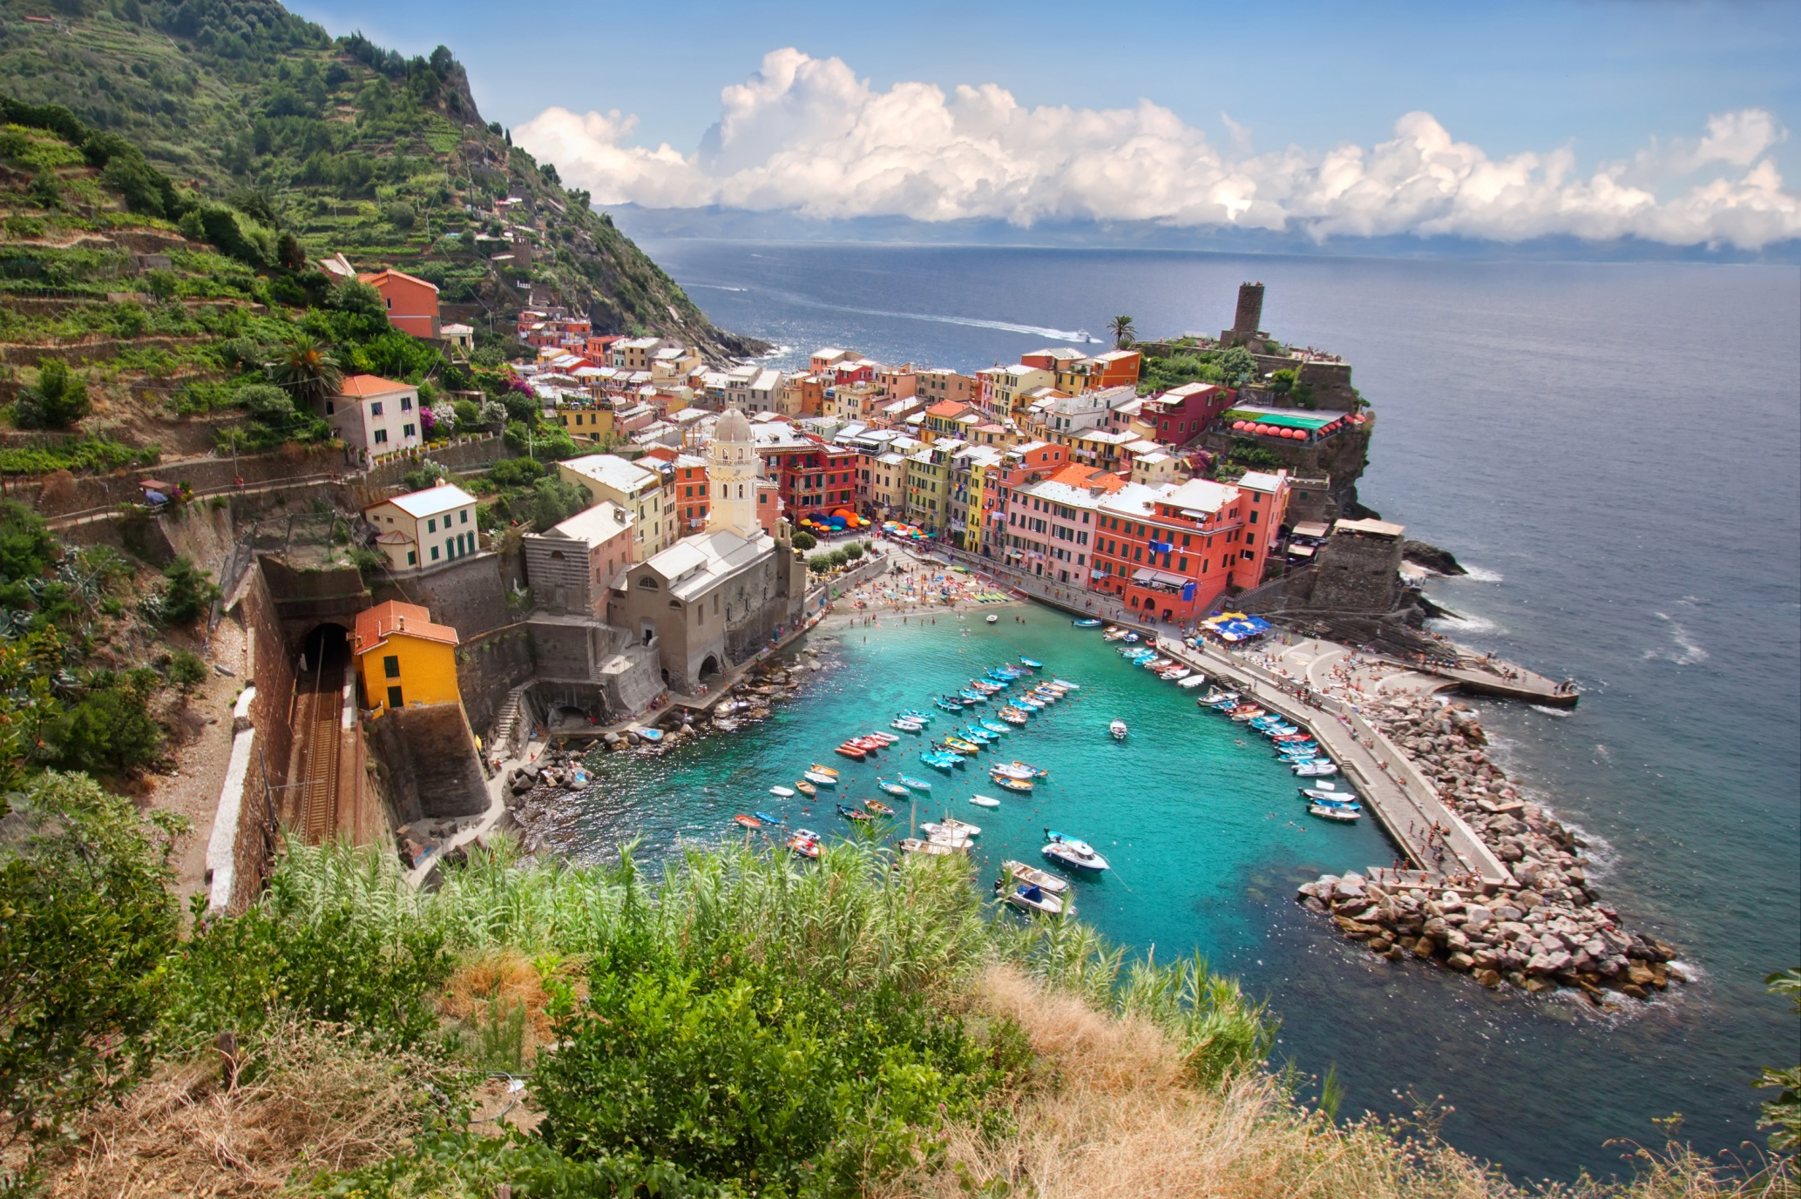
Photo courtesy of WanderingtheWorld on Flickr
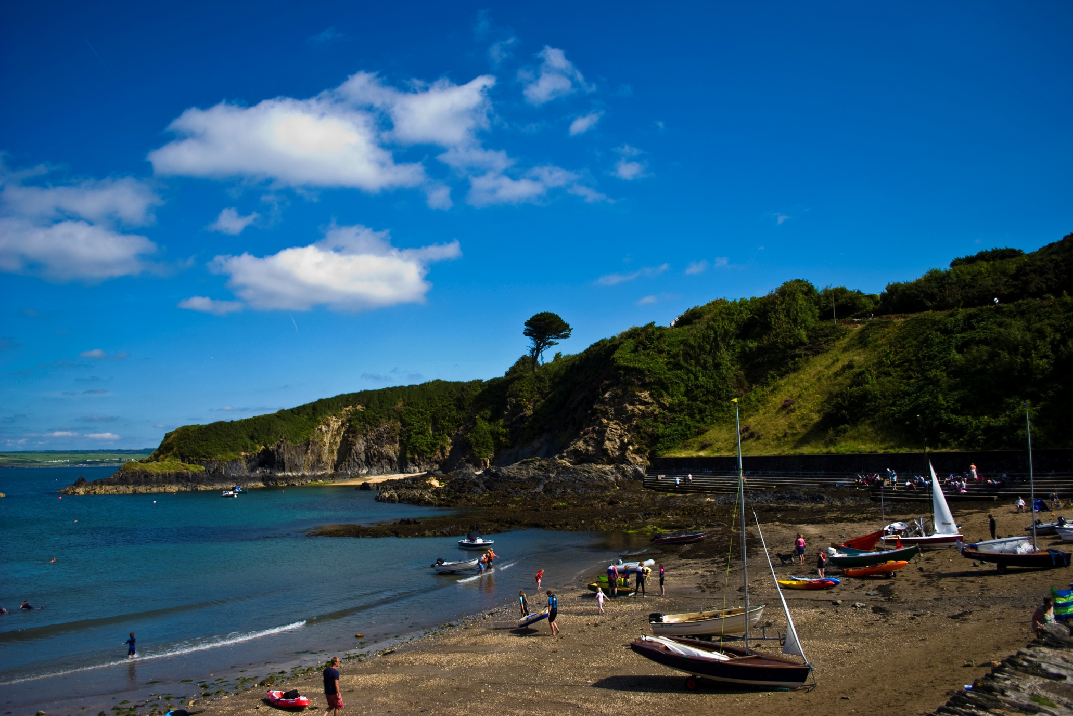
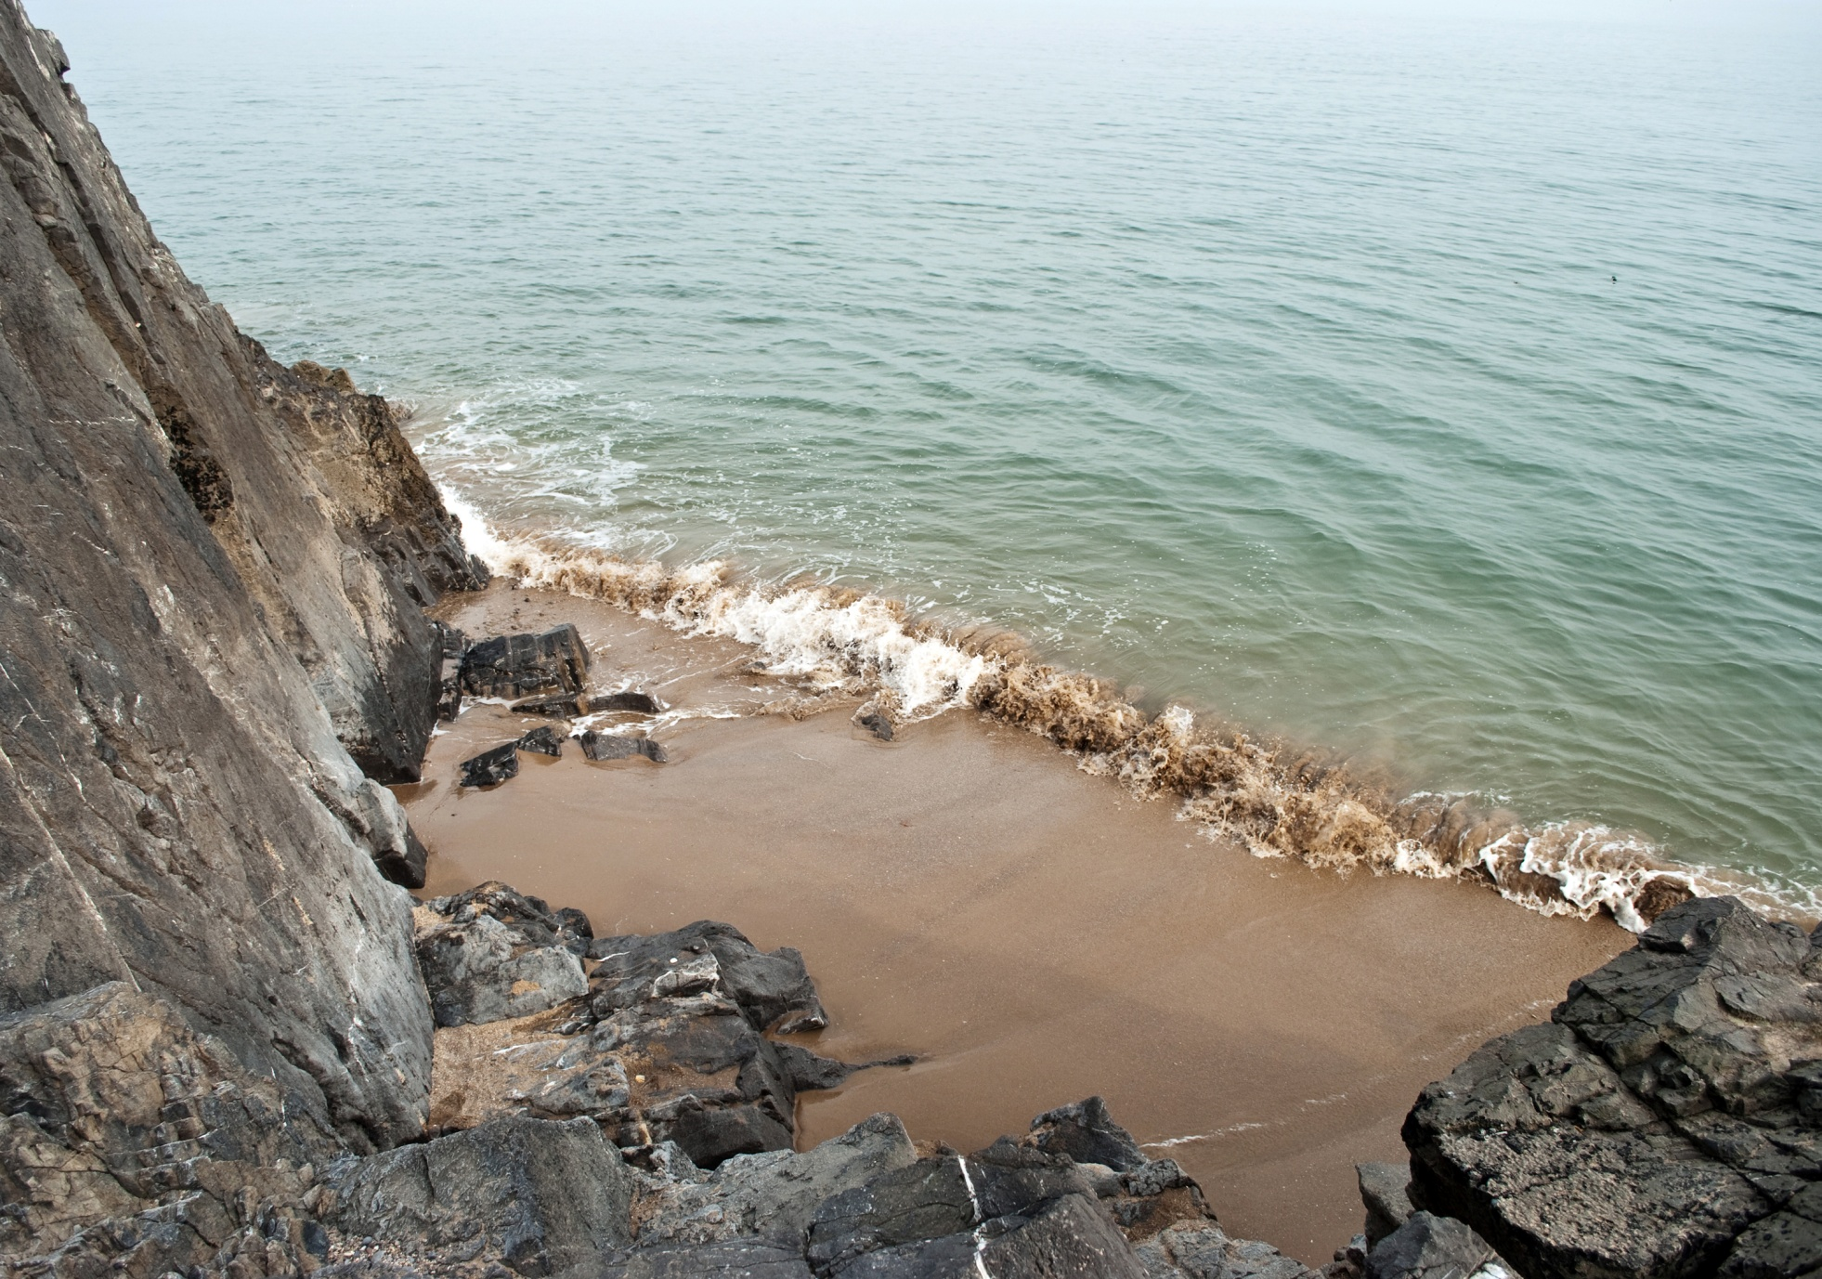

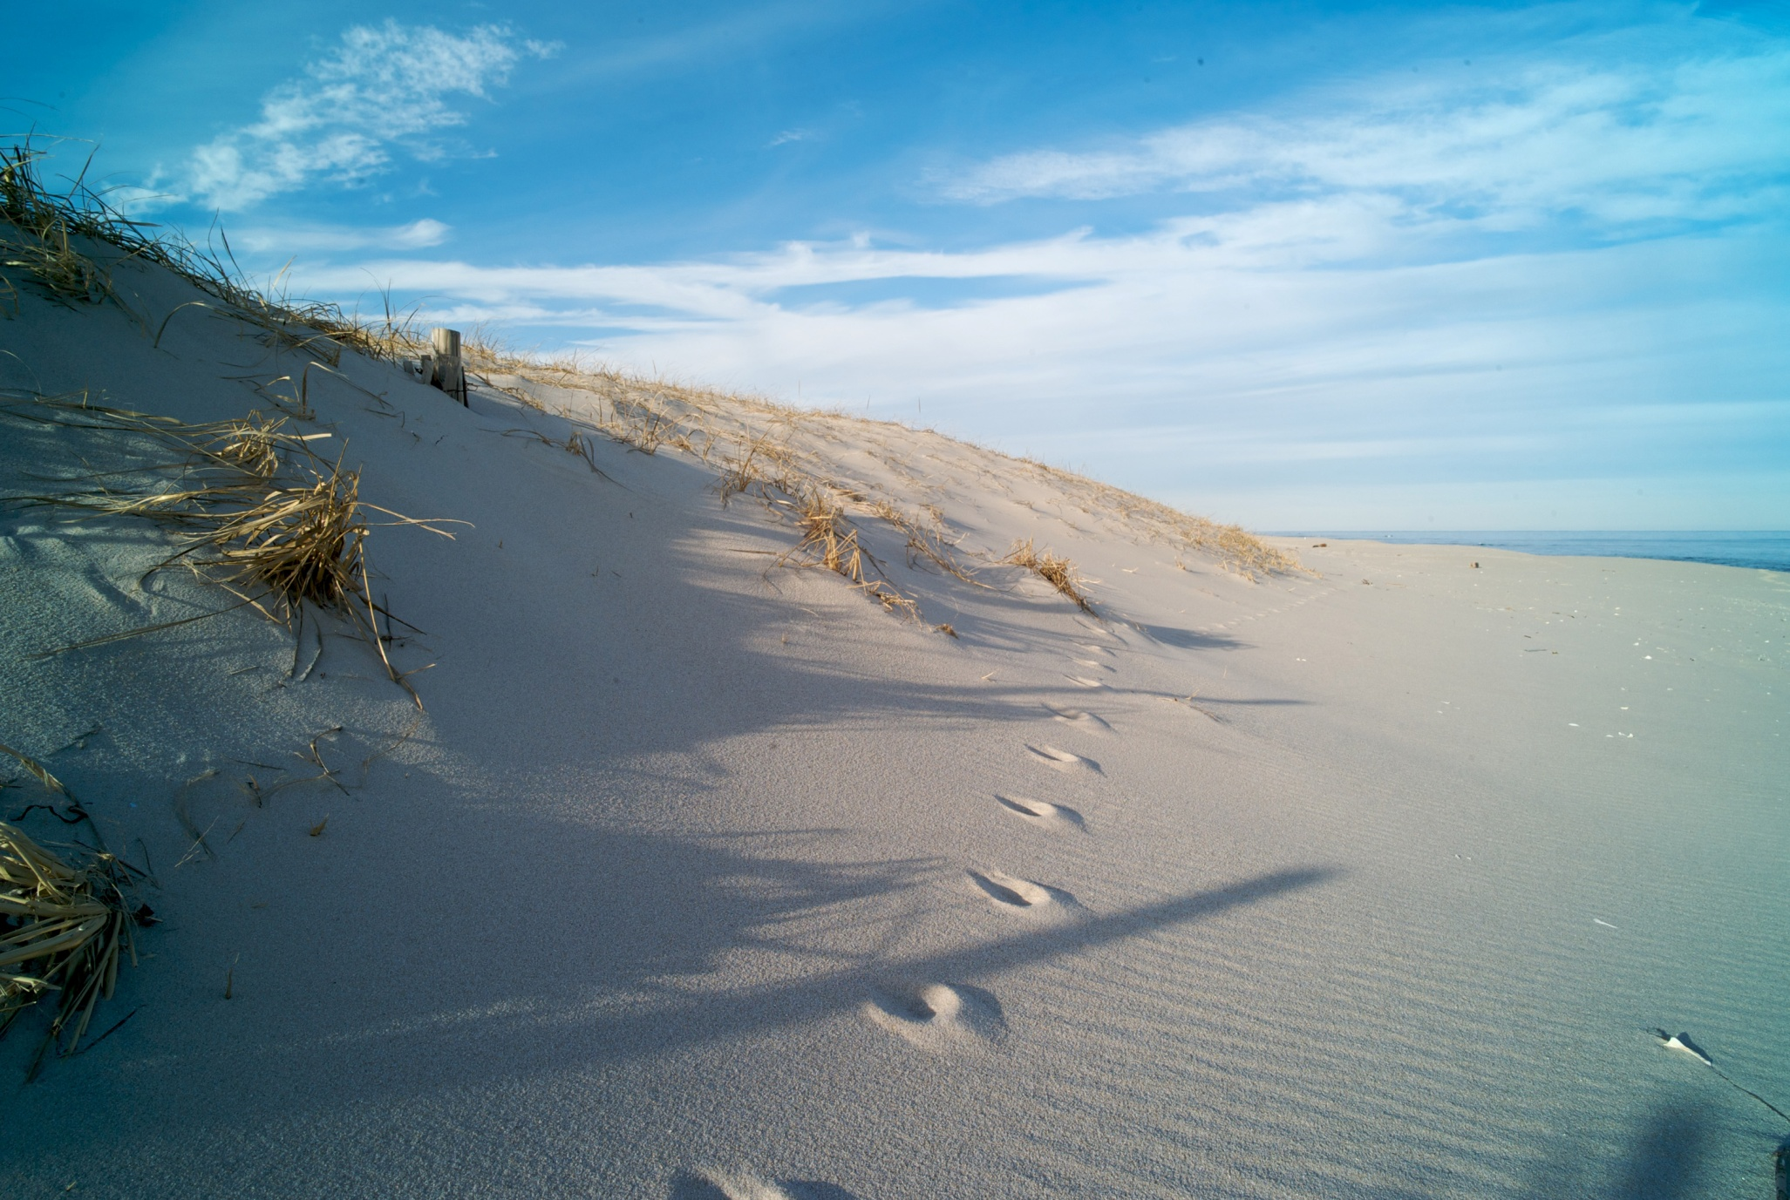
Photo courtesy of jaimekop on Flickr
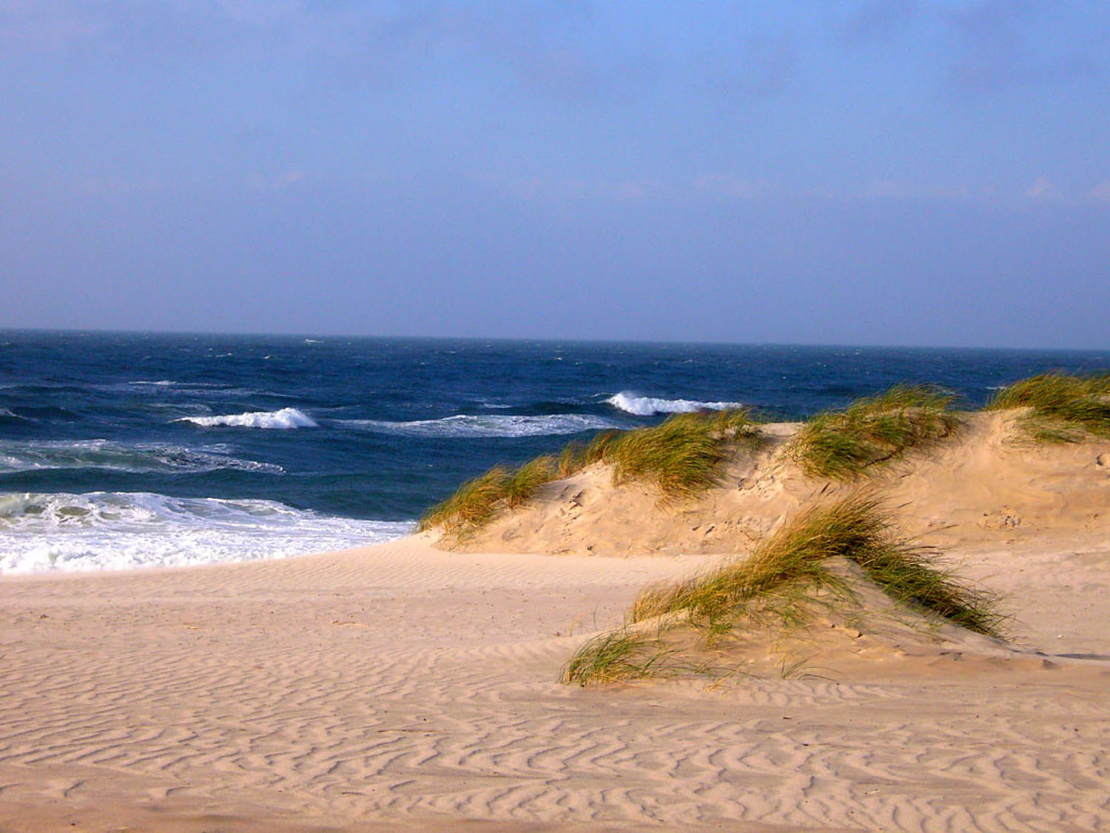

Photo courtesy of temporalata on Flickr
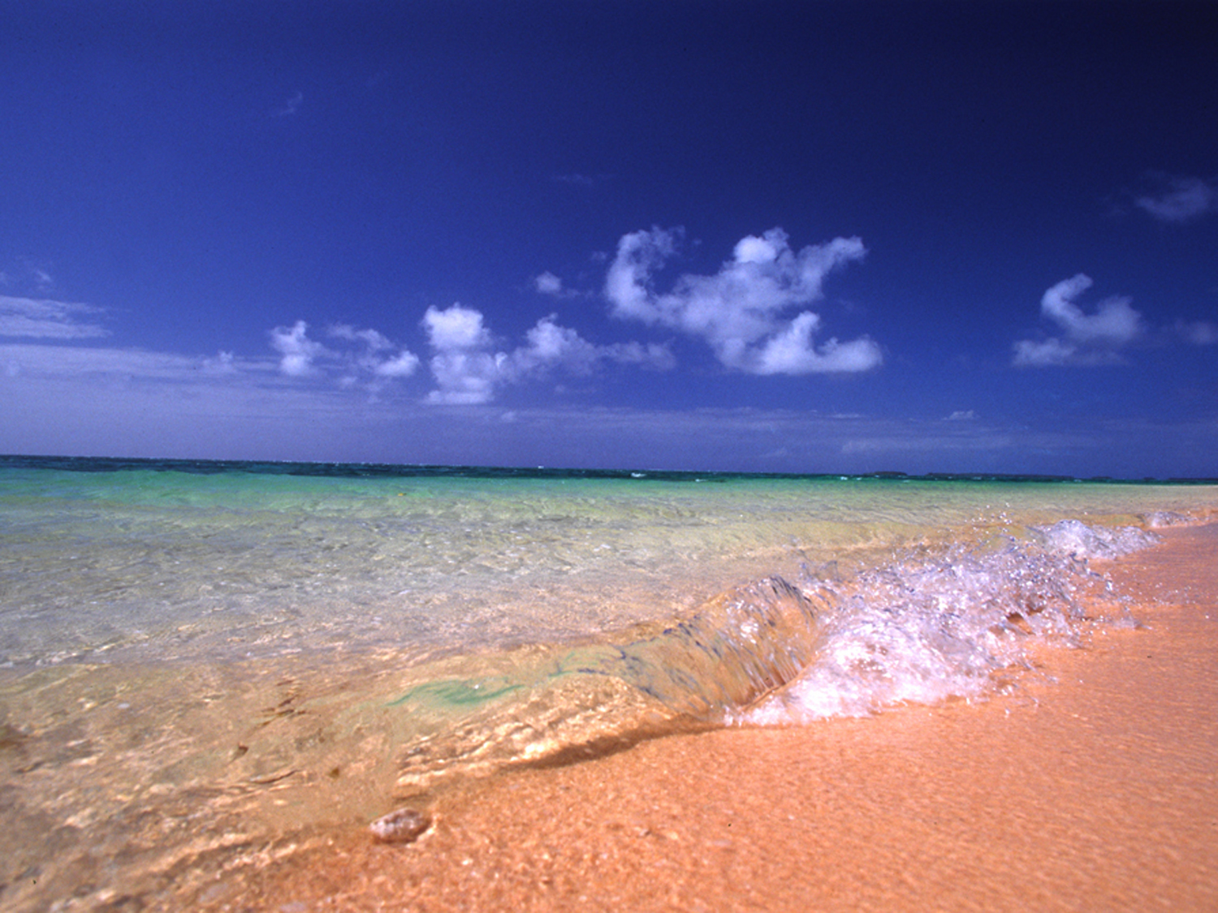

Photo courtesy of mrlins on Flickr
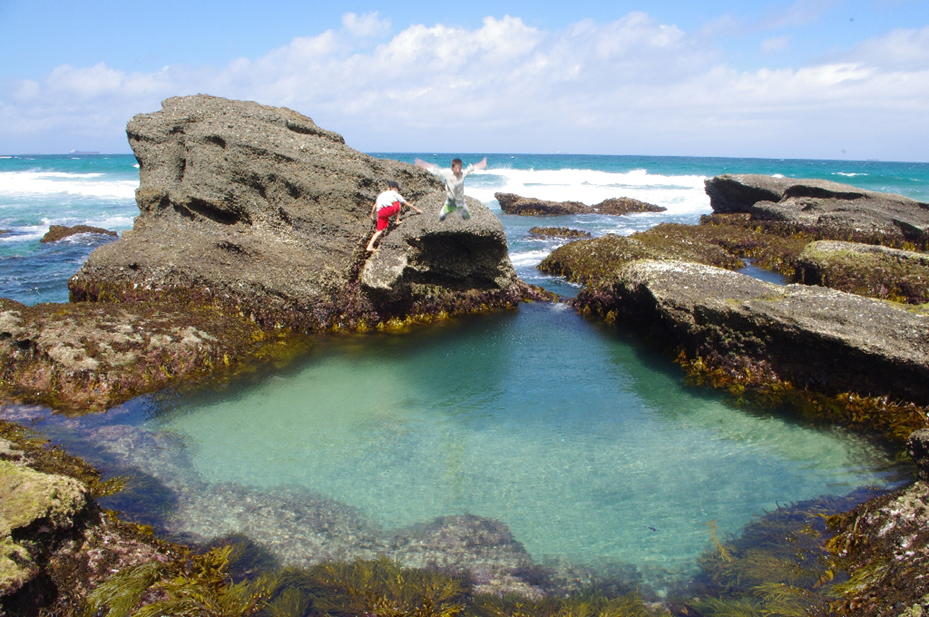
Photo courtesy of eyeweed on Flickr
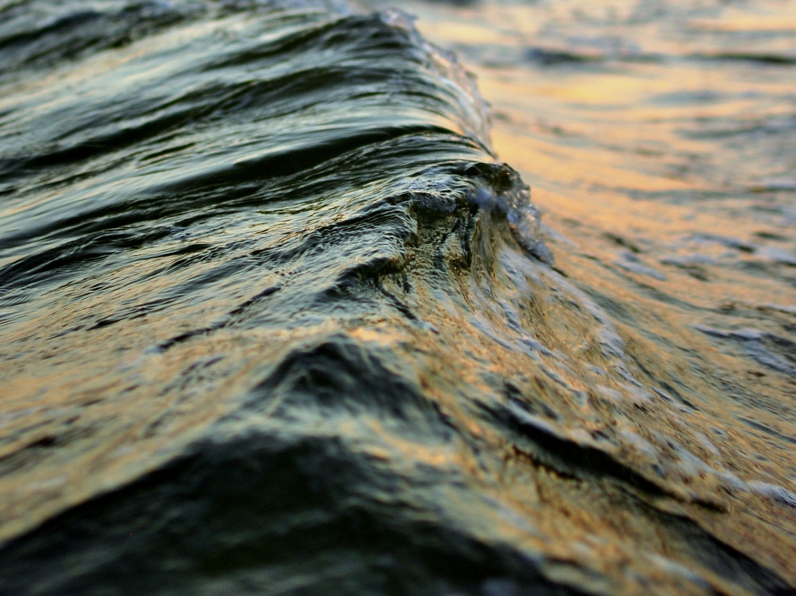

Photo courtesy of wiserbailey on Flickr
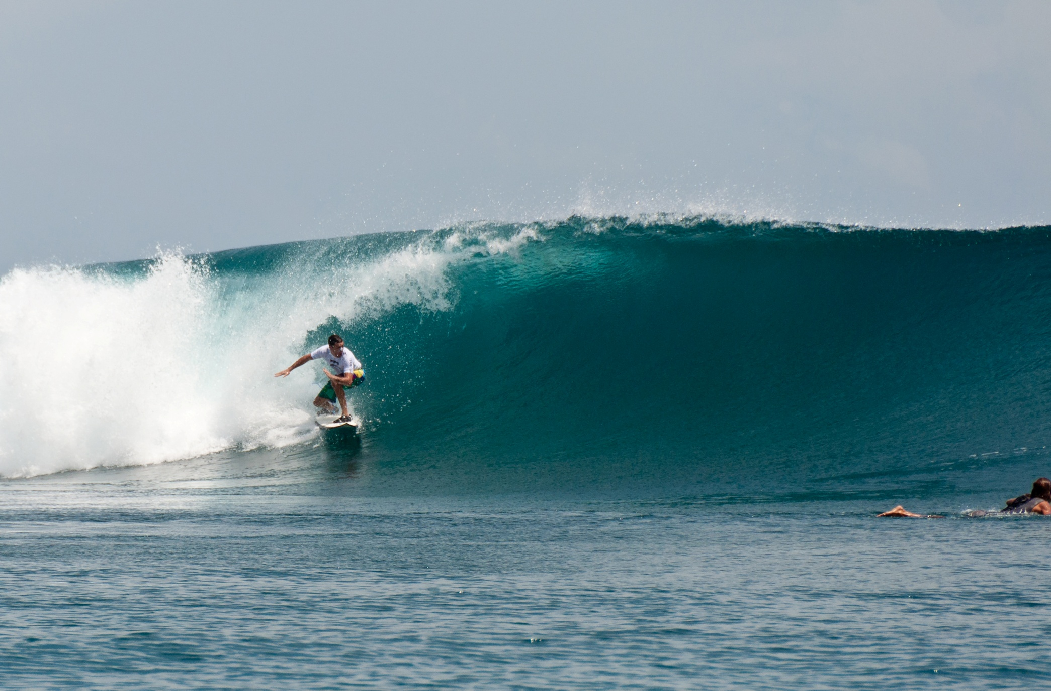
Photo courtesy of sebr on Flickr
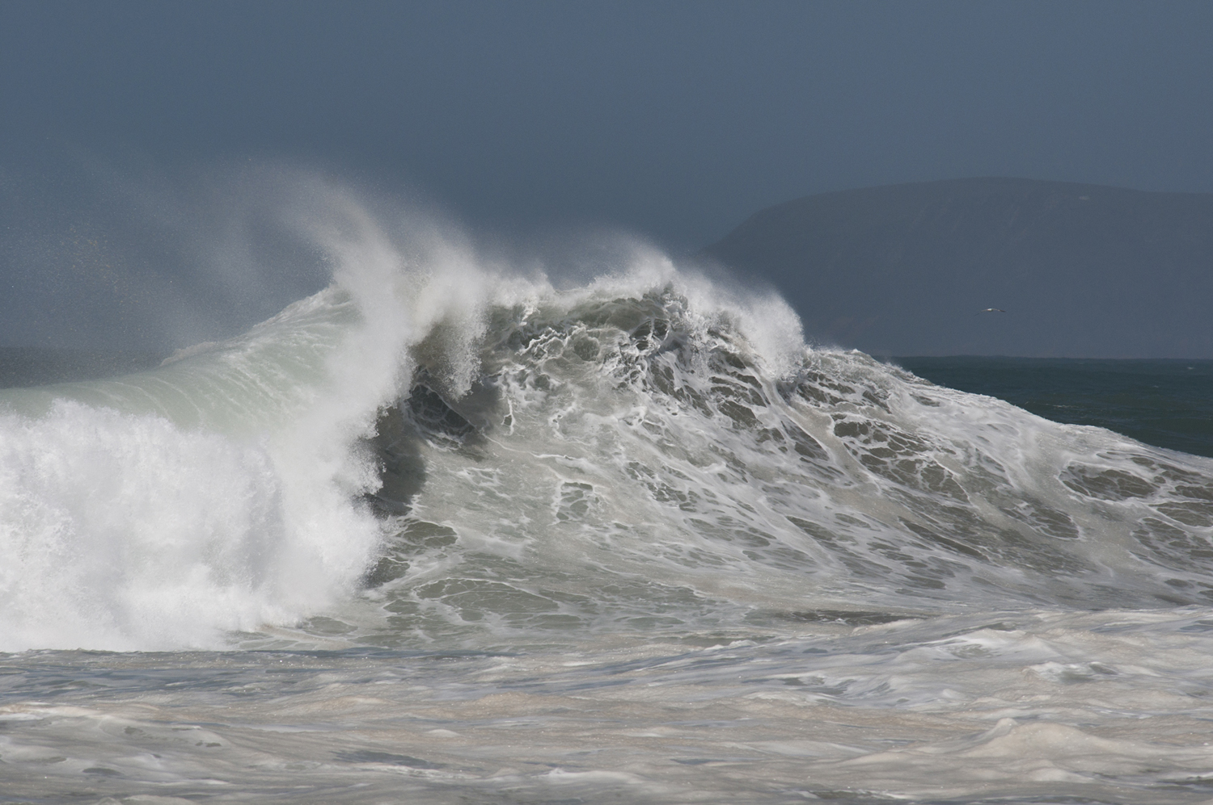
Photo courtesy of puliarf on Flickr
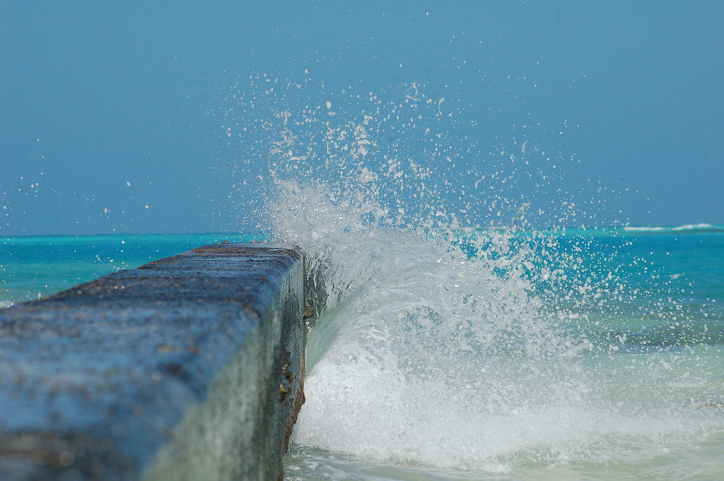
Photo courtesy of greghartmann on Flickr
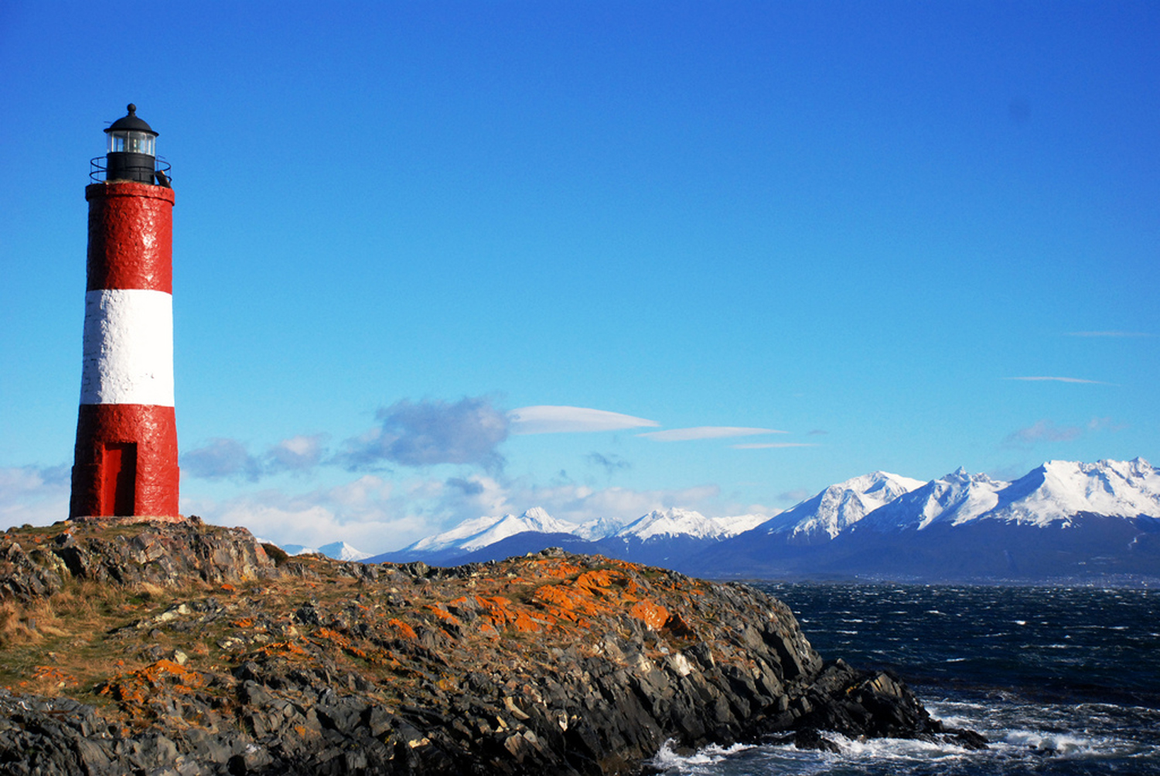
Photo courtesy of caro77 on Flickr
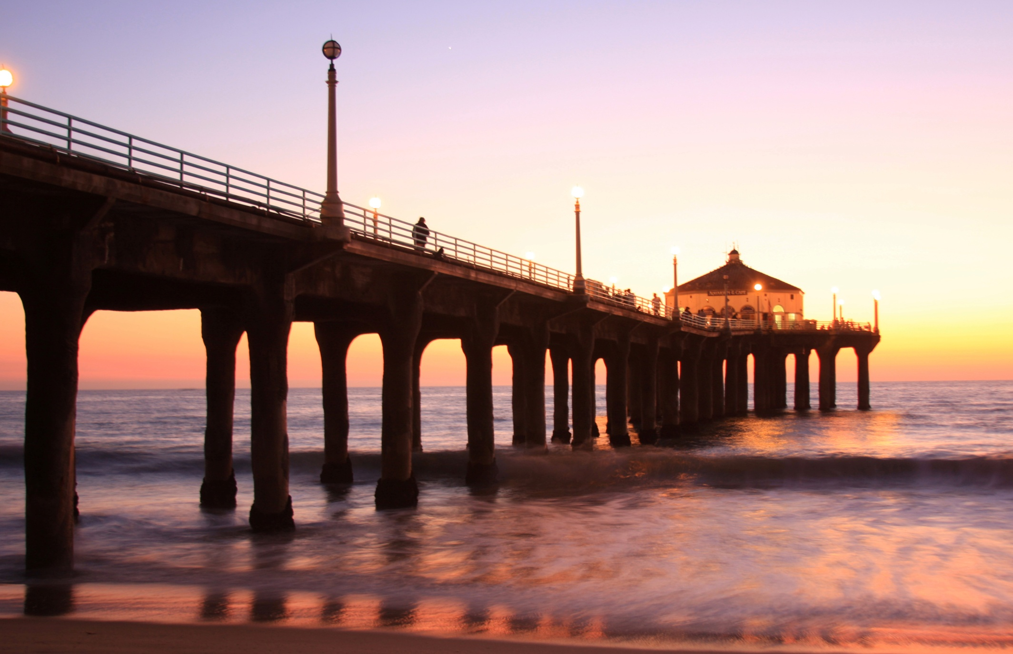
Photo courtesy of PC - My Shots@Photography on Flickr
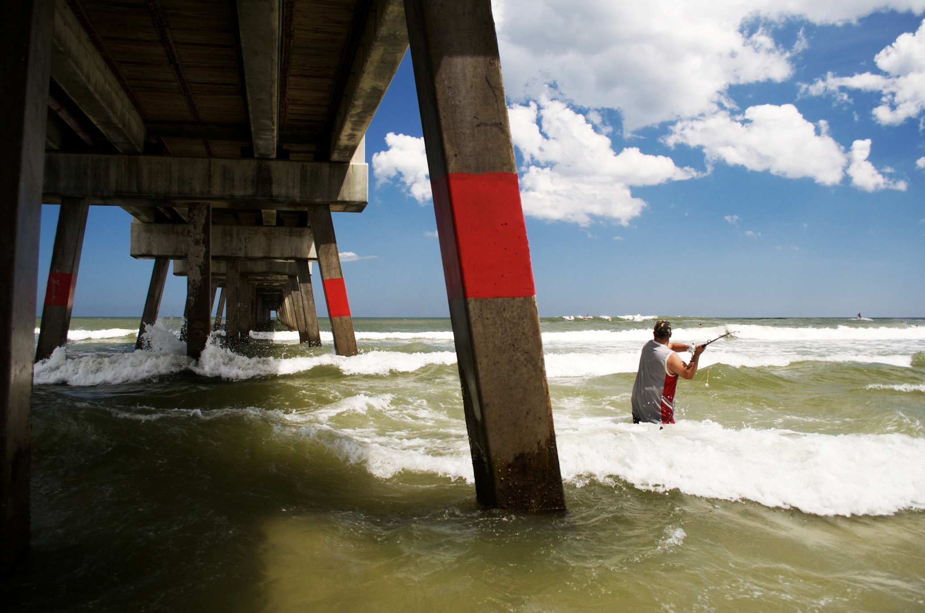
Photo courtesy of ernestkoe on Flickr
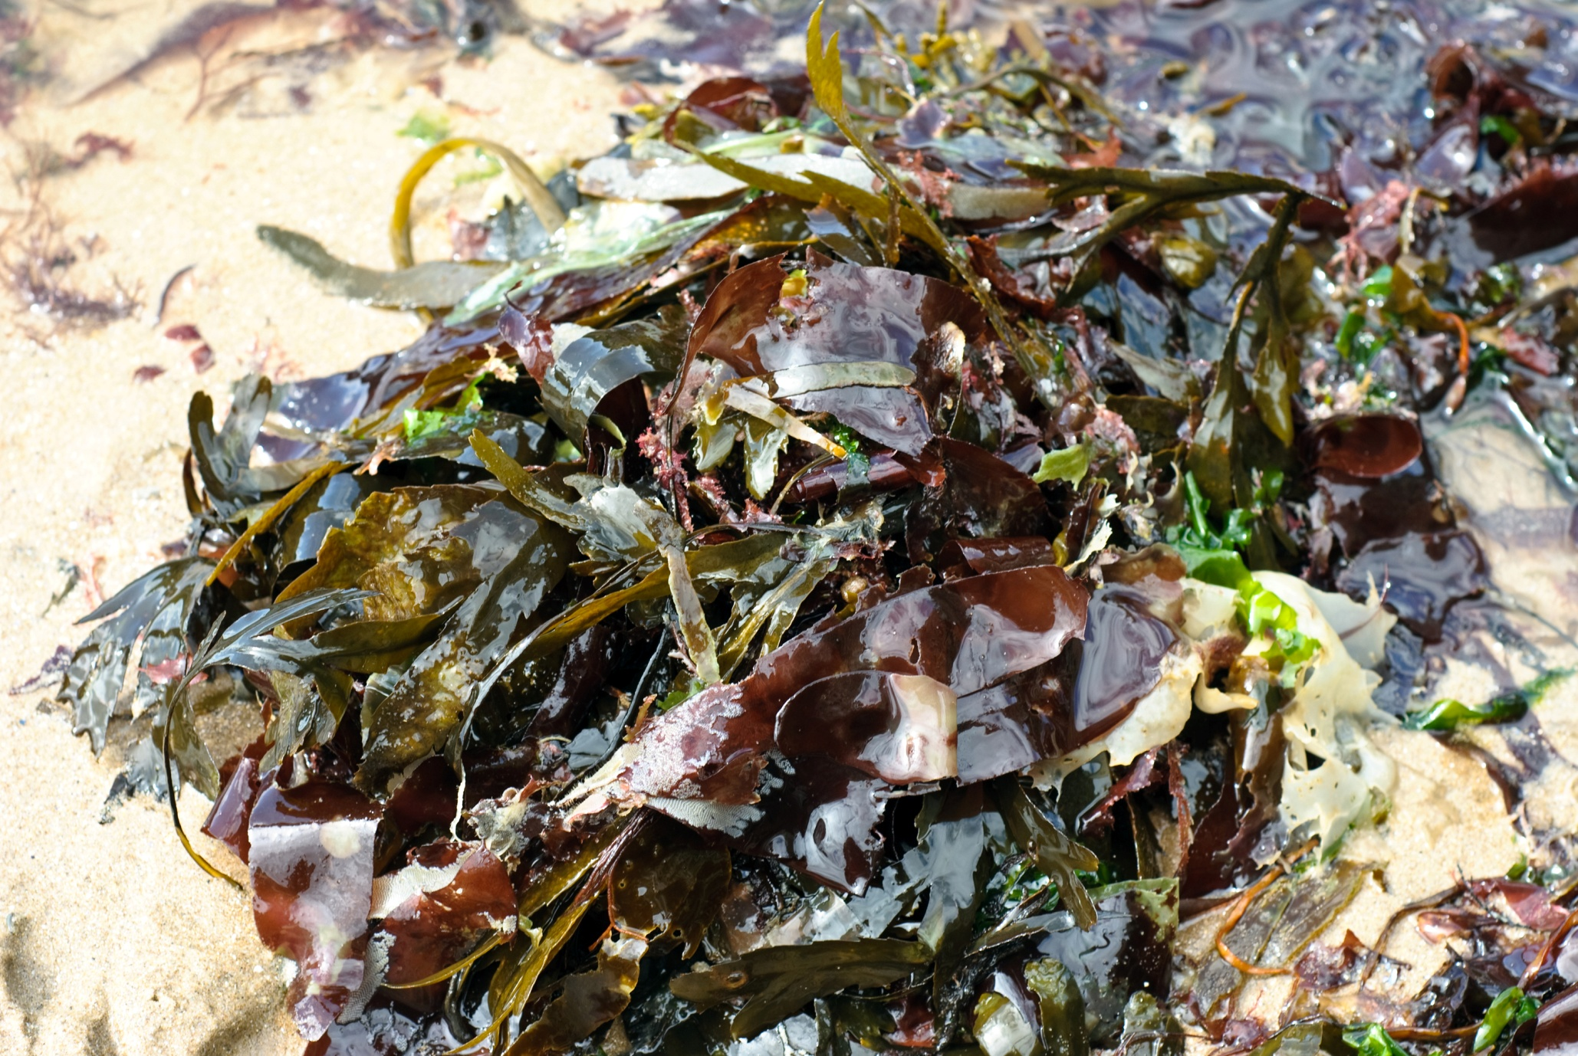
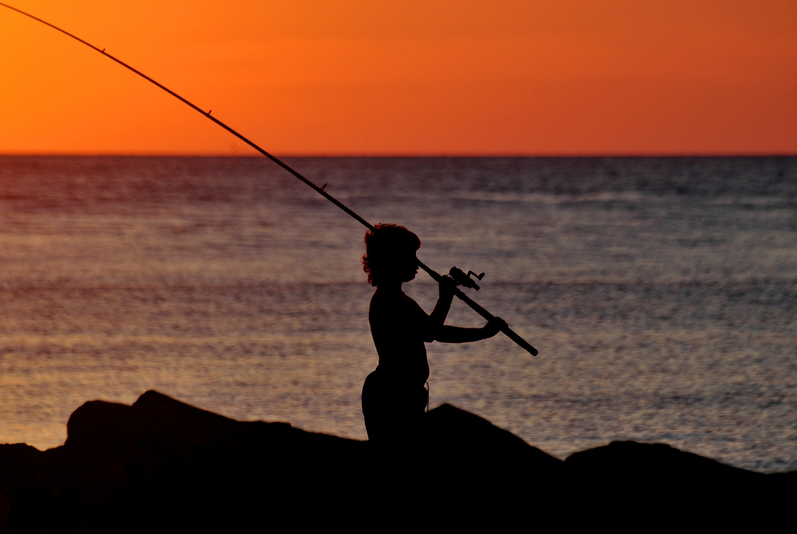
Photo courtesy of Rickydavid on Flickr
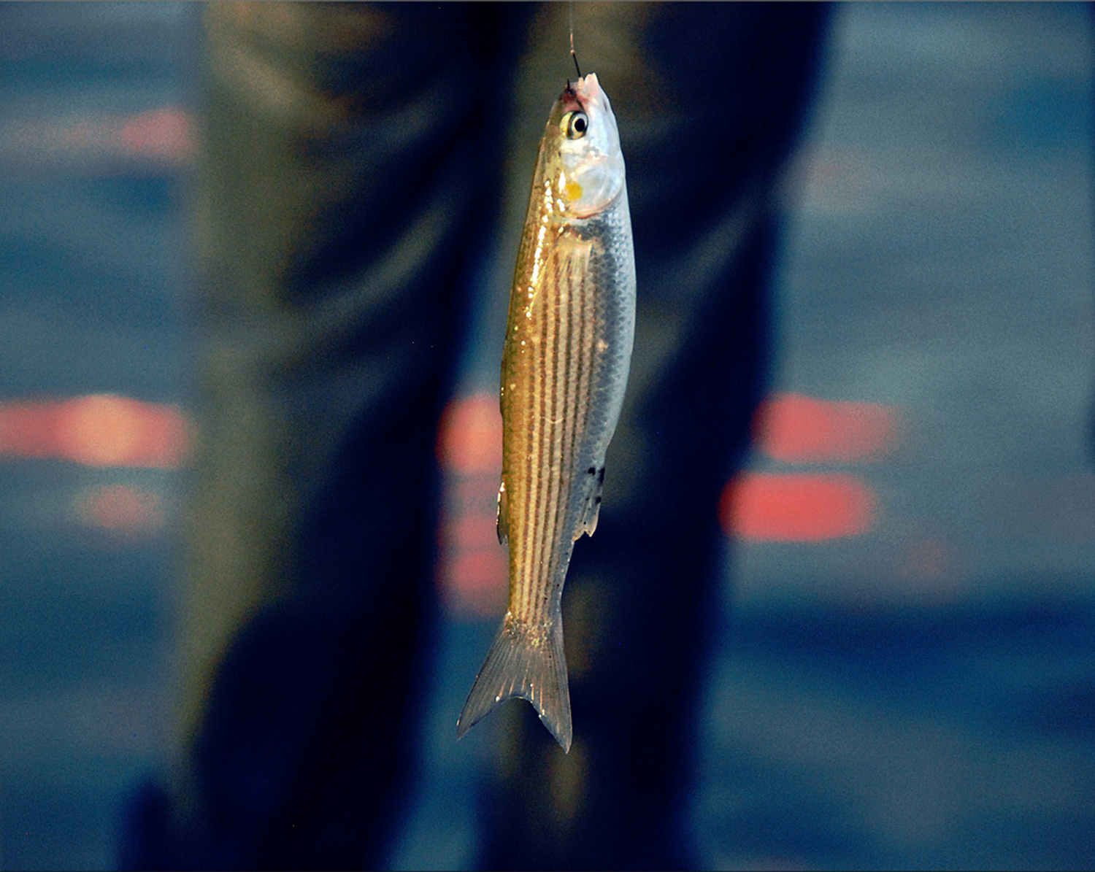

Photo courtesy of BlueGoaॐ☮ on Flickr
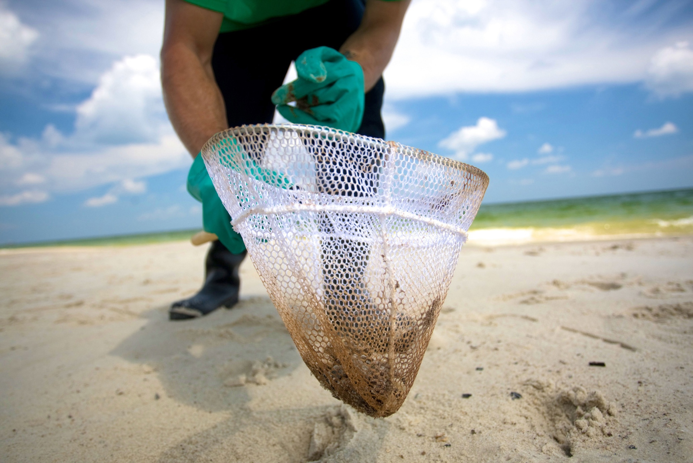
Photo courtesy of BP America on Flickr
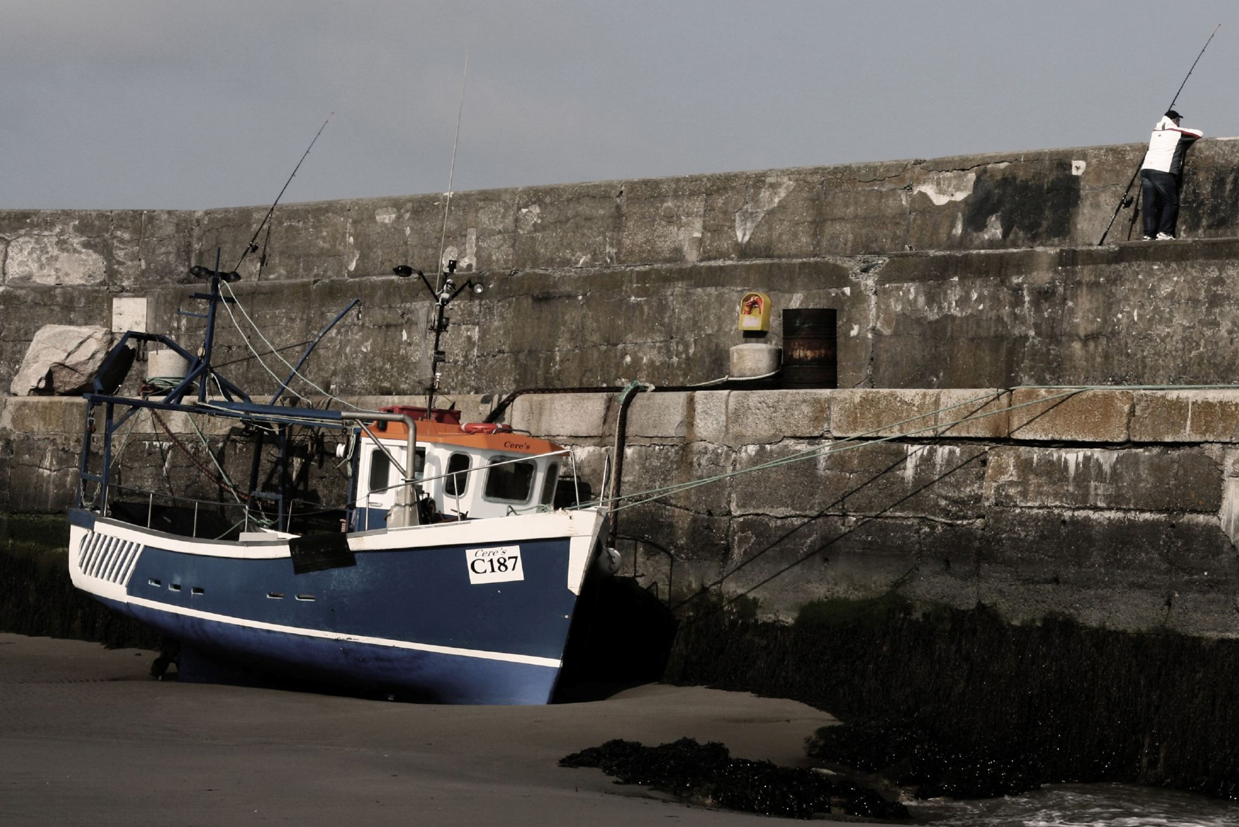
Photo courtesy of Neil Dorgan on Flickr
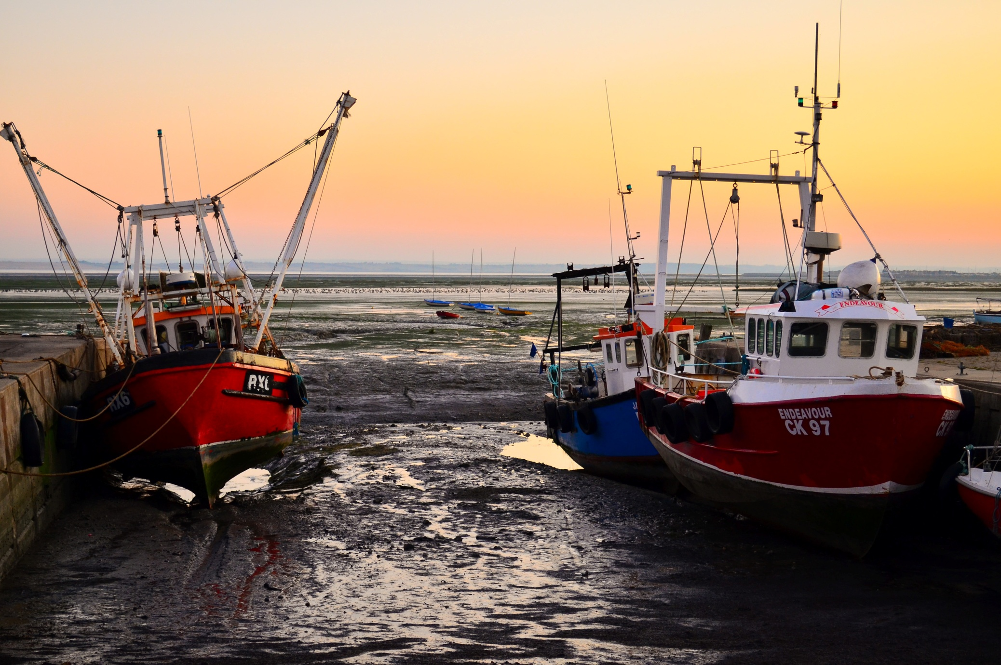
Photo courtesy of garryknight on Flickr
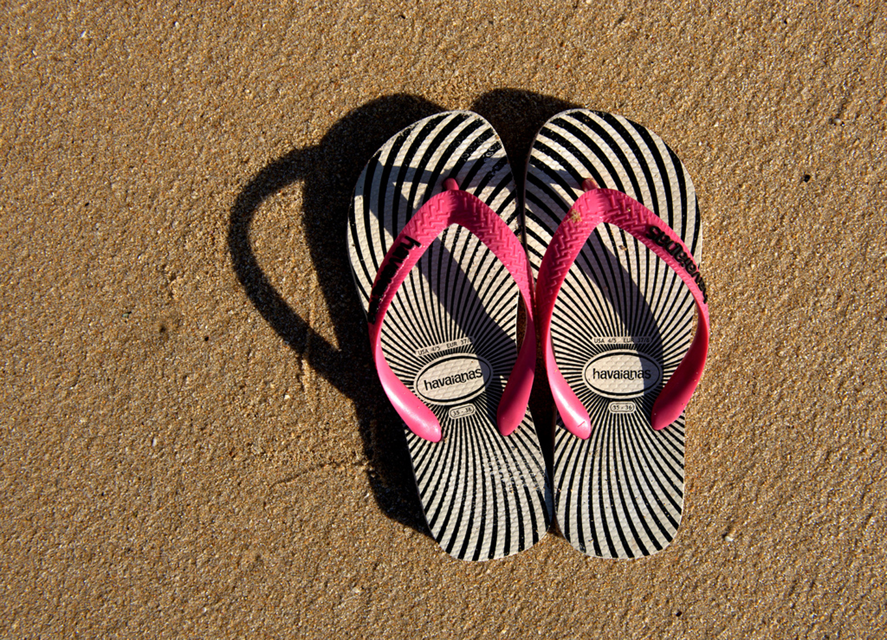

Photo courtesy of Johnny Jet on Flick
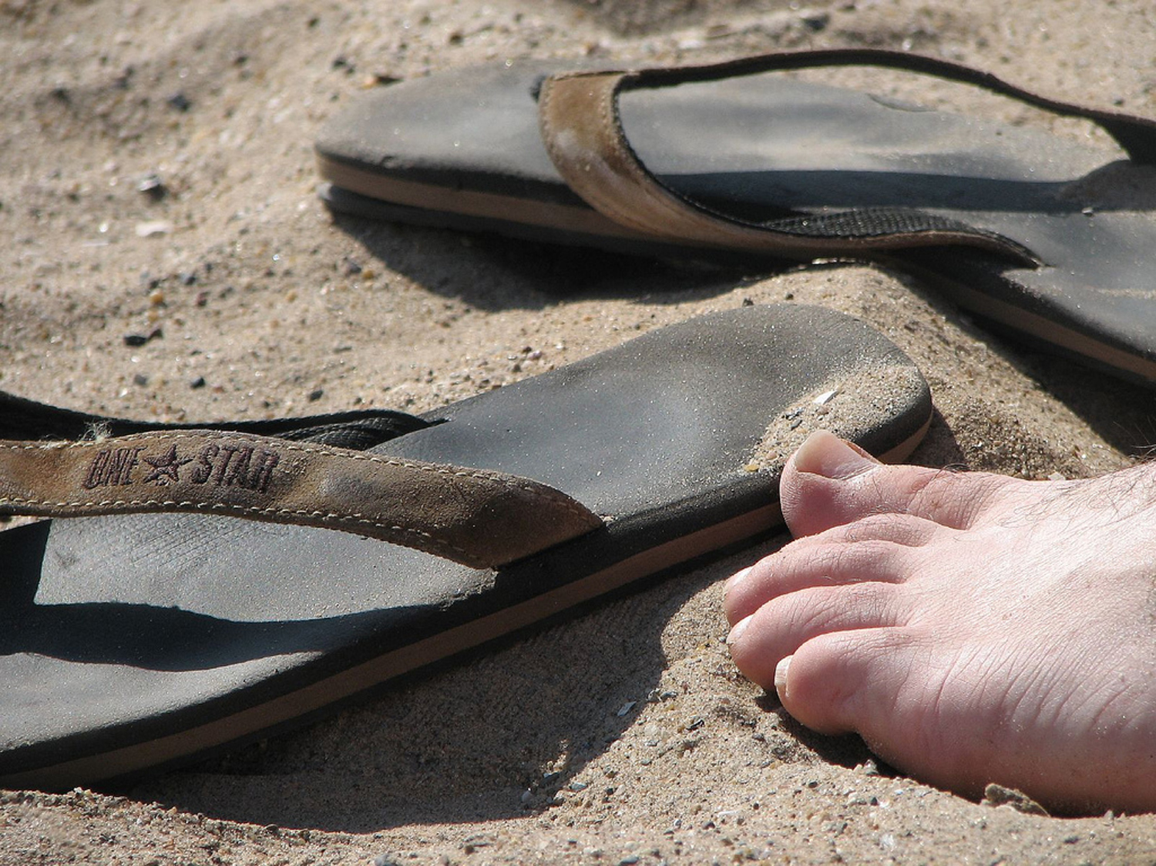

Photo courtesy of mrsporkchop on Flickr
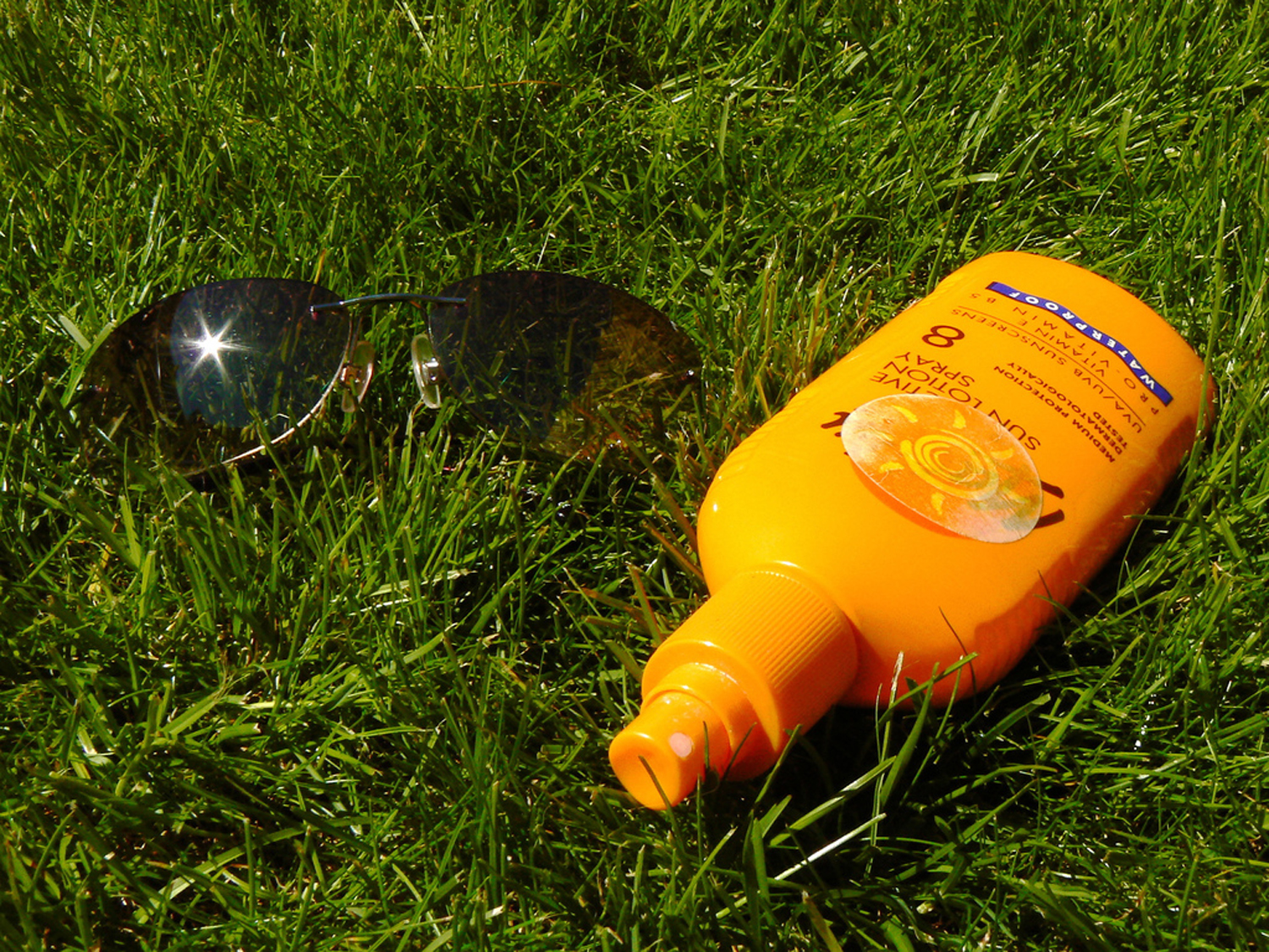

Photo courtesy of John Wardell (Netinho) on Flickr
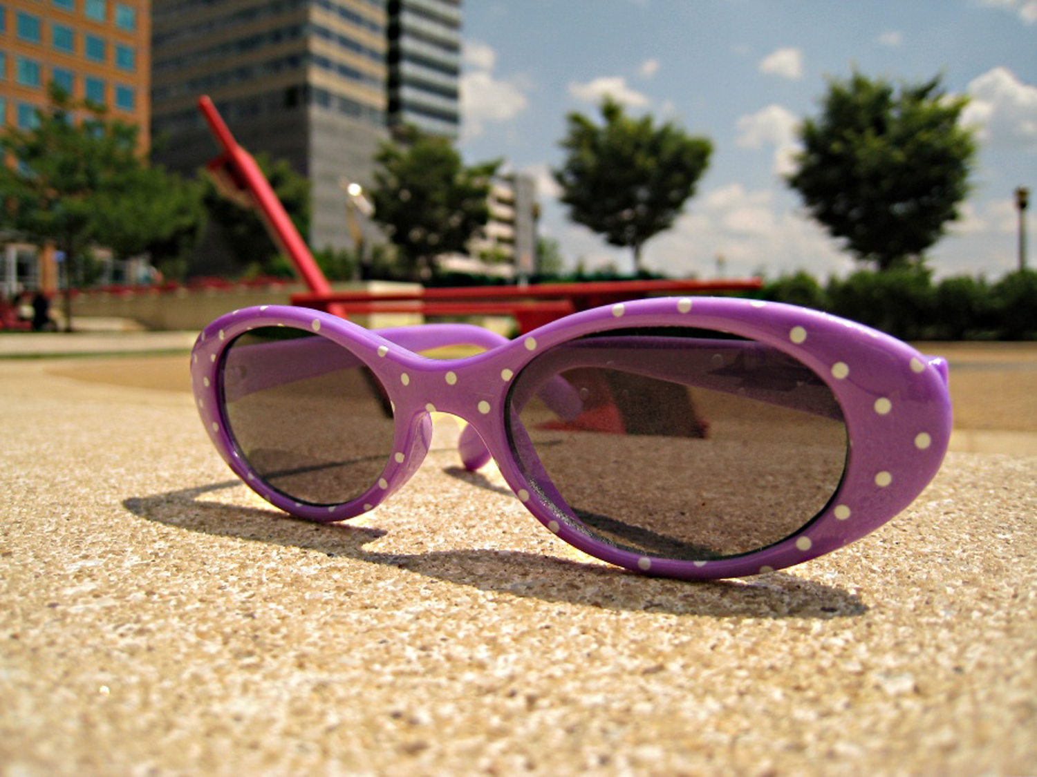

Photo courtesy of Jennuine Captures on Flickr
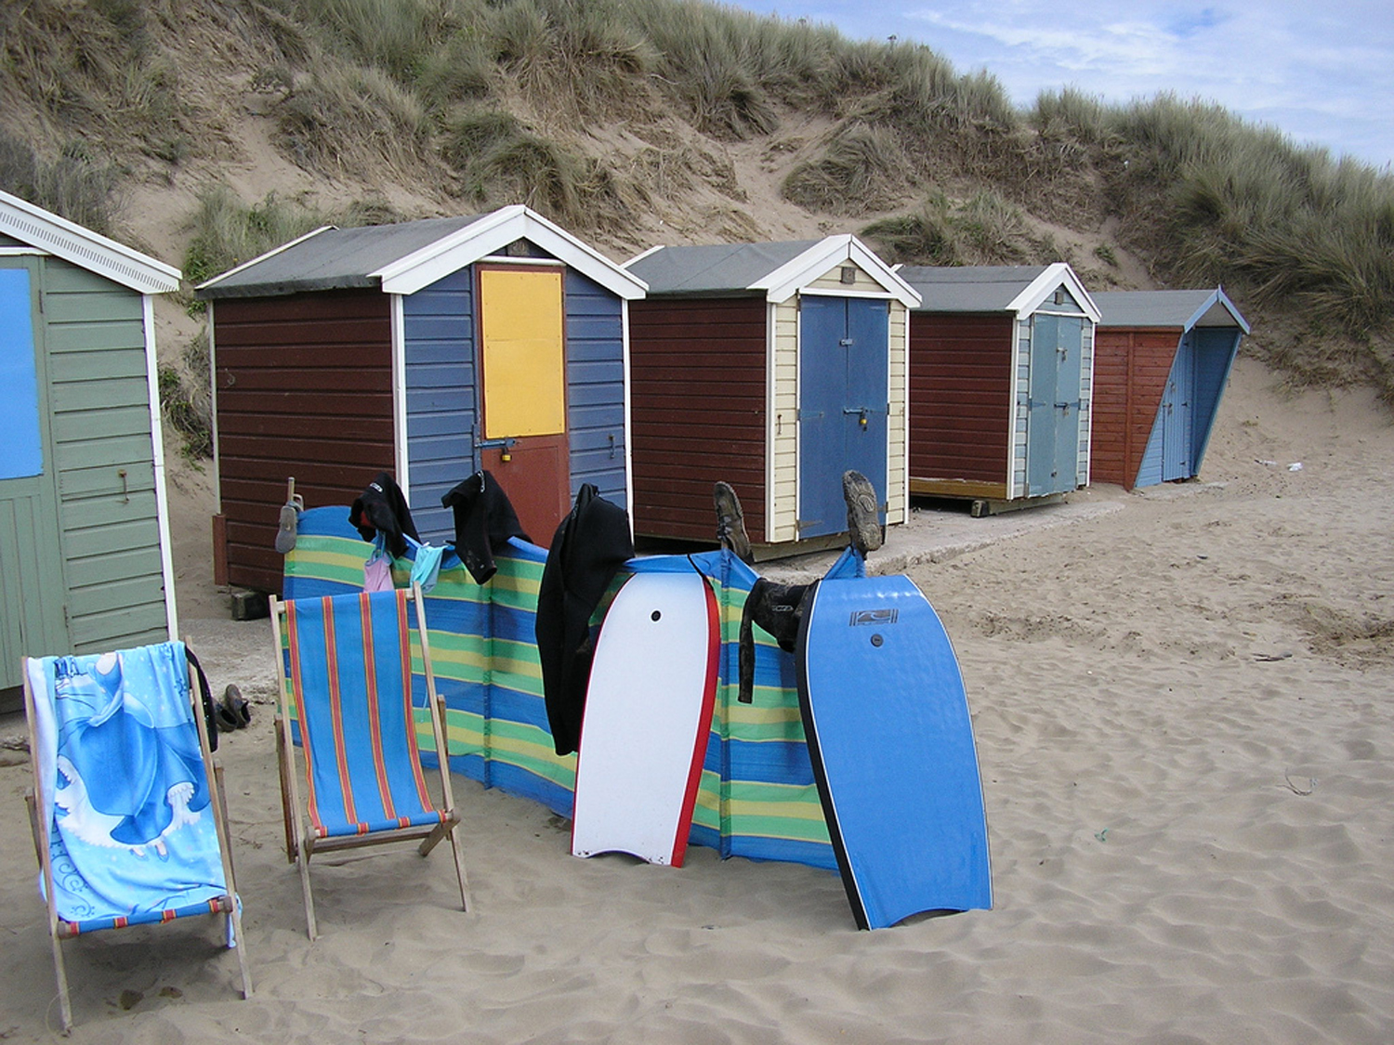

Photo courtesy of Markles55 on Flickr
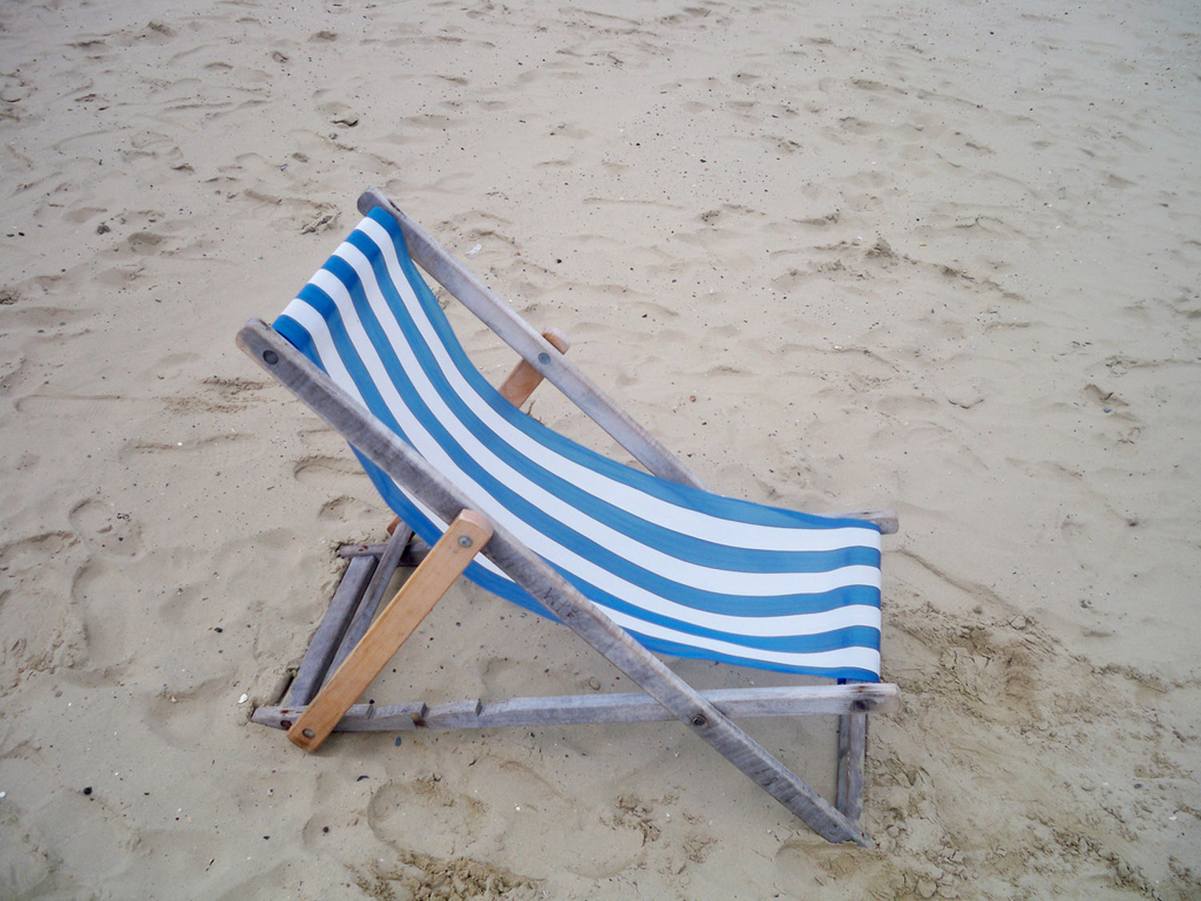

Photo courtesy of FutUndBeidl on Flickr
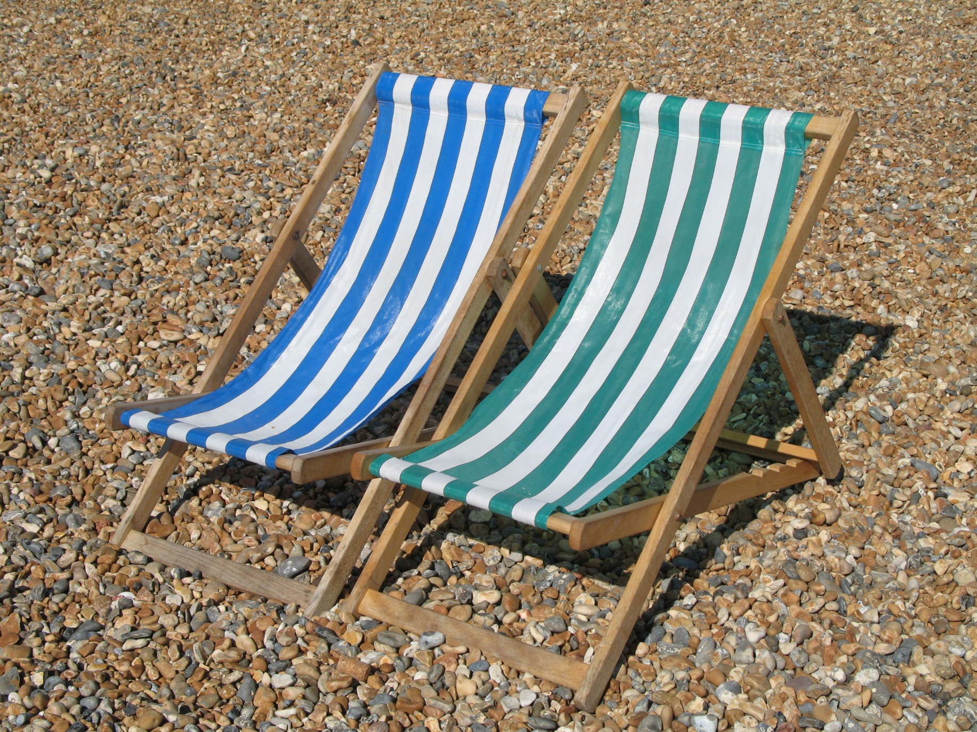

Photo courtesy of nataliej on Flickr
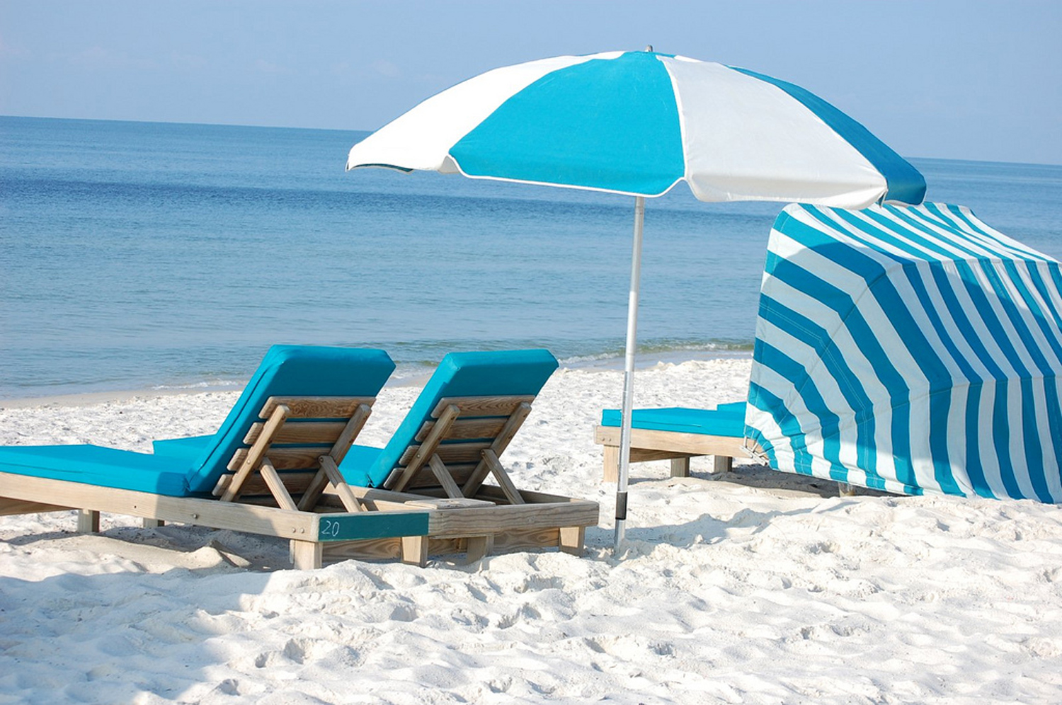
Photo courtesy of JM Taylor on Flickr
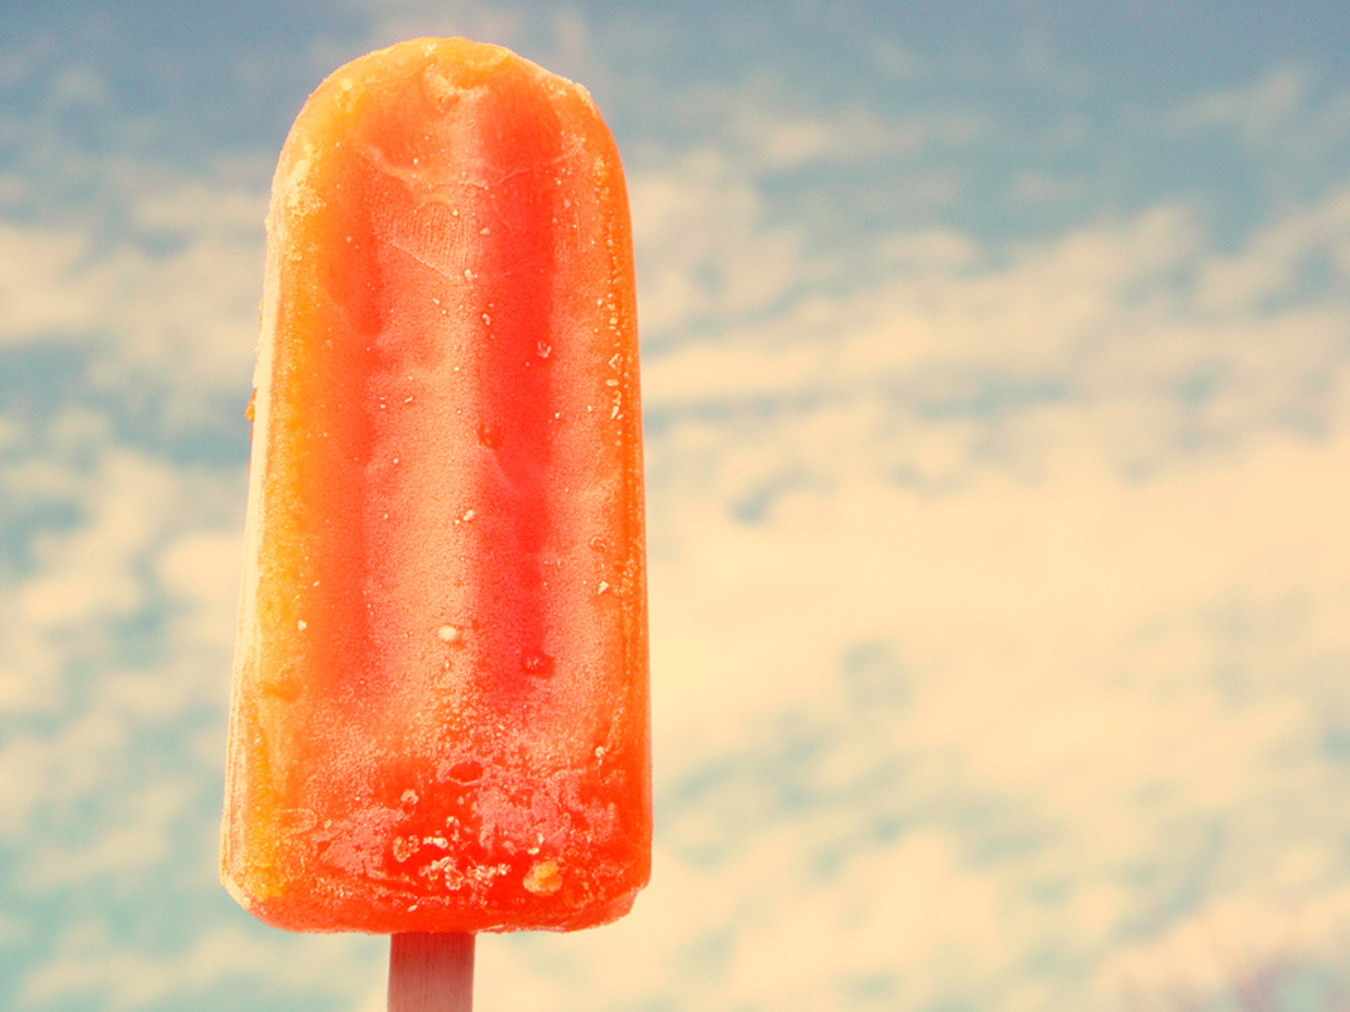

Photo courtesy of la on Flickr

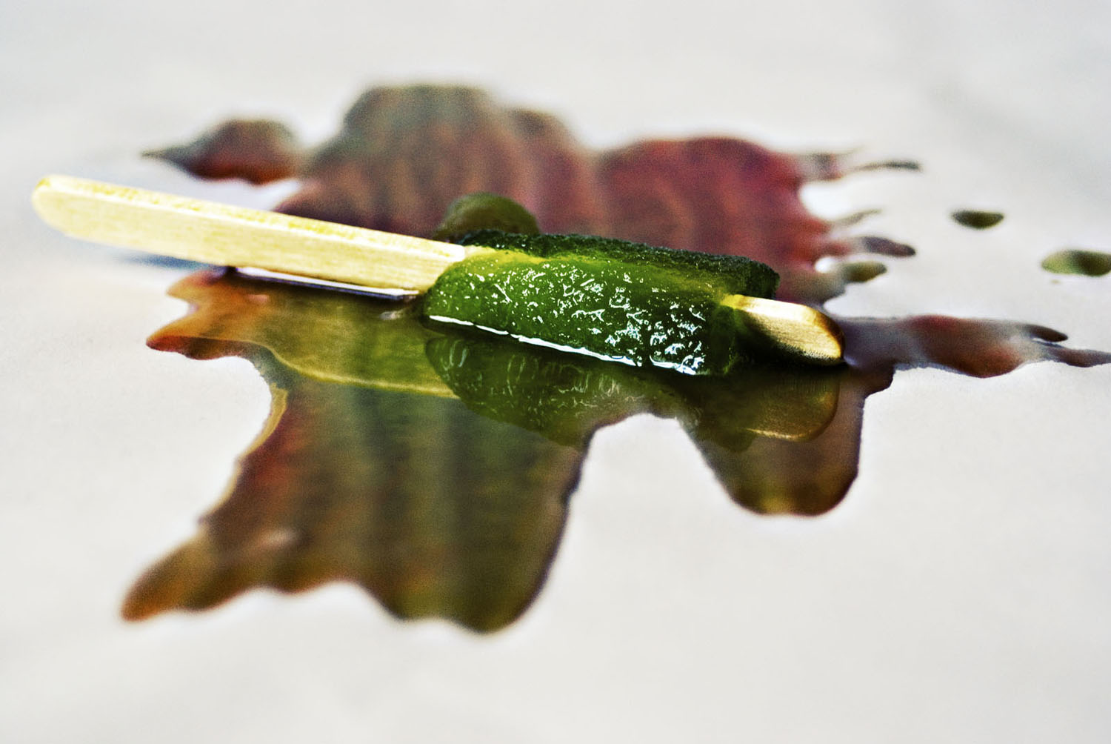
Photo courtesy of fras1977 on Flickr
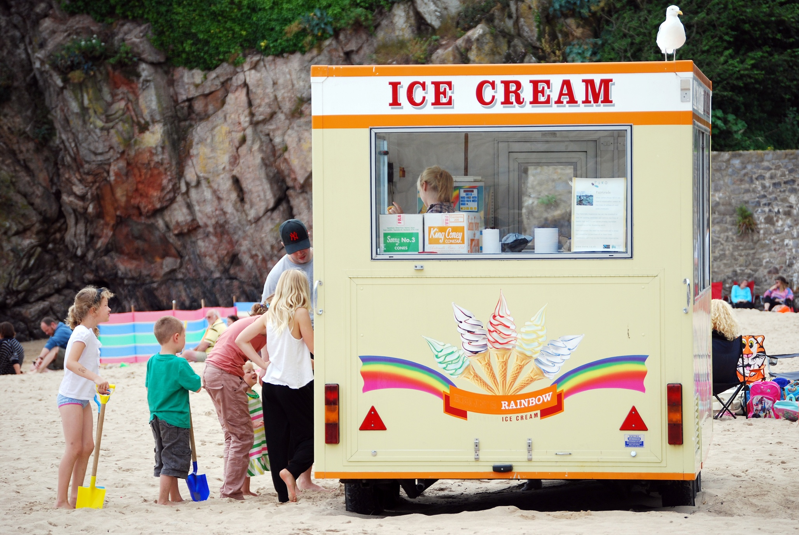
o courtesy of dachalan on Flickr
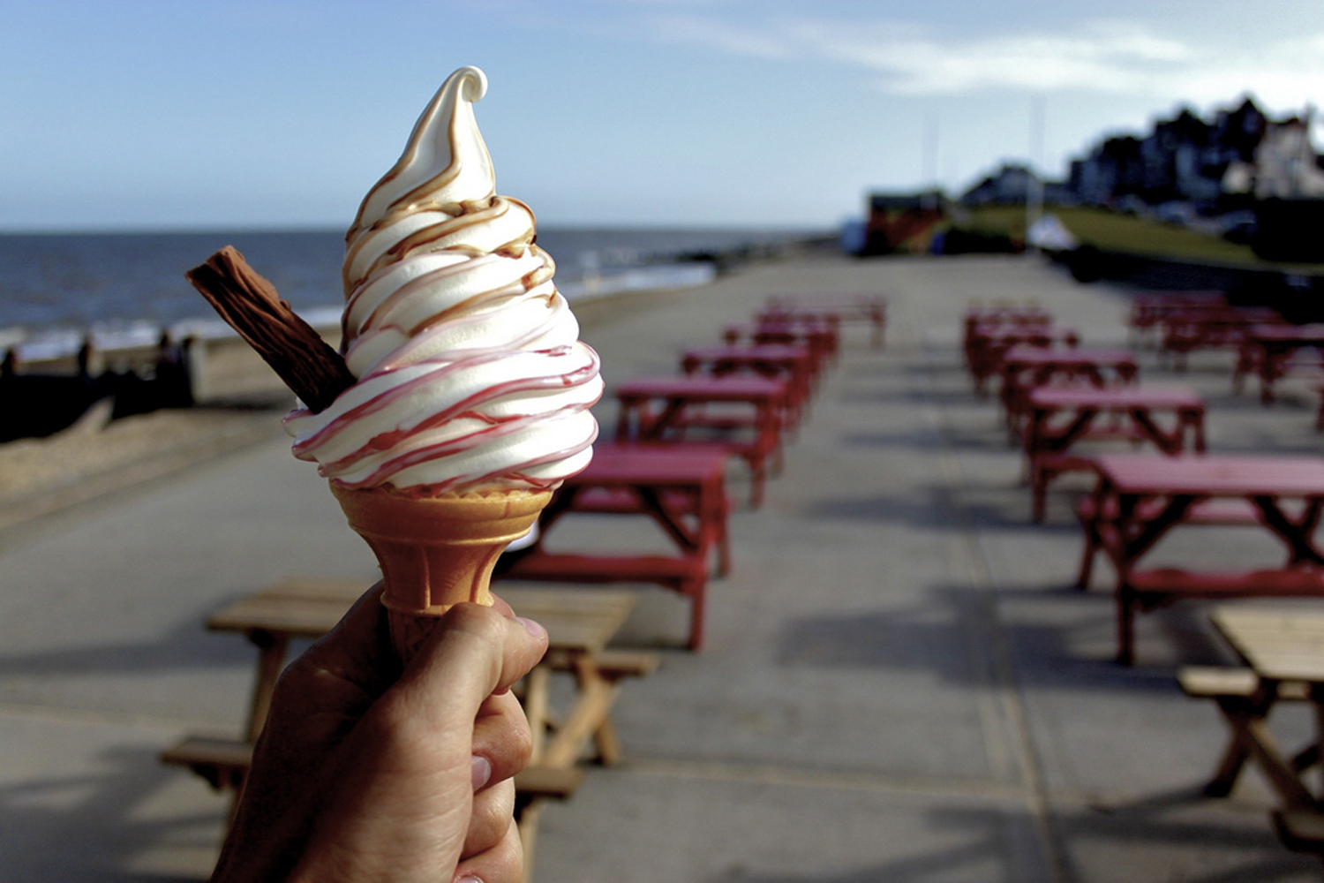
Photo courtesy of mrmanc on Flickr
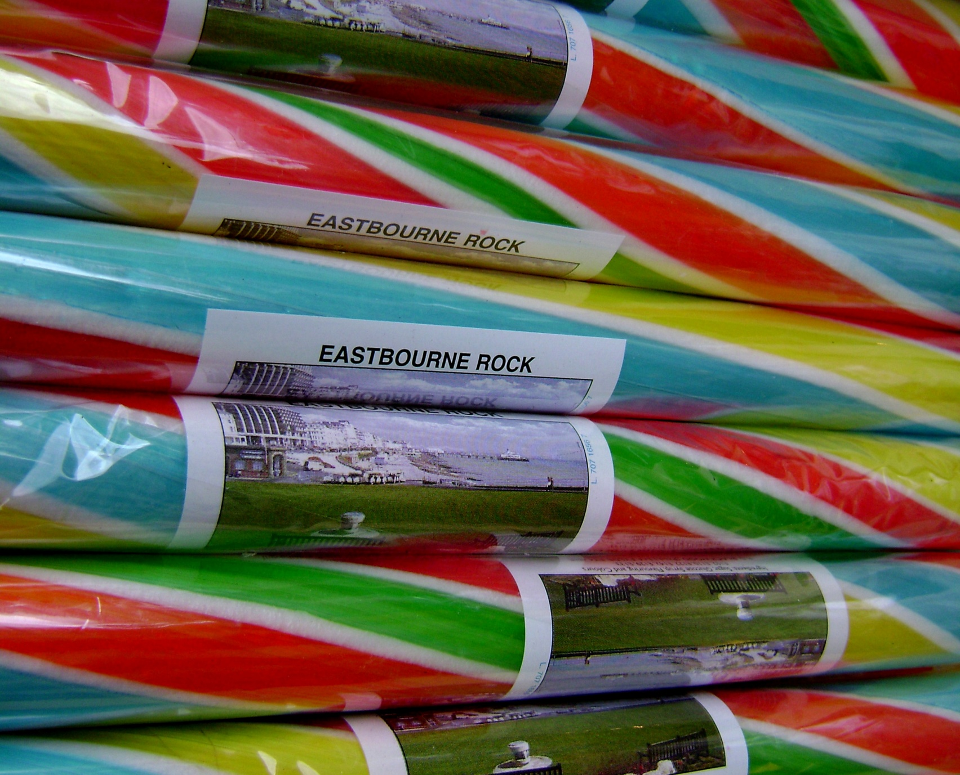

Photo courtesy of Sharon Hall Shipp on Flickr
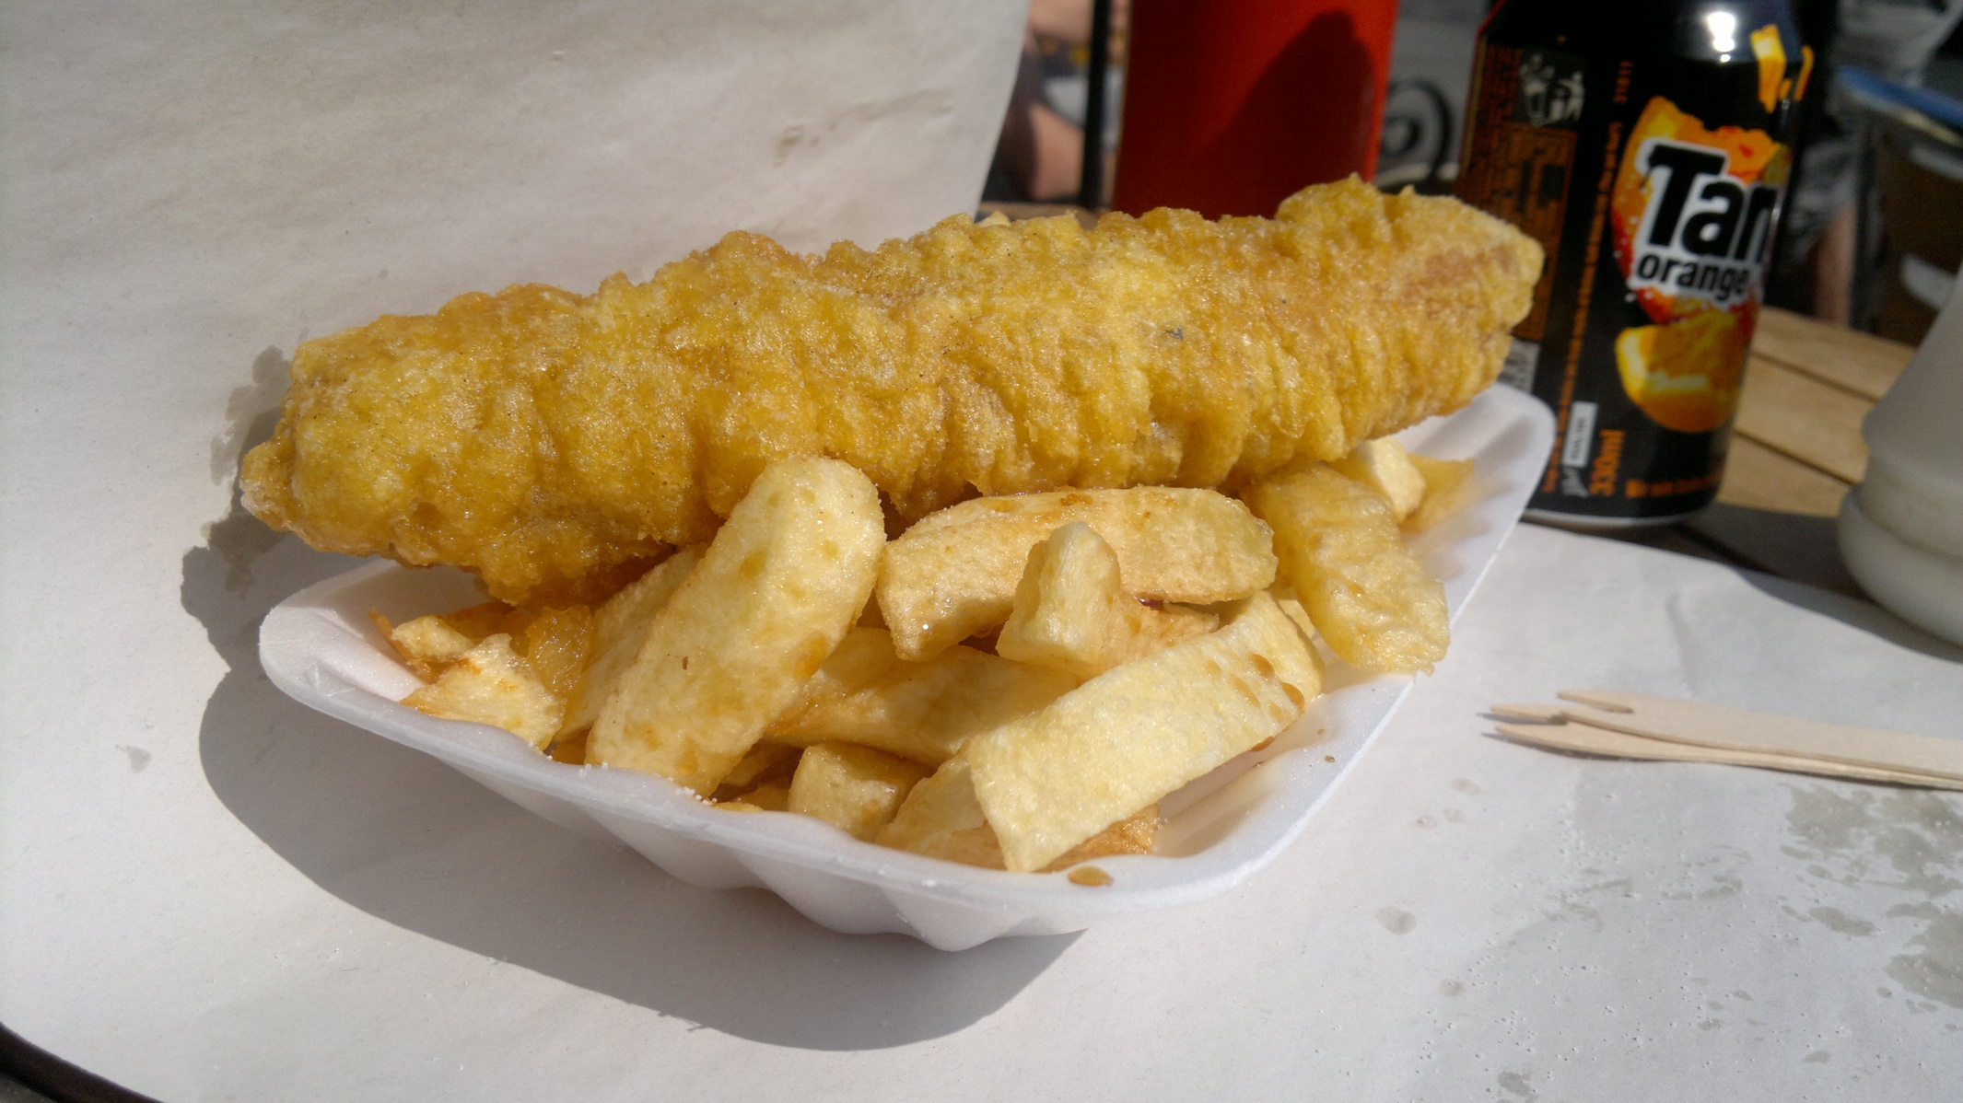
Photo courtesy of whatleydude on Flickr

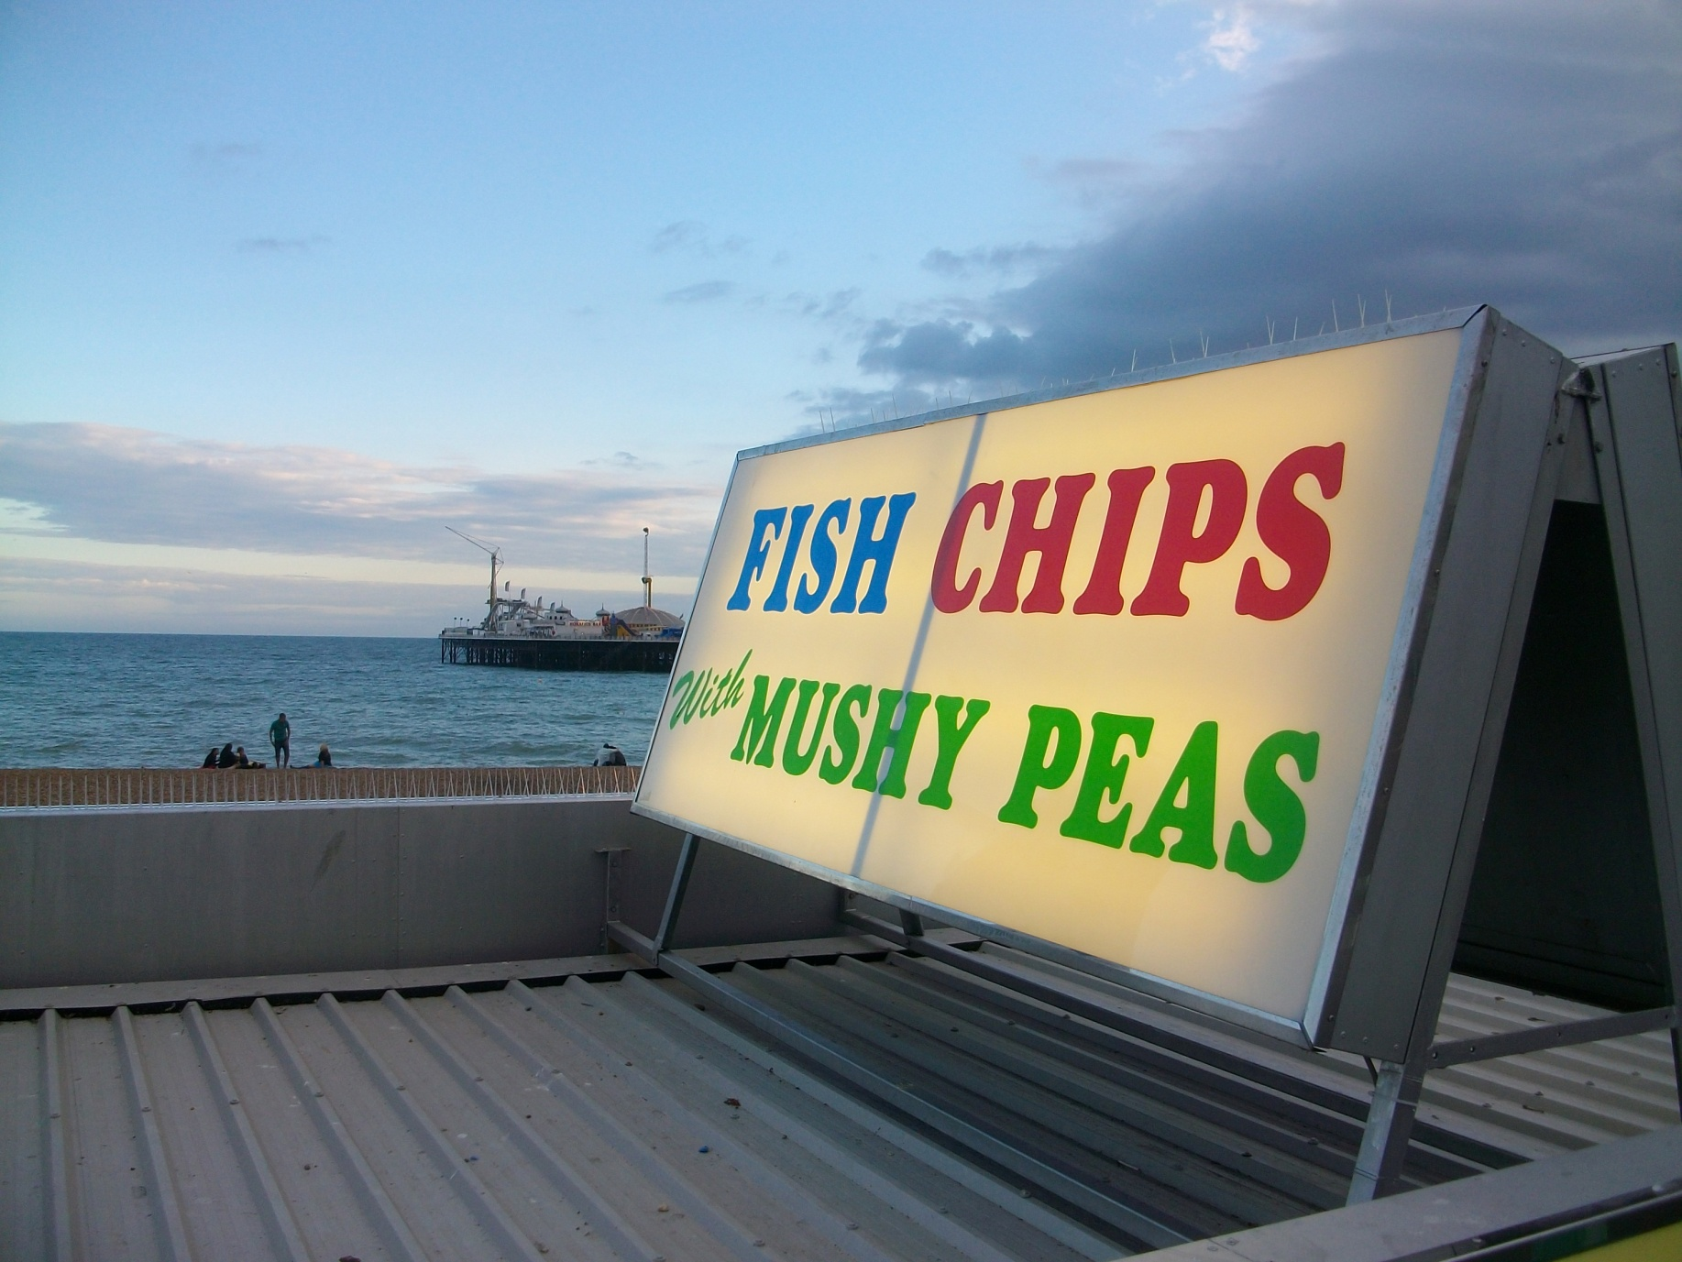

Photo courtesy of EEPaul on Flickr
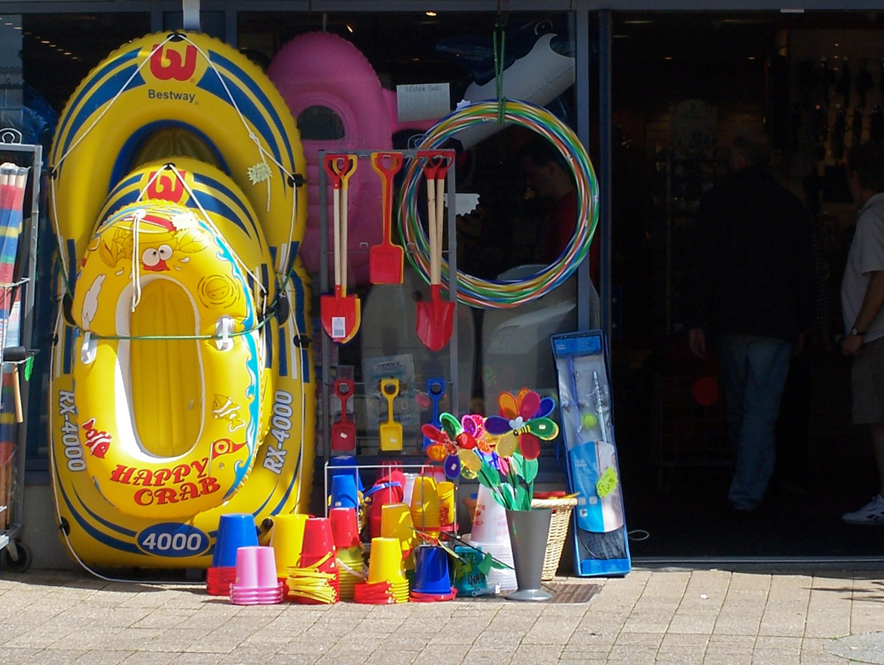

Photo courtesy of Dave Goodman on Flickr
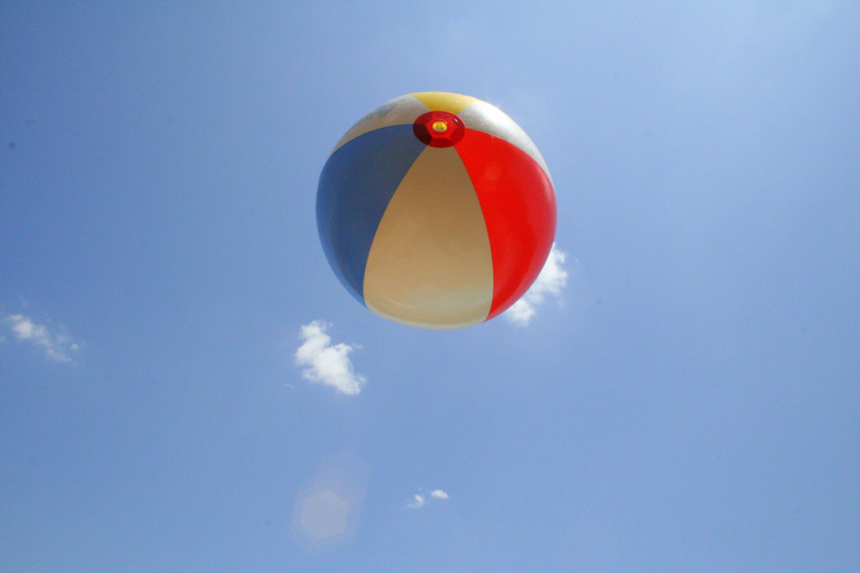
Photo courtesy of mfrascella on Flickr
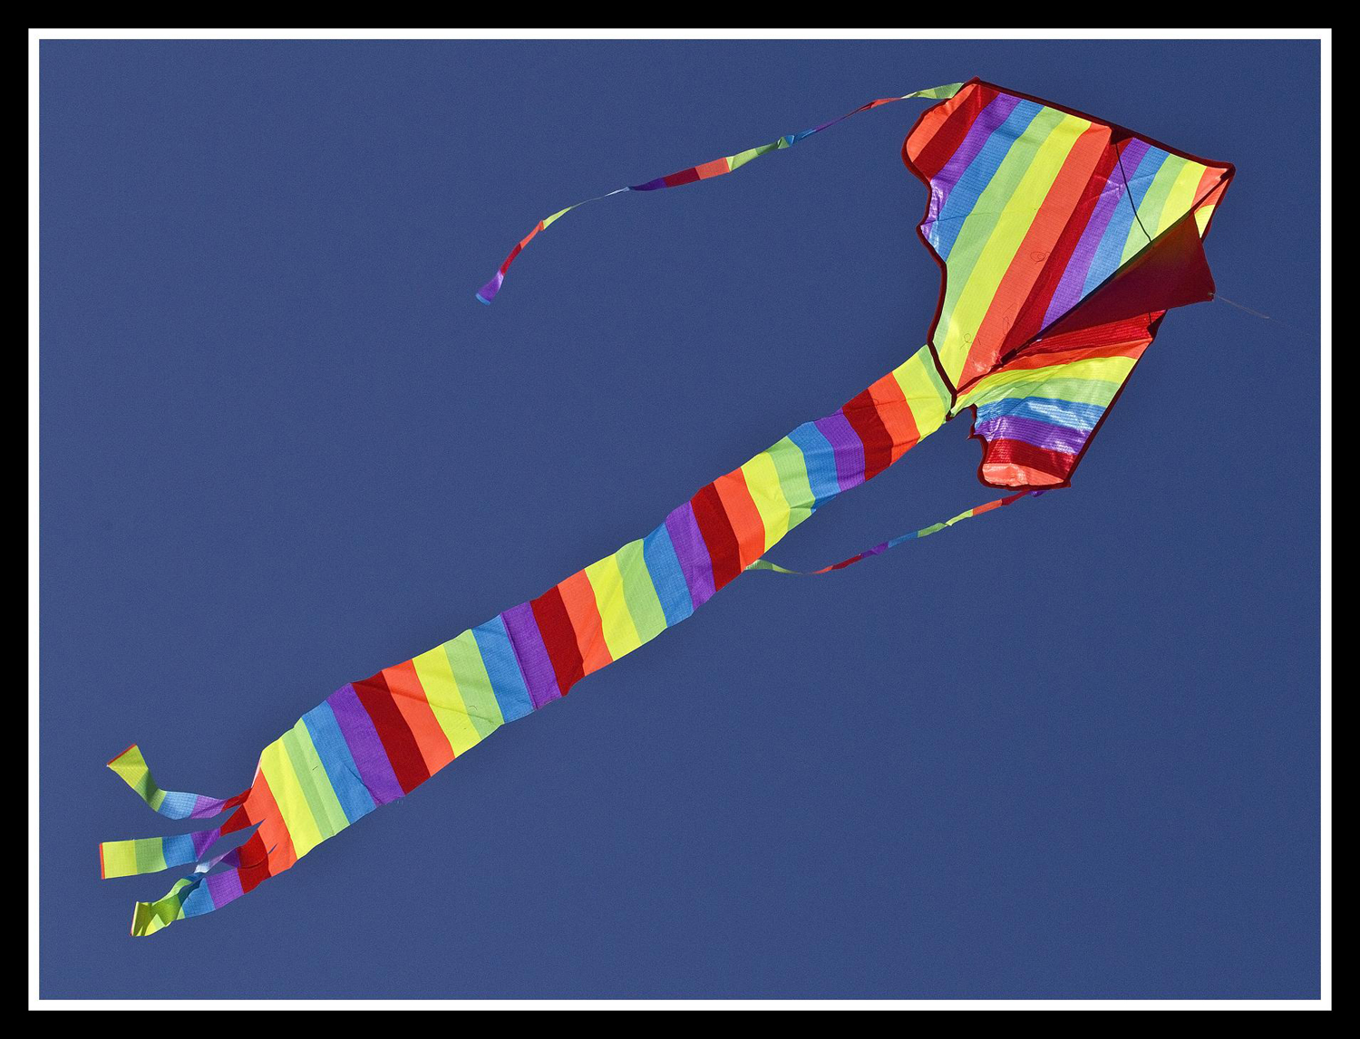

Photo courtesy of Sheba_Also on Flickr
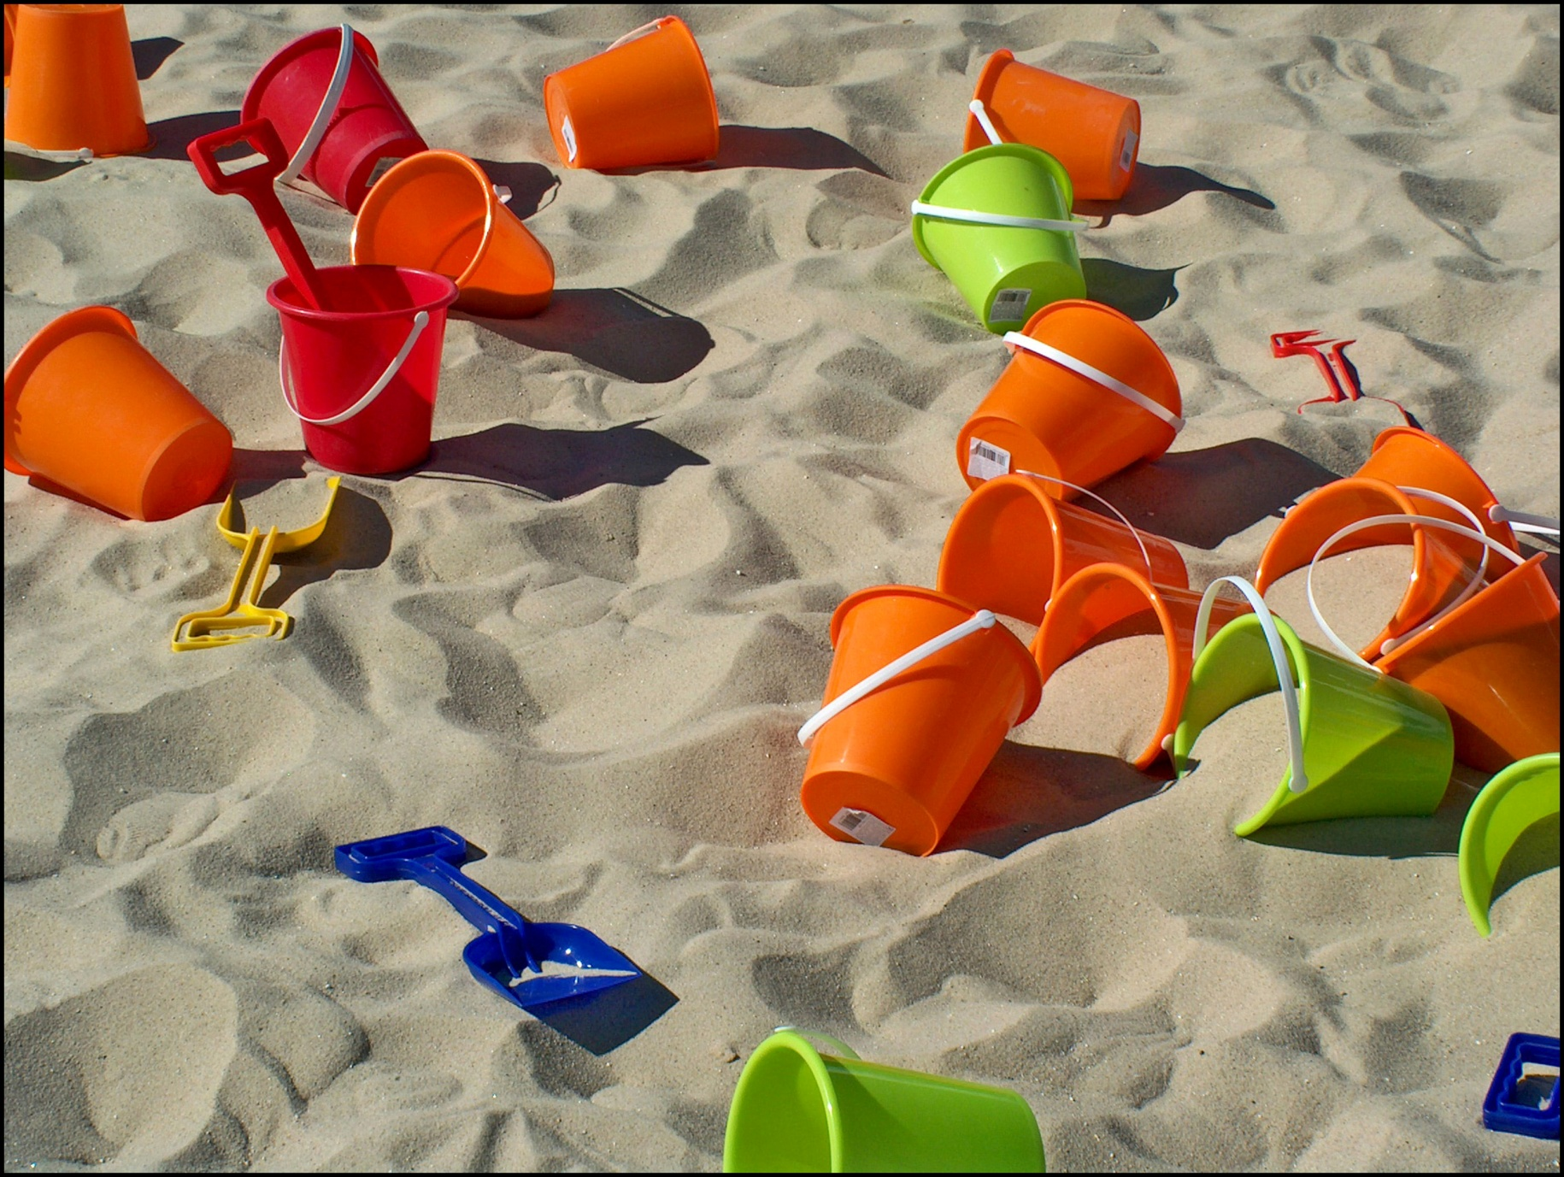

Photo courtesy of Flicktone on Flickr
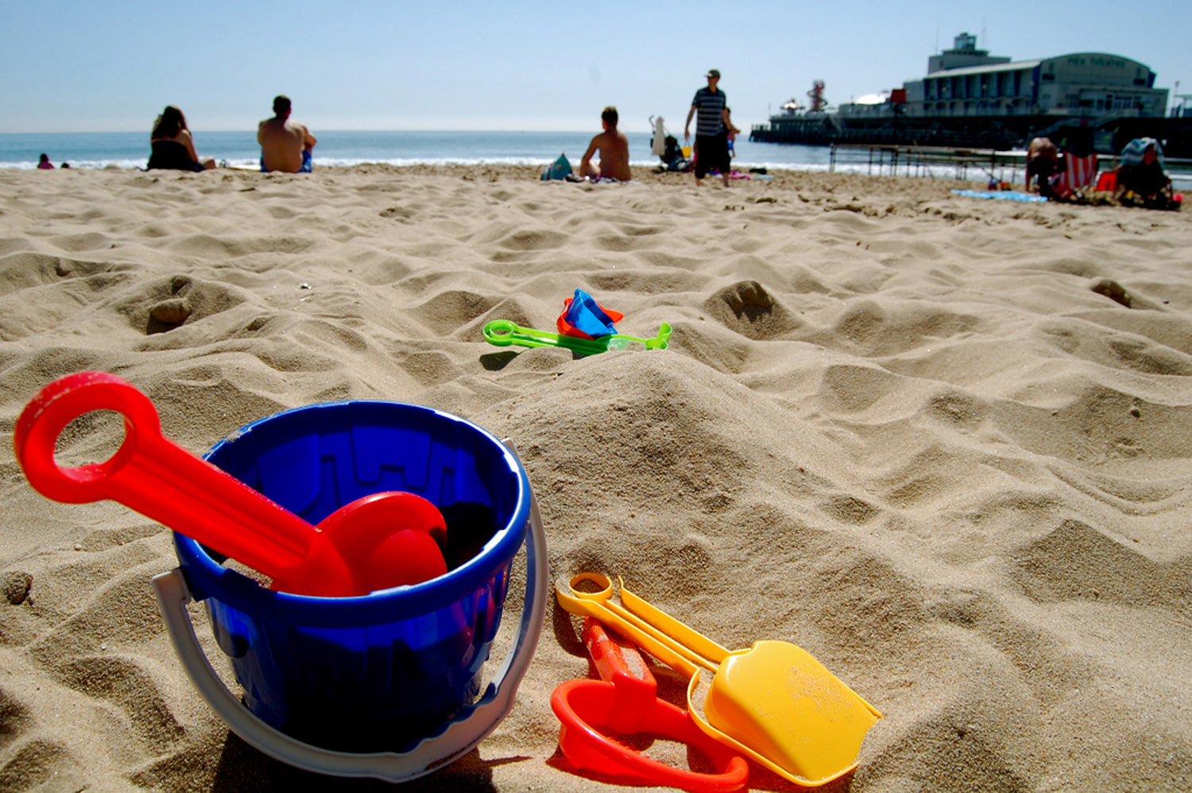
Photo courtesy of imcountingufoz on Flickr
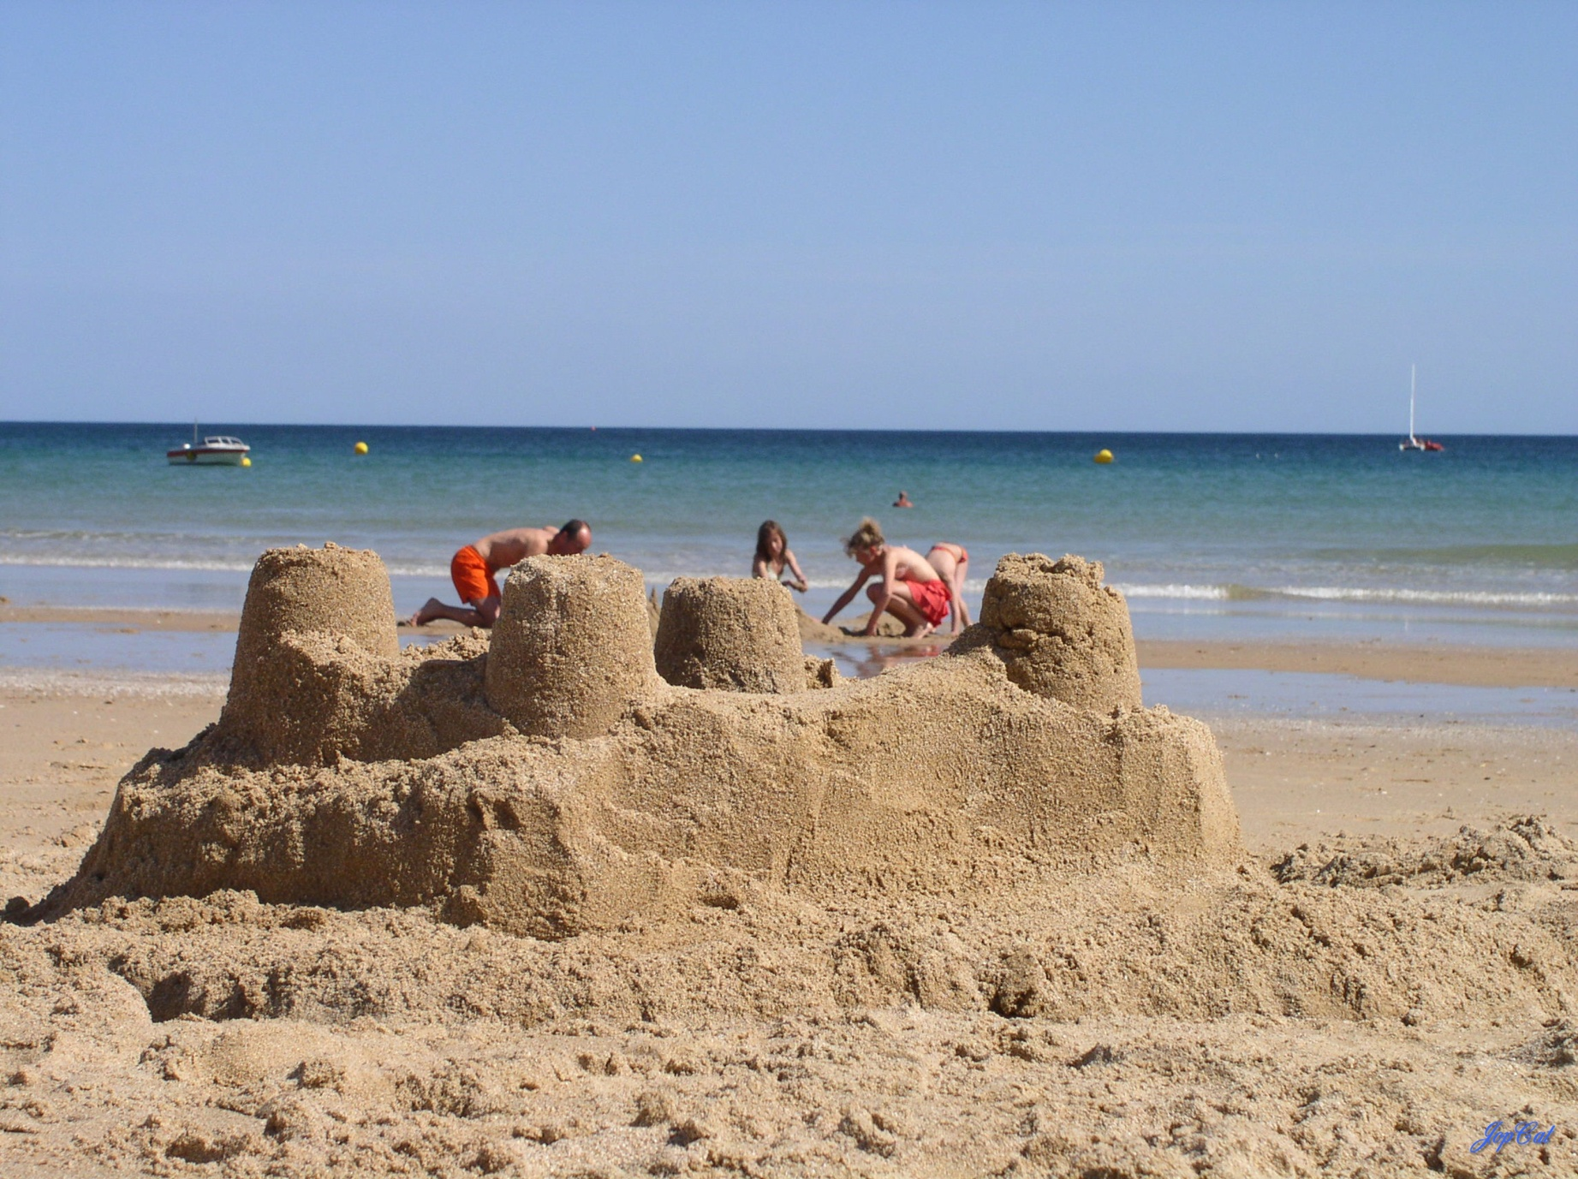

Photo courtesy of paral lax Â°) on Flickr
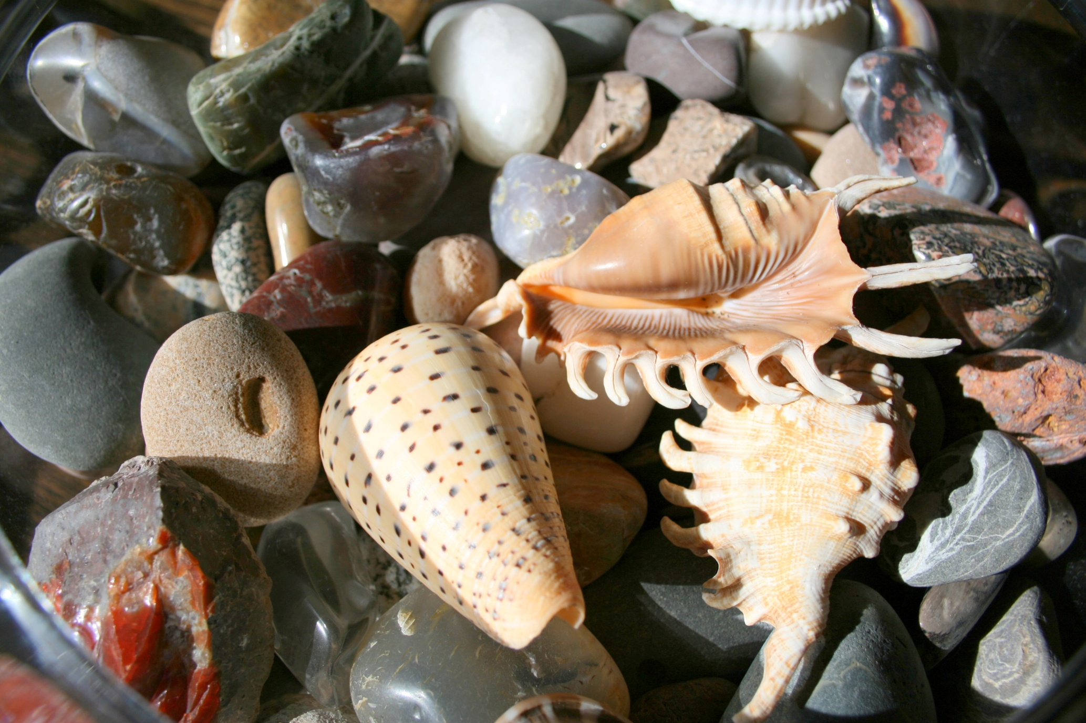
Photo courtesy of alasam on Flickr
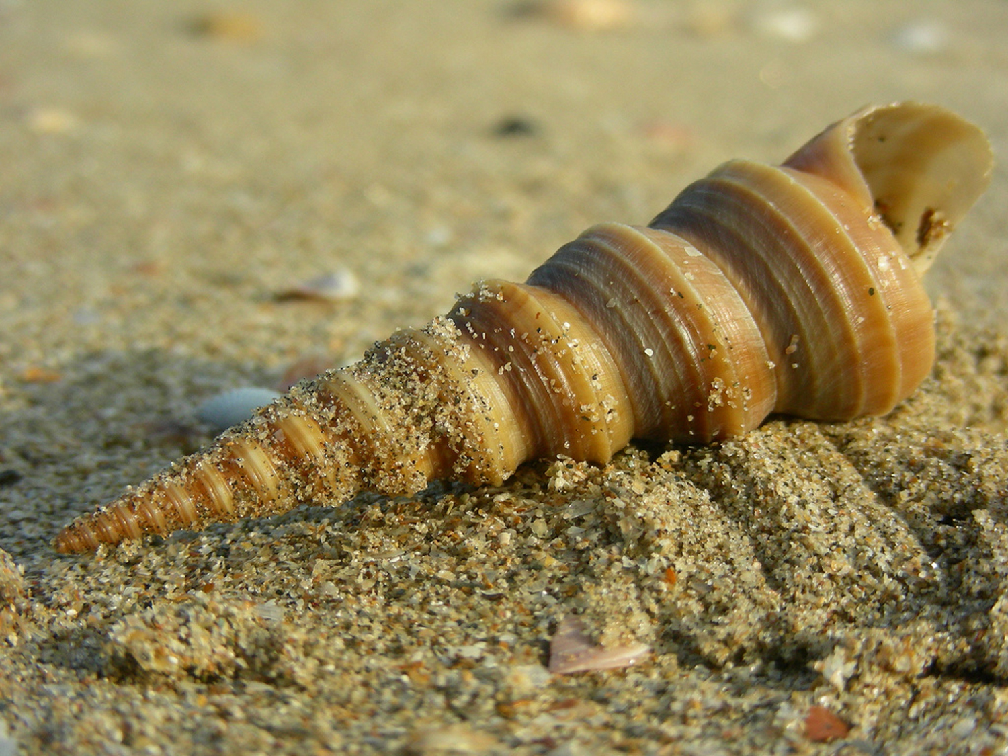

Photo courtesy of bavdeka on Flickr
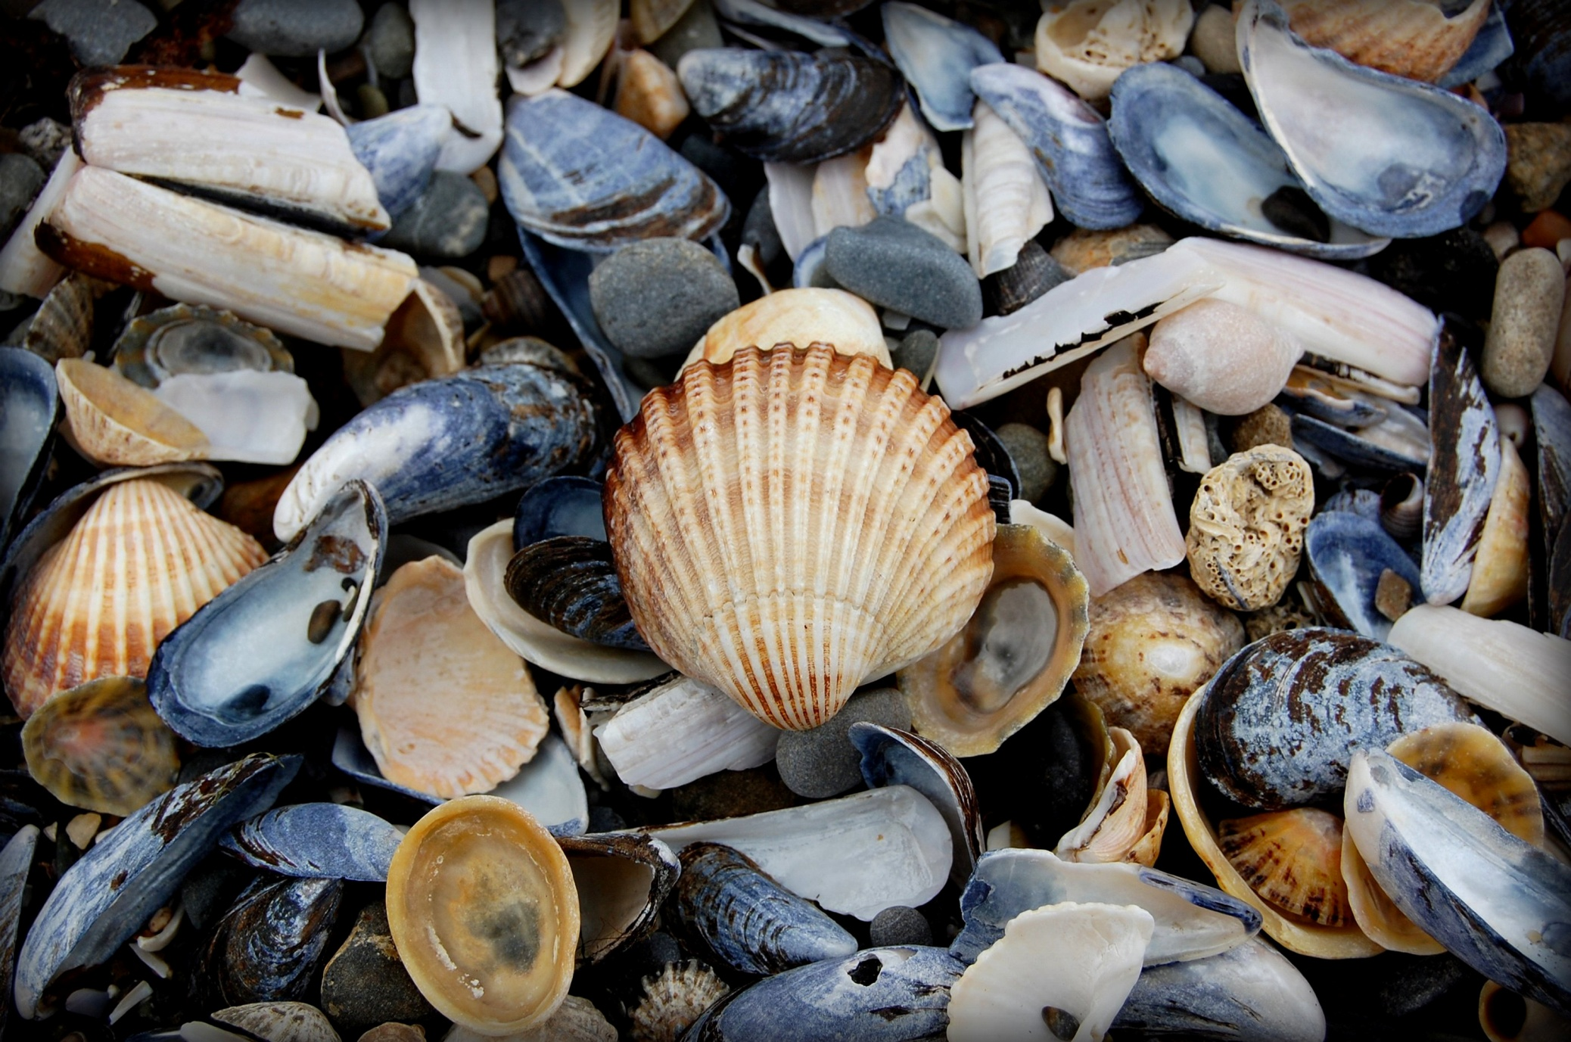
Photo courtesy of notspavin on Flickr
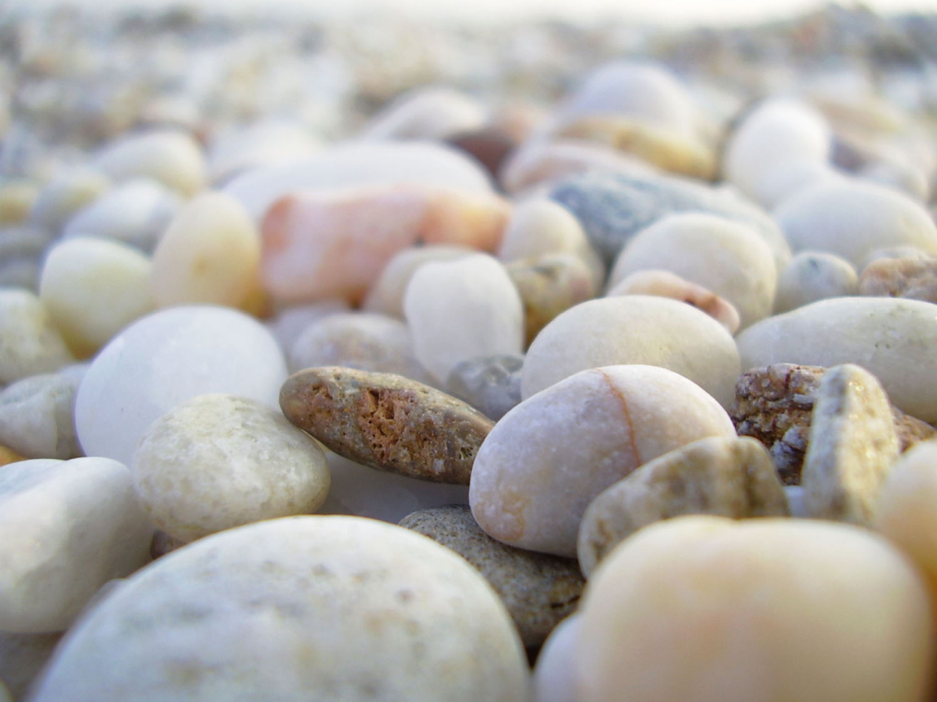

Photo courtesy of tamburix on Flickr
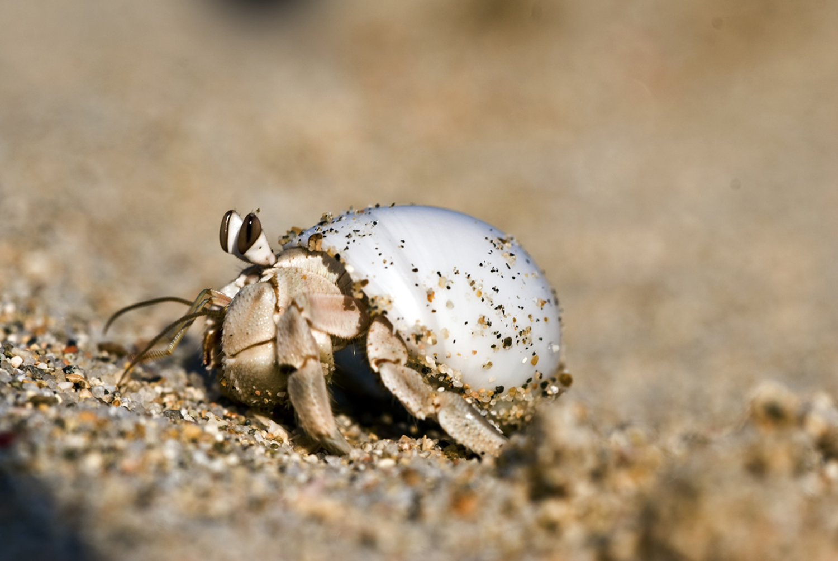
Photo courtesy of dtrimarchi on Flickr
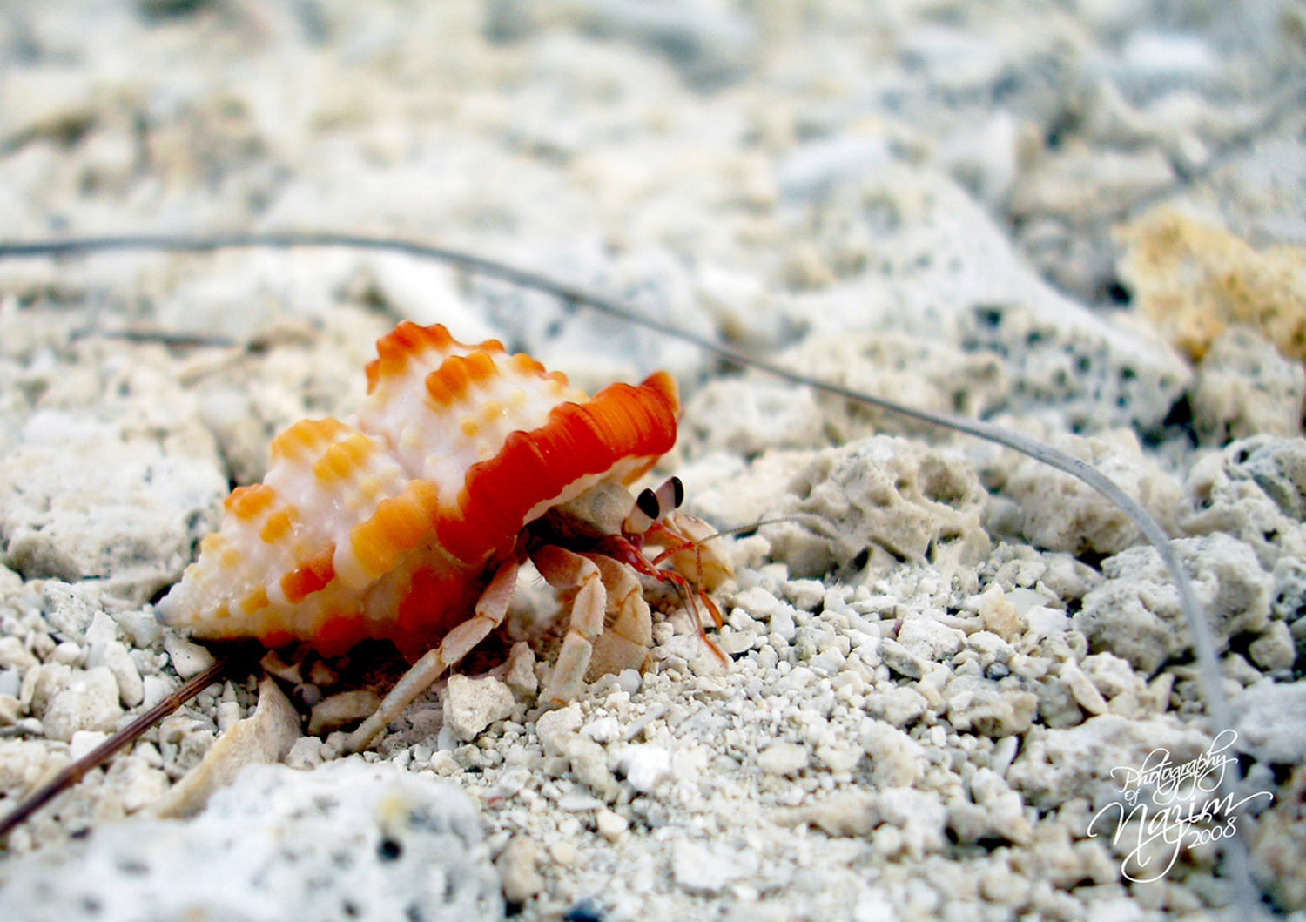

Photo courtesy of GraveBone on Flickr
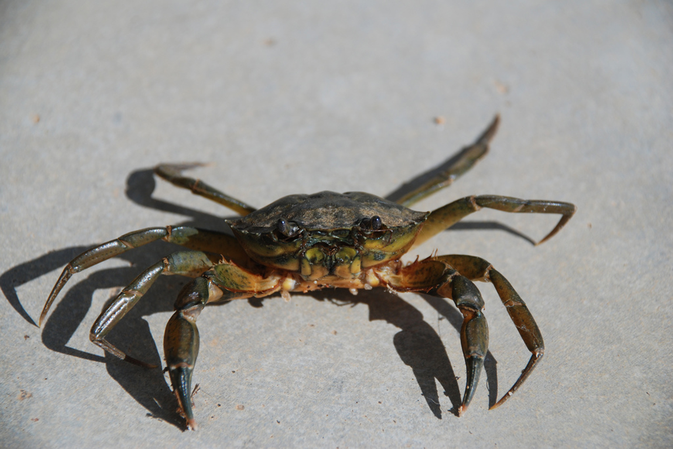
Photo courtesy of matley0 on Flickr
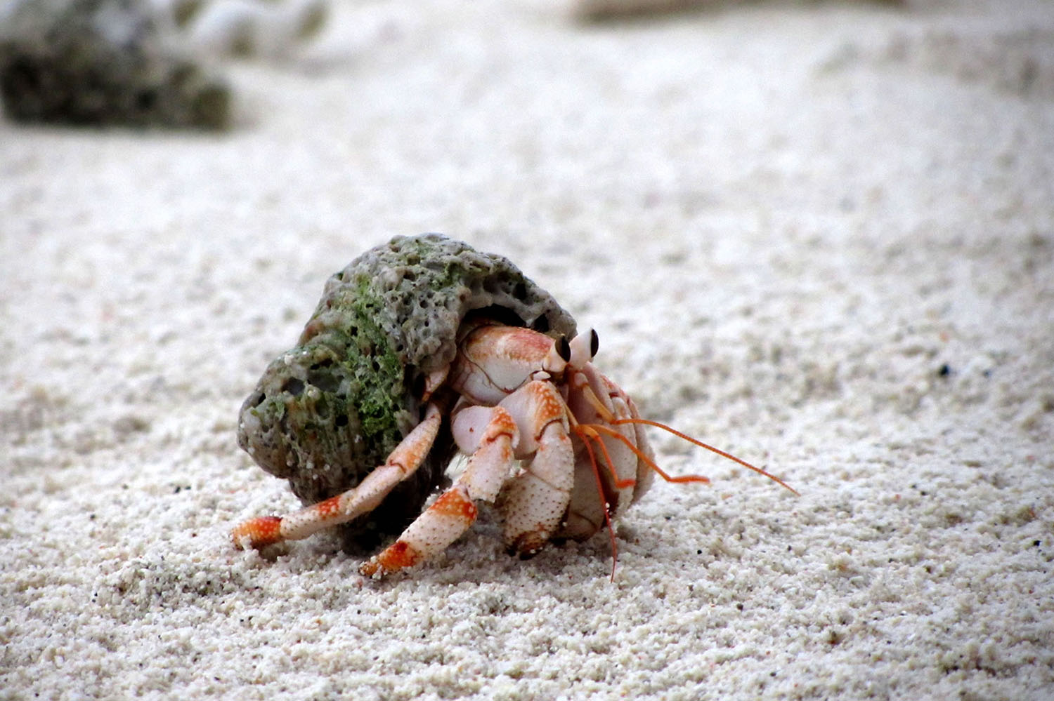

Photo courtesy of warrenski on Flickr

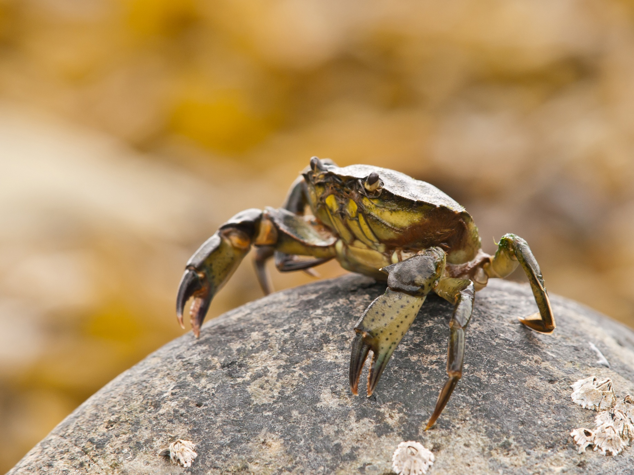

Photo courtesy of wwarby on Flickr
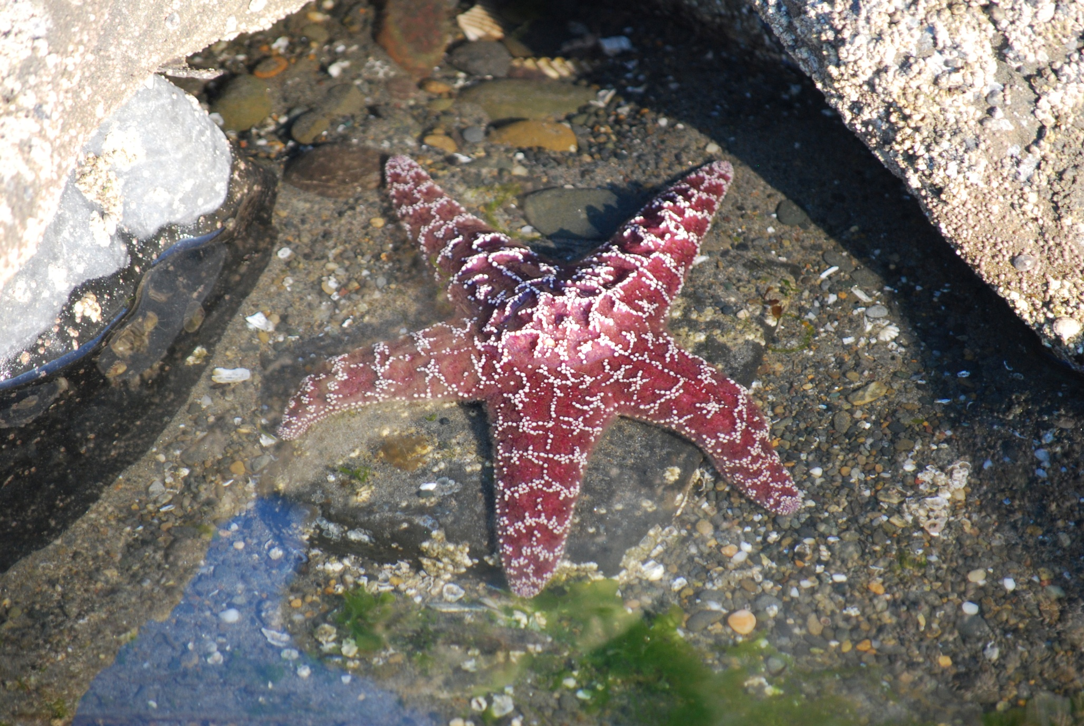
Photo courtesy of GD Taber on Flickr
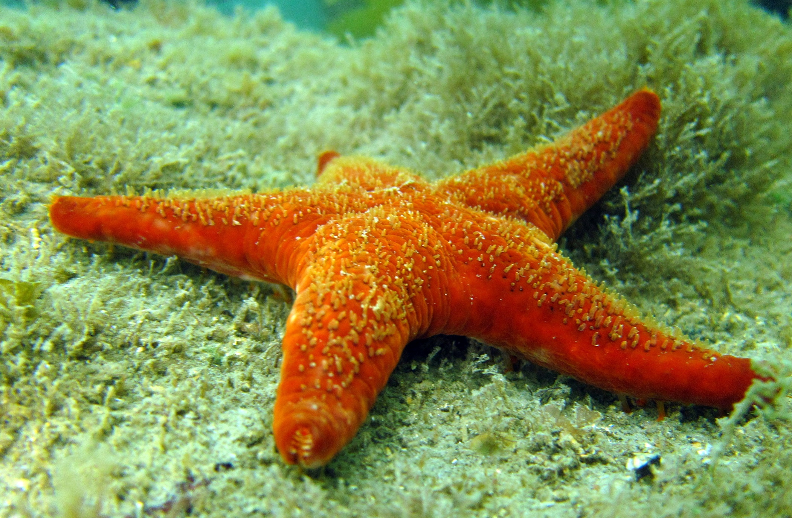
Photo courtesy of Saspotato on Flickr
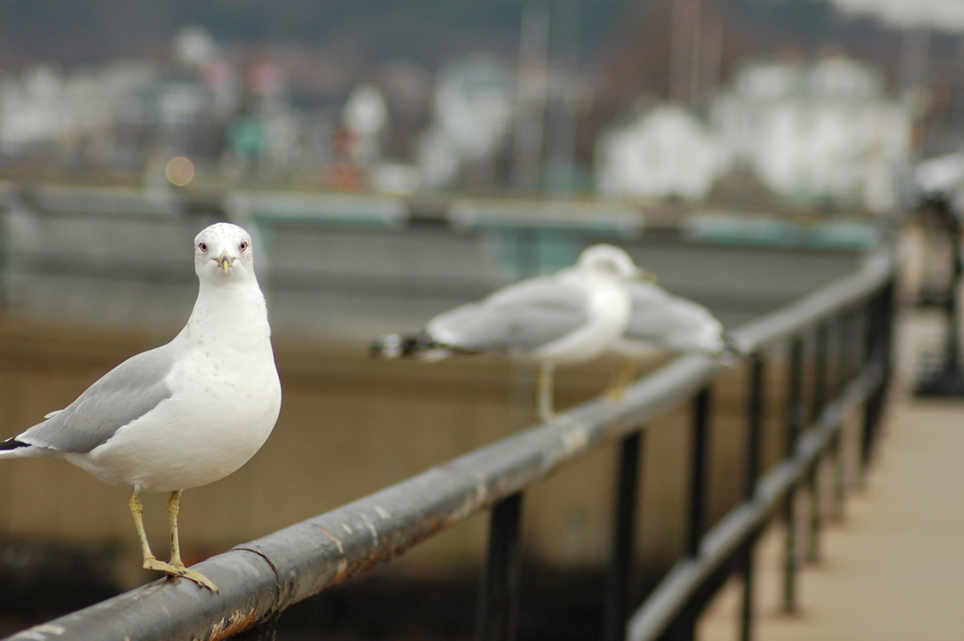
Photo courtesy of kicksave2930 on Flickr
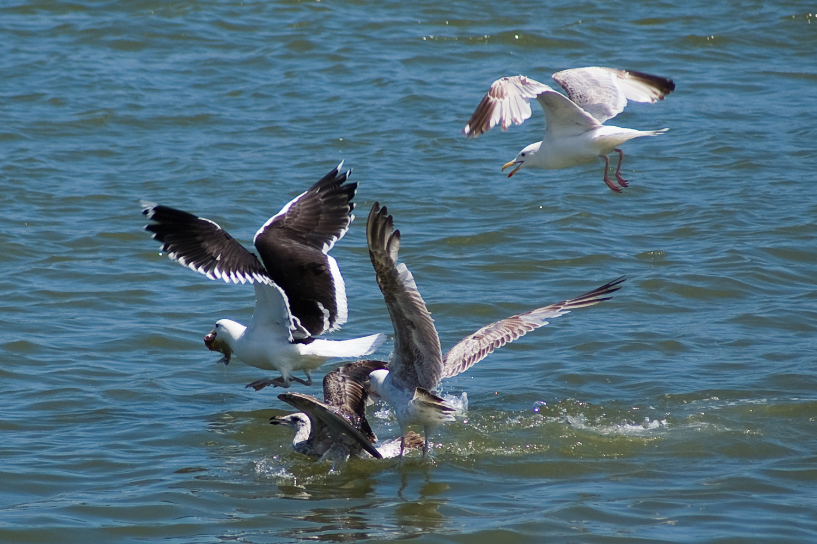

Photo courtesy of Valerian Gaudeau on Flickr

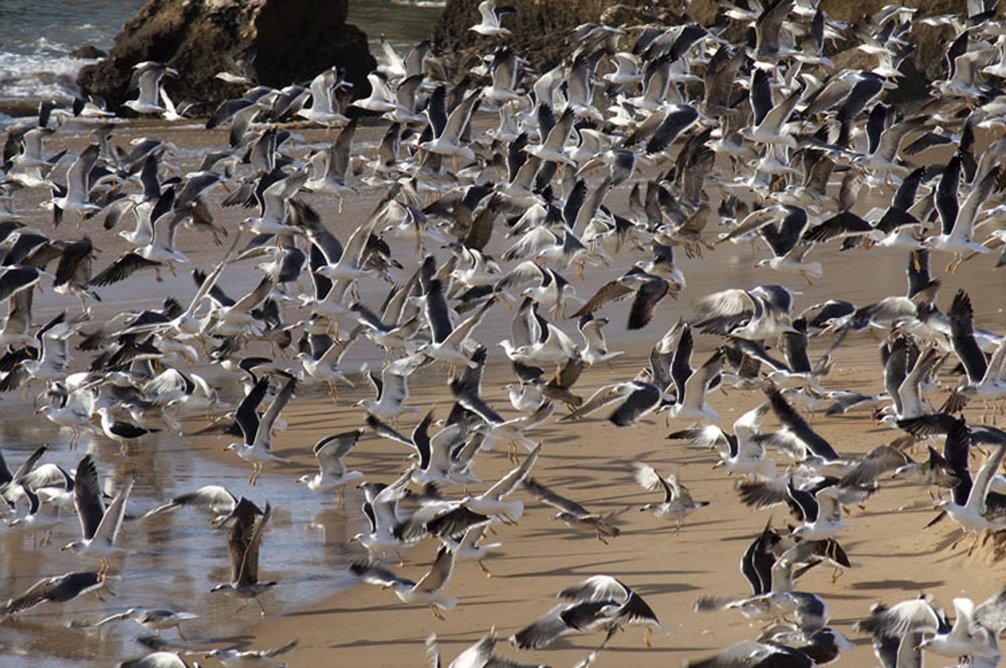

Photo courtesy of VitÃ³ on Flickr

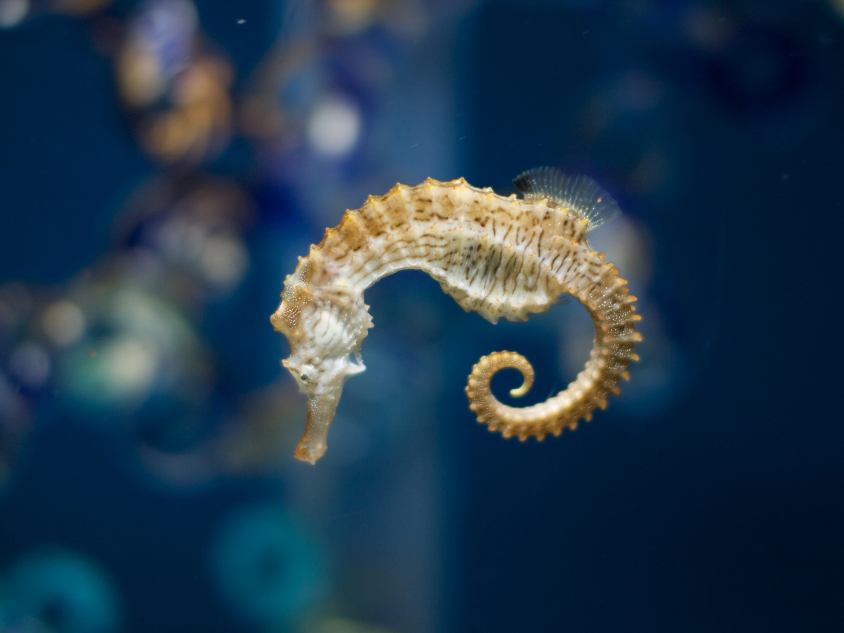

Photo courtesy of shellac on Flickr
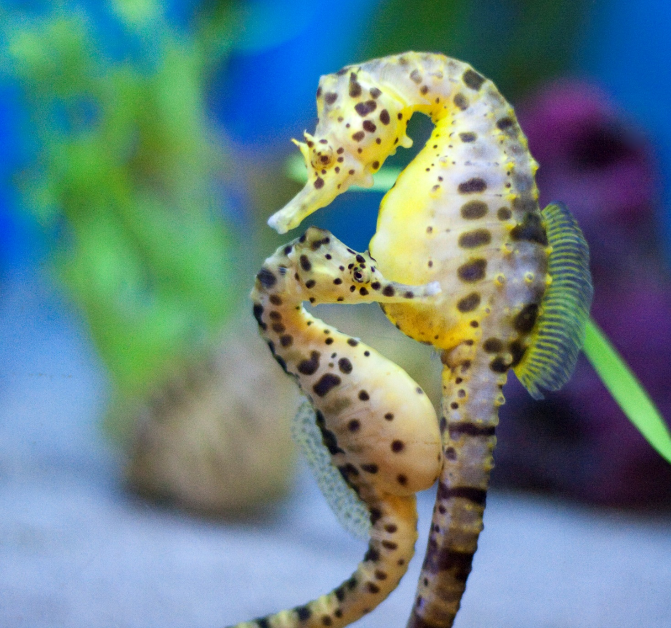

Photo courtesy of San Diego Shooter on Flickr
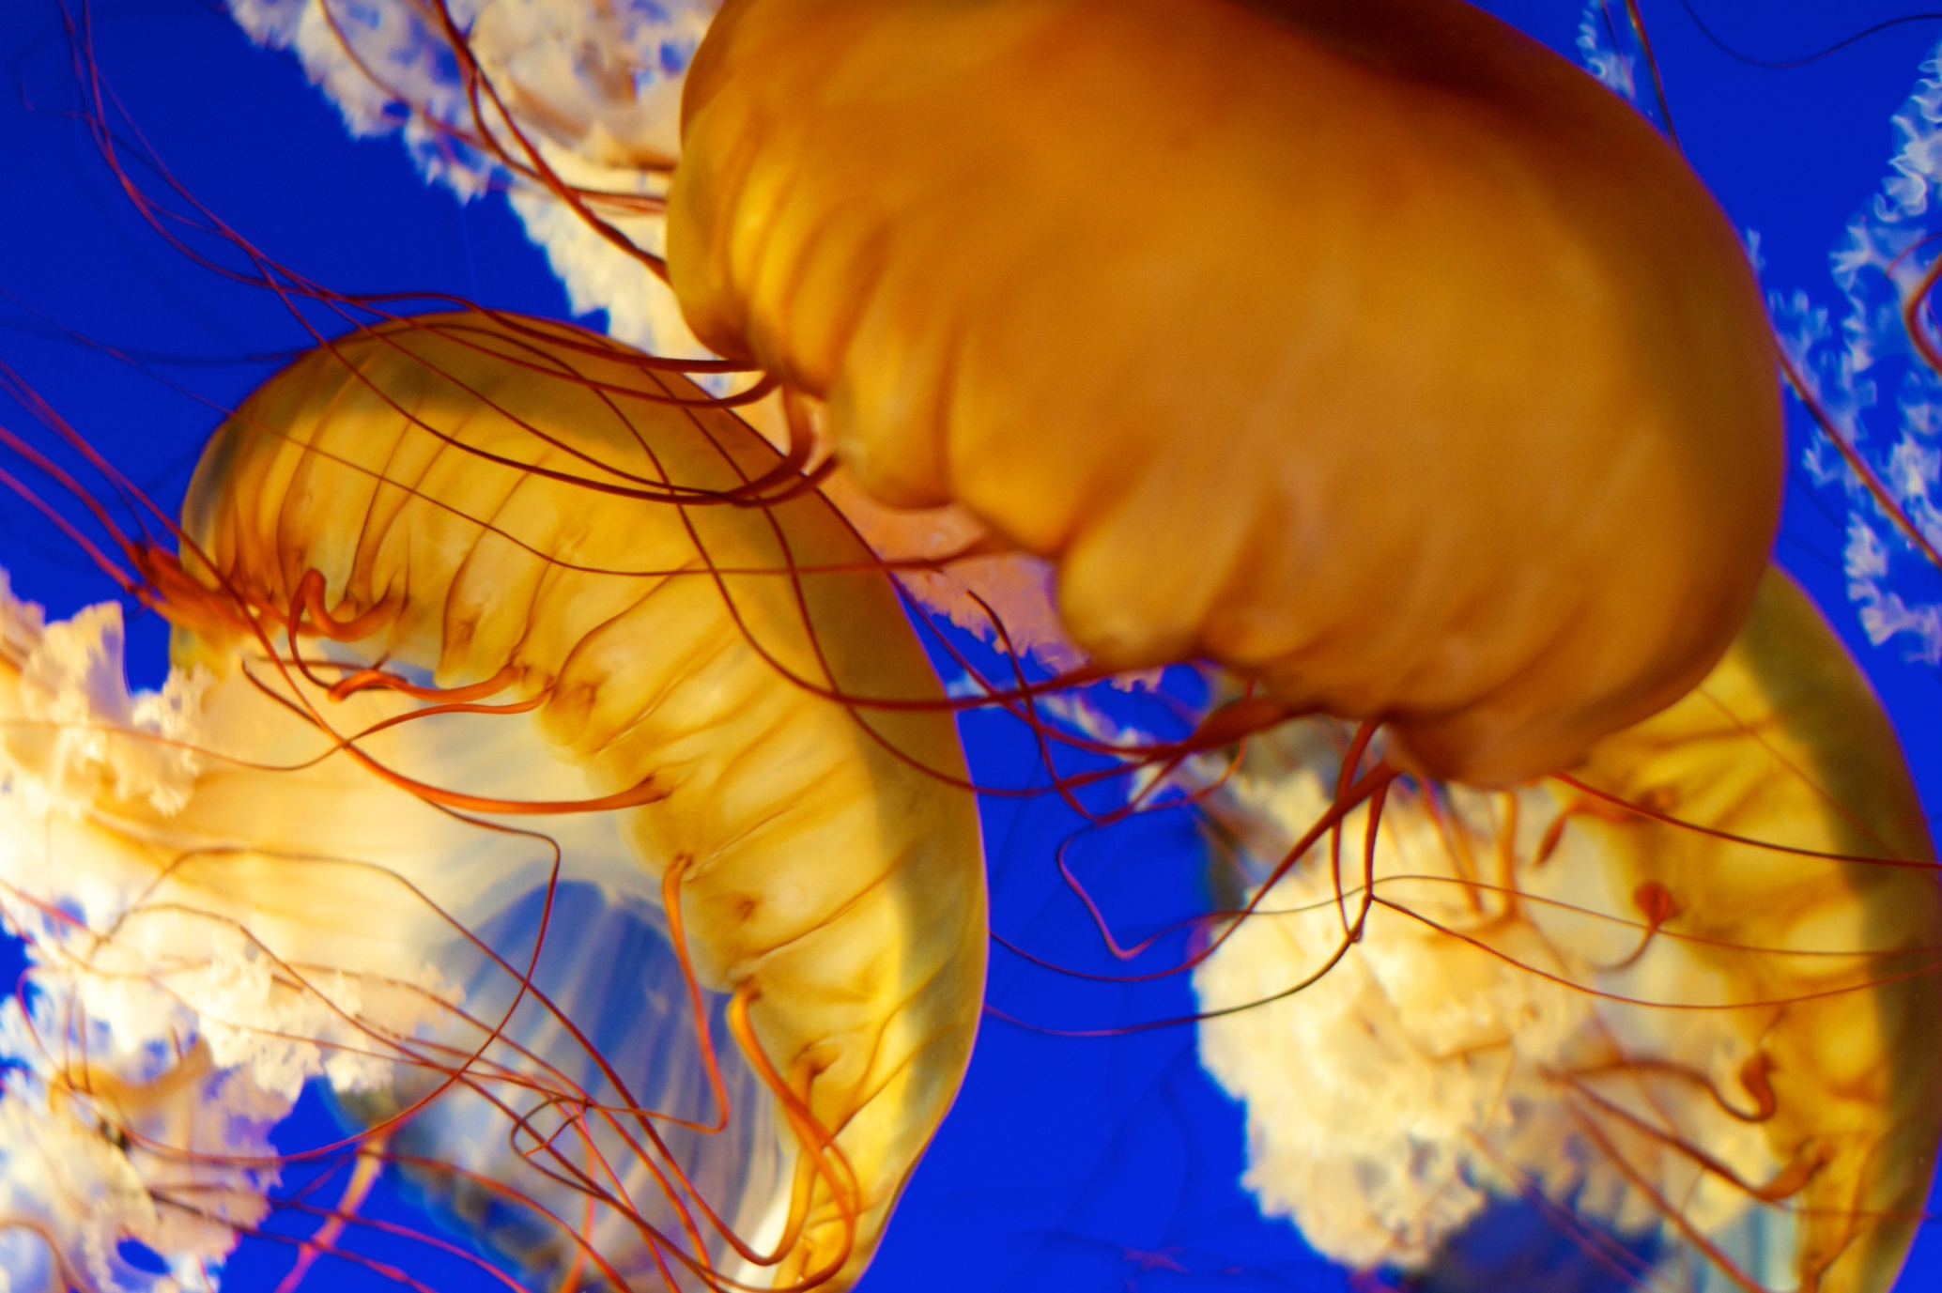
Photo courtesy of Paul Bratcher Photography on Flickr
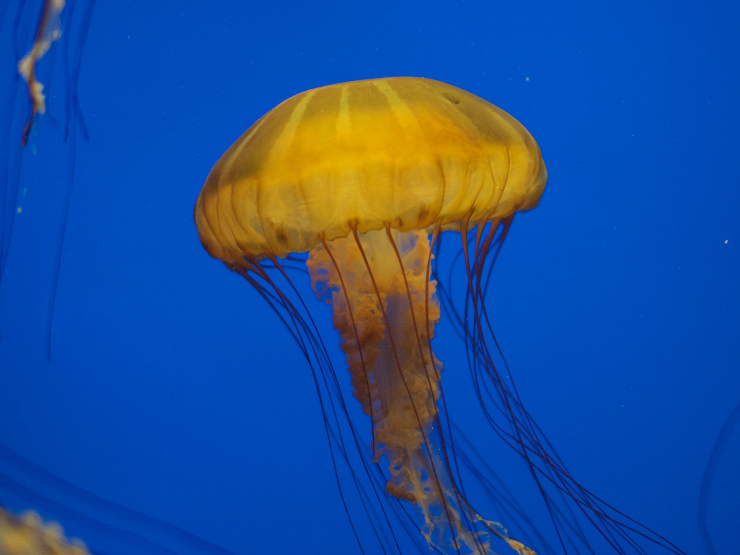

Photo courtesy of shellac on Flickr

