
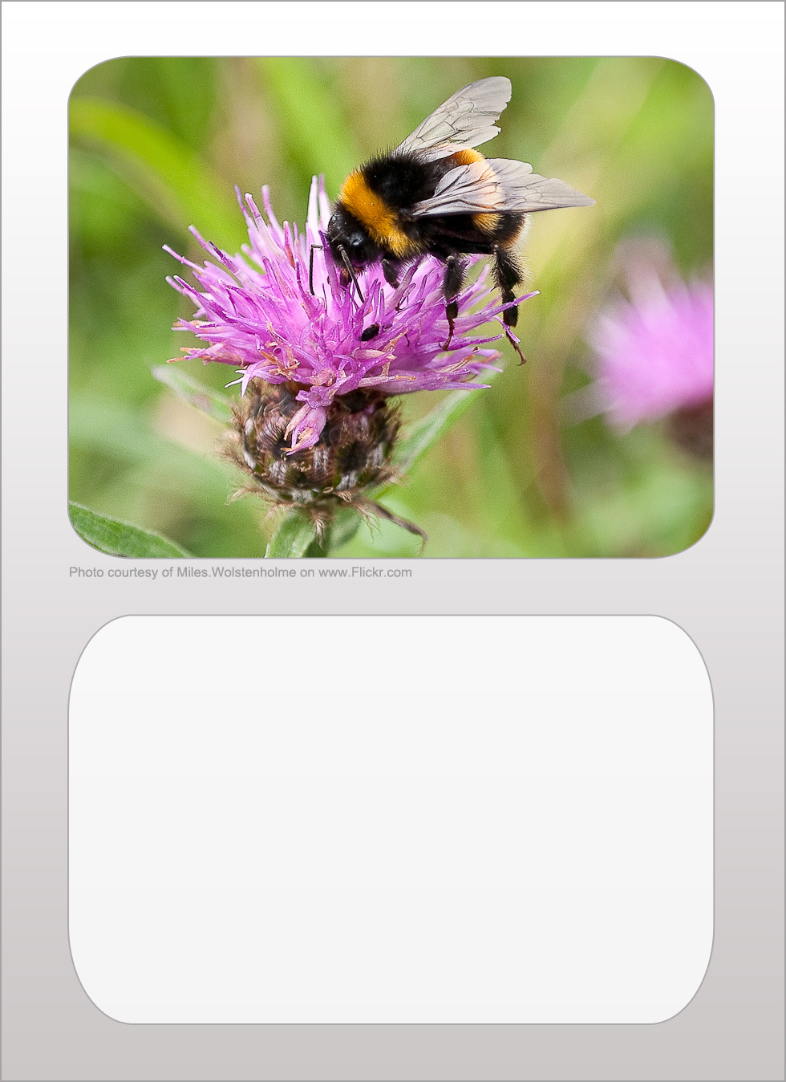
butterfly
legs 6
size 10
popularity 10
camouflage 0

bumblebee
legs 6
size 6
popularity 6
camouflage 1

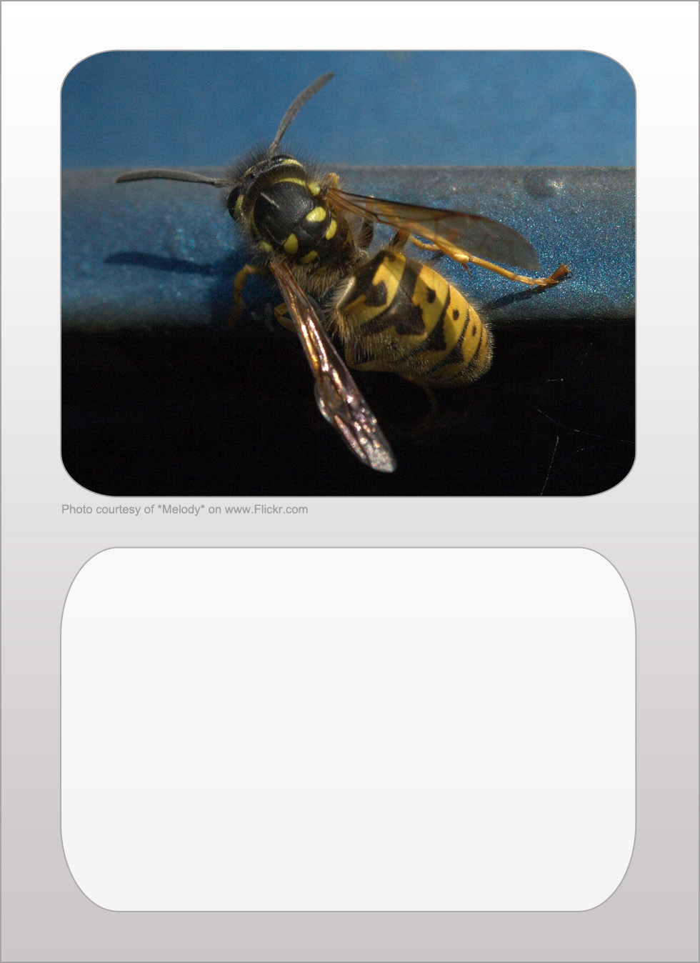
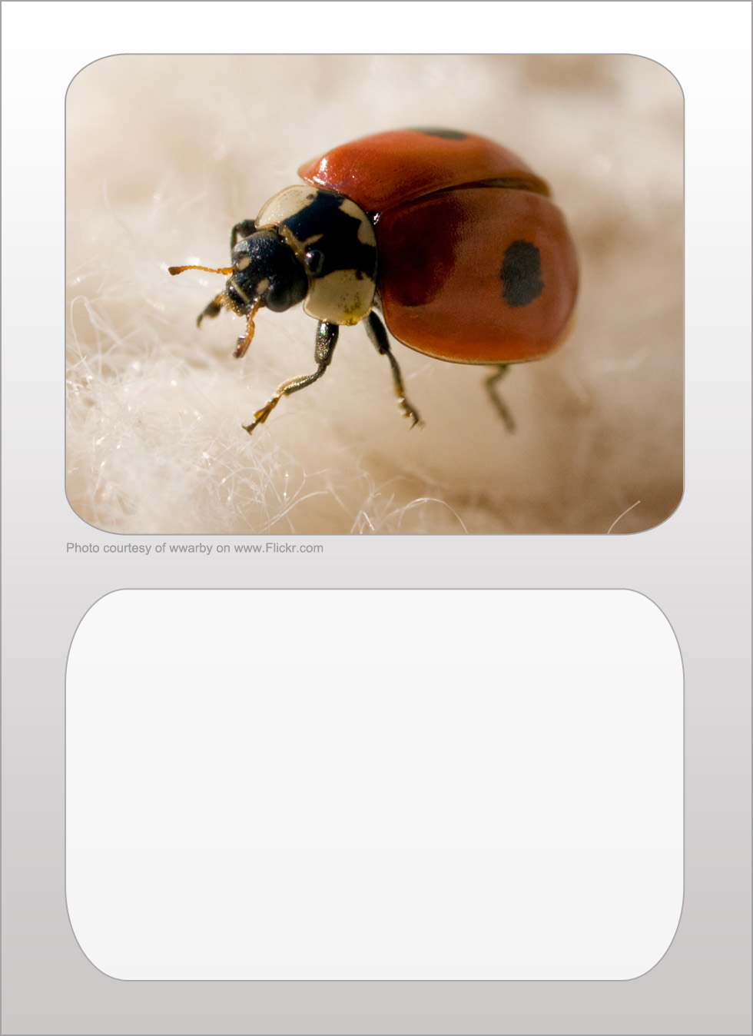
wasp
legs 6
size 5
popularity 0
camouflage 1

ladybird
legs 6
size 1
popularity 10
camouflage 0

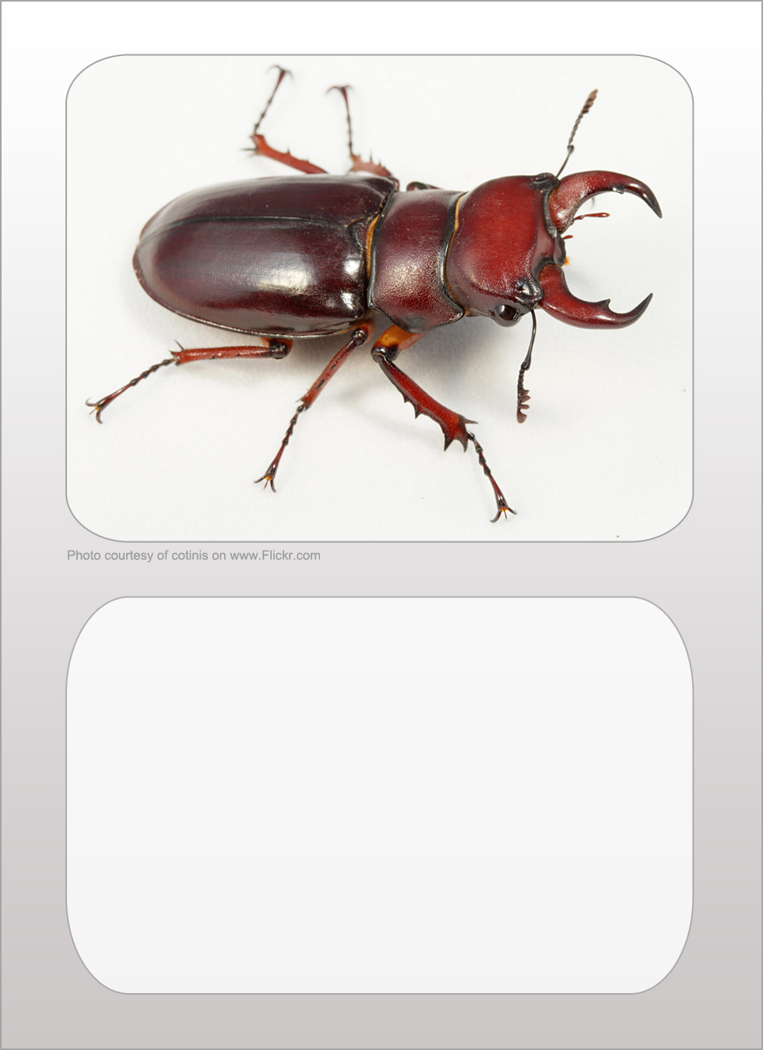
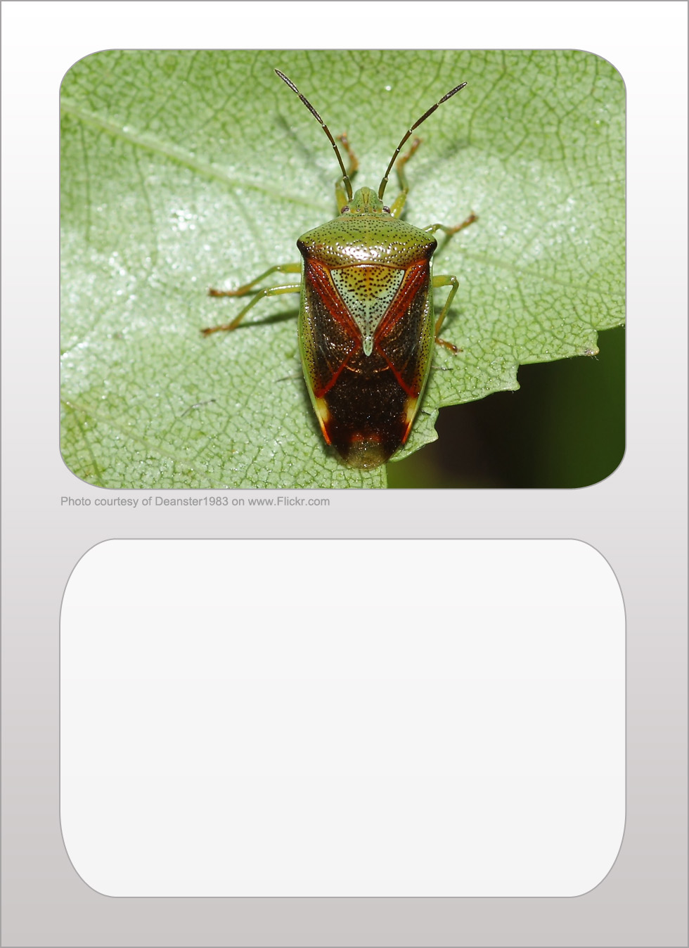
stag beetle
legs 6
size 4
popularity 6
camouflage 0

Shield bug
legs 6
size 5
popularity 5
camouflage 10

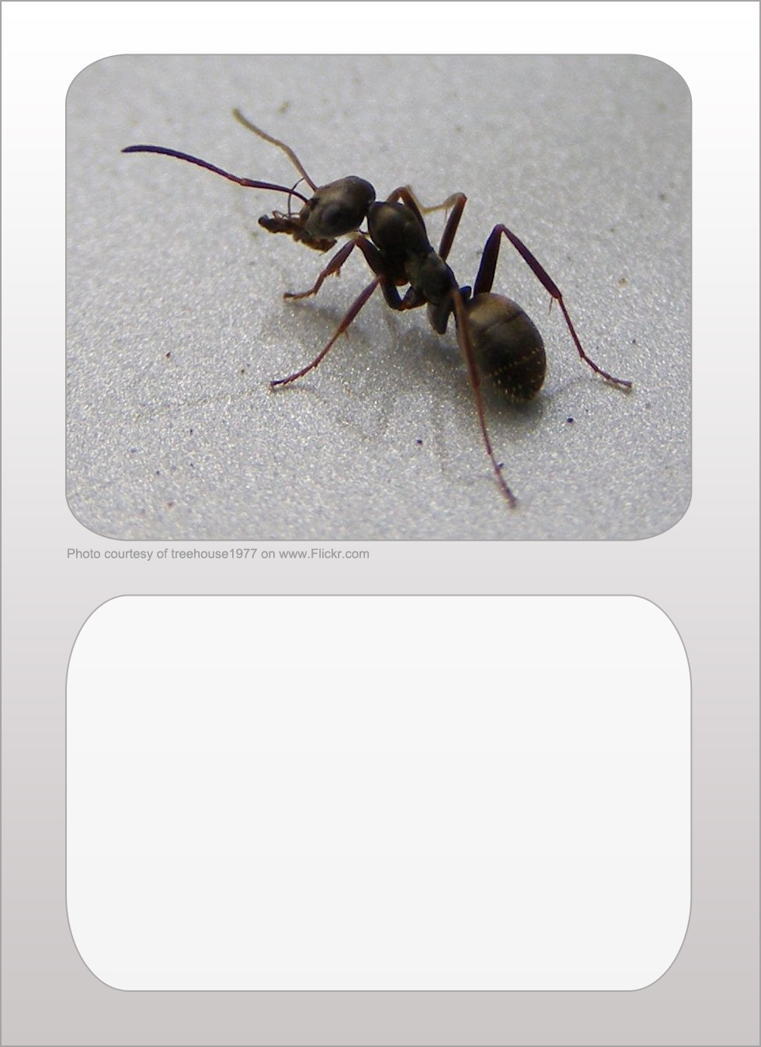
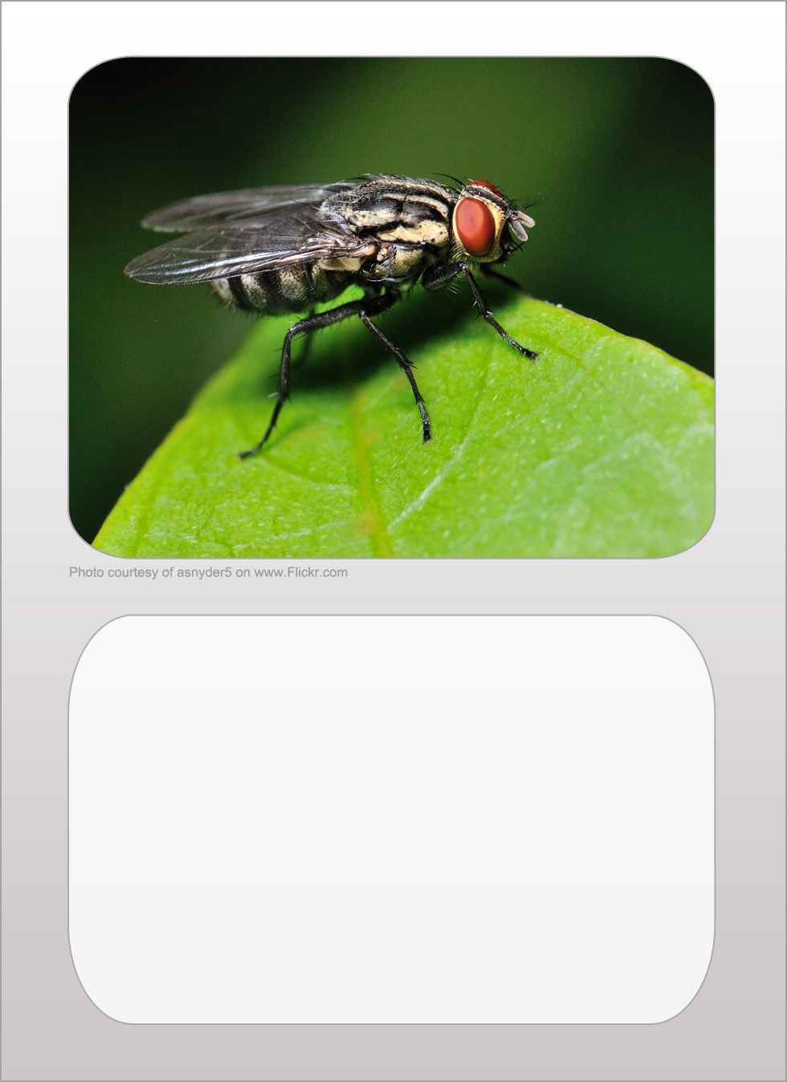
ant
legs 6
size 0
popularity 3
camouflage 7

fly
legs 6
size 1
popularity 0
camouflage 2

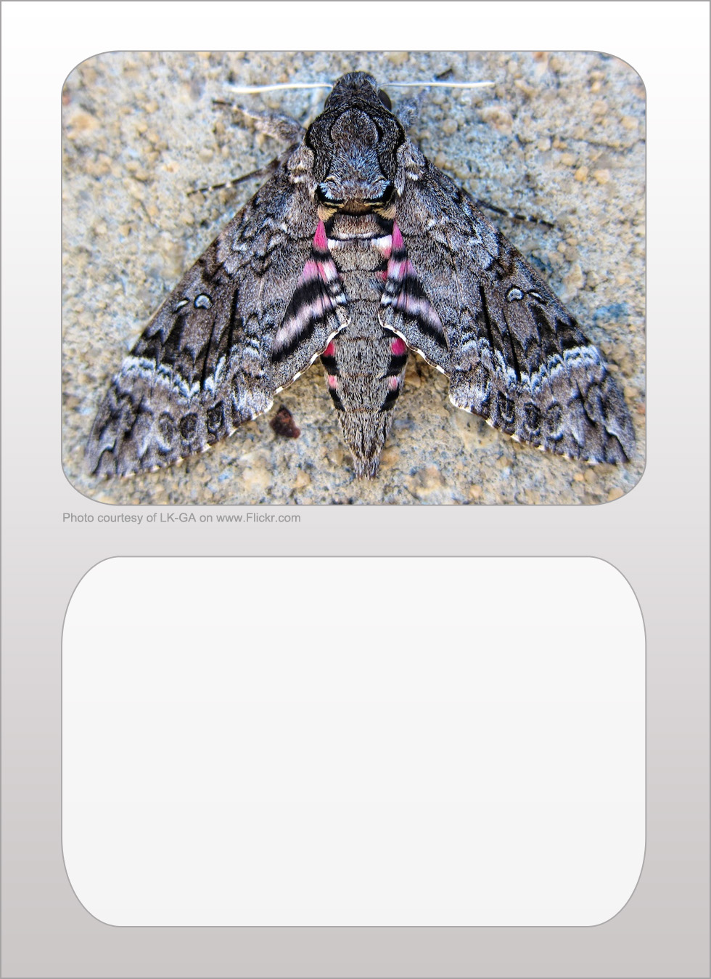
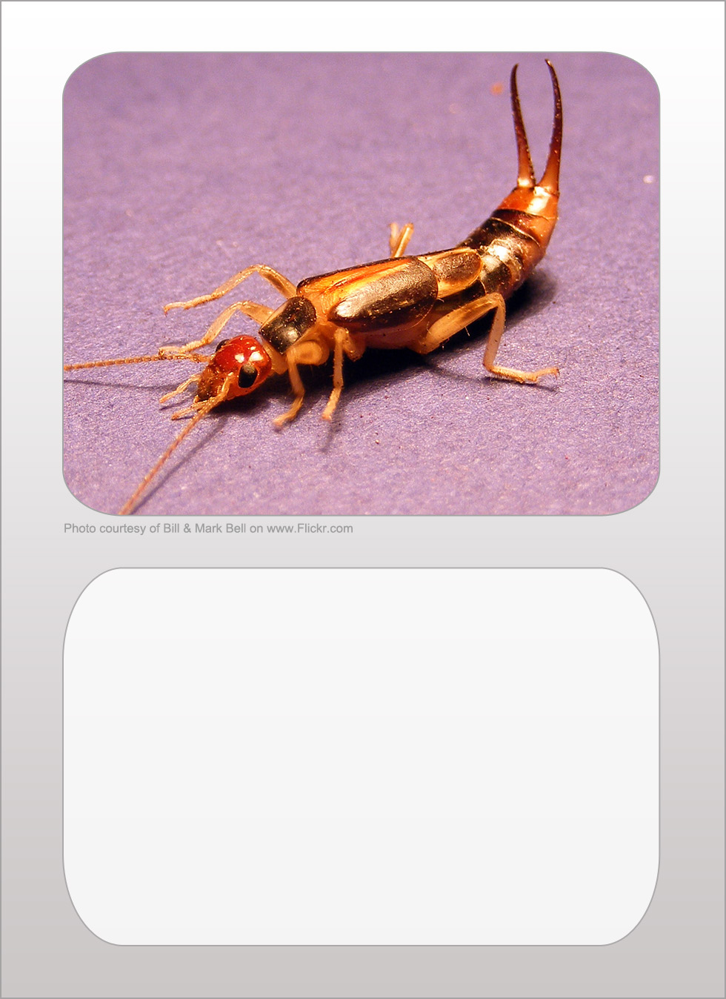
moth
legs 6
size 9
popularity 8
camouflage 9

earwig
legs 6
size 4
popularity 2
camouflage 5

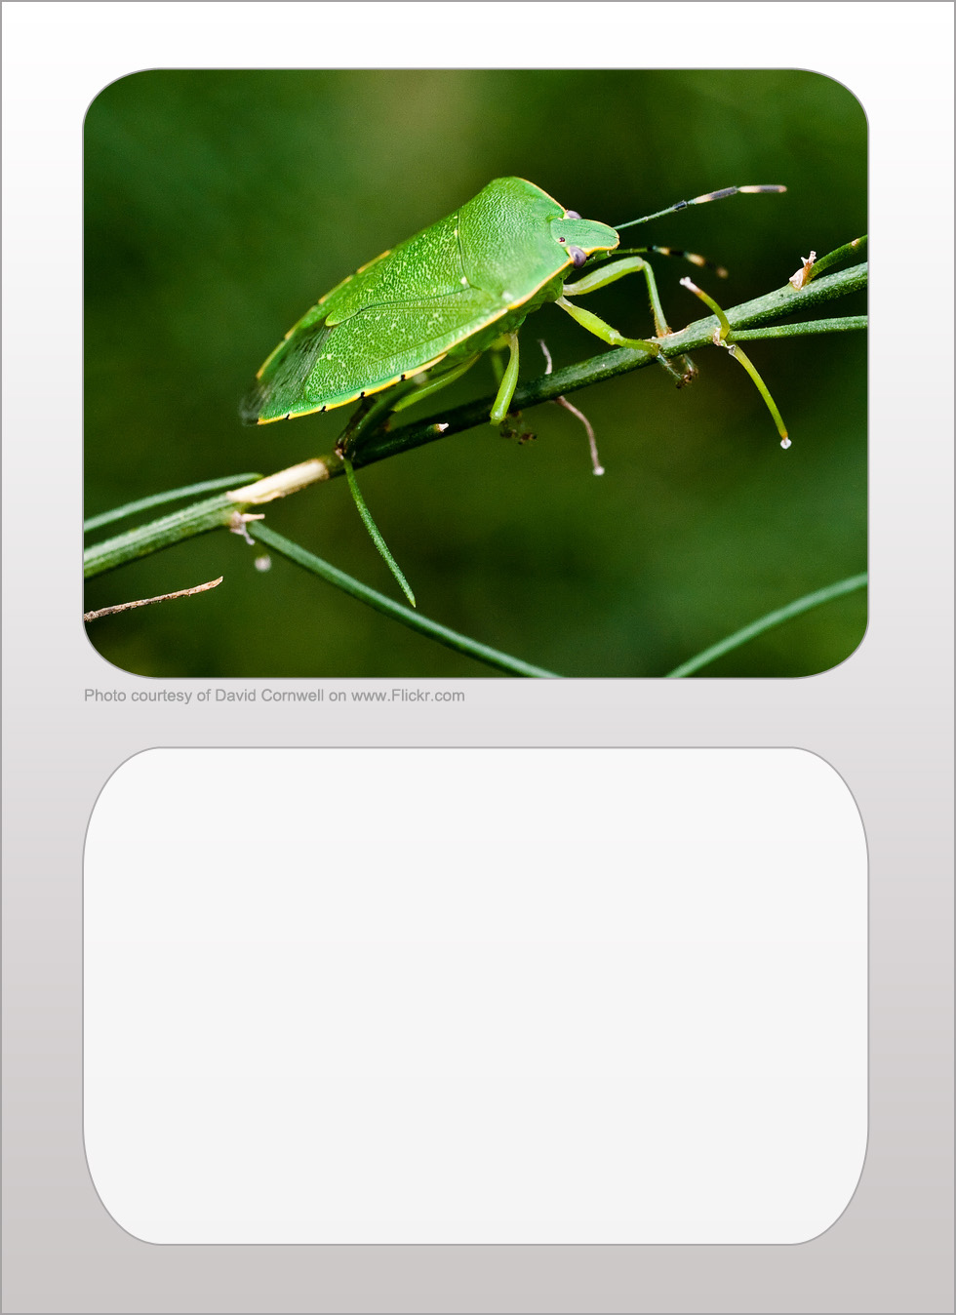
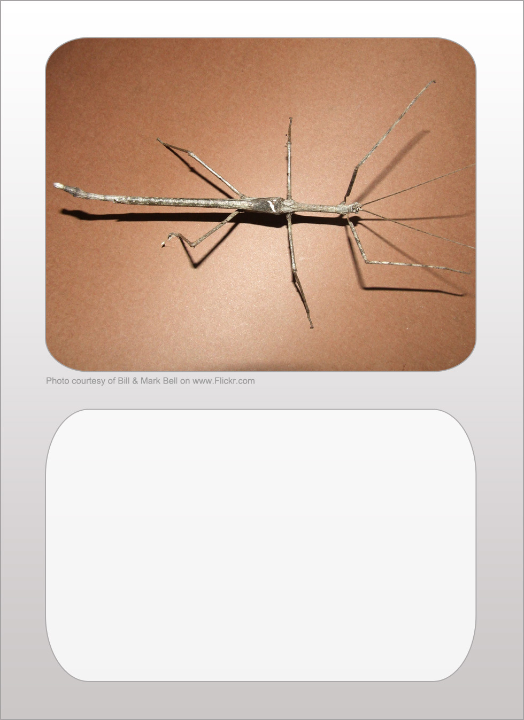
aphid
legs 6
size 0
popularity 2
camouflage 9

stick insect
legs 6
size 7
popularity 8
camouflage 10

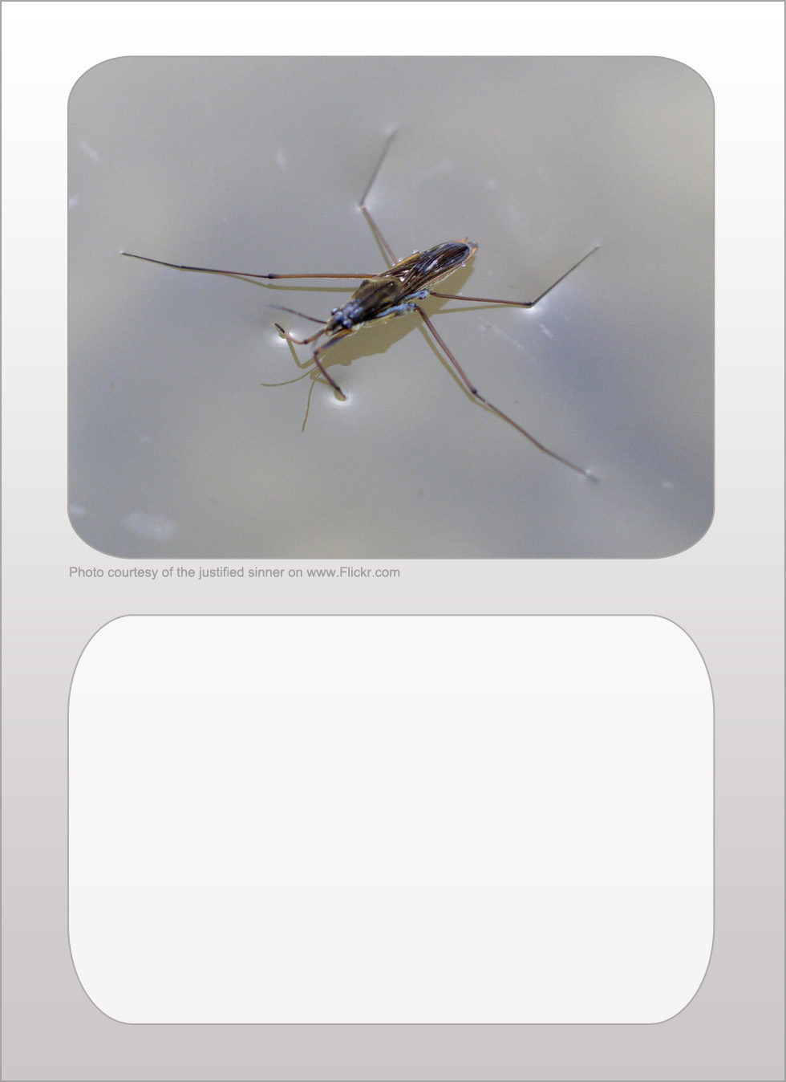
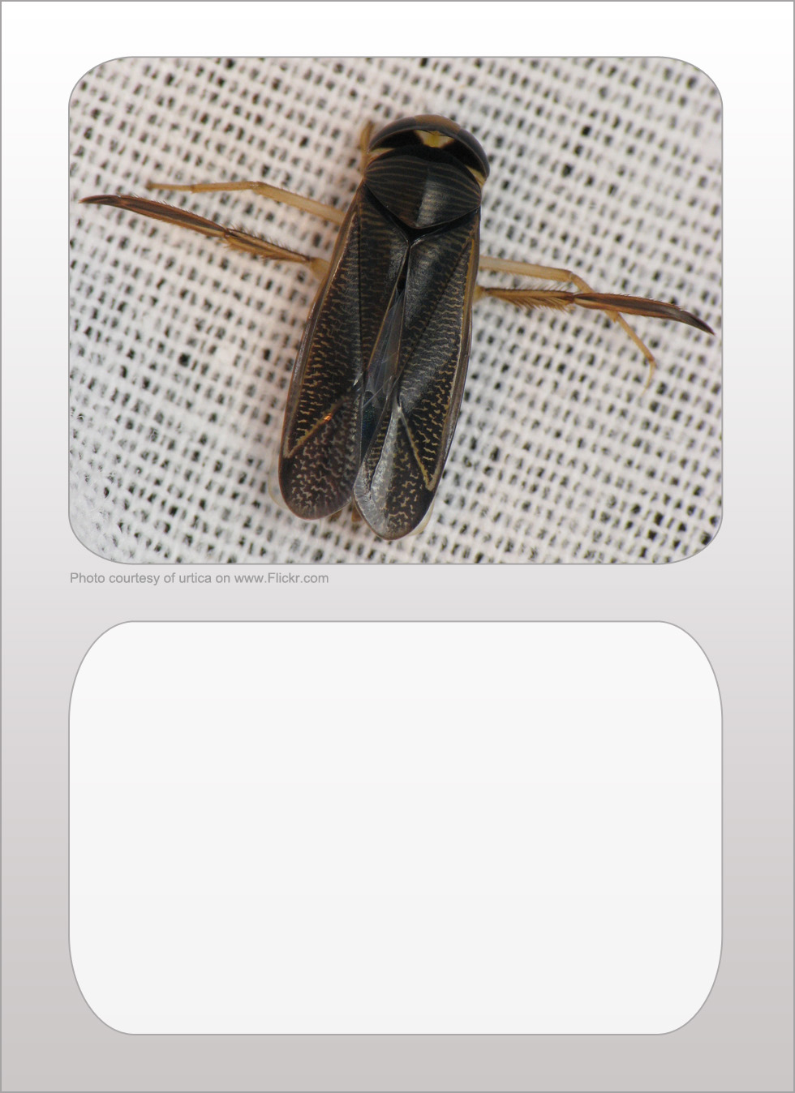
pond skater
legs 6
size 1
popularity 7
camouflage 8

water boatman
legs 6
size 2
popularity 7
camouflage 8

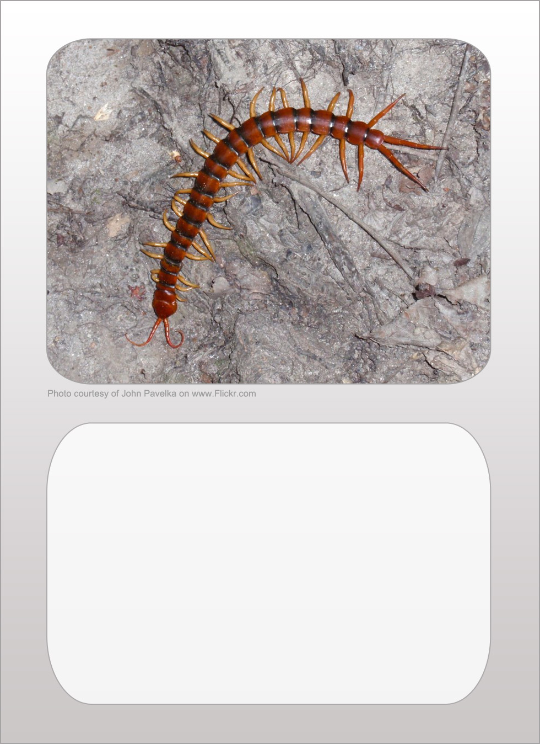
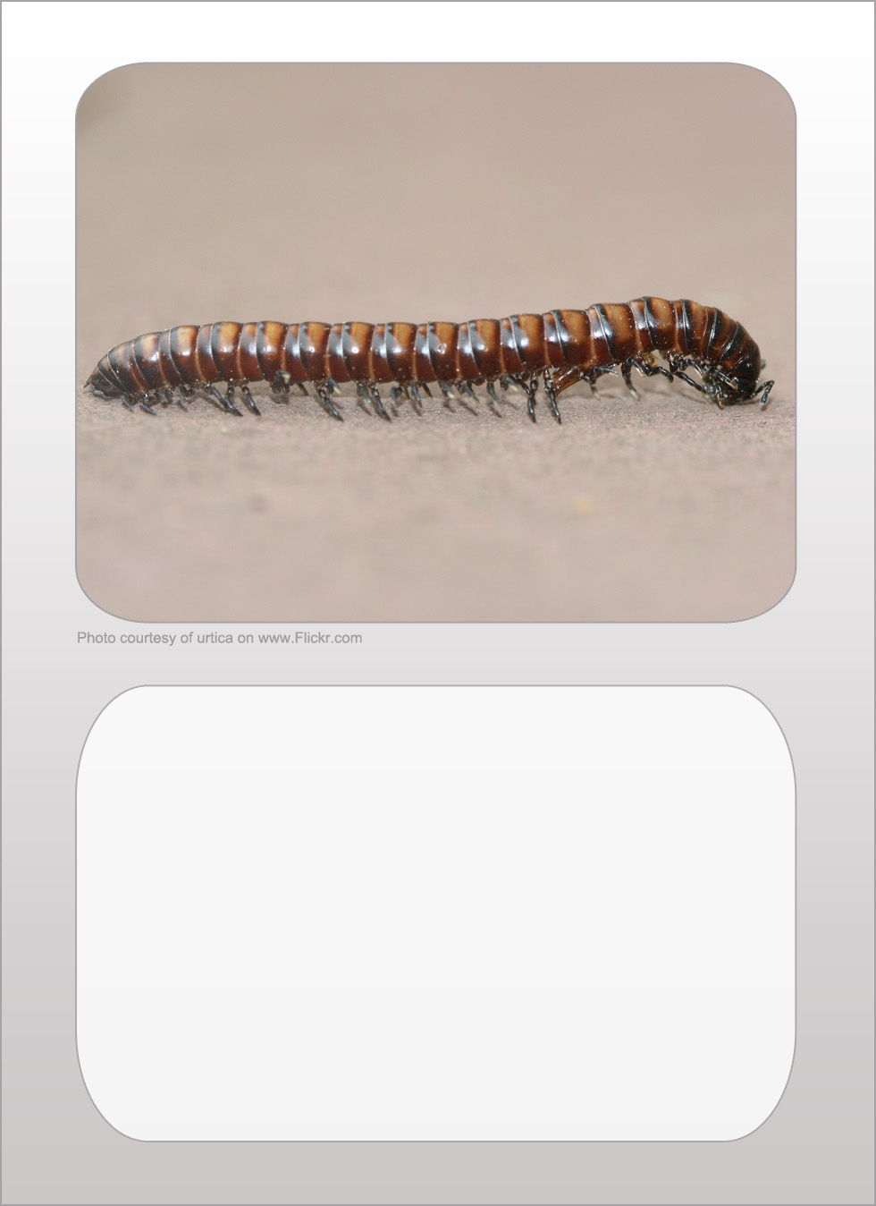
centipede
legs up to 177
size 3
popularity 2
camouflage 4

millipede
legs up to 200
size 3
popularity 2
camouflage 5

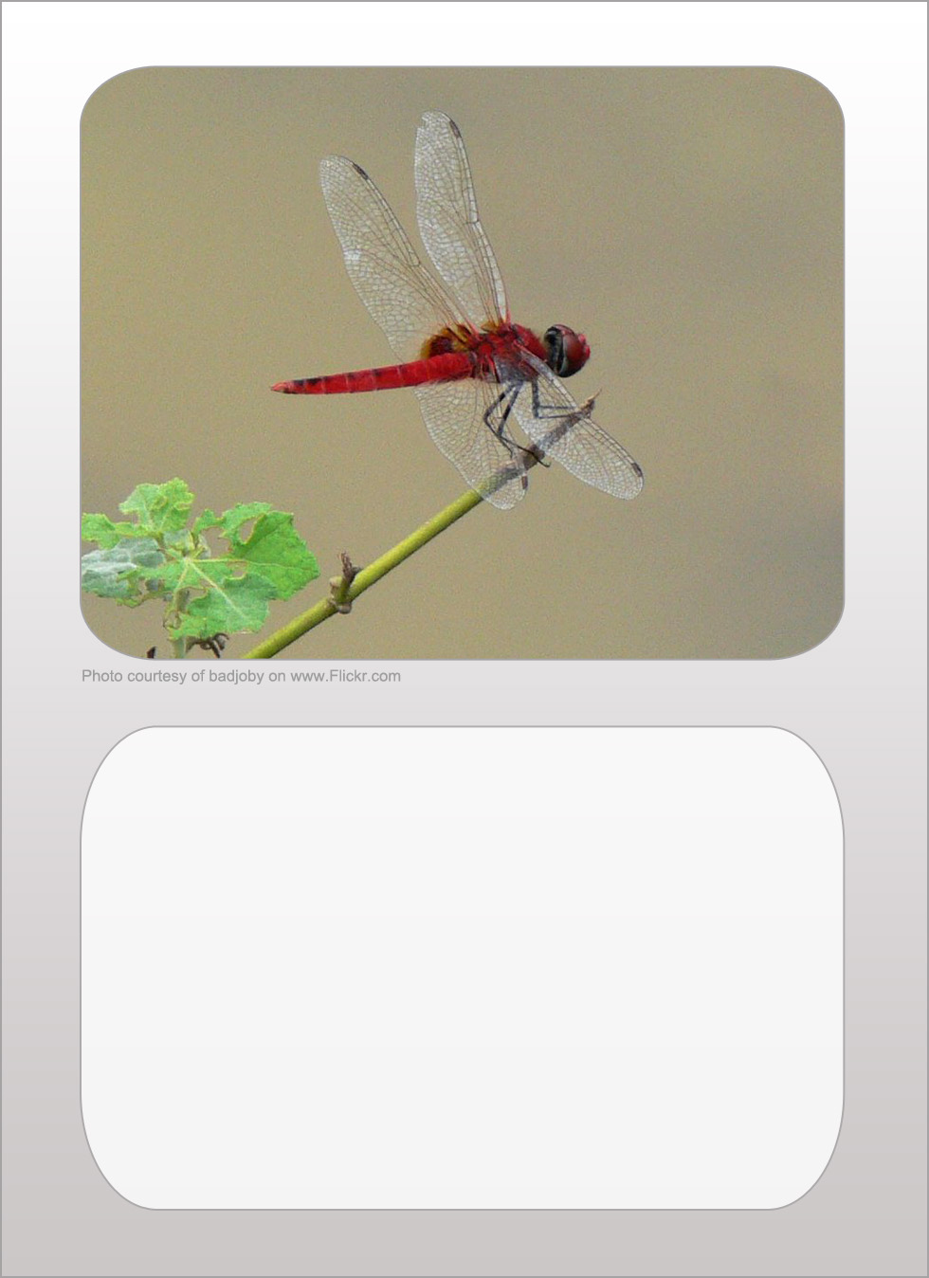
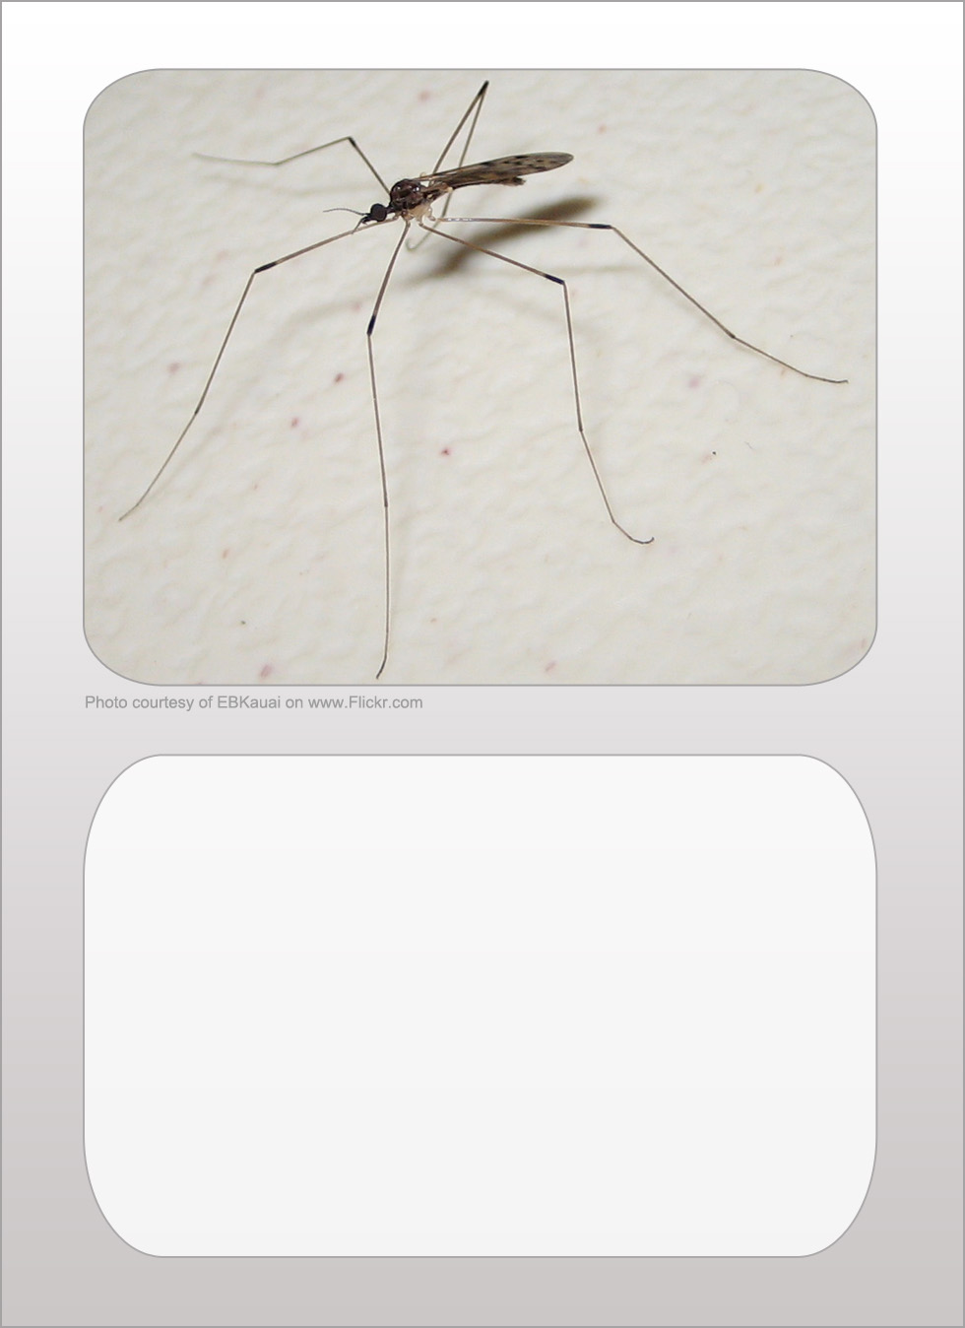
dragonfly
legs 6
size 8
popularity 9
camouflage 2

crane fly
legs 6
size 8
popularity 5
camouflage 4

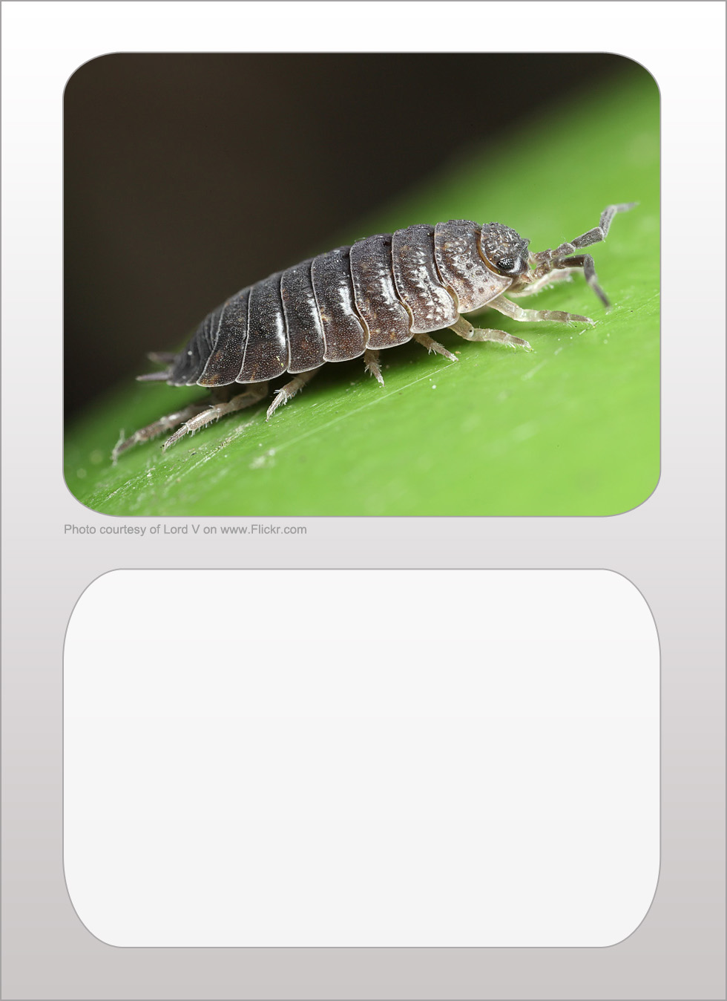
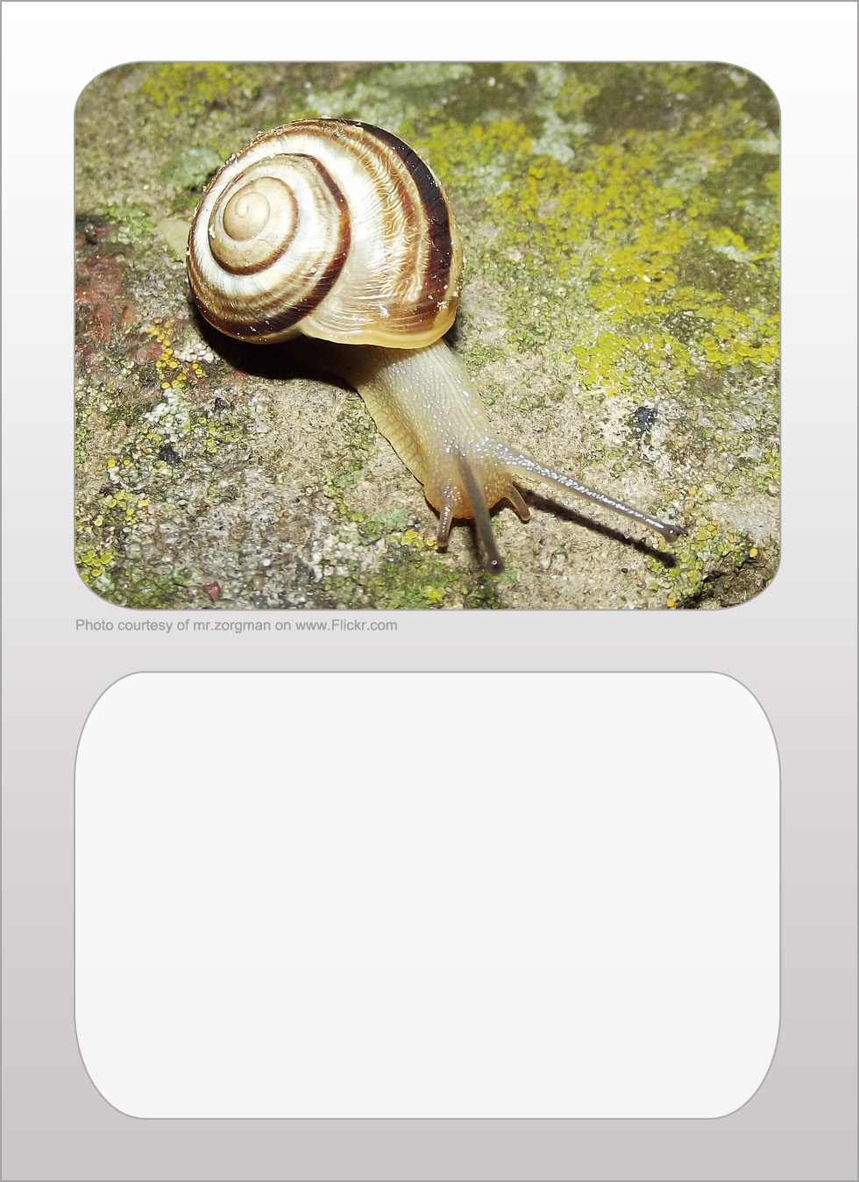
woodlouse
legs 14
size 2
popularity 4
camouflage 6

snail
legs 0
size 7
popularity 3
camouflage 5

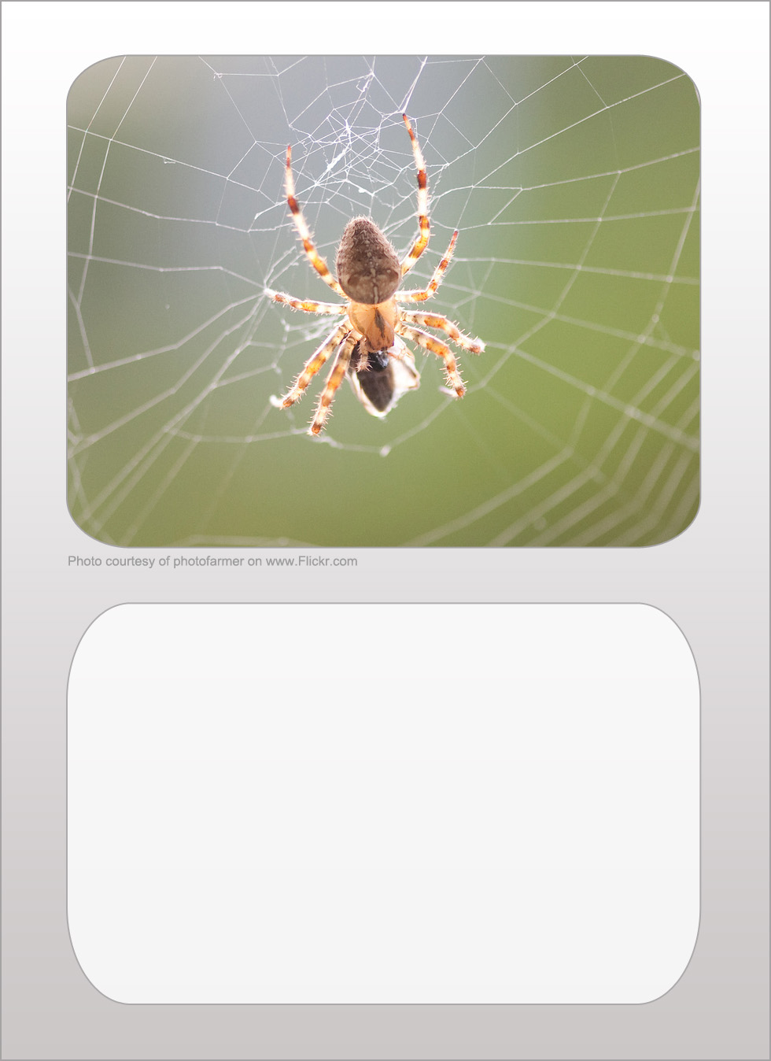
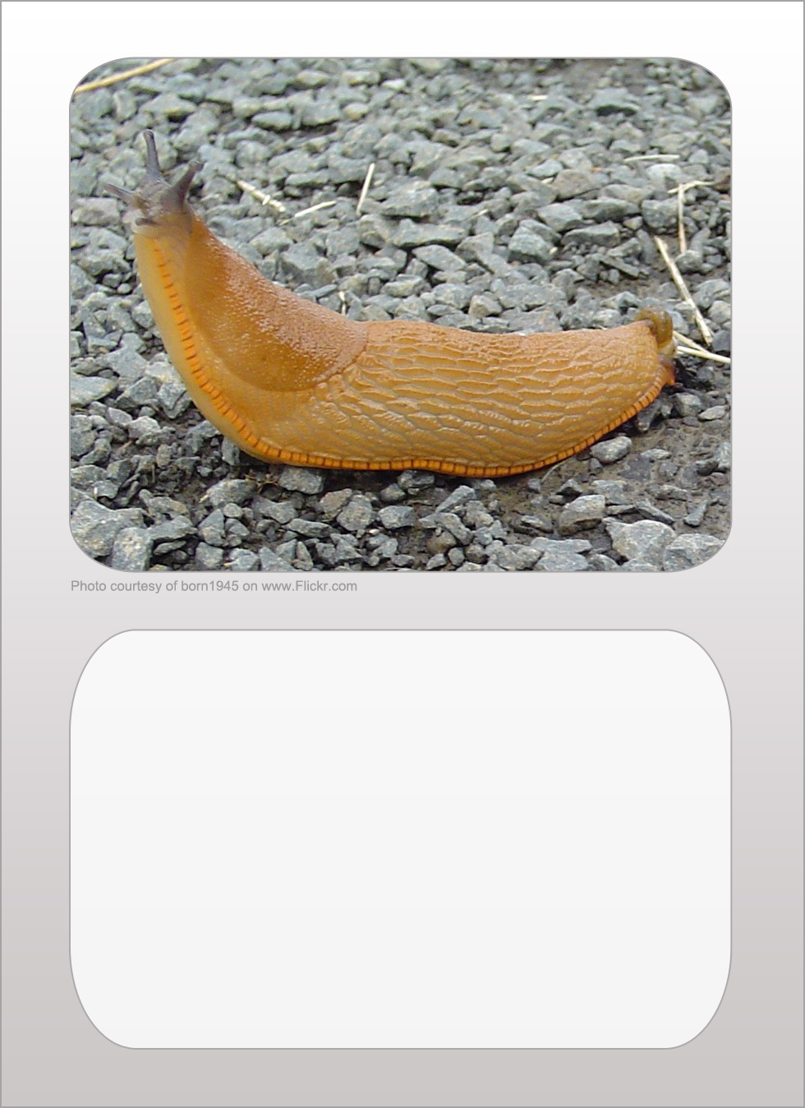
spider
legs 8
size 4
popularity 3
camouflage 6

slug
legs 0
size 10
popularity 0
camouflage 3

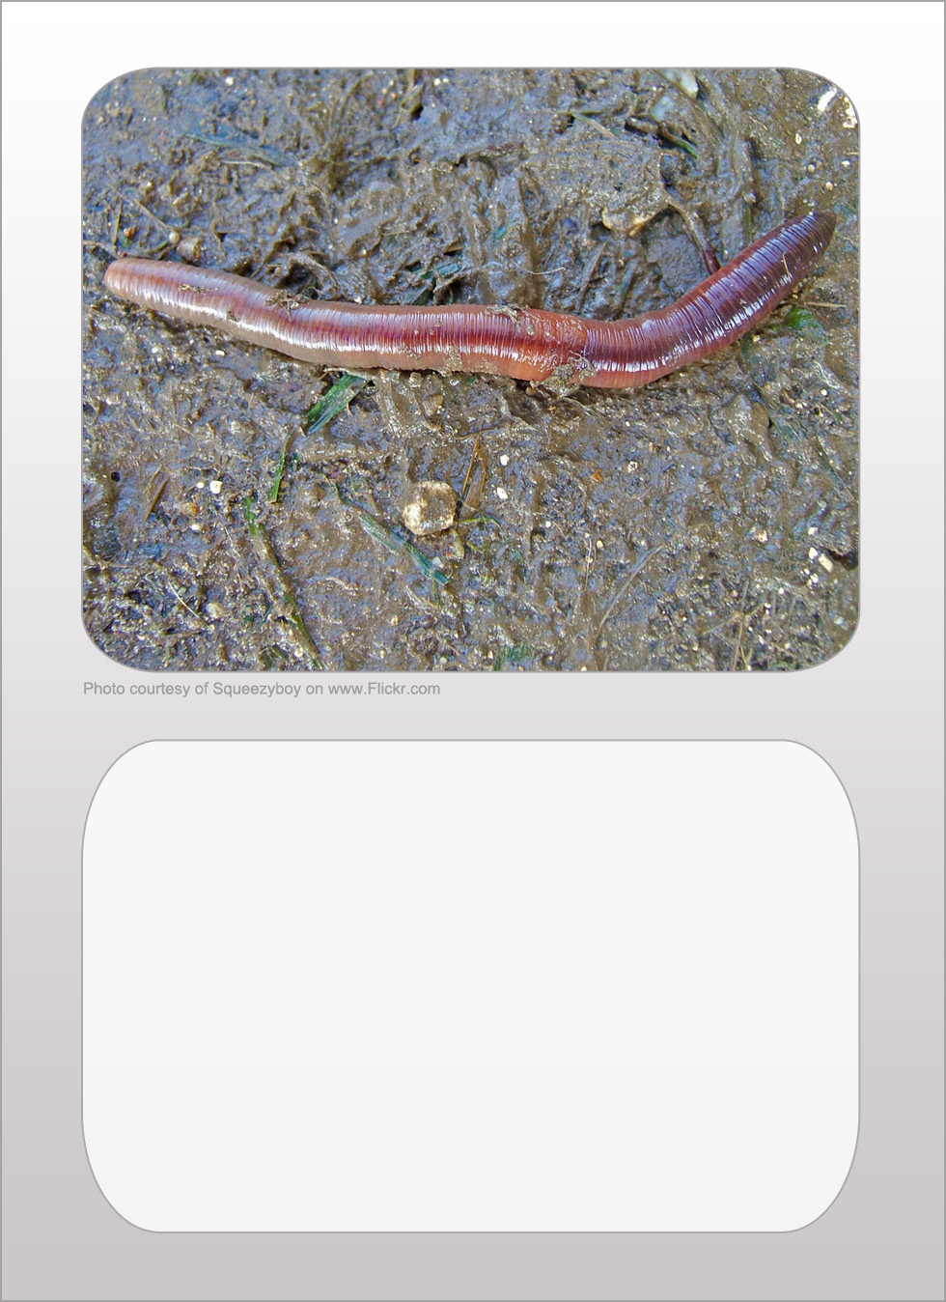
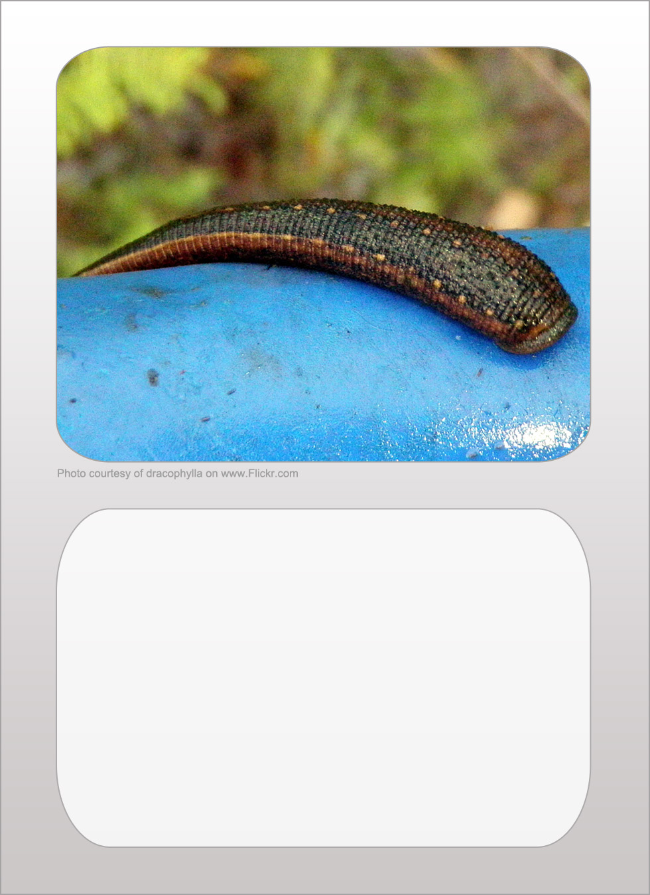
earthworm
legs 0
size 9
popularity 9
camouflage 2

leech
legs 0
size 6
popularity 1
camouflage 3

