
Photo courtesy of Toban Black on Flickr
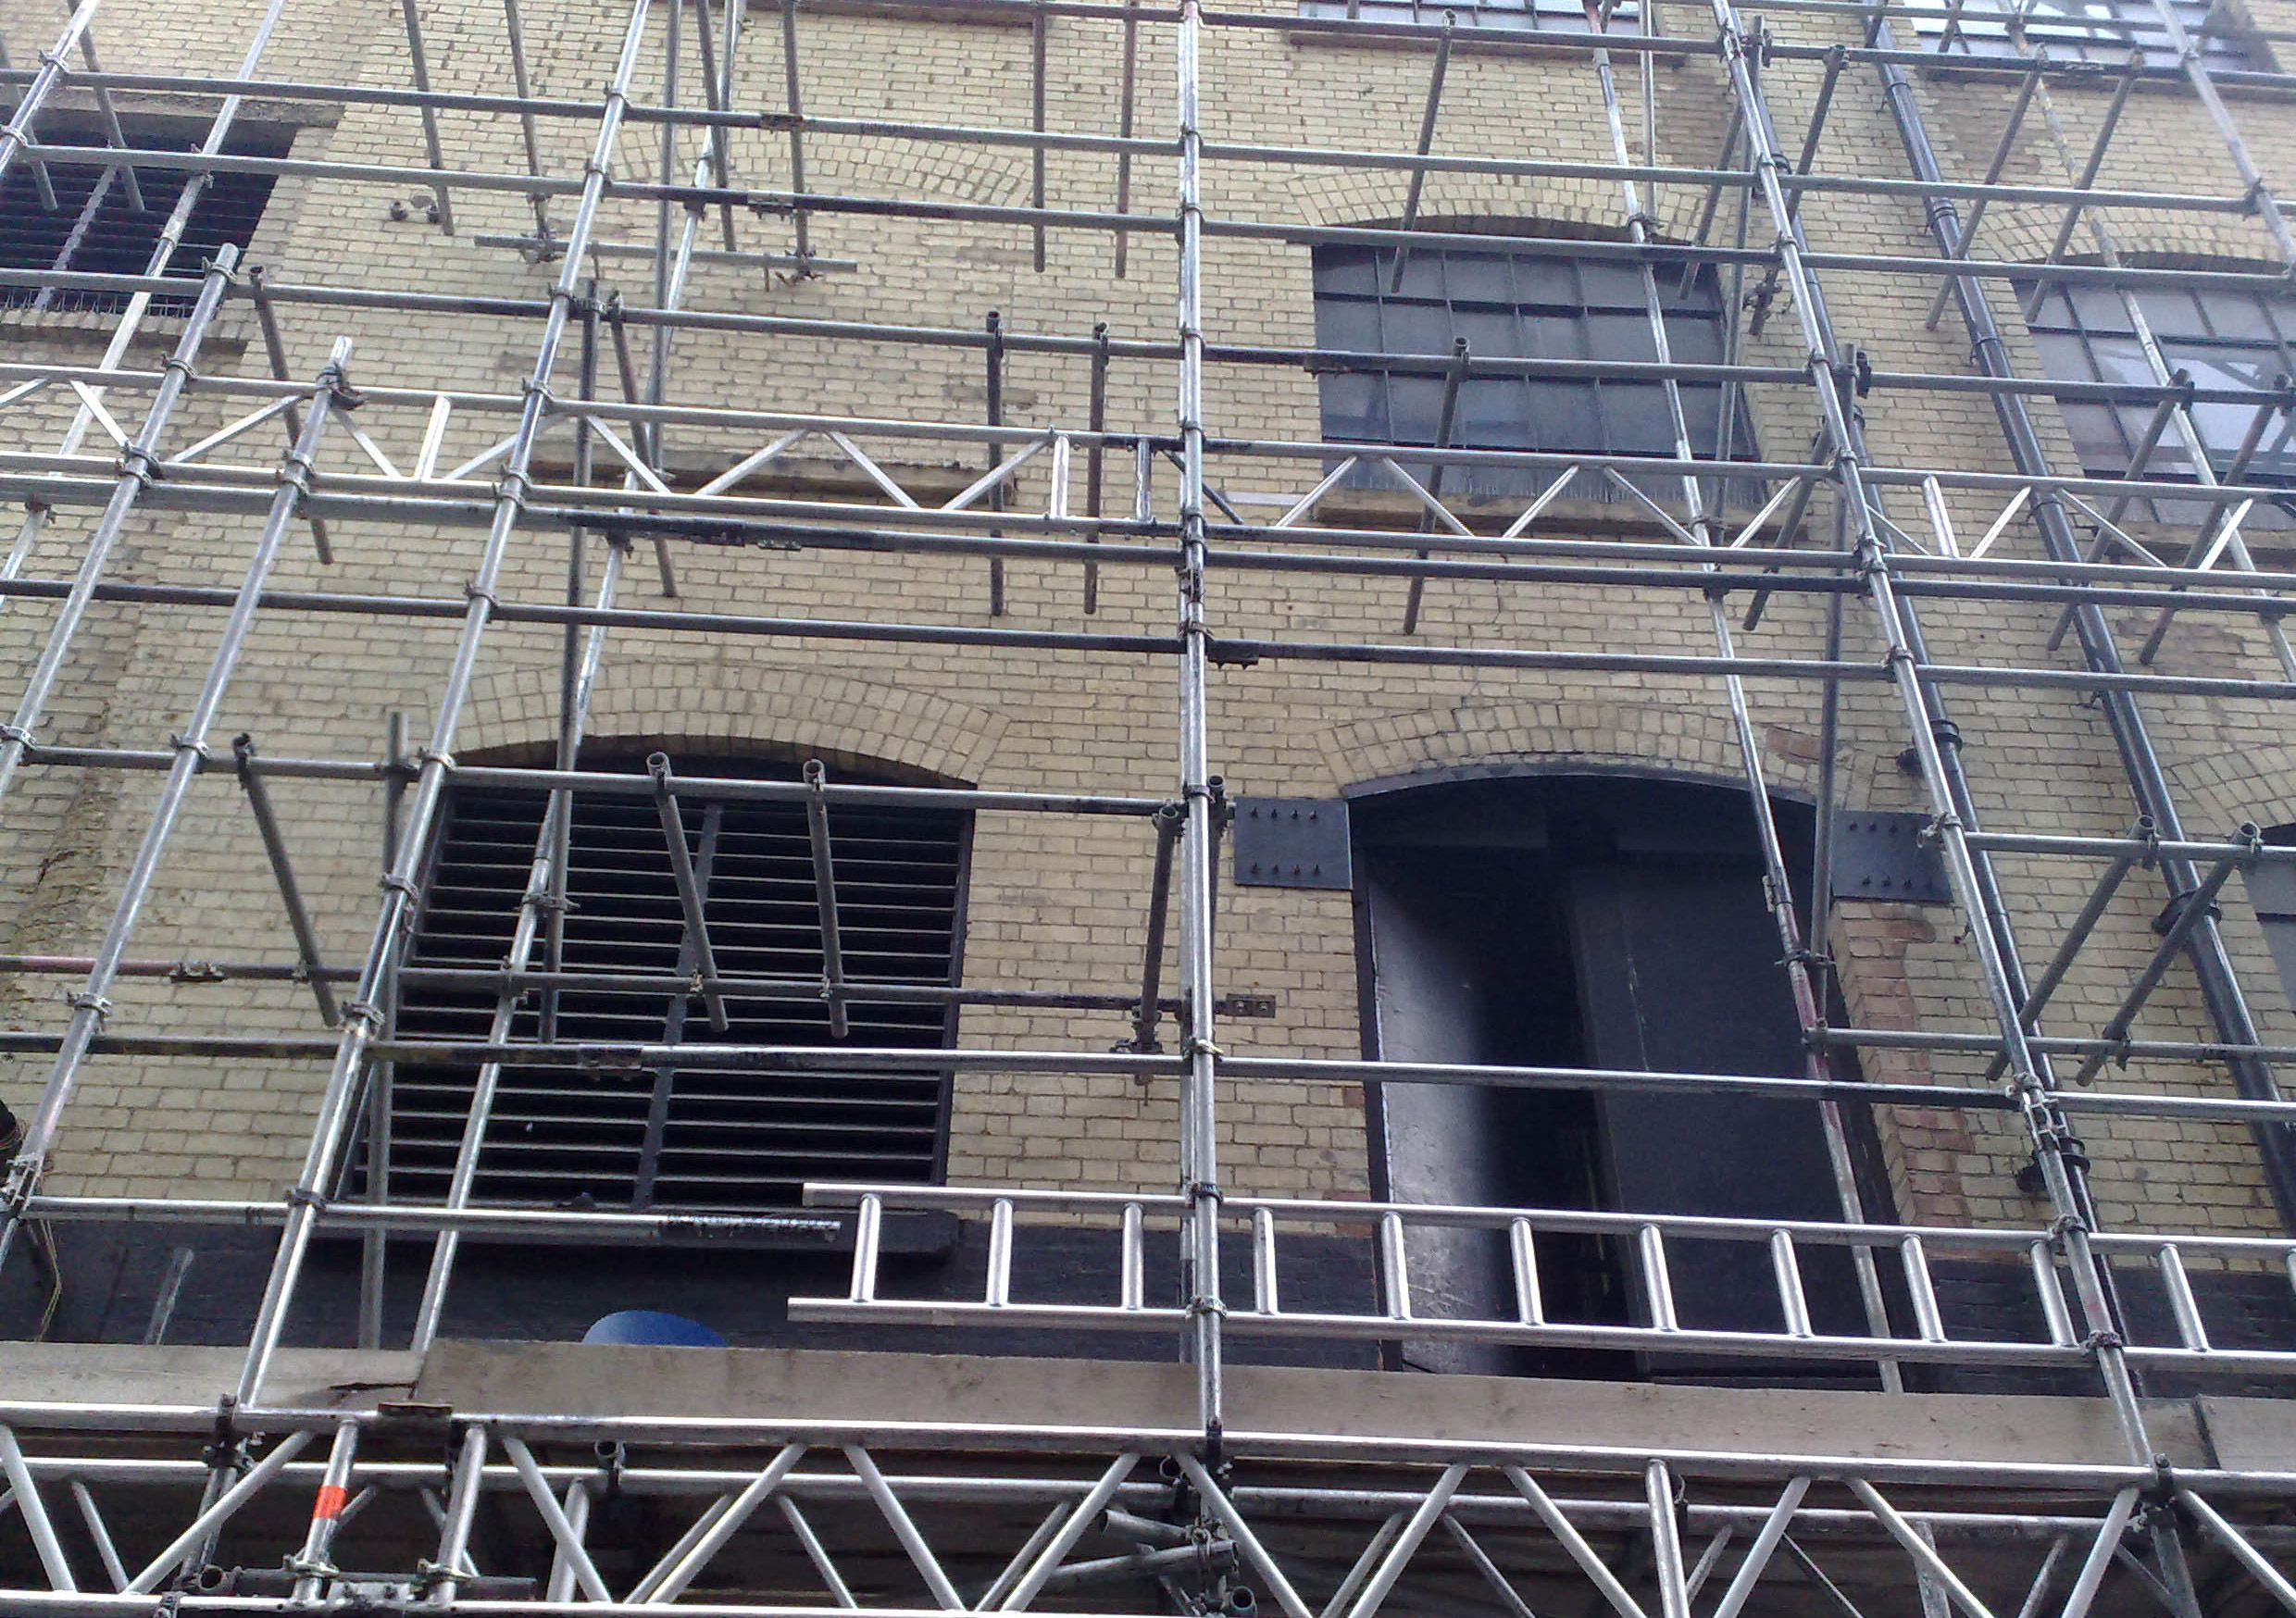
Photo courtesy of secretlondon123 on Flickr

Photo courtesy of Jared Cherup on Flickr

Photo courtesy of afflictedmonkey on Flickr

Photo courtesy of kenjonbro on Flickr
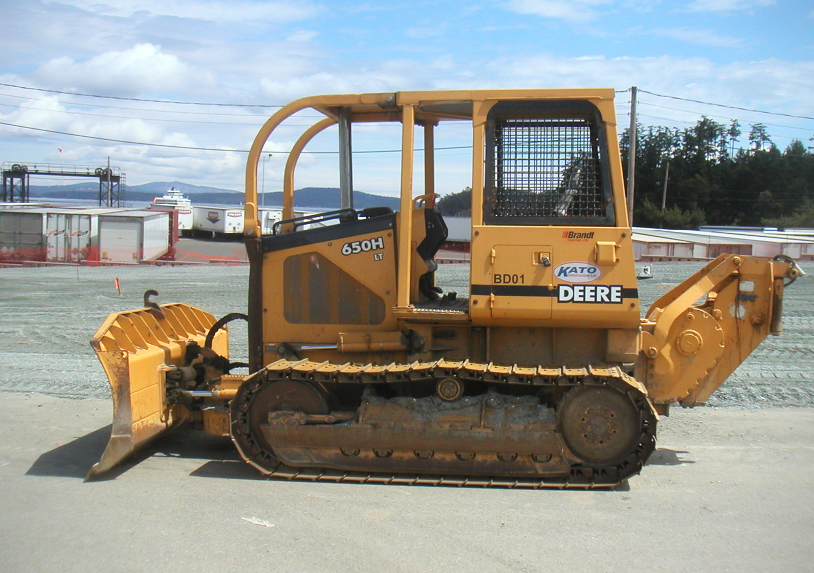
Photo courtesy of russilwvong on Flickr
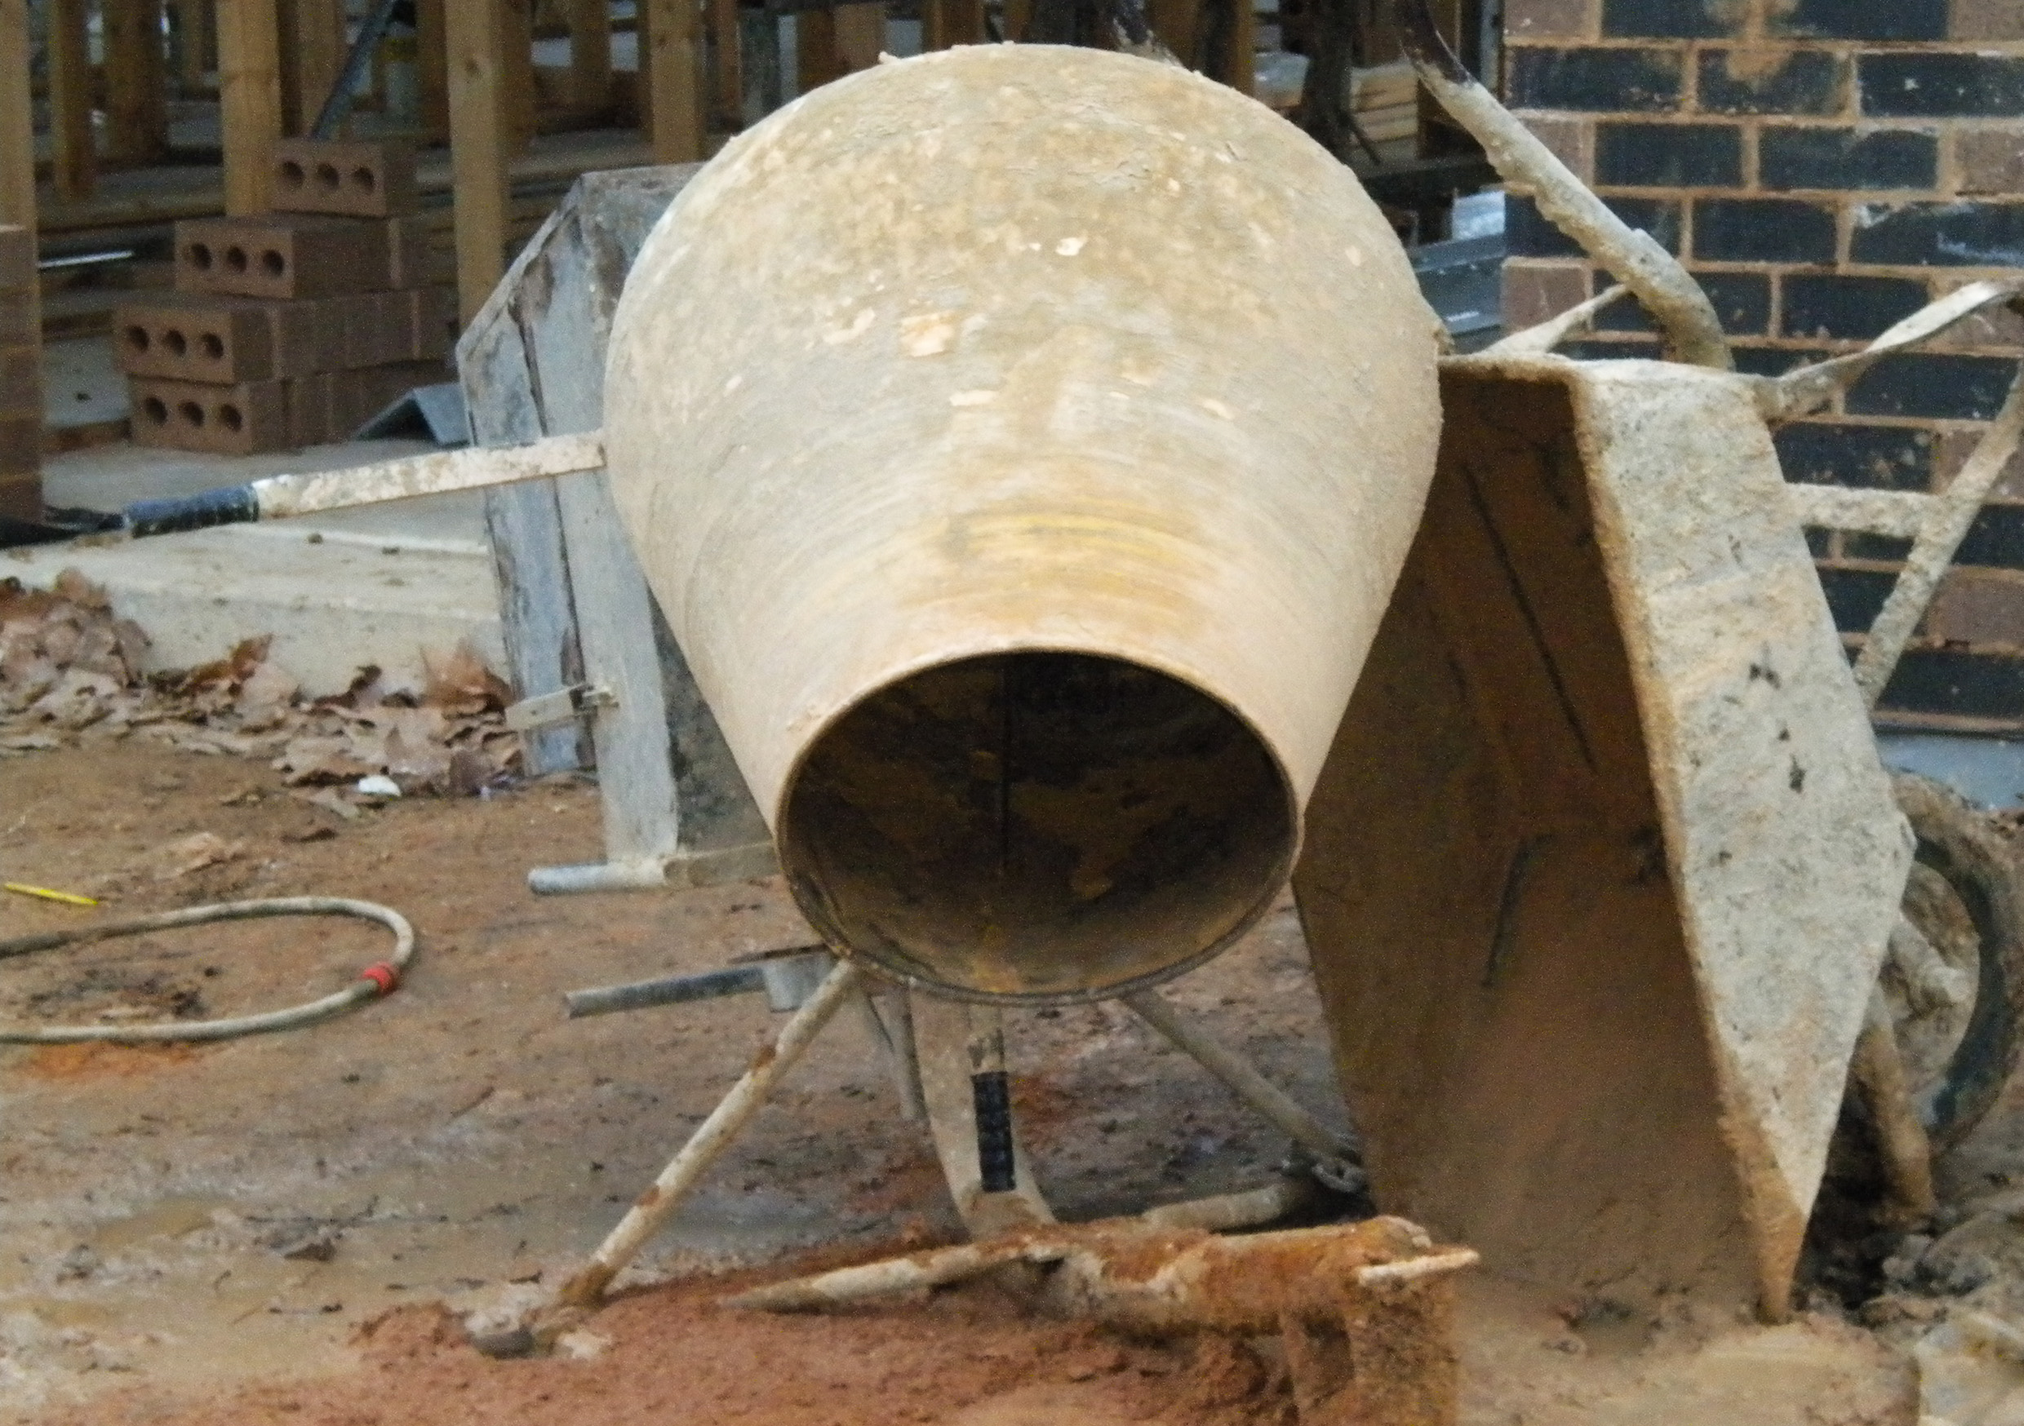
Photo courtesy of mikecogh on Flickr

Photo courtesy of -Bert23- on Flickr

Photo courtesy of NestlÃ© on Flickr
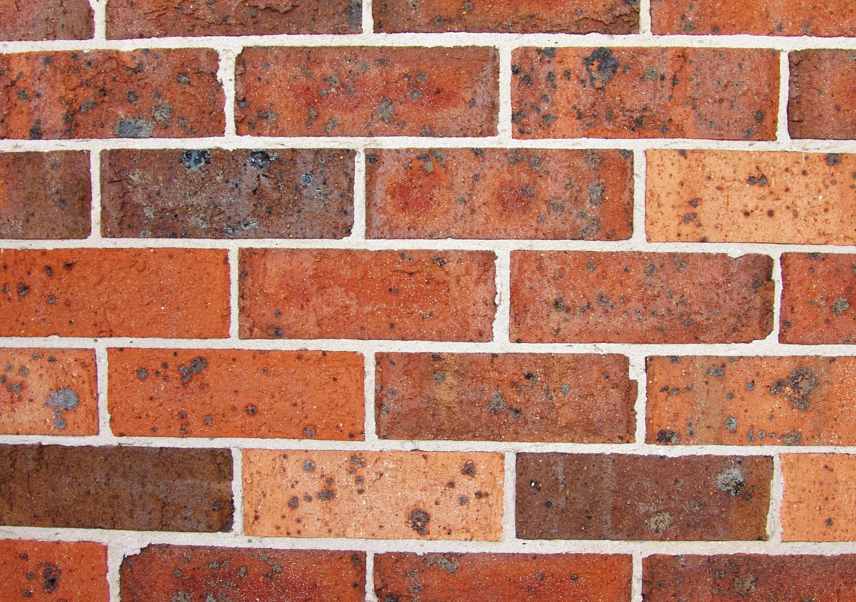
Photo Courtesy of Joriel "Joz" Jimenez on Flickr

Photo courtesy of Màrtainn on Flickr

Photo courtesy of DrJohnBullas on Flickr

Photo courtesy of WorldSkills on Flickr
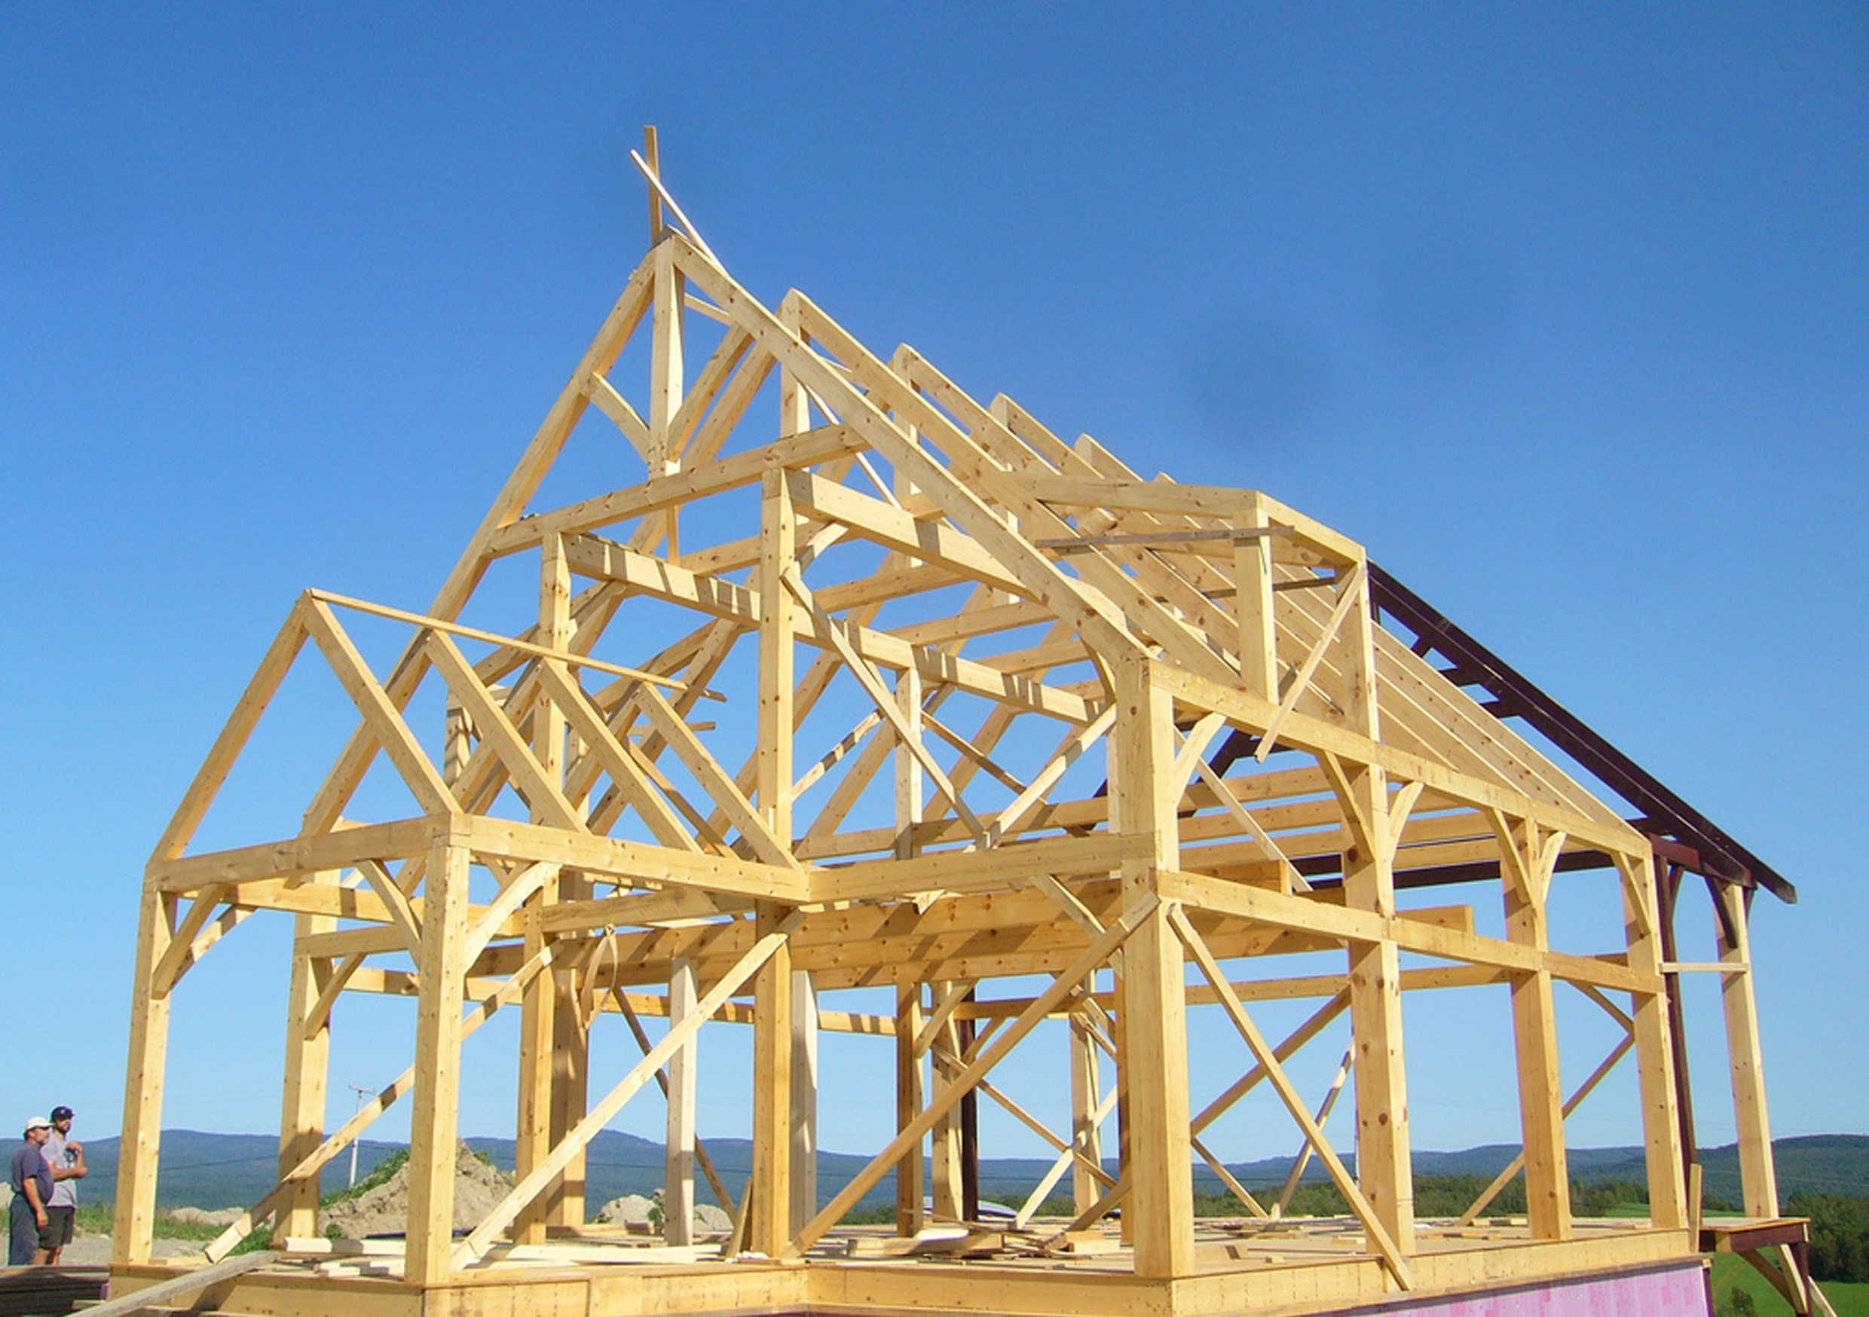
Photo courtesy of ARBRE ÉVOLUTION on Flickr
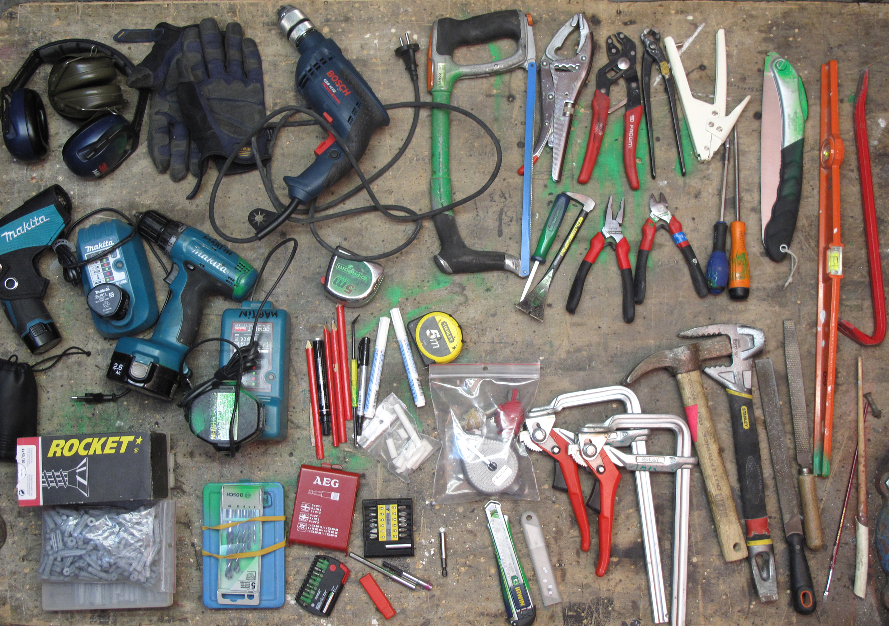
Photo courtesy of martingautron.com on Flickr
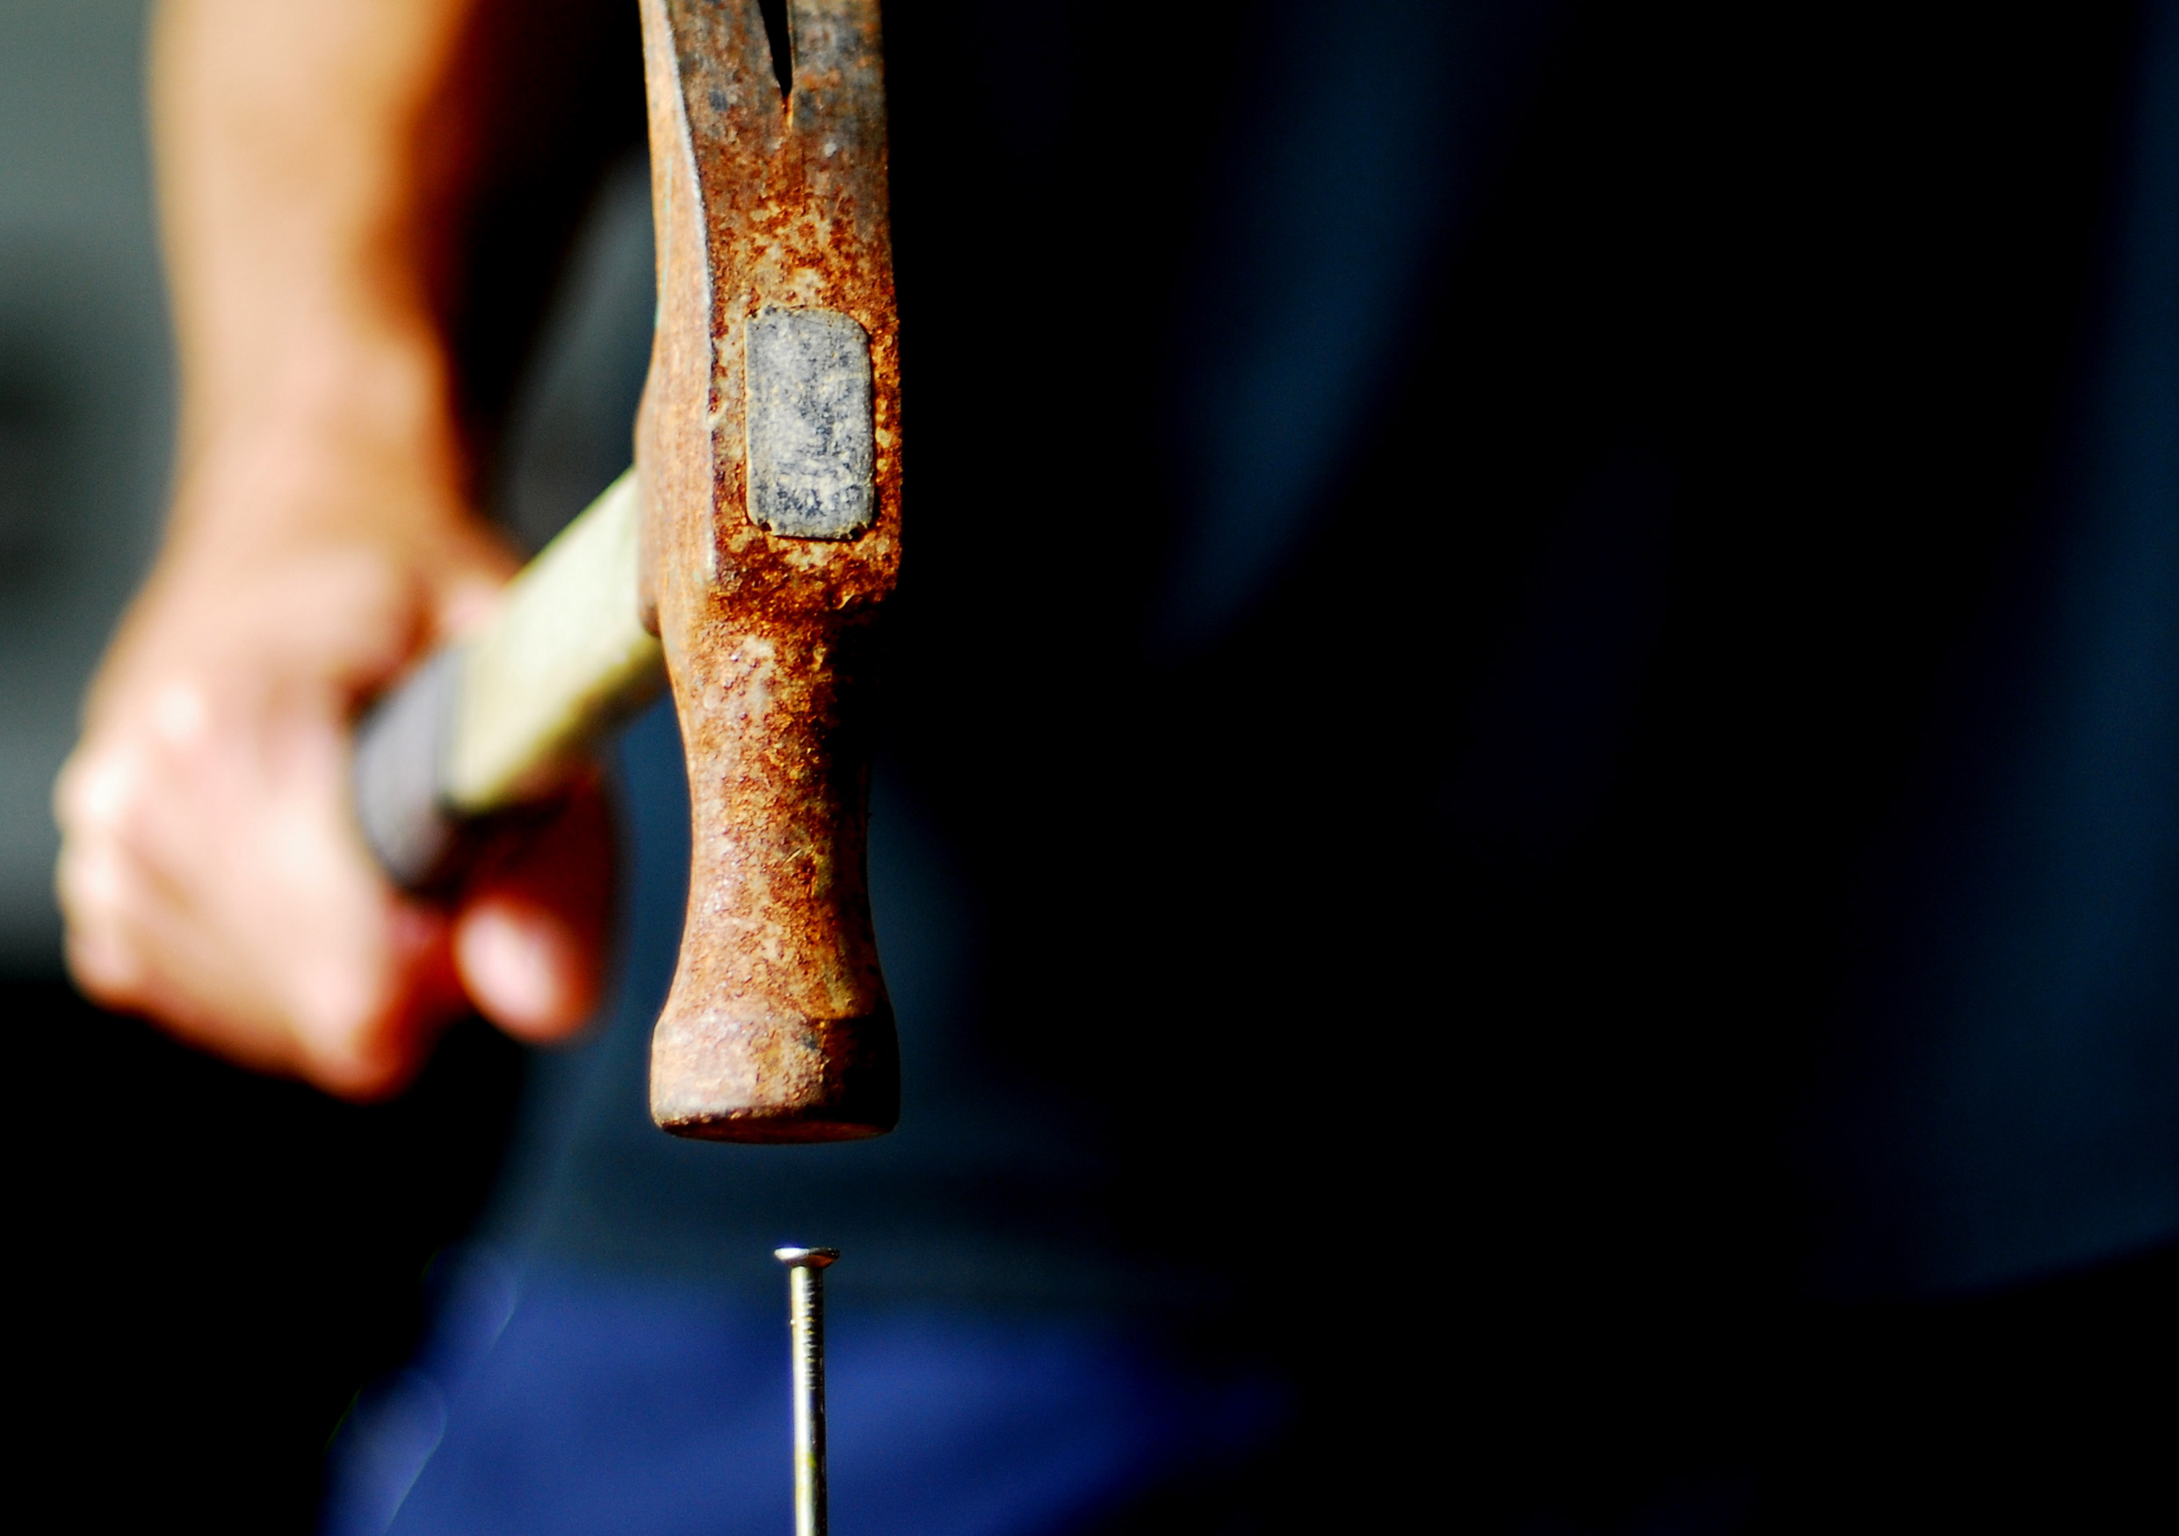
Photo courtesy of bitzcelt on Flickr

Photo courtesy of Vicky TGAW on Flickr

Photo courtesy of hunxue-er on Flickr
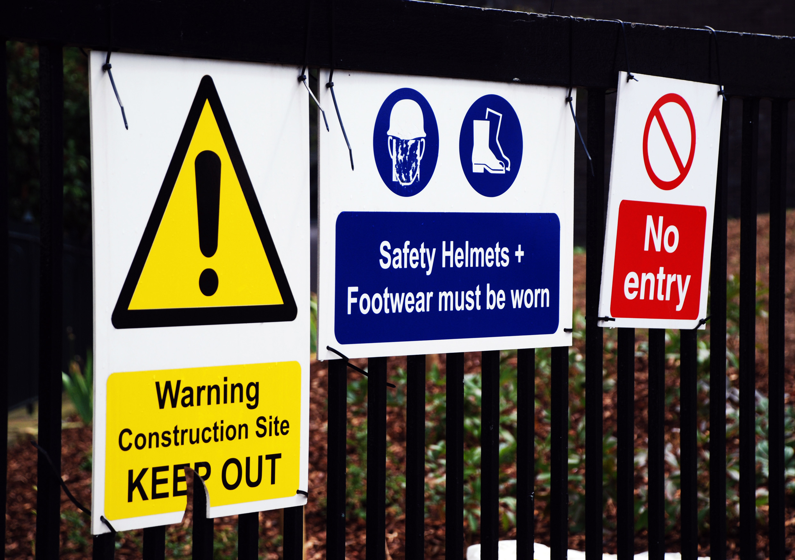
Photo courtesy of incurable_hippie on Flickr
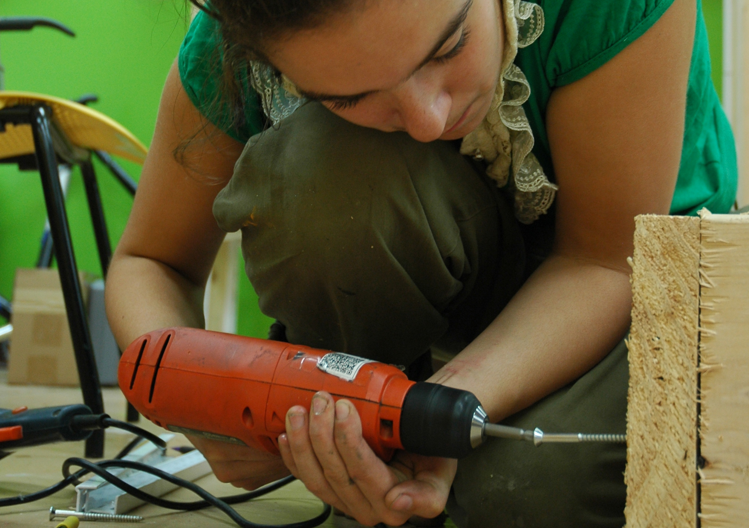
Photo courtesy of the.sprouts on Flickr
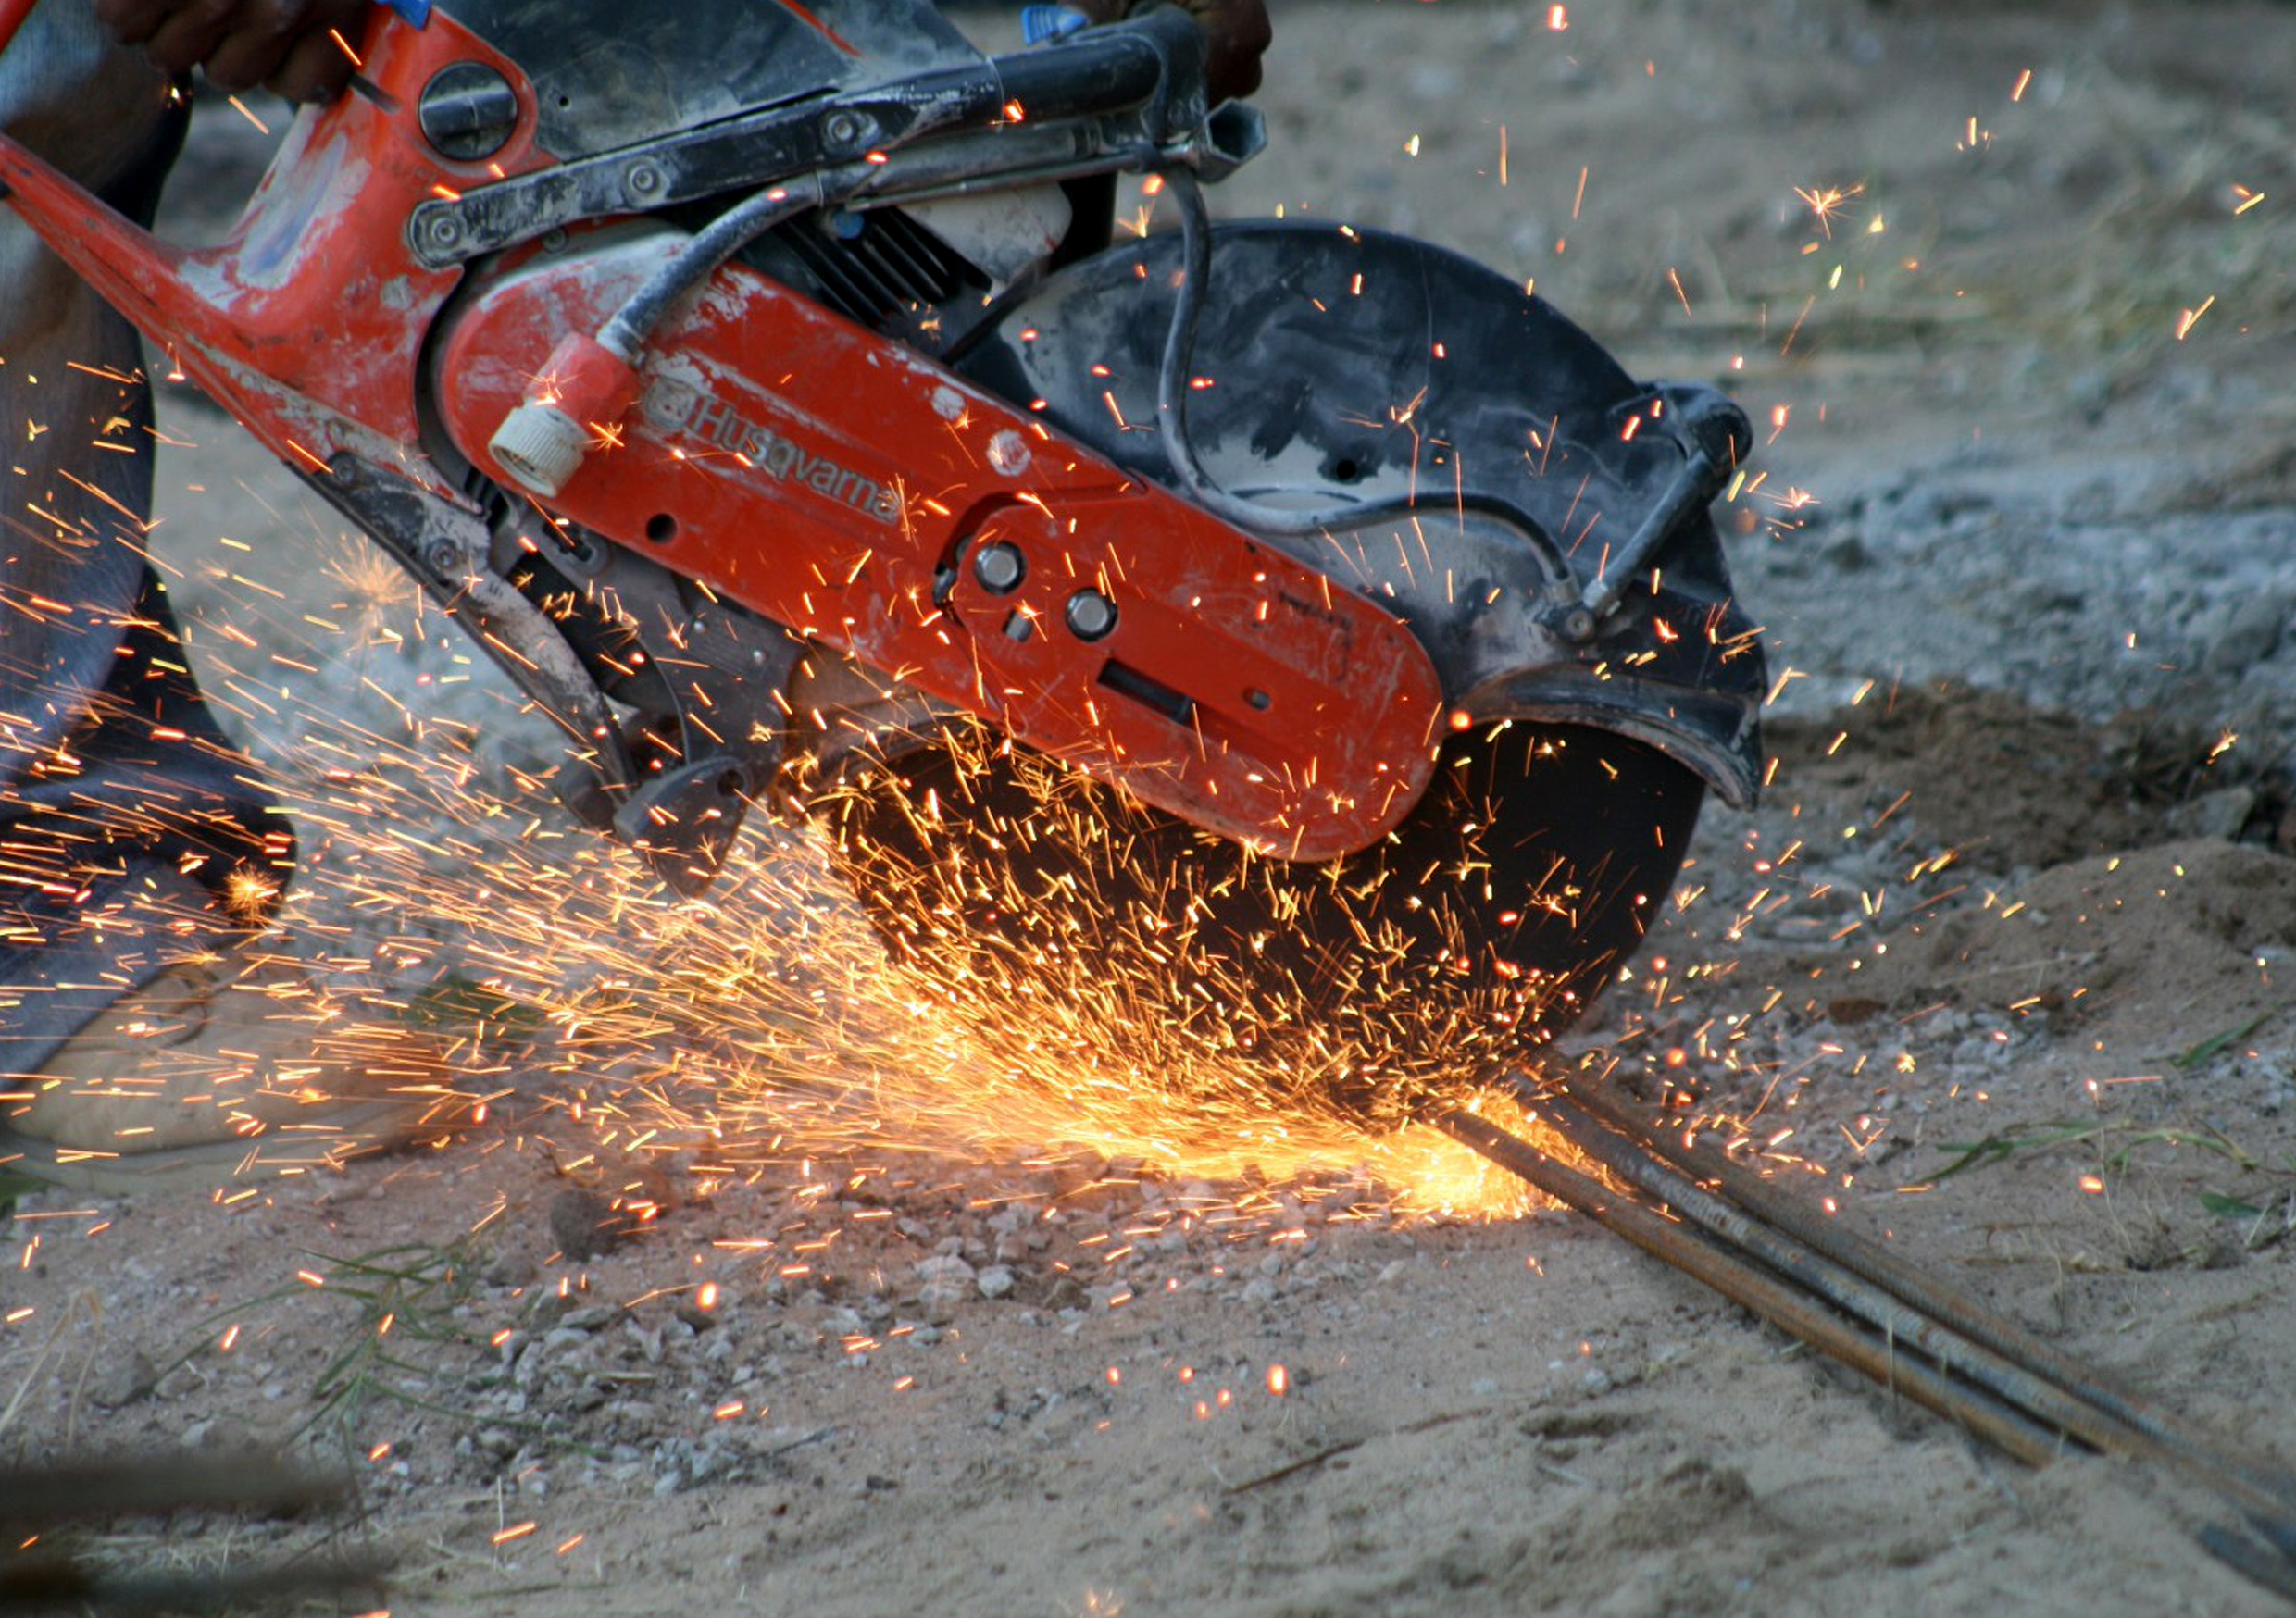
Photo courtesy of Les_Stockton on Flickr
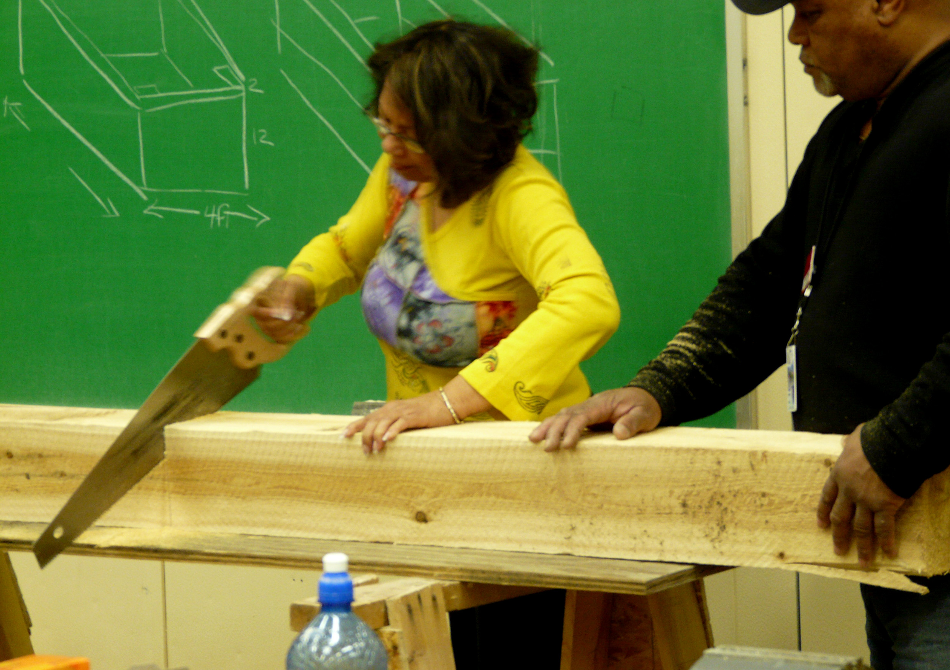
Photo courtesy of Emily Barney on Flickr

Photo courtesy of Katie & Ian on Flickr
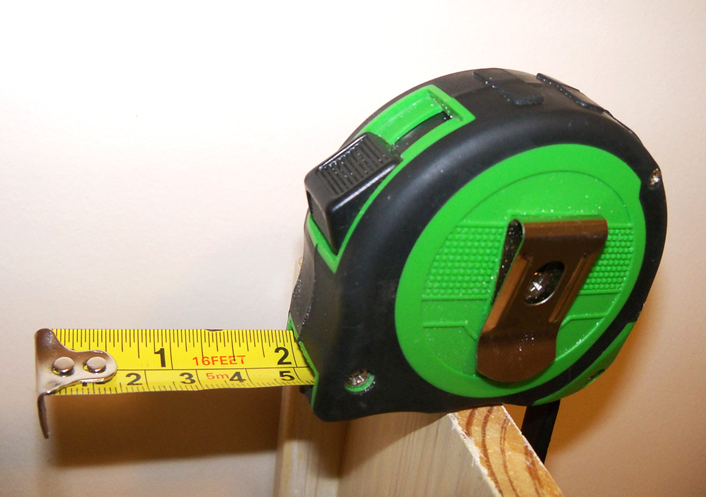
Photo courtesy of Galactic Circus Diplodocus on Flickr

