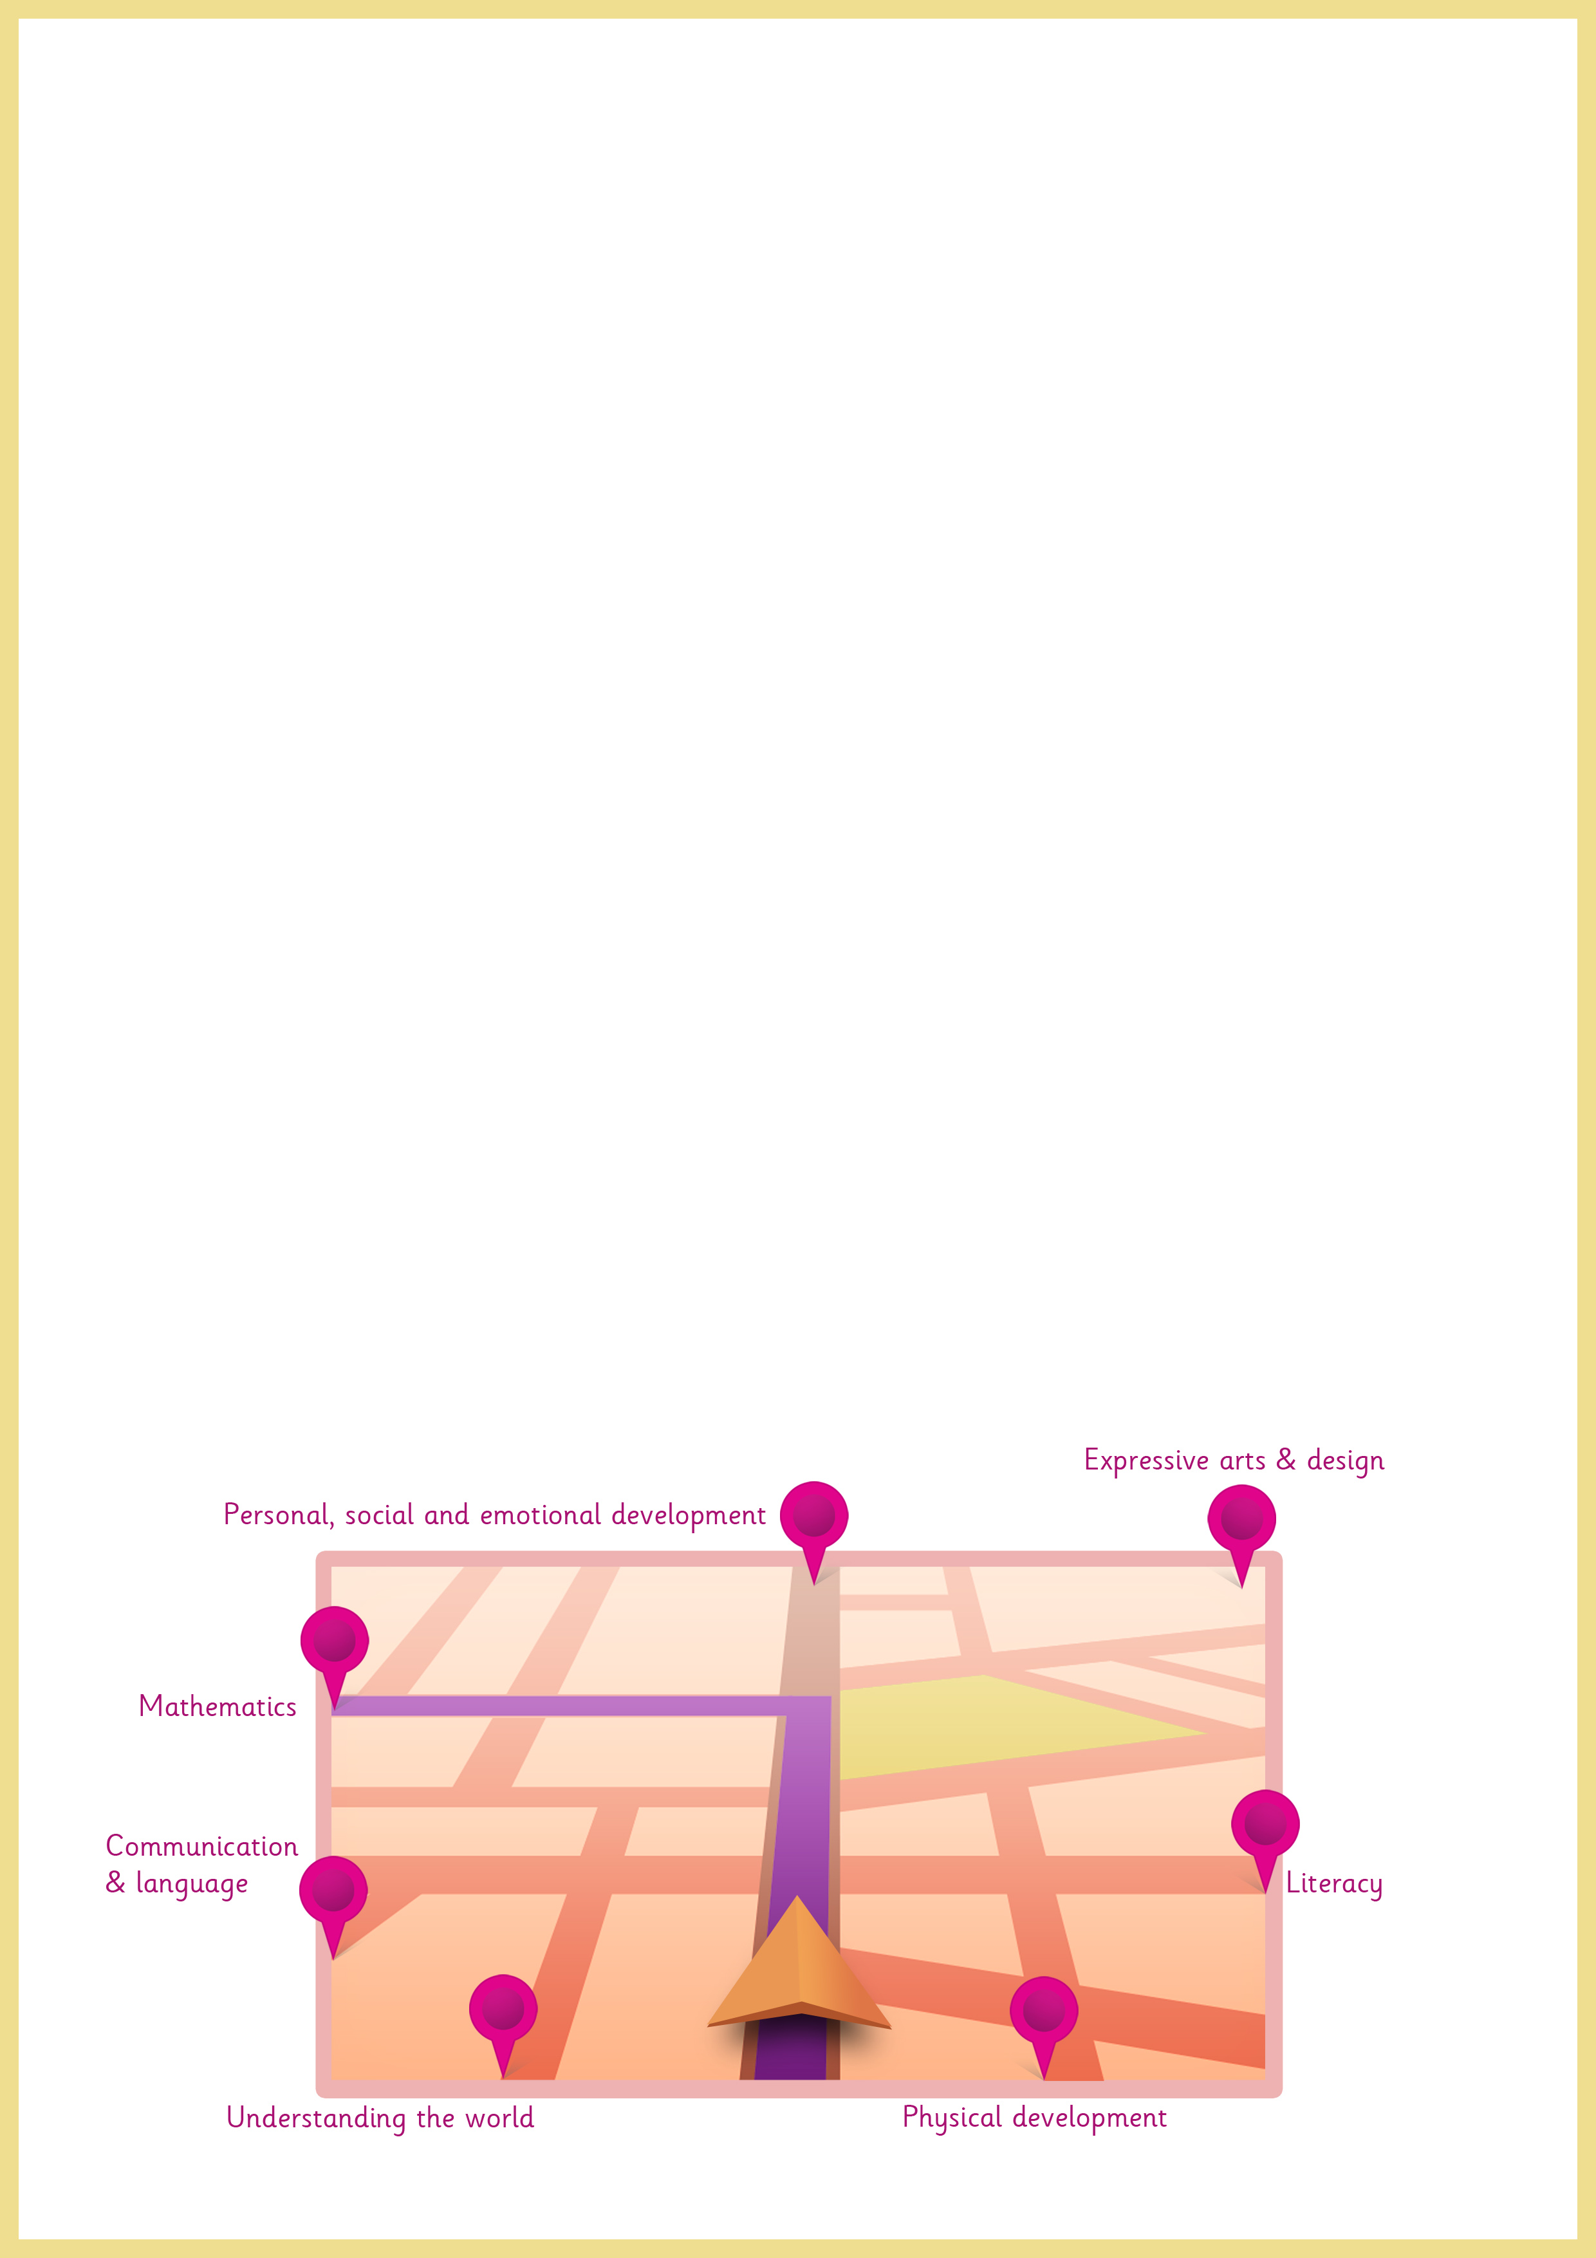
Welcome to your child’s learning journey!
This will become a unique record of your child’s learning in all the developmental areas of the EYFS. It will include photos of your child in various activities, examples of their artwork and written observations including the child’s own words.
You are welcome to take it home at any point to share with the rest of your family and to add photos and comments of your own. Please speak to your child’s key person to arrange this.

Home Link Page
Please date, sign and add share your thoughts and observations each time you return your child’s learning journey.

Date | Signature
Family comment…

Please share any recent photos that are relevant to your child by sticking them in the space below. Please be sure to include any photos of special events, celebrations and festivals.

